ML Detection Engine: Implementation and Evaluation Report

1. Architecture Alignment and Strategy
To satisfy the zero-trust requirements of the Dynamic Orchestration Framework, the ML Detection Engine was designed using a dual-layered approach. Recognizing that a single global model would generate high false positive rates (FPR) across diverse 5G traffic, the engine was heavily decentralized. Separate models were trained exclusively for each slice type (eMBB, URLLC, mMTC) using the 5G-SATORI dataset, ensuring that the detection boundaries accurately reflected the unique traffic behaviors of each network slice.

2. Data Preprocessing and Feature Engineering
To ensure low-latency real-time inference within the VNF sidecar monitors, the raw 5G-SATORI telemetry underwent aggressive dimensionality reduction and cleaning:
- Data Sanitization: Artifacts such as empty trailing columns and missing labels were stripped. Infinite values resulting from division-by-zero flow calculations were converted to zero.
- Zero-Variance Filter: Features that remained static across all flows were dropped.
- Correlation Matrix: A strict correlation threshold ($> 0.90$) was applied to strictly benign traffic to eliminate redundant network features, drastically reducing the computational weight of the final models.
- Standardization: The remaining highly independent features were scaled using StandardScaler to prevent high-magnitude features (e.g., total byte volume) from dominating the machine learning algorithms.

3. Unsupervised Learning: Zero-Day Anomaly Detection
To detect novel, unseen attacks that deviate from normal slice behavior, two unsupervised models were trained exclusively on Benign traffic:
- Packet-Level Detection (One-Class SVM): An SVM utilizing a Radial Basis Function (RBF) kernel was deployed to draw a hard decision boundary around normal traffic. Evaluation showed an exceptionally high benign recall rate (averaging 97-98%), proving its safety for the network. However, its malicious recall was lower (e.g., 34% for eMBB), as it evaluated traffic packet-by-packet and was easily bypassed by stealthy, legitimate-looking packets used in Request Bombing.
- Flow-Level Temporal Detection (LSTM Autoencoder):
To catch the sequential build-up of DoS and QoS Degradation attacks, an LSTM Autoencoder was engineered to process traffic in a sliding window of 10 time steps. By measuring the Mean Squared Error (MSE) of the sequence reconstruction, the LSTM successfully flagged temporal anomalies that the SVM missed.
- Dynamic Statistical Thresholding: Instead of relying on a static error threshold, the system mathematically calculated the 95th percentile of the reconstruction error from the benign training data. Slice-specific thresholds were established (eMBB: 0.9177, URLLC: 2.8485, mMTC: 1.1438). This dynamic tuning successfully capped the False Positive Rate at exactly 5%, protecting healthy VNFs from unnecessary isolation while maintaining strict security.

4. Supervised Learning: Known Threat Classification
To complement the zero-day anomaly detectors, a supervised learning layer was introduced to perfectly identify known attack vectors.
- XGBoost Classifier: An Extreme Gradient Boosting model was trained on a mixed dataset containing both benign traffic and simulated attack traffic.
- Results: By memorizing the exact mathematical signatures of the Request Bombing and QoS Degradation scripts, the XGBoost model achieved a flawless 1.00 (100%) Precision, Recall, and F1-Score across all three slices on the 20% testing holdout. This provided an impenetrable frontline defense against known threats.
Correlation Matrix

1. eMBB
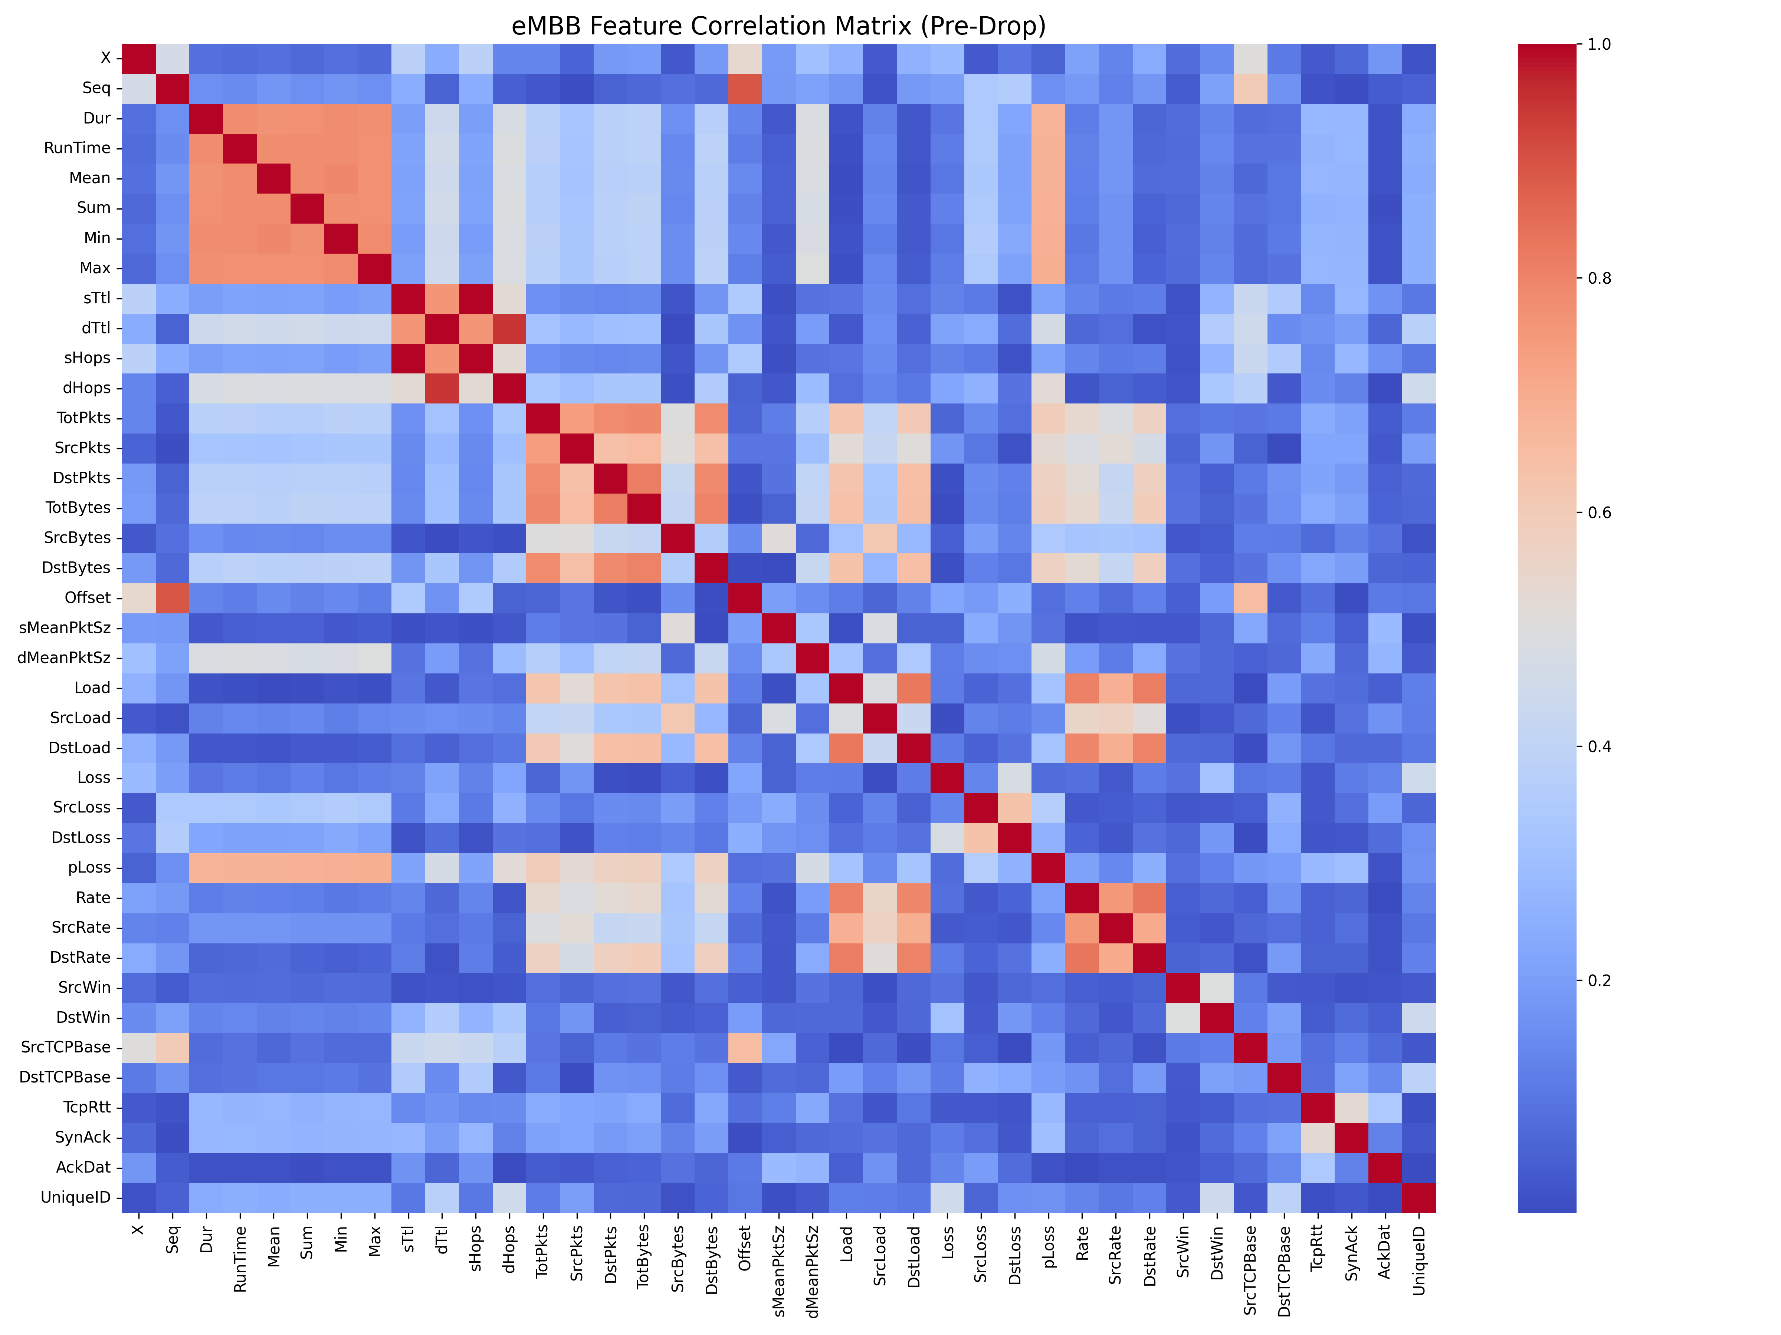
2. mMTC
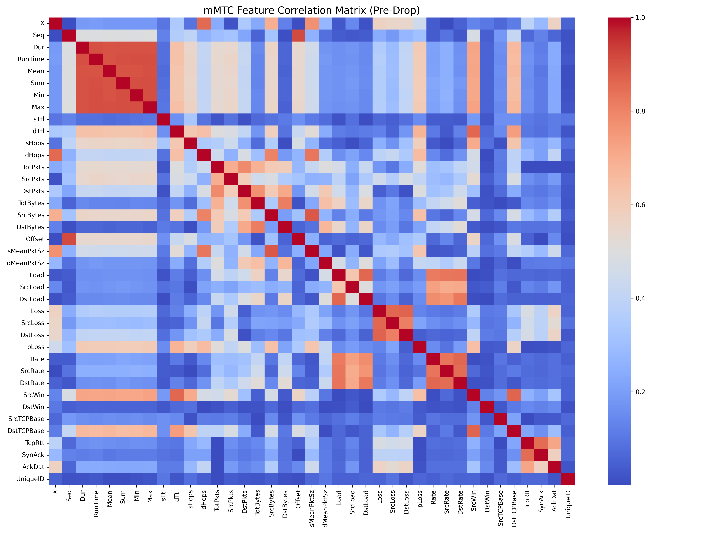
3. uRLLC

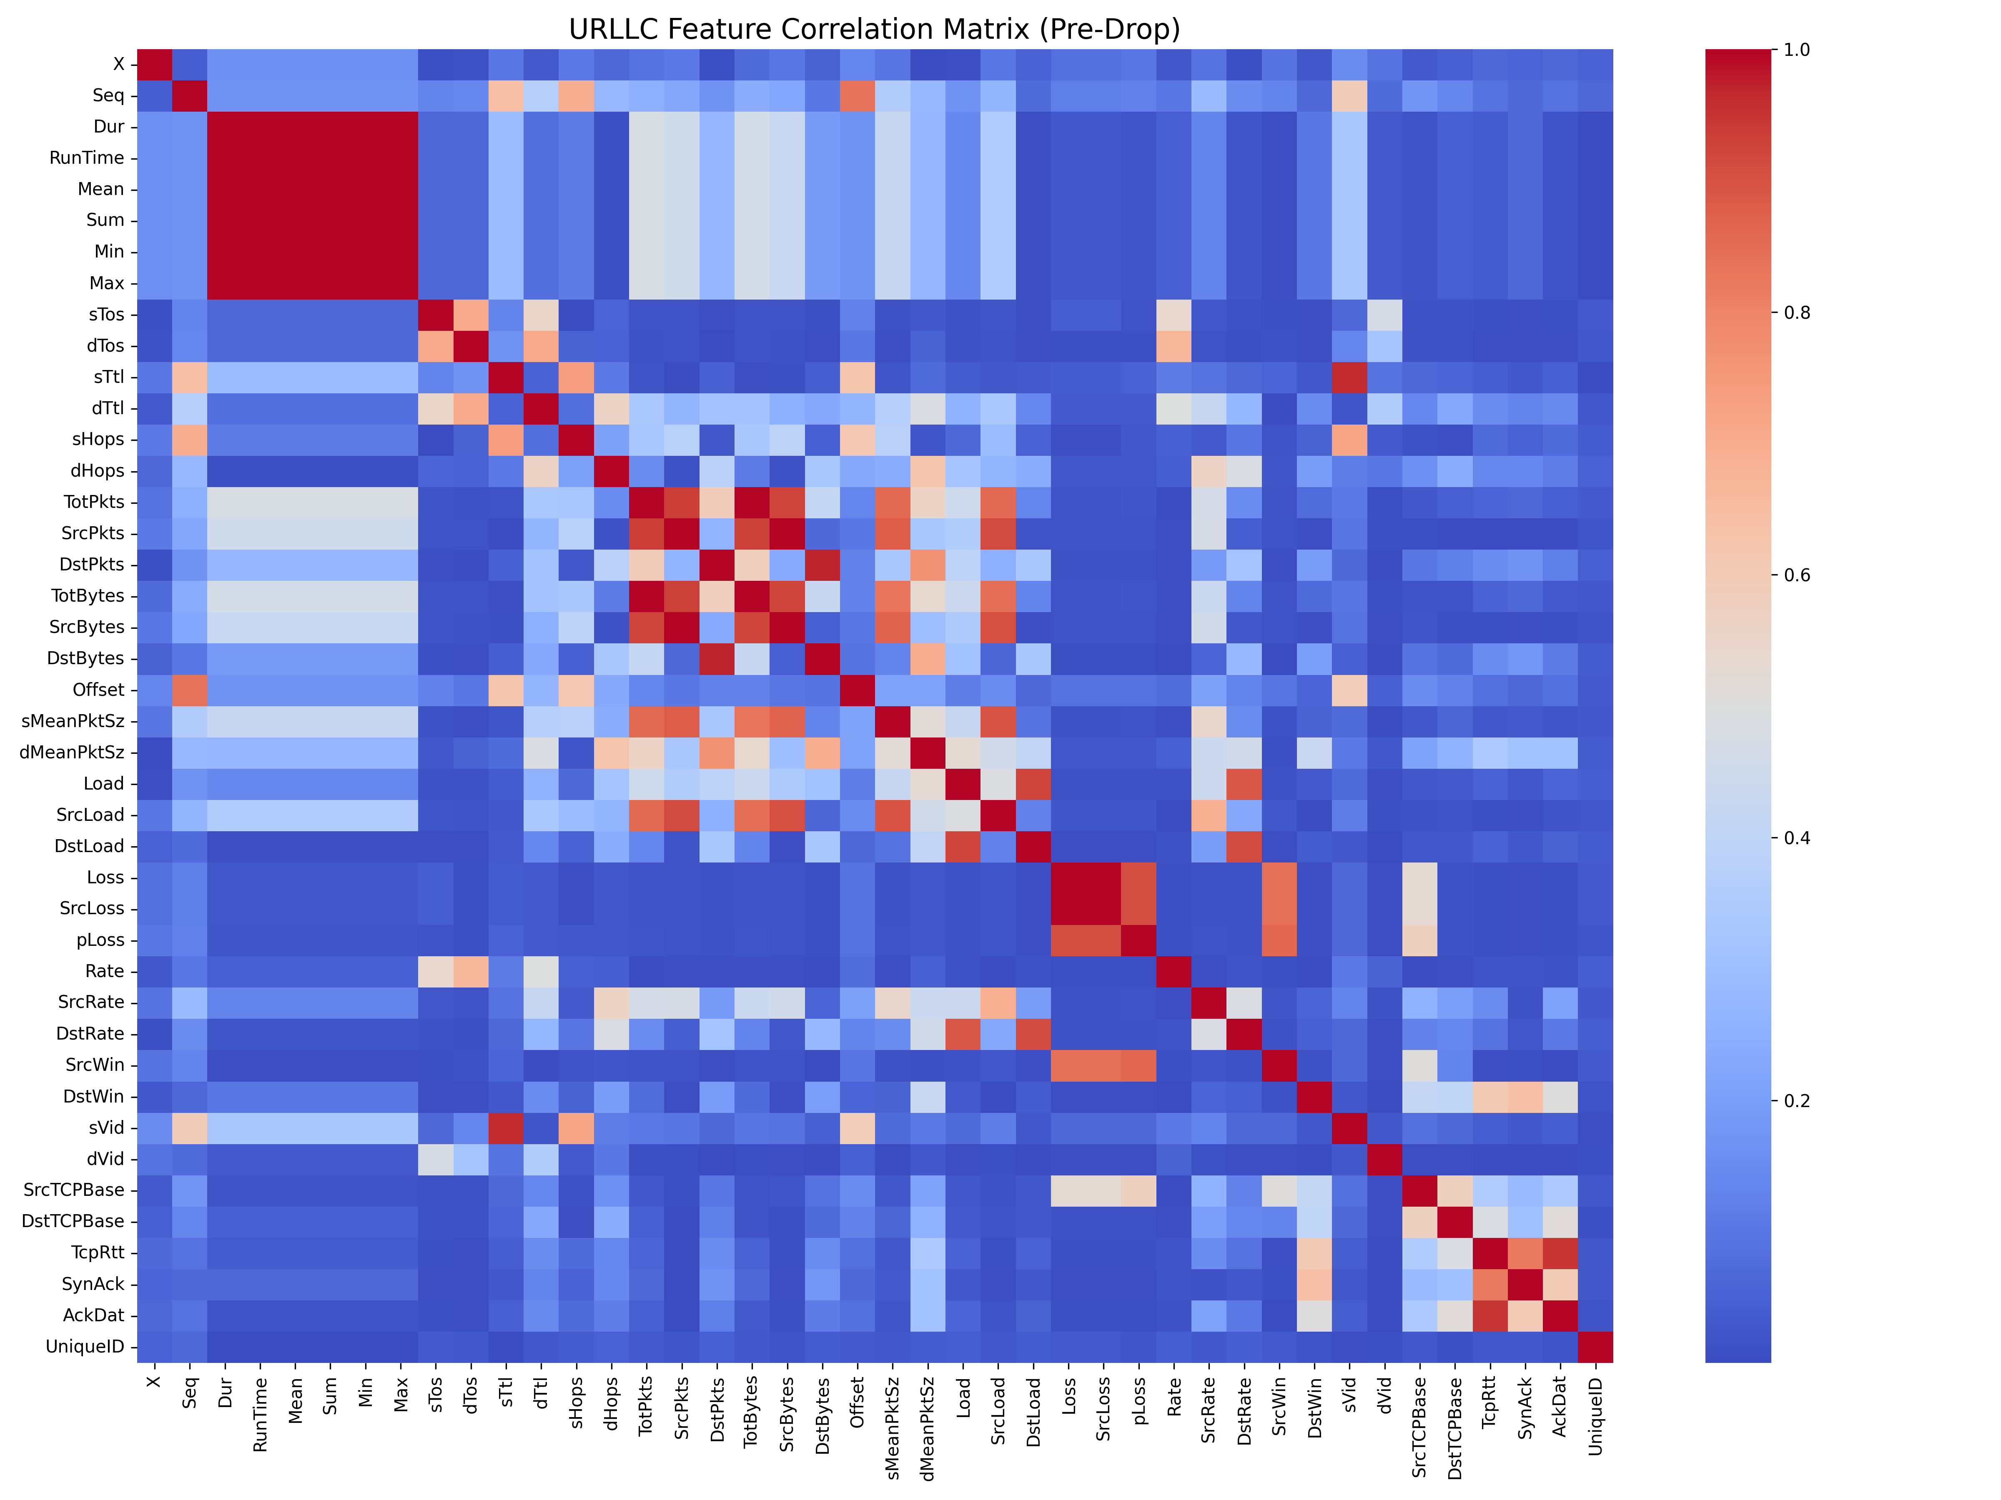

LSTM Threshold calculation

1. eMBB
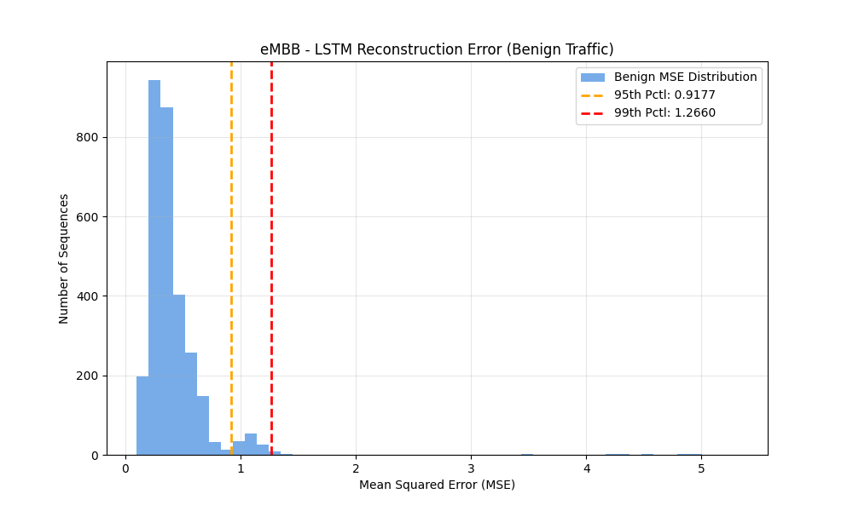
2. mMTC
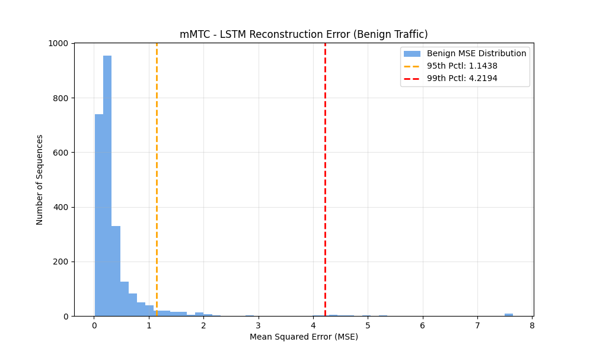
3. uRLLC
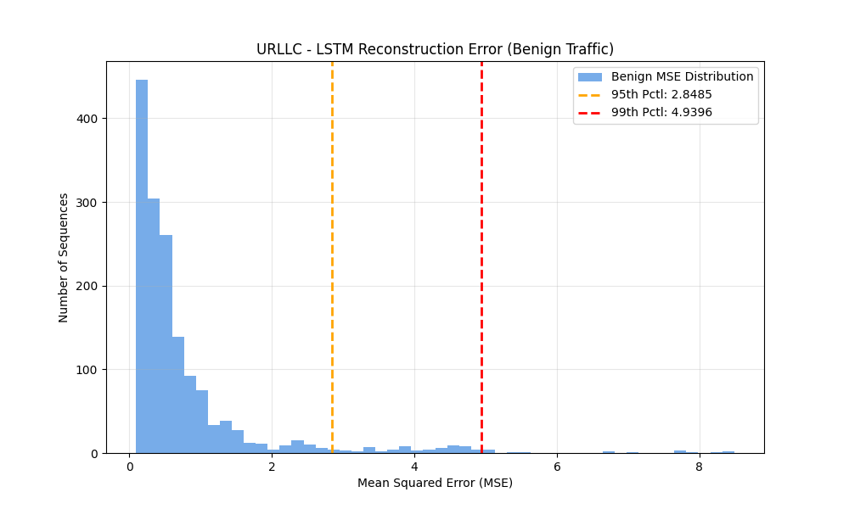
PERFORMANCE METRICS

1. eMBB
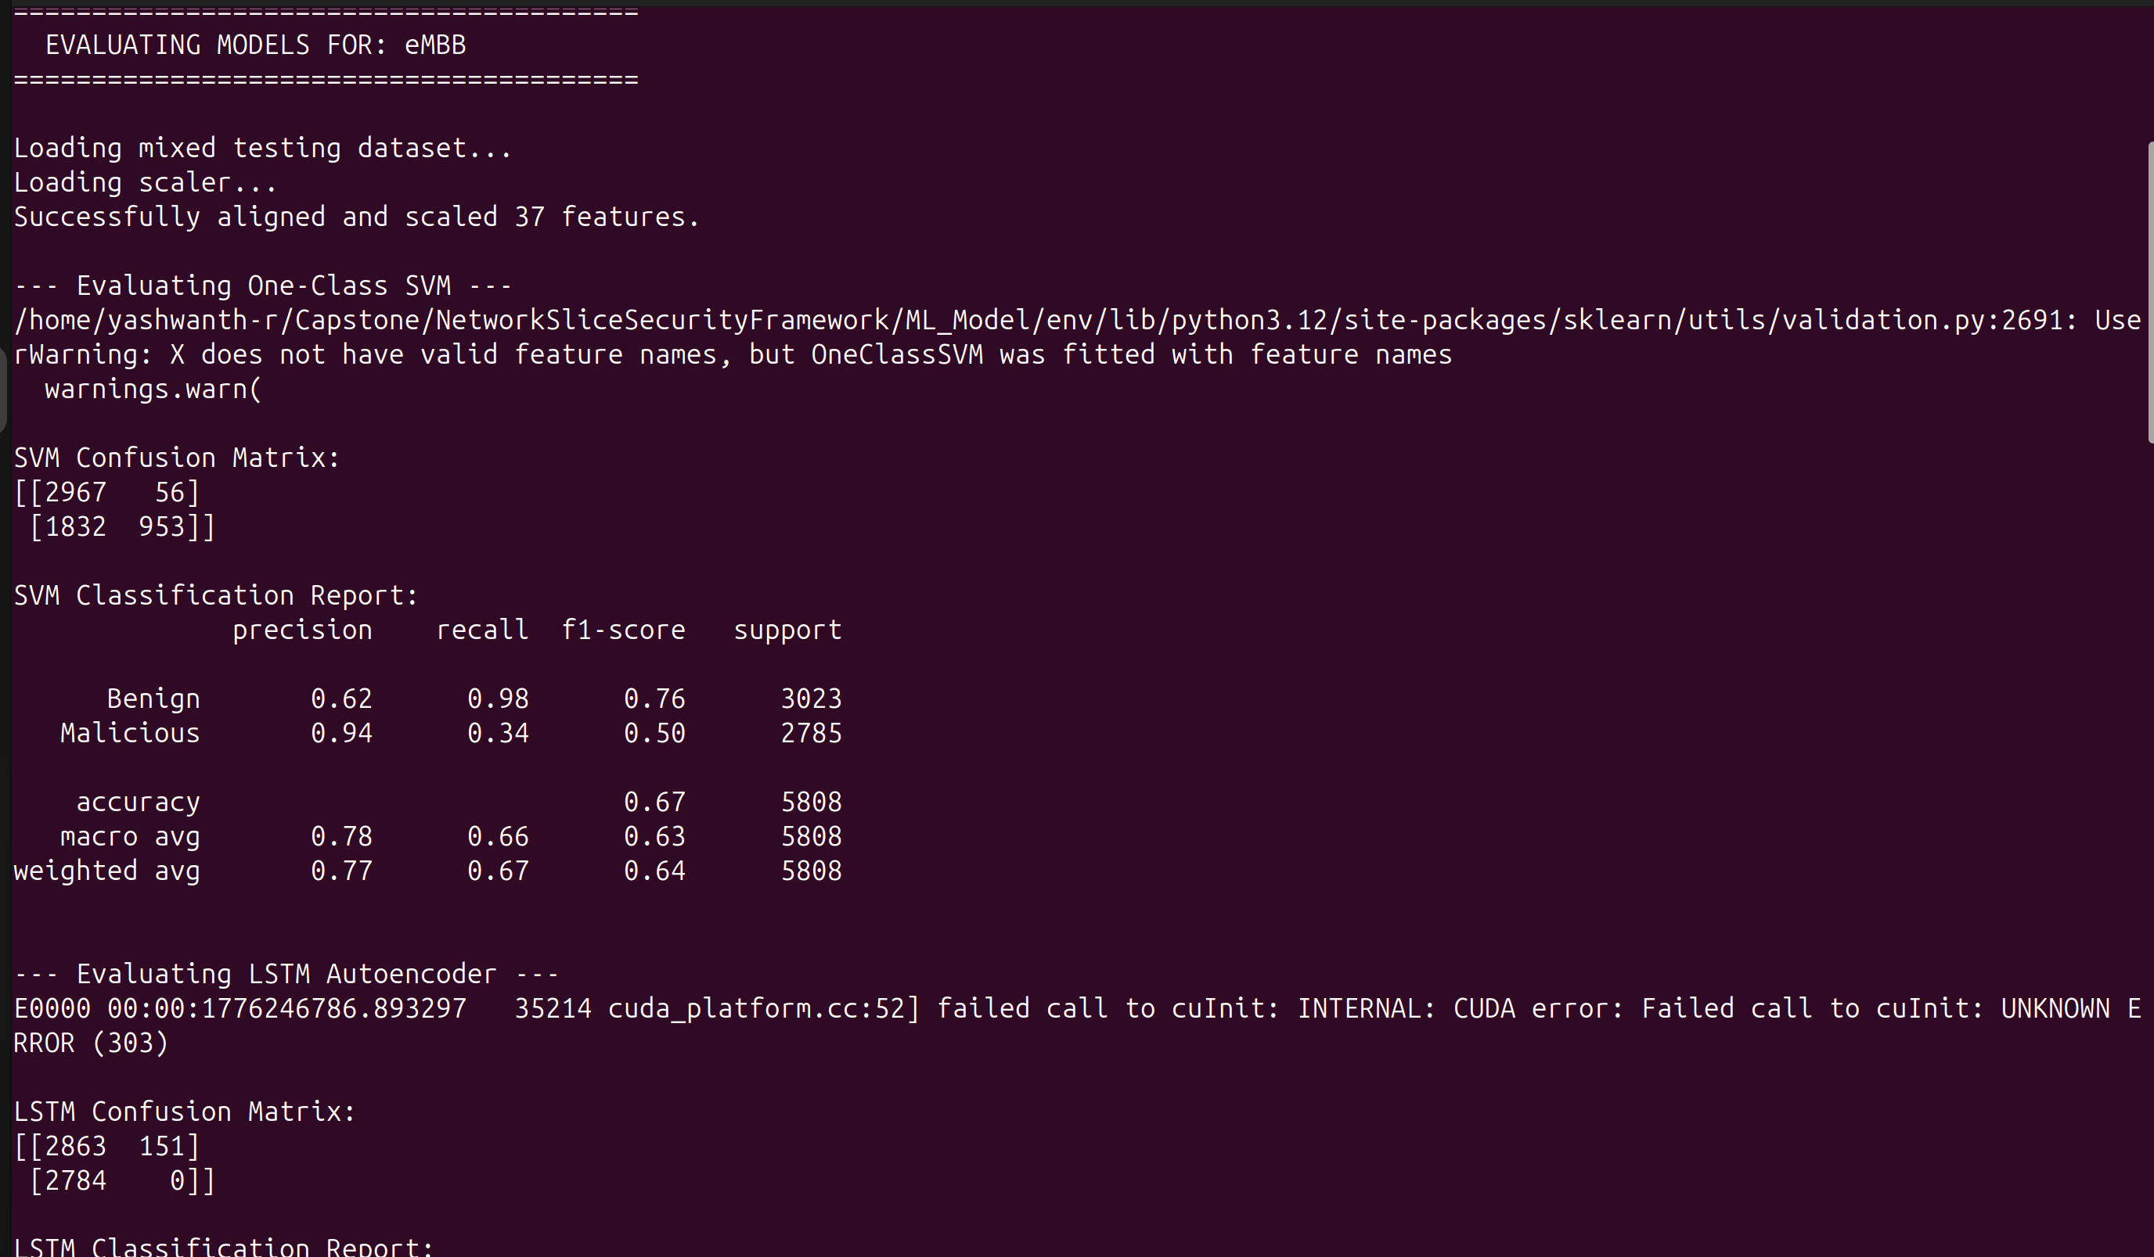
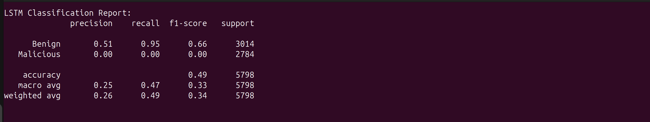
2. mMTC
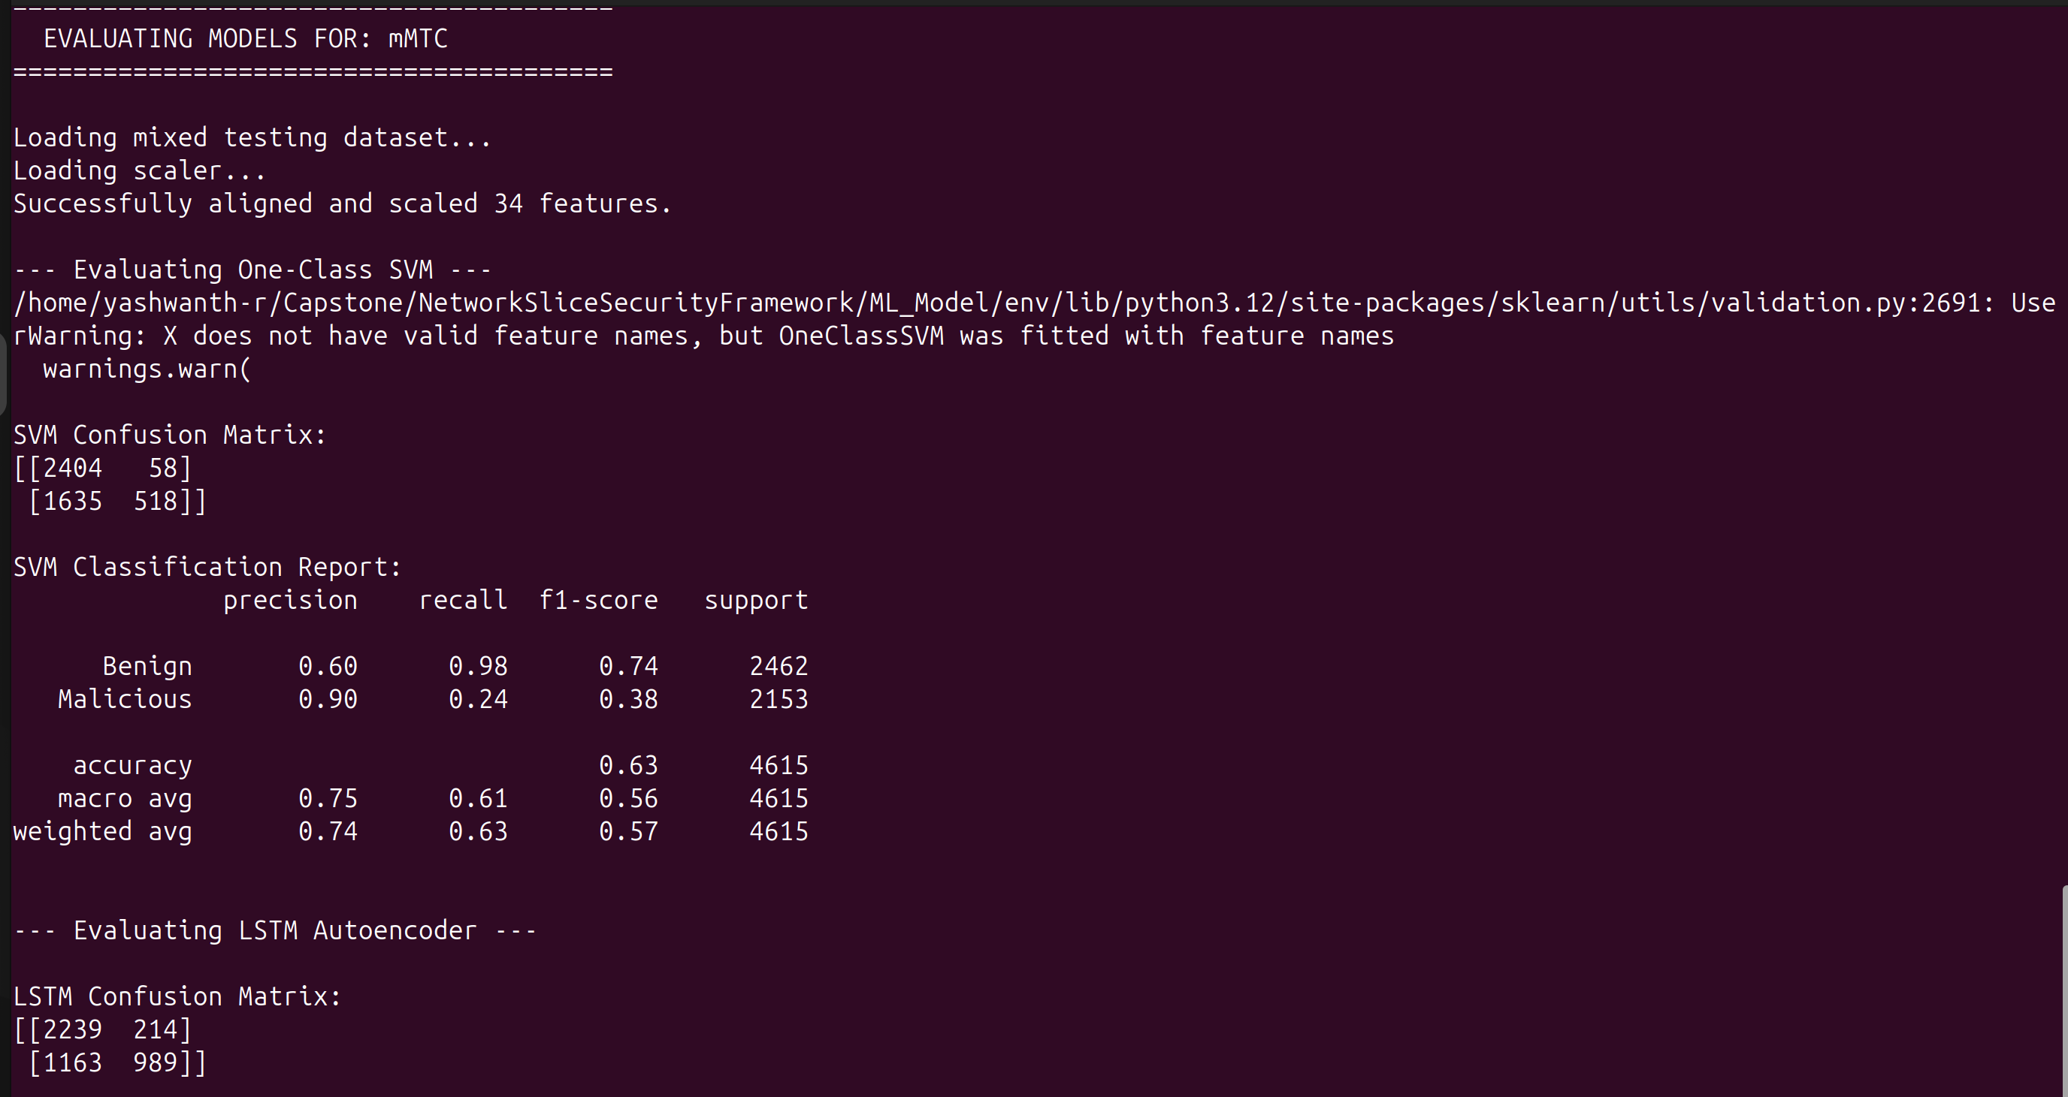
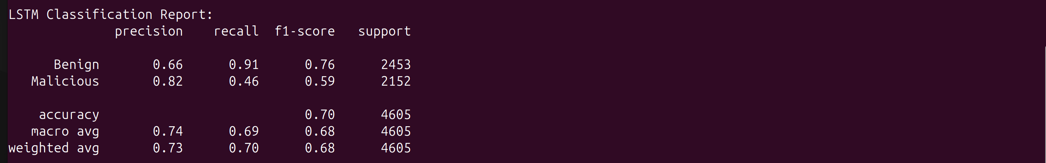
3. uRLLC
