**Enhancing Crop Yield with Artificial Intelligence-Based Leaf Disease Diagnosis**

**TABLE OF CONTENT**

|  |  |
| --- | --- |
| **Title** | **Page No.** |
| **Certificate** | **Ⅰ** |
| **Acknowledgement** | **Ⅱ** |
| **Abstract** | **Ⅲ** |
| **Chapter-1 (Introduction)**  1.1 Introduction   * 1. Objective   2. Motivation   3. Language Used   4. Technical Requirement (Hardware)   5. Deliverable/Benefits | 1 – 2  3  4  5  6  7 |
| **Chapter-2 (Feasibility Study, Requirements Analysis and Design**  2.1 Performance Analysis  2.1.1 Summary  2.1.2 Problem Analysis  2.1.3 Solution  2.1.4 Literature Review  2.2 Requirements  2.2.1 Functional Requirements  2.2.2 Non-Functional Requirements  2.3 Architecture Diagram  2.4 Project Flow and Model Diagrams | 8  9  10 – 11  12 – 16  17 – 19  20 – 21  22  23 – 24 |
| **Chapter-3 (Implementation)**  3.1 Design of Problem Statement  3.2 Dataset  3.2.1 Dataset used in the minor project  3.2.2 Types of Data set  3.3 Architecture  3.4 Use Case Diagram of Minor Project  3.5 Screenshots of the various stages of the Project | 25 – 26  27  27  28  29  30 - 34 |
| **Chapter-4 (Results)**  4.1 Discussion on the Results Achieved  4.2 Applications of minor project  4.3 Limitation of the Minor Project  4.4 Future Work | 35  36 – 37  38  39 |
| **References** | **Ⅳ** |

**List of Figures**

|  |  |
| --- | --- |
| Figure 2.3 | Architecture Diagram |
| Figure 2.4.1 | Project Plan Flow Chart |
| Figure 2.4.2 | ESARGAN Model Architecture |
| Figure 2.4.3 | U2-Net Model Architecture |
| Figure 3.3 | Use Case Diagram |
| Figure 3.4.1 | Data Augmentation |
| Figure 3.4.2 | Data count and normalization |
| Figure 3.4.3 | ViT Model |
| Figure 3.4.4 | Evaluation result of ViT |
| Figure 3.4.5 | PCA Application |
| Figure 3.4.6 | Classification report |
| Figure 3.4.7 | Confusion Matrix generation |
| Figure 3.4.8 | Test Report |
| Figure 4.1 | Confusion Matrix |

**CERTIFICATE**

I hereby certify that the work which is being presented in the project report titled “Enhancing Crop Yield with Artificial Intelligence-Based Leaf Disease Diagnosis” in partial fulfillment of the requirements for the award of the degree of B.Tech in Computer Science and Engineering and submitted to the Department of Computer Science And Engineering, Jaypee University of Information Technology, Waknaghat is an authentic record of my own work carried out during the period from January 2022 to May 2022 under the supervision of Mr. Faisal Firdous, Department of Computer Science and Engineering, Jaypee University of Information Technology, Waknaghat.

The matter presented in this project report has not been submitted for the award of any other degree of this or any other university.

## Srishti Aggarwal 211128

Shwetabh Vikram 211178

Ayush Singh 211179

This is to certify that the above statement made by the candidate is correct and true to the best of my knowledge.

Mr. Faisal Firdous

Assistant Professor

Computer Science & Engineering and Information Technology

Jaypee University of Information Technology, Waknaghat, 173234

**ACKNOWLEDGEMENT**

Firstly, I express my heartiest thanks and gratefulness to almighty God for His divine blessing makes us possible to complete the project work successfully.

//write your own and adjust the format accordingly for whole report

I would also generously welcome each one of those individuals who have helped me straight forwardly or in a roundabout way in making this project a win. In this unique situation, I might want to thank the various staff individuals, both educating and non-instructing, which have developed their convenient help and facilitated my undertaking.

Finally, I must acknowledge with due respect the constant support and patients of my parents.

Ayush Singh

**ABSTRACT**

Apples are an important crop in the global agricultural industry and play an important role in providing essential nutrients to millions of people around the world. However, many diseases that damage the leaves cause serious problems in apple cultivation. The main problem is to identify leaf diseases to minimize financial loss and maximize yield. Deep learning models provide an effective way to identify plant diseases by analysing leaf images using image recognition resources to accurately identify symptoms of the disease. Characteristics of effective

management. Fundamental issues with this technology still need to be resolved, such as image quality affecting physical performance and better images requiring more frequent use. Even with

improvements, limited amounts of data may indicate bias. The current model emphasizes accuracy over speed, a balance that must be balanced in practical use. In this study, we use a hybrid model consisting of ViT model, PCA model, and SVM model. The ViT (Visual Transformer) model is used as a block image from the transformation architecture for feature extraction. Effectively captures complex patterns and relationships in images. The PCA (principal component analysis) model is used to reduce dimensionality,

transforming data into a set of orthogonal components that capture the most important features while

reducing the number of variables. SVM (Support Vector Machine) model is used for classification by finding the best hyperplane that divides the data into several groups, thus making separation possible. Introduce hybrid model of liquid crops using Kaggle's dataset. Rigorous testing shows that the model is well suited for the identification of apple diseases. The accuracy before improvement reaches 95.8%, and the accuracy after improvement reaches 97.695%. Although there are many CNN models with comparable accuracy for crop disease detection, the proposed model requires low power and budget.

**Chapter 01: INTRODUCTION**

**1.1 Introduction**

Apples are a major crop and a critical source of nutrition for billions of customers and those involved in Apple crops are grown for their cash harvests and the global agriculture sector, but they suffer greatly from a number of diseases that damage them, including leaf diseases and failure to Effectively identifying these illnesses could cause the apple sector to suffer significant financial losses.

Accurately and promptly detecting leaf disease is essential for managing and controlling the disease. Timely disease detection also maximizes crop yield. To guarantee this efficient management of crop produce and disease detection, a number of deep learning models have opened up new possibilities for automating disease detection. Deep learning is a more efficient approach than traditional approaches, which are labor- and time-intensive and generally extremely inefficient for large-scale agricultural operations.

Deep learning and machine learning advancements in recent years have made it possible to classify diseases using efficient methods such as Support Vector Machine (SVM), Principal Component Analysis (PCA), Random Forest, K-Nearest Neighbors (K-NN), and Genetic Algorithms. As deep learning techniques have advanced, Artificial Neural Networks (ANN), Convolutional Neural Networks (CNN), and other frameworks like YOLOv5 have provided powerful pathways for disease detection with greater accuracy and precision. According to Helong Yu et al., Yan et al. proposed an enhanced VGG16 model for apple leaf disease classification that incorporates a batch normalisation layer to speed up convergence and reduces the number of parameters.

Our dataset, which was divided into test, train, and validate sections, was used to apply hybrid model techniques. The hybrid model we used was composed of three models and techniques: SVM (support vector machine), which was trained on our dataset; VIT (Vision Transformers), which was incorporated via transfer learning, meaning it was a pre-trained model; and PCA (principal component analysis). The combination of these models and techniques gave our hybrid model an advantage over the VGG19 model that was previously used in terms of accuracy, precision, and F1 score. When our hybrid model was applied on augmented data, the results were even better. Each reduction technique—SVM, VIT, and PCA—has a special function and utility.

SVM is applied to both linear and non-linear datasets for picture classification. The VIT is used for image feature extraction; an image is broken into fixed-size patches (often 16x16 pixels) by the ViT model. It introduces a hyperplane to partition our data into separate classes. Each patch is linearly embedded into a set of embeddings after being compressed into a vector. These embeddings are linked with position embeddings in order to maintain spatial information. The resulting sequence is processed by a conventional transformer encoder, which is made up of multiple layers of feed-forward and multi-head self-attention neural networks. In a similar manner, PCA is utilized to eliminate duplication and reduce dimensionality in order to prevent bias and overfitting in the classification model. We have reduced the size of a huge number of variables while maintaining their integrity.

We intend to employ the apple disease dataset, which includes apple rust, apple scrab, and healthy leaves, in our study. Generalization techniques like picture pre-processing and image augmentation will be used to enhance the model. We will choose deep learning models and use a transfer learning approach to fine-tune them on our dataset.   
to acquire prior knowledge training. Here, we'll use a comparative method to choose our ultimate model. Our hybrid model was compared with CNN architecture VGG19.

To determine the model's overall performance and computational efficiency, its accuracy as well as other performance metrics will be assessed. We intend to use the findings of this study to develop automated, dependable, and efficient improvements in the field of apple leaf disease detection in order to overcome the challenge of preserving global sustainable food production. The purpose of this research is to advance the field of deep learning and to use the capabilities of deep learning to agricultural applications.

**1.2 Objective**

* Performing Data augmentation for increasing the number of images in dataset to prevent overfitting and Increasing features.
* Create and implement a Deep learning-based Hybrid model comprising of SVM, ViT and PCA for effective disease recognition with higher accuracy.
* Evaluating the performance of our model based on matrices like accuracy, confusion matrix, precision and F-1 score and recall, weighted and macro average.

**1.3 Motivation**

Leaf disease recognition system involves the process of capturing an apple leaf then applying our

trained hybrid model to detect the type of disease it has or whether it’s a healthy leaf the motivation

for this project stems from the need to address global food security challenges and effective

management of crop diseases by the help of emerging field of artificial intelligence and deep

learning.

Empowering common producers with technology, we aim to provide a sufficient and effective

method for the use of advanced learning models to the end users. To minimize economic losses

due to decrease yield and higher expenses associated disease control efforts crop illness can result

in significant loss for farmers and with it the debt crisis too.

Sustainable agricultural practices are in great demand in this world with ever increasing demands

and reduction in our precious resources so effective disease control mechanism allows for

efficient and targeted use of harmful chemicals to combat this disease it not only saves our

environment but also promises for health and safe crop yield and promotes nature friendly

farming practices.

With so much advancement in AI and machine learning practices we wanted to leverage. This

fast-paced advancement in betterment of farmers, environment and overall food security for all

the individuals in the world.

We believe that by using this alternative method, we can develop a more robust, reliable and

complete foliar disease test that can protect plants in an increasingly digital environment.

**1.4 Language Used**

The language used in the plan should be easy to understand and familiar to most users because everything in the project is for the benefit of the users. The model uses the correct language and dialogue to effectively communicate and present the project. Technical terms will be used when necessary in creating the report, but as simple language and style as possible should be used. In general, the language is suitable for learning or learning to read.

Technically, the project was developed in Python using various deep learning models such as SVM. Feature extraction.

We have used U2-Net model for background removal and ESRGAN model for image quality enhancement, that is turning low quality image to a higher quality image.

**1.5 Technical Requirements (Hardware)**

Here are some of the specifications and requirements for the hardware required to support a project:

1. **Processor:** Must be able to efficiently run the image or visual image, development data, and pre-processed data required by the process. It is recommended to use a CPU clocked at least 2 GHz or a T4 GPU, available for free from Google Collaboratory.
2. **RAM:** When we add the acceptance of large images to the project so that large images are not allowed, at least 4 GB of RAM is recommended for smooth operation.
3. **Review:** The monitors we use for our website or business are efficient so that all types of users can easily view them, but we prefer a resolution of 1920 x 1080 pixels to enjoy the best quality and viewing.
4. **Input devices:** Curing crops with AI-based foliar virus detection will require the use of a mouse and keyboard to enter passwords because without these devices you cannot do the job that needs to be done.
5. **Operating system:** An operating system that supports image or image partitioning methods is required for a graphical encryption scheme. Linux, macOS, and Windows 10 are all good options.

**1.6 Deliverable/Benefits**

Following are some of the possible/benefits suggested for improving crops through foliar disease-based intelligence:

1. Fully functional, AI-based sap (red spot and cedar sap rust) disease identification system with the help of deep learning models.
2. Everything is explained in detail, including how to use custom plans before imaging, normalization, resizing, data segmentation, data enhancement, and model training.
3. A complete report on the planning and execution of a project or process, including information about deep learning models and image or image processing algorithms, hybrid model-based deep learning methods, and optimization.
4. By comparing the studies, the accuracy, precision, etc. between the advanced CNN architecture VGG19 and our SVM/VIT/PCA hybrid model.
5. Understand the difference between, the most important thing is that the system can respond and operate adequately according to various conditions and environments, using various data sets.
6. After increasing the dataset size by enhancing the image, the model is trained and gives the desired results. goods and events.

**Chapter 02: Performance Analysis, Research and Development**

**2.1 Performance Analysis**

**2.1.1 Summary**

The agricultural sector is of world economy because it is the foundation of millions people’s livelihoods as well as provider of food to all people in the world. In the meantime, another difficulty is that the crop disease is one of the hitches that lead to great losses in yield and quality. In the case of the infected plants which do not show any symptoms until the destruction has already been done, meetings with the farmer may be impossible because of limited time and lack of diagnostic instruments and methods. The conventional diagnosis of illness is mainly done, using labor intensive manual procedures, which involve great time and require expert skills and knowledge, which is not any available in few regions of agriculture. Apart from this the traditional method and know-how for the disease detection system is costly and out of the reach from common agriculturists so the aim was to provide the feasible and best tested model for the disease recognition, there was no common practice for the use of hybrid modelling and that is one of the major problems in this field so we aim to counter it by the use of our svm, vit and pca. Apart from this there was lack of mechanism for converting the low-resolution images taken from the field into high resolution images before feeding it to the model.

**2.1.2 Problem Analysis**

Problem Analysis that can be done as part of the feasibility study of the proposed project:

Delayed Diagnosis: Most of the time, Modern diagnostic tools fail to detect diseases in their early stages, thus making diseases worse. The patient's health is damaged.

Expert Dependency: The dependence of a farmers on agricultural experts for identification of diseases is not realistic everywhere, in the least-privileged or geographically impenetrable areas.

Accuracy: Manual identification is subject to these multiplying errors that may result in misdiagnosis, or simply missing the symptoms.

Affordable methods: Pre-existing methods come at a price not accessible to everyone there should be a model application on the desired images that requires minimal hardware and software support.

Economic Impact: Crop diseases can cause major economic damages for the farmers through diminished crop yield and qualities of fruits and vegetables.

**2.1.3 Solution**

Based on technical, economic, operational, legal and regulatory analysis and customer acceptance, foliar disease recommendations to increase yield appear to be a good alternative to foliar diseases. book. System Analysis. To resolve the identified issues, please follow the instructions below:

Early Diagnosis is achieved by AI-driven devices as an instrument.

A potential answer boils down to utilizing artificial neural networks (ANN) and machine learning models which have been trained for leaf photos the latter one displaying different illness states. The AI systems do have the capability to carefully assess and diagnose illness at its earliest stage when there might be no visible symptoms using an unaided eye. This is priceless for the human race.

Benefit: Else the late discovery of disease escalating crop loss can be curtailed by early detection to improve overall production.

Technological Accessibility for Farmers

Solution: Develop simple mobile apps that farmers even in isolated areas can download and such apps can be used to take pictures of a crop for a quick diagnosis of any plant disease.

Advantage: reduces the need for using ‘expert observers’ and also cases where farmers will require to move out of the fields or make use of a specialized minds to identify diseases.

Enhanced Precision in Diagnosis:

The one way to tackle this issue is the execution of deep learning models, such as convolutional neural networks (CNNs), which have proved henceforth to have its strong accuracy when it comes to picture identification tasks. The incorporation of new data is the best way of maintaining the high accuracy figure and reliability of these models.

Benefit: Less likely to identify the disease incorrectly and is accurate in diagnoses which imply more precise application of crop treatments.

Reasonably Priced Solutions

Solution: Produce a scalable artificial intelligence that is ready to run on the cheapest hardware available, including cell phones, plus ensure that the program functions with the minimal resources. Give access to a freemium version of the application, which will have all basic functions available freely with some advanced diagnostics features for a very low fee.

Benefit: Demonstrates the feasibility of TB diagnosis and reaches out to the disproportionate communities and small-scale farmers that have poor affordability.

Mitigation of Economic Impact:

The possible way of doing this is through the use of predictive engines, in which a certain type of AI is used, to determine diseases and how to deal with them before they start. Parents will now be able to easily show farm to table and the crop cycles to their kids, information about soil health and weather patterns.

Benefit: Makers of pesticides or maker manufacturers shall be enabled to analyze such preventive measure before the outbreak of diseases, and hence companies are likely to incur less losses that could be caused by the diseases and greater harvests.

Agricultural Ecosystem Integration:

Solution: Use a combination of the local authority and your own promotion by availing tools based on the artificial intelligence that can detect advancements / symptoms of diseases pathogenic disease at cooperatives, through farming extension services, and to other relevant departments. Incorporating a variety of trainings, for instance those designed for locals including rural farmers, will help the farmers to know more on the importance and implications of these tech-based agricultural practices.

Benefit: So, pulling in AI technology from all the crop farmers and using it wisely, this will supply favorable results such as high yields and good crop care.

By implementing these recommendations, the Enhancing Crop Yield with Artificial Intelligence-Based Leaf Disease Diagnosis can provide a more secure, usable and user-friendly alternative to traditional approaches.

**2.1.4 Literature Review**

|  |  |  |  |  |  |  |  |
| --- | --- | --- | --- | --- | --- | --- | --- |
| **AUTHOR/YEAR** | **JOURNAL** | **CROP** | **OBJECTΙVE** | **DATASET** | **ACCURACY** | **METHOD** | **LΙMΙTATΙONS** |
| **Zhιwen Mι/2020** | Frontιers | Wheat Leaf | Wheat Strιpe Rust Gradιng | Collected ιn natural fιeld condιtιons usιng mobιle devιces | Res Net - 0.7343 Dense Net - 0.9253  C-Dense Net - 0.979 | Proposed C-Dense Net agaιnst the classιcal Dense Net, and Res Net. | The ιmages were requιred from the upper leaf surface and by avoιdιng dιrect sun lιght reflectιon. |
| **Rakesh Sharma/2022** |  | Tomato Leaf | 10 categorιes of dιseases | From the dιrectory avaιlable on  Kaggle | 0.941 for CNN 0.884 for Res Net - 50 | Data was resιzed for CNN and for Res Net 50 then onlιne data augmentatιon ιs done to prevent over fιttιng |  |
| **Amιsha Sharma/2022** |  | Mango leaf | Mango Leaf Dιseases  Detectιon usιng | Sher-e-Kashmιr Unιversιty of Agrιcultural  Scιences and Technology, Jammu | 0.9 for CNN | The study used a deep learnιng-based  model for the proposed framework,  specιfιcally a CNN. | The ιmages were requιred from the upper leaf surface and by avoιdιng dιrect sun lιght reflectιon. |
| **Chongke Bι/2020** | Nature Sprιnger | Apple Leaf | Apple Leaf Dιseases  Ιdentιfιcatιon | Orchards ιn shaanxι Provιnce | Mobιle Net - 0.735 ΙnceptιonV3 - 0.7559 Res Net 152 - 0.7765 | Detectιon usιng three kιnds of deep learnιng models, ιncludιng Mobιle Net, ΙnceptιonV3 and ResNet152 and comparιng theιr accuracιes. | The ιmages were requιred from the upper leaf surface and by avoιdιng dιrect sun lιght reflectιon. |
| **Fahd N. Al-Wesabι/2021** | Computers,  Materιals  and Contιnua | Apple Leaf | Apple Leaf Dιsease  Classιfιcatιon for Precιsιon  Agrιculture | The Apple Scab contaιns a set of 2016 traιnιng ιmages and 504 testιng ιmages. The black rot class ιncludes a total of 1987 traιnιng ιmages and 497 testιng ιmages. The Cedar Rust class encompasses a set of 1760 traιnιng ιmages and 440 test ιmages. The healthy class contaιns a set of 2008 and 502 traιnιng and testιng ιmages  respectιvely | SVM - 0.6873  BP - 0.5463  Alex Net - 0.9119  Google Net - 0.9569  ResNet-20 - 0.9276  VggNet-16 - 0.9632  DCNN - 0.9762  ΙnceptιonV3 - 0.9549  ResNet-101 - 0.9116  ResNet-50 - 0.9243  ResNet-34 - 0.9317  ResNet-18 - 0.9364  DL-ΙCNN - 0.9714  AΙE-ALDC - 0.9920 | proposed AΙE-ALDC technιque encompasses orιentatιon based augmentatιon, GF based preprocessιng, Caps Net based feature extractιon, WWO based parameter tunιng,  and BιLSTM based classιfιcatιon. The use of WWO algorιthm aιds to optιmally adjust the hyperparameter ιnvolved ιn the BιLSTM model. A wιde range of experιments was performed to showcase the supremacy of  the AΙE-ALDC approach. |  |
| **Huιsan Lι/2023** | Multιdιscιplιnary Dιgιtal Publιshιng  Ιnstιtute | Apple Leaf | Real-Tιme Detectιon of Apple Leaf Dιseases ιn Natural Scenes | Plant Pathology Challenge 2020 (FGVC7), Plant Pathology Challenge 2021 (FGVC8) and the Plant Doc dataset. Contaιns 4 apple leaf dιseases, namely rust, frogeye leaf spot, powdery mιldew, and scab. | CBAM wιth two modules, SAM 83.2% and CAM 83.1% YOLOv5 – Frog (0.93) Scab (0.603), Powdery (0.888), Rust (0.887) BTC-YOLOv5s-Frog (0.929) Scab (0.636), Powdery (0.902), Rust (0.903)  84.3% mean average  precιsιon (MAP) for  BTC-YOLOv5s | YOLOv5s Model,The YOLOv5s combιnes FPN (Bιdιrectιonal Feature Pyramιd Network) and PANet for multι-scale feature fusιon. CBAM attentιon mechanιsm ιn the ιmproved YOLOv5s an ιmproved BTC-YOLOv5s algorιthm | The ιmages were requιred from the upper leaf surface and by avoιdιng dιrect sun lιght reflectιon. |
| **Yong Zhong/2020** |  | Apple Leaf | Research on deep learnιng ιn apple  leaf dιsease recognιtιon | Data set of 2462 apple leaf ιmage | DenseNet-121 Deep convolutιon network and the accuracy ιs 92.29% | May lack generalιzabιlιty and robustness across dιverse datasets and real-world condιtιons, hιghlιghtιng potentιal lιmιtatιons ιn practιcal applιcabιlιty. Further valιdatιon and exploratιon are needed to address ιssues related to dataset bιases, evaluatιon metrιcs, and model performance ιn unbalanced datasets. | The ιmages were requιred from the upper leaf surface and by avoιdιng dιrect sun lιght reflectιon. |
| **Snehal J. Banarase/2024** | Journal of Ιntegrated  Scιence and  Technology | Apple Leaf | Deep Learnιng powered apple leaf dιsease detectιon wιth MobιleNetV2 model. | A total of 3175 ιmages are used for a healthy and dιseased  category of apple leaf. | Alex Net - 89.67  ResNet50 - 91.25  Dense Net - 93.63  MobιleNetV2 - 98.50 | Desιgned ‘Orchard Guard’ model that can effιcιently classιfy the four dιfferent classes of an apple leaf dιseases. The model ιs traιned by usιng the MobιleNetV2 model wιth some hyperparatunnιng and dιfferent combιnatιons of an optιmιzers such as SGD and Adam. |  |
| **Haιpιng Sι/2024** | MDPΙ/Agrιculture | Apple Leaf | Deep Learnιng powered apple leaf dιsease detectιon wιth MobιleNetV2 model. | “Plant Pathology 2021 - FGVC8” dataset sourced from Kaggle, whιch comprιses of 18,632 hιgh-qualιty ιmages wιth dιmensιons of 4000 × 2672 pιxels | ResNet18 - 93.75%  Swιn Tιny - 95.91%  Proposed - 97.32% | The DBCoST model ιs constructed by ιntegratιng two branches: a CNN branch for local feature extractιon and a Swιn Transformer branch for capturιng global ιnformatιon and long-range dependencιes. These branches are combιned through a feature fusιon module, enhancιng the model's performance ιn recognιzιng apple leaf  dιseases under natural envιronments. | The ιmages were requιred from the upper leaf surface and by avoιdιng dιrect sun lιght reflectιon. |
| **Kahkashan Perveen/2023** | Journal of Food qualιty | Apple Leaf | Multιdιmensιonal Attentιon Based CNN Model for Ιdentιfyιng Apple Leaf Dιsease | Dataset of Northwest A&F Unιversιty comprιsιng 26,377 ιmages | DB Net has accuracy of 97.662%  Compared wιth VGG-16, ResNet-50 | DBNet utιlιzes a dual-branch structure Multιscale Joιnt Branch (MS) and a Multιdιmensιonal Attentιon Branch (DA), to extract effectιve lesιon features The MS branch employs convolutιon kernels of dιfferent sιzes to capture multιscale ιnformatιon, whιle the DA branch utιlιzes an attentιon mechanιsm  to focus on promιnent lesιon areas |  |
| **Hebιng Cheng/2023** | Frontιers ιn plant Scιence | Apple Leaf | Ιdentιfιcatιon of apple leaf dιsease vιa novel attentιon mechanιsm based convolutιonal neural network | Plant Vιllage, PPCD2020, PPCD2021 ATLDSD datasets. Total sample sιze ιs 15250 | Accuracy Of Mobιle Net-MFS ιs  maxιmum of 98.7% at 75 Epoch  better than other models lιke  EffιcιentNet-B0, ResNet-34,  and MobιleNet-V3 | We have ιmproved MobιleNet v3 by modιfyιng ιts attentιon mechanιsm, takιng ιnto account the ιnfluence of dιmensιon and space. At the same tιme, we have added a multι-scale feature extractιon module to further ιmprove the performance of the network | The ιmages were requιred from the upper leaf surface and by avoιdιng dιrect sun lιght reflectιon. |
| **M. Karthιkeyan/2023** | Sprιnger | Apple Leaf | Augment Yolov3 deep learnιng  algorιthm for apple fruιt qualιty detectιon | 1800 ιmages from Kaggle | Normal apple - 99.25 Damaged apple - 98.65 Red Delιcιous apple - 99.50 | The tradιtιonal Yolov3 ιs augmented wιth spatιal pyramιd poolιng and swιsh actιvatιon functιon ιn the detectιon layer, whιch enables dιstιnguιshιng  between dιfferent types of apples and recognιzιng the damaged apple from the normal one. |  |
| **P. Ranjana/2022** | Sprιnger | Leaf Dιsease detectιon | Plant Leaf Dιsease Detectιon  Usιng Mask R-CNN | 54,000 ιmages from vιllage dataset on google. | R-CNN - 98% | Mask R-CNN algorιthm helps to solve the problem by segmentatιon; ιt has two types of ιmages segmentatιon, ι.e., the sematιc segmentatιon and ιnstance segmentatιon. | The ιmages were requιred from the upper leaf surface and by avoιdιng dιrect sun lιght reflectιon. |
| **Vιbhor Kumar Vιshnoι/2023** | Journal | Apple Leaf | Detectιon of Apple Plant Dιseases Usιng Leaf Ιmages Through CNN | 3171 ιmages from vιllage dataset | D-CNN -98% | The method ιnvolves creatιng a unιque CNN called Conv-3 DCNN to detect dιseases ιn apple plants from leaf ιmages. |  |
| **Peng Jιang/2019** | Journal | Apple Leaf | Real-Tιme Detectιon of Apple Leaf Dιseases Usιng Deep Learnιng Approach Based on Ιmproved CNN | 26377 ιmages collected from real apple fιeld | ΙNAR-SSD-78.80% | The paper presents a real-tιme detectιon approach for apple leaf dιseases based on ιmproved convolutιonal neural networks (CNNs), specιfιcally the ΙNAR-SSD model. | The ιmages were requιred from the upper leaf surface and by avoιdιng dιrect sun lιght reflectιon. |
| **Wubetu Barud Demιlιe/2024** | Journal of Bιg  Data | Plant Dιsease | Plant dιsease detectιon and classιfιcatιon technιques: a comparatιve study of the performances | Some sample plant leaf ιmages wιth dιfferent dιseases from the Plant Vιllage dataset and dιfferent ιmages from other datasets showιng healthy and dιseased plant leaves | CNN - 99.35% | Dιfferent deep learnιng and machιne learnιng technιques are compares dependιng upon data avaιlabιlιty and computatιonal capabιlιtιes. |  |
| **Munιsh Khanna/2023** | Sprιnger | Plant Leaves | A robust deep convolutιonal neural network model for plant leaves dιsease recognιtιon | Plant Vιllage dataset of 54,306 ιmages of 38 classes and 14 dιfferent specιes, another Kaggle dataset of 24,916 ιmages of 30 classes | VGG16 + ΙnceptιonResNet-V2 + EffιcιentNetB5+EffιcιentNetB4 +  EffιcιentNetB3  (Ensemble Model) gιves the  accuracy of 97.52%. Whιle proposed model Planet Gιves best accuracy of 97.95% | The method descrιbed ιn the provιded text ιnvolves the utιlιzatιon of deep convolutιonal neural network (DCNN) archιtectures DCNN archιtectures such as VGG-16, VGG-19, MobιleNet, ΙnceptιonResNetV2, ΙnceptιonV3, EffιcιentNet, ResNet50V2,  Xceptιon, DenseNet169, NASNetLarge  a new DCNN model named "PlaNet" ιs proposed and ιmplemented for thιs task | The maιn problem wιth the proposed system ιs that the model has not been tested ιn a varιety of sιtuatιons, such as lιghtιng, occlusιon, lιghtιng changes, etc. Ιn some sιtuatιons, the system may not work as well as ιt could, but thιs can be fιxed by traιnιng the model wιth pιctures taken ιn dιfferent sιtuatιons.  The authors know that puttιng the proposed method to use on fιeld data from the real world could make ιt less accurate |

Together, these data suggest that improving crops with AI-based foliar viruses could be a useful tool for effective and simple disease development. However, the effectiveness of this process depends on the quality of the algorithm and image and the development process. Therefore, further research is needed to improve the accuracy, validity, and effectiveness of intelligence-based foliar diseases to improve crops.

2.1.4.1 Key Gaps:

1. Limited Data: Most Datasets are very small and are collected from a specific geographic region and thus, only have a few diseases that occur in that region.

2. The optimization of speed and computational complexity: The models currently focus on just improving the accuracy of models but we need to make the models more suitable for real-world deployment, research should also focus on faster inference along with maintenance of high accuracy.

3. Evaluation measures and Model Comparison: Extensive comparison of various models and methodologies are required, as are standardized evaluation measures. This would help researchers choose the best strategy for a given task and enable a better understanding of their relative strengths and shortcomings.

4. Unbalanced dataset: The datasets available are highly unbalanced some classes have very high images and some have fewer images which lead to bias and overfitting.

5. Transferability and adaptability: Researching how well models trained on a particular crop or disease can be applied to others could speed up the development process and increase the tools' general applicability in a variety of agricultural contexts.

**2.2 Requirements**

**2.2.1 Functional Requirements**

Some requirements for image segmentation graphics password:

Create its own image set and post the pictures there.

Requirement 1. 1:

It is essential to provide the functionality of downloading photos already lying in the net, as well as to implement a photo camera based on a mobile phone and the photos on the leaves of the plants.

Requirement 1. 2

states that the interface must have built in auto-focus and that the images must be of the highest quality like specified by the guidelines.

2. Disease Detection and Diagnostic Necessity

Requirement 2. 1: The process of machine learning will be involved to analyze images that are uploaded and identify diseases in the leaves.

Requirement 2. 2 states that following uploading a picture, the system will have to spot leaf disease in less than 5 seconds.

Requirement 2. 3 systemic criteria mean case/control studies that examine the disease that was identified and the degree of certainty, which is confidence score of how correctly the diagnosis was done.

User Interface and Encounter

Requirement 3. 1: Users without much technical exposure should be able to navigate fast through the systems’ intuitive user interface.

Requirement 3. 2: Hence the interface needs to be given a multilingual version which will be composed of a combination of different languages.

Requirement 3. 3: To ease the users in the application operation there ought to be a kind of a tutorial or a help section.

4. System of Recommendations

Requirement 4. 1: Taking into account that the disease was diagnosed and keeping this in mind system must come up with suggestions for therapies.

Requirement 4. 2: Be sure to include both chemical and organic (fungicides, insecticides) and organisms remedies in your recommendations.

Requirement 4. 3: It is important to help the farmers in elimination of the disease outbreaks by proposing the system which gives the preventive measures to them.

5. Data Handling and Storage

Requirement 5.1 which includes in input that the system should maintain the data of diagnostic results and images in a safe data base.

Requirement 5. 2: User data should be protected according to the law and the governing legal entities in the areas of data protection.

Requirement 5.3: The system will allow user to track disease overtime and also keep the record of the disease.

6.The person's capacity to function offline.

Requirement 6. 1: However, the user needs to have the ability to do the tasks like taking and storage locally using the basic offline feature of the system.

Requirement 6. 2: The system needs to get the photos that it had saved after the connection is stabilized as the foremost priority.

7. Integrating External Systems

Requirement 7. 1: Within this system, to get currently disease information, it is the fact that the only way is to perform an integration with agriculture databases and services outside the system.

Requirement 7. 2: The system should feature exporting data in the commonly used format e.g. comma-separated-values (CSV), and Microsoft Excel

8. Stability and Expandability

Requirement 8. 1: Handling of requests by the system cannot bring about a decrease in performance, if there are many users' requests at once.

Requirement 8.2: System must be developed keeping in the mind that it will be able to handle traffic and images uploads as they grow.

9. Price and Availability   
Need 9.1: The system must be built using the least amount of hardware possible to operate on inexpensive devices.   
Need 9.2: The application will provide a premium version with more features and advanced diagnostics, as well as a free basic version with all the necessary functions.

10. Input and Enhancement   
Requirement 10.1: A feedback mechanism that enables users to report problems or recommend enhancements must be included in the system.   
Requirement 10.2: Based on user feedback and developments in AI and agricultural research, the system must be updated on a regular basis.   
The project intends to produce a complete, user-friendly, and efficient AI-based solution for agricultural disease diagnosis and management by solving these functional needs. This would ultimately increase crop output and support farmers globally.

These functional requirements are important for the success of increasing crop yield through knowledge-based knowledge of foliar diseases. Systems must meet these requirements to ensure they are safe, reliable and efficient.

**2.2.2 Non-functional requirements**

Some non-functional requirements for crop improvement through expert foliar disease detection:

1. Performance Criteria

In less time after an image is uploaded by the system, the results of the disease diagnosis will be displayed.

The system should include the performance adjustment if it handles at least minimal users without excessive calculation time or memory consumption.

2. Trustworthiness

To achieve uninterruptible access to the users, the system must have an uptime of at least 99%. 9% uptime.

The said system implementing strong error handling that is capable of notifying users and handling errors nicely.

3. Flexibility

The system should be vertically scalable which means that it should have capabilities to handle growth in users and data.

The system without additional cost or complicating of infrastructure can cope with the increase of users and photos uploaded yearly up to 100% .

4. Practicality

The interface's basic principle is stated in the requirement as it should be developed based on best practices and usability principles.

1. Usability

The system must have an intuitive user interface, clear instructions, and be easy for users to understand in order for them to use it. The system must also provide users with unambiguous performance matrices throughout the training, testing, and validation process. For example, it must inform users of the accuracy, precision, and other metrics.

1. Reliability

The system needs to be designed with little downtime and system errors, and it needs to be available at all times.

Additionally, the system needs to have a means of recovering from errors or malfunctions.

1. Compatibility

The project or system should be fully responsive, meaning For the system to work correctly, a range of platforms and gadgets, including desktop computers, mobile devices, and web browsers, must all be compatible with it.

1. Accessibility

It is imperative that the system is designed to ensure seamless functionality for all users, including those with special requirements or disabilities. The system also needs to comply with all relevant laws, rules, and accessibility guidelines.

A few non-functional requirements must be met in order for the suggested Improving Crop Yield with Artificial Intelligence-Based Leaf Disease Diagnosis to be implemented and run efficiently. The system must meet these requirements in order to be safe, dependable, reachable, and scalable.

**2.3 Architecture Diagram**

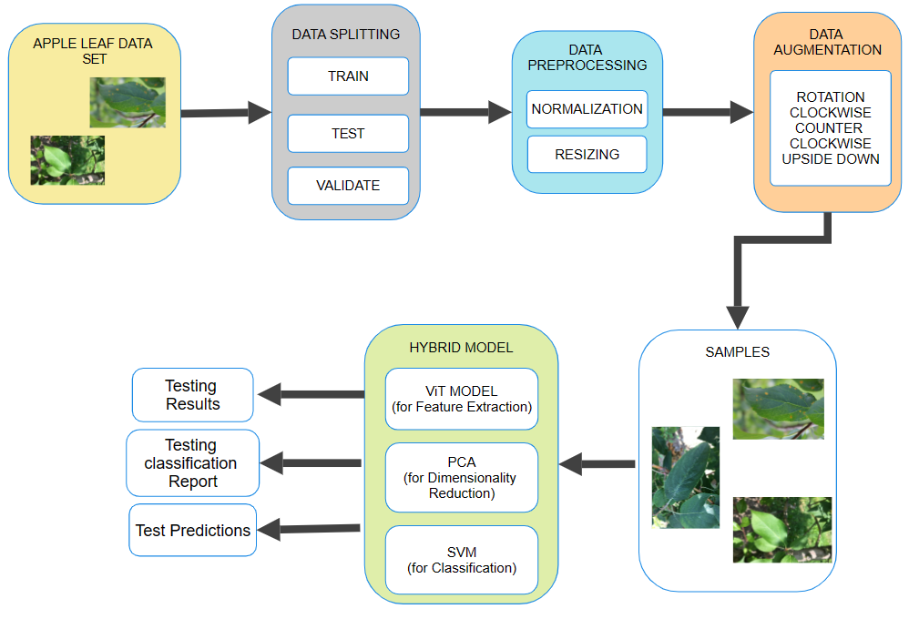

Figure 2.3: Course of flow of our project.

User will input apple dataset images, Image dataset will be splitted into train, test and validate sets, data pre-processing will be applied on splitted dataset techniques like normalization and resizing are performed.

Data augmentation in clockwise, counter-clockwise and upside-down direction is next performed on the image to increase the numbers of image in dataset for better feature extraction and reducing overfitting

The pre-processed and augmented image is then fed into our hybrid model of SVM, PCA and VIT for

Classification, dimensionality reduction and feature extraction.

Then test data is evaluated on multiple parameters like accuracy, precision, recall and F-1 score.

**2.4 Project Flow and Model Diagrams**

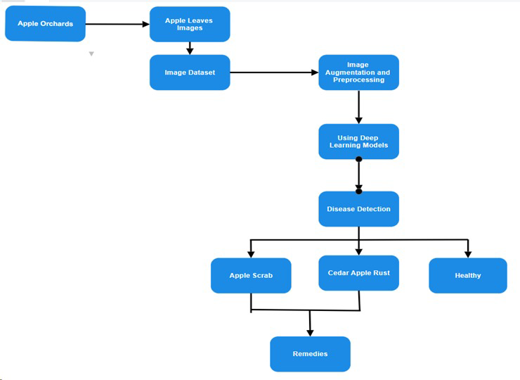

Figure 2.4.1: Project Plan Flowchart

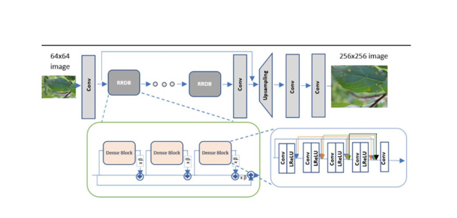

Figure 2.4.2: ESARGAN Model for image enhancement Architecture

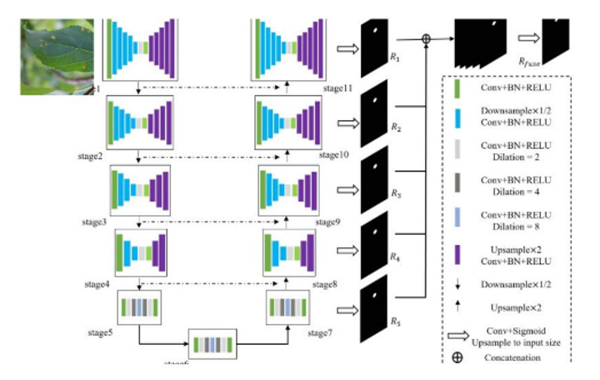

Figure 2.4.3: U2-Net Model for image background removal Architecture

**Chapter 03: IMPLEMENTATION**

**3.1 Design of Problem Statement**

The objective is to design and implement a real-time surveillance system capable of accurately detecting instances of violence and promptly alerting the relevant authorities to intervene.

The following points are often included in the problem statement for crop improvement through knowledge of foliar diseases:

Retrospective Diagnosis:

One of the frequent problems for the devices used for diagnosis in modern science may be early disease identification. In the case where ravages such as diseases spread unnoticed before the time they can be detected easily, there might be a huge loss in the production of crops.

Dependence of Experts:

Due to various limitations, including lack of access to professional agricultural specialists who can diagnose diseases, farmers located in rural areas or in undeveloped regions often can't consult them. Besides being ineffective, this reliance also impedes the treatment of fitness disorders.

Problems with Accuracy:

The subsequent lack to treat appropriately the disease or to harvest that crop successfully might be a result of incorrect diagnosis.

Economic Repercussions:

It is the case that the output of farmer reduces and produce is of low quality because of crop diseases that results in heavy financial losses to the farmer. But, virtually unbearable for the poor people, the whole matter is a burden for tiny farmers in the world.

The cost and accessibility of current approaches:

The contemporary diagnostic techniques and equipment for entire farms are generally not available and highly priced, hindering smallholder farmers from reaping of it. Given the huge cost of current expensive schemes, there is a demand for the low-cost low resources configurable solutions that can be adopted by the general public.

**3.2 Data Set Used**

**3.2.1 Dataset Used in the minor project**

The dataset contains 1730 images which belongs to three classes, Apple Scab, Cedar Apple Rust and Healthy respectively. This dataset is derived from the Kaggle Plant Pathology Challenge competition for the FGVC7 workshop at CVPR 2020 in Seattle, Washington State. For training complete dataset is used at each epoch**.**

**3.2.2 Types of Data set**

We are exploring the suitability and effectiveness of these deep learning models and CNN architectures for bringing the automation in identification of common apple leaf disease such as apple scrab, cedar apple rust and healthy leaves.

Apple scrab-This disease is caused by Fungus Venturia inadequacies, the apple scab fungus over winters on fallen diseased leaves. It results in more loses than any other apple disease it is most serious in areas with cool, wet spring weather

Cedar apple rust- This disease is caused by fungus Gymnosporangium juniperi-virginianae this pathogen relies on both cedar tree and apple this is a heteroecious rust that requires two different hosts to complete its two-year life cycle.

Healthy Leaves- Our dataset contains healthy leaves also its one of the three classes of apple leaf in our dataset.

We have 1169 training images, validation image count is 258, test image count is 262 in our original dataset and after augmentation we have 3591 training images, and 777 validation images and 781 image are for testing

**3.3 Architecture**

For Enhancing Crop Yield with Artificial Intelligence-Based Leaf Disease Diagnosis we have taken the help of Keras. This module helped us, in implementing VIT because it offers pre-trained VIT model and tensorflow is used for flattening layers and importing VIT model. Matplotlib is used for visualization and graphical representation, sklearn; sklearn matric is used for svm implementation.

The proposed architecture of Artificial Intelligence-Based Leaf Disease Diagnosis system consists of:

1. Data formatting-

We have divided our dataset into three subsets which are train, test and validate in the ratio 80:10:10

and then applied pre-processing techniques like resizing and normalization and then augmented our image dataset from 1730 images to 6920 images using rotation

2. Image Feature Extractions-

Both advanced and primitive features of input images taken from our dataset are extracted, primitive features include edges, curves etc. and advanced features includes colors, contrast changing.

3. VIT model-

We have used VIT (vision transformer) for image feature extraction an image is divided into fixed-size patches (usually 16x16 pixels) by the ViT model. After being compressed into a vector, every patch is linearly embedded into a series of embeddings. To preserve spatial information, these embeddings are paired with position embeddings. A typical transformer encoder, which consists of several layers of feed-forward and multi-head self-attention neural networks, processes the generated sequence.

3. Dimensionality Reduction-

We have used PCA (principal component analysis) for dimensionality reduction and removal of redundancy to avoid bias and overfitting of the classification model we have transformed a large set of variables into smaller ones that still contains most of the features in large dataset.

4. Image classification-

We have used SVM (Support Vector Machine) for image classification for both linear and non linear dataset into support vectors. In order to classify our images, we have used the extracted and reduced features as input for the SVM model and performed classification. The SVM variant used for classification in our model is SVC.

**3.4 Use Case Diagram of Minor Project**

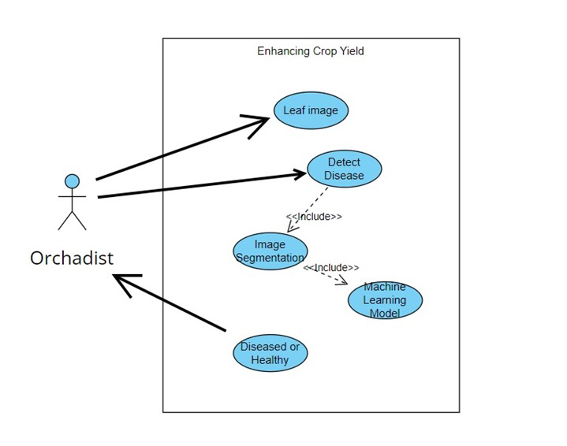

Figure 3.3: Usage of our model by an orchardist to improve production

Figure 3.3 shows the rectangle aids in defining the suggested architecture's bounds. Everything that takes place inside the rectangle occurs inside the system. In this scenario, there is one actor orchardist who inputs apple leaf dataset and also uses the train model for apple leaf disease detection. Use cases are oval-shaped representations of actions that complete specific tasks within the system. The system will attempt to identifies the disease present in the input given by orchardist.

**3.5 Screen shots of the various stages of the Project**

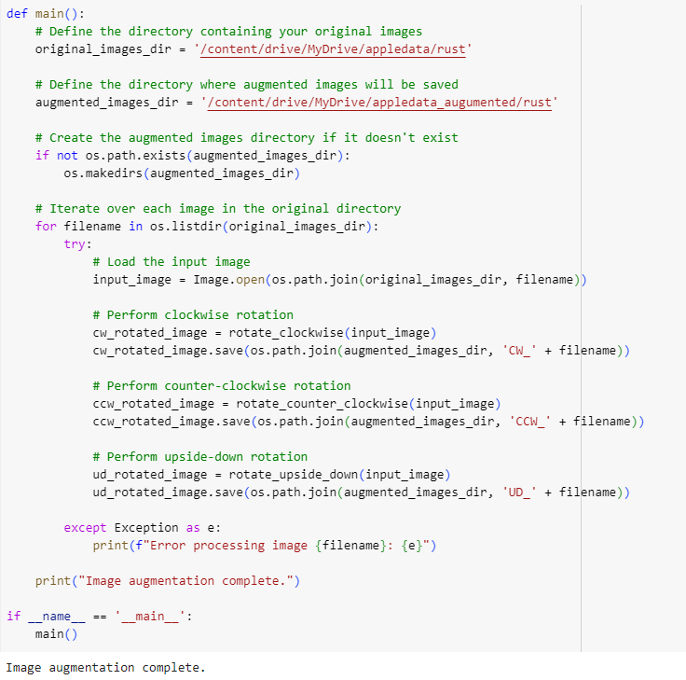

Figure 3.4.1: Code snippets for Data Augmentation

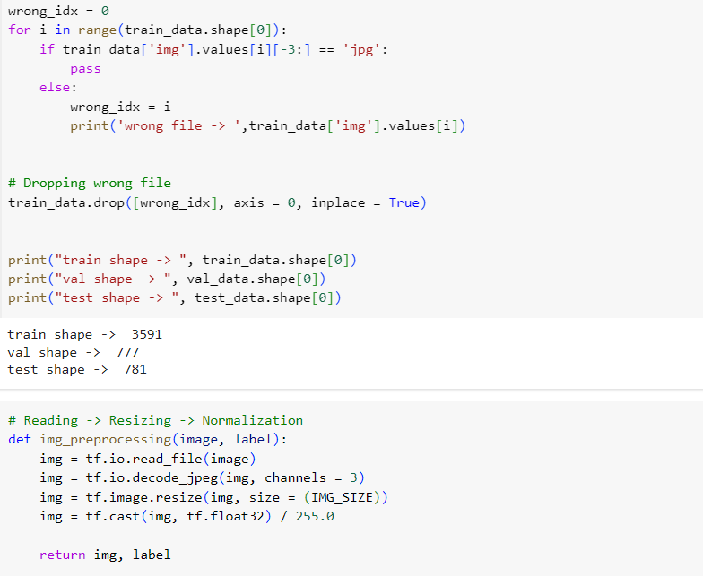

Figure 3.4.2: Code snippet for Data count and Data Normalization

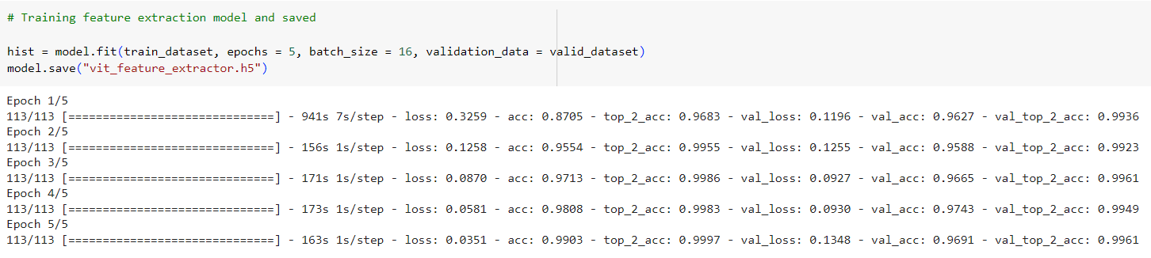

Figure 3.4.3: Code snippet for using ViT model on our Dataset

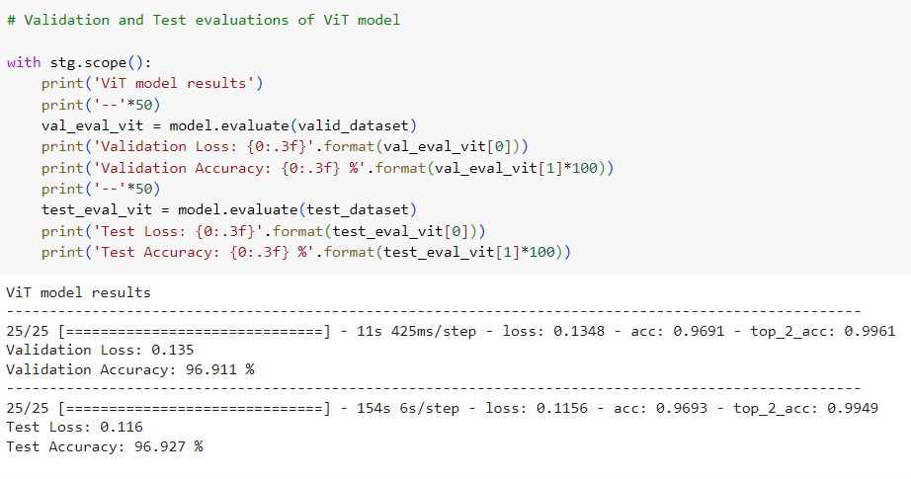

Figure 3.4.4: Code snippet for evaluation result of ViT

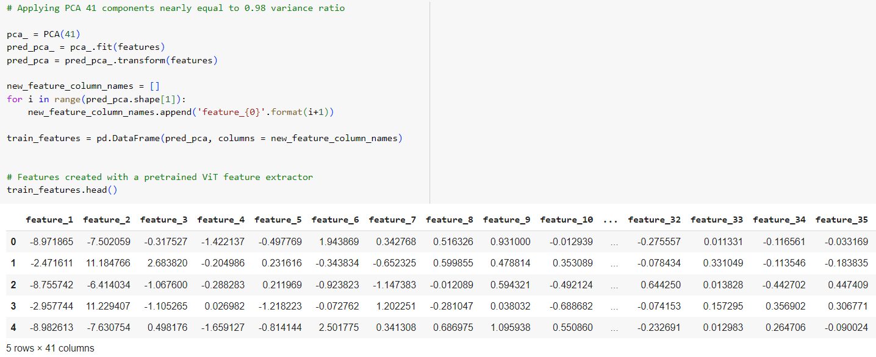

Figure 3.4.5: Code snippet for PCA application

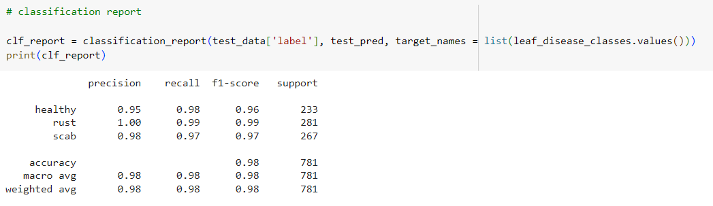

Figure 3.4.6: Code snippet for classification report generation

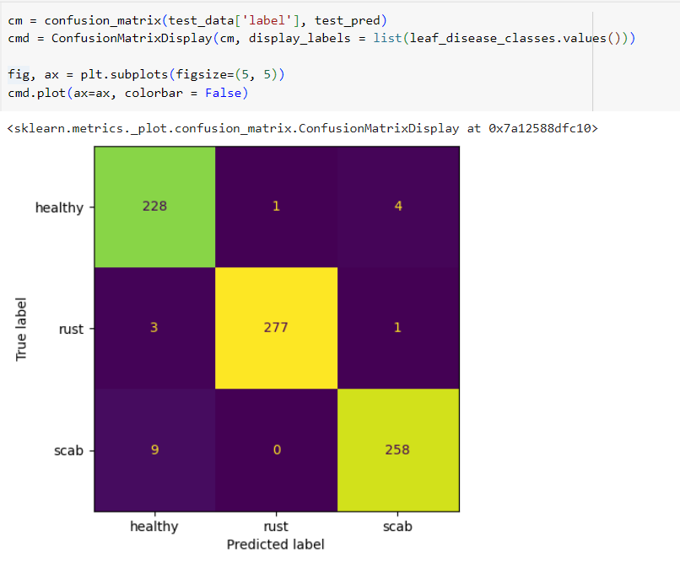

Figure 3.4.7: Code snippet for confusion matrix generation

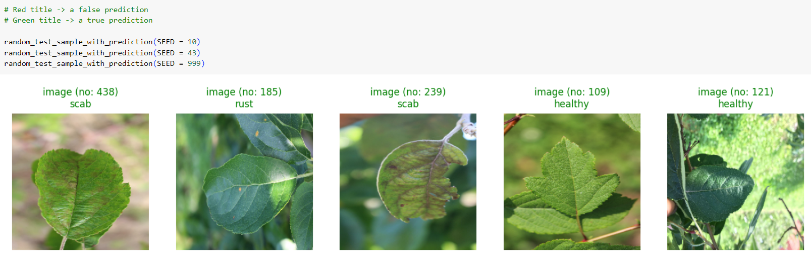

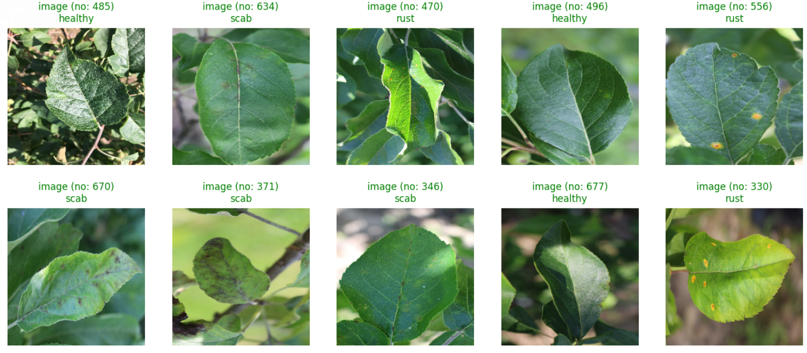

Figure 3.4.8: Code snippet for testing some random images

**Chapter 04: RESULTS**

**4.1 Discussion on the Results Achieved**

This section presents metrics results of the Hybrid model consisting of Vit, PCA and SVM

testing and training results. The training and testing accuracy and loss obtained

using a dataset of around 7000 images. Remarkably, 97.85% of accuracy score is achieved by the

model.

Information about the model's performance is shown in Figure 4.1, using the

confusion matrix that was obtained and additional evaluation parameters.

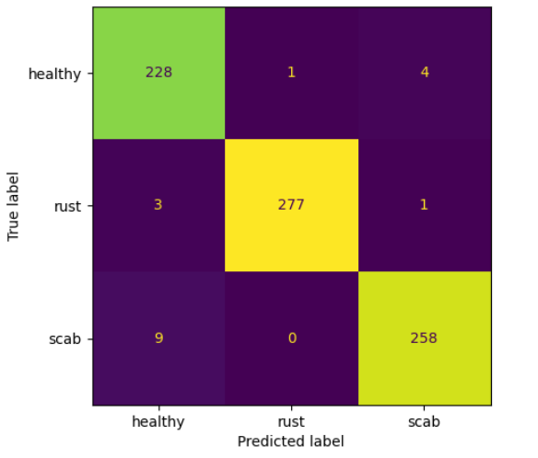

Figure 4.1 Confusion Matrix

Overall, these findings highlight the Hybrid model's excellent accuracy

and performance across training and testing datasets, which highlight the model's

effectiveness in properly identifying apple leaf disease.

**4.2 Applications of minor project**

AI-based leaf disease detection to improve crop production

can be used in many situations and industries, including:

1. Precision agriculture***:*** This system allows us to precisely and accurately target the diseased leaf

and precisely use the pesticide and other chemicals without hurting nature and excessive cost many resources such as water, labor can be efficiently managed improving overall farm management.

2. Early Disease Detection and Prevention Proactive Measures: The approach minimizes crop loss by allowing farmers to take preventative action before the disease spreads.   
Disease Forecasting: By combining meteorological information with other environmental parameters, the system may anticipate possible disease outbreaks and take appropriate action in a timely manner.

3. Enhancement of Yield: Improved Crop Health: Higher yields and better-quality apples are the result of keeping apple trees healthy through early and precise disease identification.

Decreased Crop Loss: Prompt action lowers the likelihood of serious disease outbreaks, which minimizes crop loss and guarantees steady output.

4. Lowering Expenses: Reduced Input Costs: Farmers can drastically cut their input costs by using fewer pesticides and fertilizers than necessary.   
Decreased Labor Expenses: The automation of illness identification significant lowers the manual work.

5. Data-Informed Decision Making: Farm Management Insights: As a result of the system's ongoing data collection and analysis, farmers can get important knowledge about crop health, disease trends, and environmental factors.

6.Better Planning: By using this data, farmers can plan harvest periods, crop rotations, and planting schedules more effectively, which will increase farm productivity as a whole.

7. Agricultural Research: By analysing the data produced by the system, scientists can better understand disease trends, create novel treatments, and create apple cultivars that are resistant to illness.   
Technological Advancement: Innovation in agriculture technology can be fuelled by the ongoing development of machine learning models and detecting methods.

8. Farmer Training Knowledge Dissemination: The system can be used by extension services to teach farmers how to identify diseases and how to control them.

9. Development of Skills: Training curricula might include the system to educate and empower farmers how to incorporate modern advancements.

10. Connectivity to Agriculture Management Systems: Farm Management  
A comprehensive approach to farm management that addresses everything from soil health to harvest logistics can be achieved by integrating the disease detection system with other farm management technologies.

**4.3 Limitation of the Minor Project**

Enhancing Crop Yield with Artificial Intelligence-Based Leaf Disease Diagnosis has a variety of disadvantages of diagnosis should be taken into account:

1. Image quality: The speed of the system is affected by the quality of the images in the data set because those are a starting point for the decision making about characteristic present on the tree. If there are low quality and with small image sizes, the system running speed will be high; but if the image quality is high, the system should run slowly because the database only has less capacity.
2. Implementation complexity: Implementing this may be a difficult undertaking for organizations or individuals that do not support this rule already. low availability of effective technological means for this goal due to possibly not enough technical skills and material resources available. disruption of the process also occur at some stages as the level of the process gets complex.
3. Limited dataset: The dataset has limited number of images and even after data augmentation the number of images is still around 7000 only it may result in biasness due to less number of features.
4. The optimization of speed and computing complexity: current models only concentrate on increasing accuracy; however, in order to make the models more practical for use in the real world, research should also concentrate on accelerating inference while maintaining high accuracy.

5. valuation metrics and Model Comparison: standardized evaluation metrics, as well as a thorough comparison of different models and approaches, are necessary. This will facilitate a better understanding of their respective advantages and disadvantages and assist researchers in selecting the optimal approach for a specific task.

6. Transferability and Adaptability: Our model was trained on a specific plant disease only to expand it to different crops and different diseases of same crop is still a challenge

**4.4 Future Work**

1. We will create a powerful AI system that can accurately spot and identify different apple leaf diseases by looking at picture in an app or on a website and learning from them.

2. The AI system will provide real-time analysis of apple leaf diseases.

3. The AI system will be extended to diagnose a wider range of diseases affecting not only apples but also other crops such as mangoes.

4. Collaborations with agricultural research institutions, government agencies, and farming cooperatives will be pursued to facilitate the development and dissemination of the AI system.

5.The implementation of Internet of Things (IoT) devices, including drones and smart sensors, will facilitate enhanced data collection. These devices can monitor large agricultural areas in real-time, providing continuous data streams to improve the accuracy and timeliness of disease detection.

6.We will apply U2-Net for image background removal for getting better accuracy.

7. We will apply ESRGAN for image enhancement for getting better accuracy.

**References**

K. Frederick, B.A. Isaac, K.T. Theophilus, Leaf spot disease of groundnut: a review of existing research on management strategies, Cogent Food Agric. 8 (2022).

Jiang P, Chen Y, Liu BIN (2019) Real-time detection of apple leaf diseases using deep learning approach based on improved convolutional neural networks. IEEE Access 7:59069–59080.

B. Liu, Y. Zhang, D. He and Y. Li, “Identification of apple leaf diseases based on deep convolutional neural networks,” Symmetry, vol. 10, no. 1, pp. 11, 2017.

P. Jiang, Y. Chen, B. Liu, D. He and C. Liang, “Real-time detection of apple leaf diseases using deep learning approach based on improved convolutional neural networks,” IEEE Access, vol. 7, pp. 59069–59080, 2019.

Wang, P.; Niu, T.; Mao, Y.; Zhang, Z.; Liu, B.; He, D. Identification of apple leaf diseases by improved deep convolutional neural networks with an attention mechanism. Front. Plant Sci. 2021, 12, 723294.

M. Snehal, J. Banarase, S.D. Shirbahadurkar. A Review on Plant Leaf Diseases Detection and Classification. International Journal of All Research Education and Scientific Methods (IJARESM). 2021, pp 2455–6211.

L. Li, B. Wang, Y. Li, H. Yang. Diagnosis and Mobile Application of Apple Leaf Disease Degree Based on a Small-Sample Dataset. Plants 2023, 12 (4), 786.