Intro
This is the report for the robot juice website. The purpose of the sight being to sell products to its users. This document will outline all the testing, the planning and the requirements from the users. With its target audience is cyclists, motorcyclists and other general users.
Planning
Before starting the Robot Juice website, I carefully read the coursework brief to make sure I understood what was needed. The project was to create a multi-page website from the designs provided, using HTML, CSS, and JavaScript, while following modern web rules and making it easy for everyone to use. The main requirements were to use proper HTML, make the site work well on all screen sizes, write clean code, and make the content accessible.
During planning, I went back over lecture and tutorial materials to refresh my understanding of important techniques like CSS Grid, Flexbox, responsive design, and using semantic HTML. I also reviewed accessibility guidance, including WCAG 2.1, to make sure the website would be easy to use for everyone.
The design and structure of the website were planned to reflect the fictitious “Robot Juice” brand, targeting cyclists and motorcyclists. Consideration was given to layout consistency, content hierarchy, and ease of navigation across all pages.
Testing and accessibility were considered right from the start. I planned to check all HTML and CSS using W3C validation tools and to test the site on different browsers and screen sizes. This helped make sure the website was easy to use, accessible, and technically correct throughout development, rather than fixing problems at the end.
Index page test
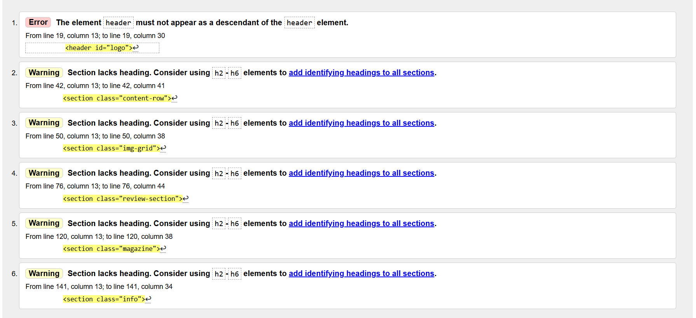
After testing the index page code this is what errors where returned. The first thing that needed changing was the header tag which I accidently duplicated. The new element looks like.
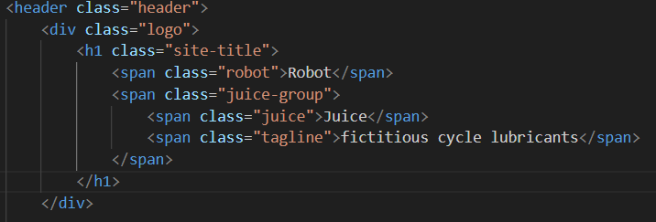
After running it through the test again it now only shows the warnings. These warning are because the header isn’t at the top of the section causing screen readers and other accessibility tools to be that cant read the header for the section making it hard to be used for all abilities. To fix this issue the headers need to be moved to the top of the section.
Product page test
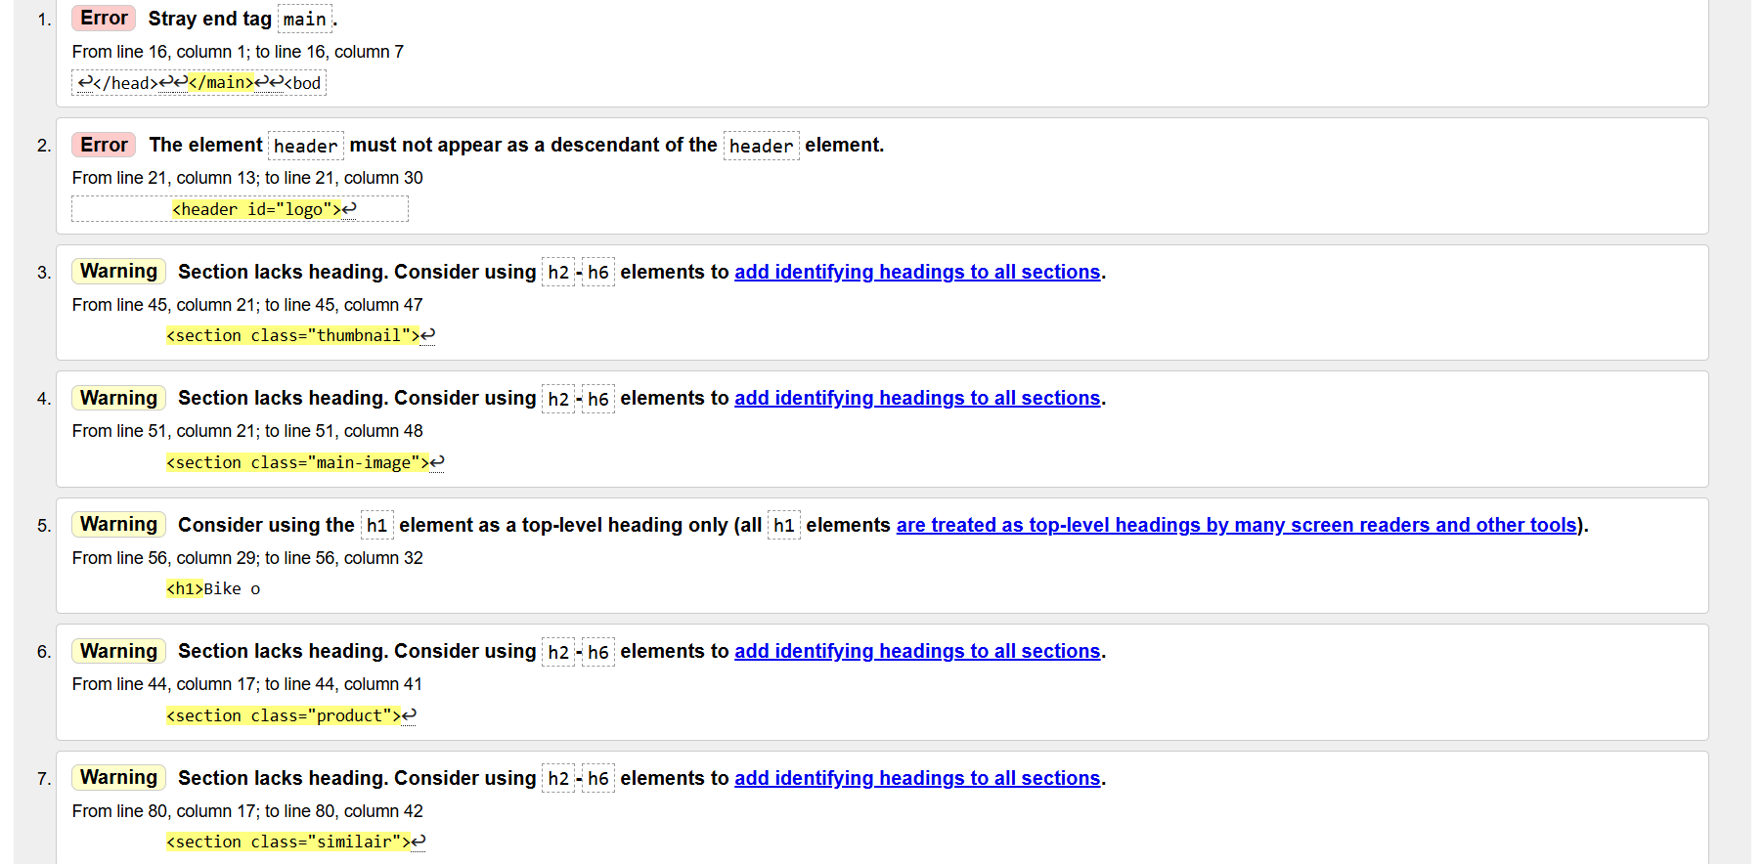
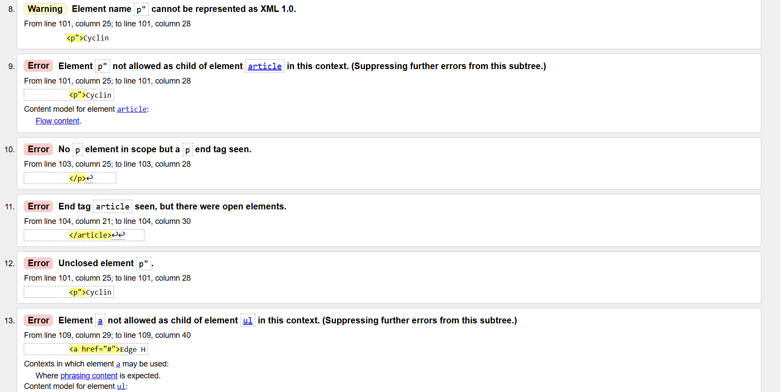
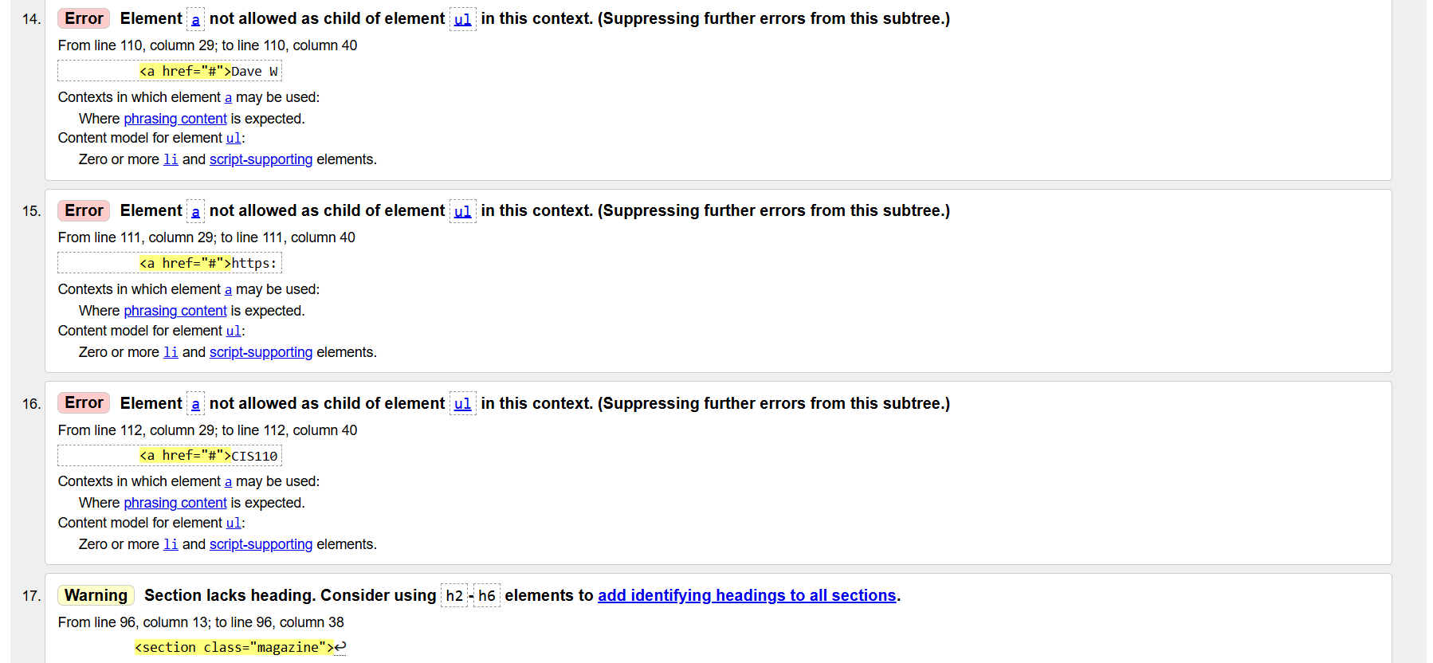
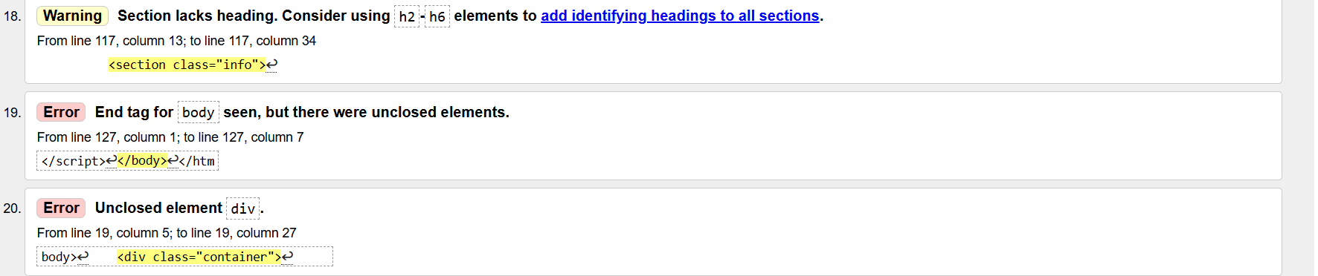
After testing the index page this is the html errors returned.
Test number | issue | fix | Does it work
1st error | Stray </main> | Delete the main closing tag | There is no longer an error
2nd error | Double header like in index page | Change to the same as index | There is no longer an error
9th error | Quote mark on p statement | Delete the quote mark | There is no longer an error
10,11,12th error | Open elements in article tag | Because of the quotation marks it has these errors | There is no longer an error
13,14,15,16th error | Wrong list elements | Change the list to li then ul and a tag | There is no longer an error

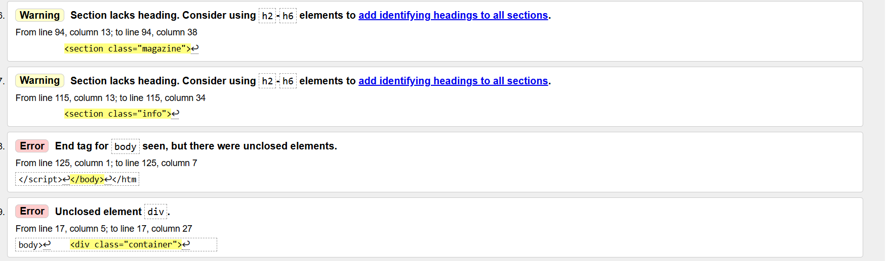
After retesting these are the errors. He div just needs closing the warning are the same from the index page.
Style css test
Grid css test
Accessibility
Accessibility was a key focus throughout the development of the Robot Juice website. Semantic HTML elements such as <header>, <nav>, <main>, <section>, <article>, and <footer> were used to give the site a clear and meaningful structure.
All images include descriptive alt text to support screen readers. The website was fully tested for keyboard navigation, ensuring a logical tab order for all interactive elements. Colour contrast was checked to meet accessibility standards, and all form fields were properly labelled.
Finally, the responsive layout supports zooming and works well on different screen sizes, ensuring the site is usable for a wide range of users, including those with visual impairments or mobility challenges.

