Feature | Test description | Test steps | Expected result | Actual result | Pass/fail | Comment on fix
First time running | Running the program for the first time to see if it works | Run  Main menu displays | The program runs without any errors and works correctly | The program runs and the main menu is displayed | Pass | N/A
Testing add item function | Selecting the add item feature | Run the program  Press 1 to access function | That the program runs and add item works | The function works | pass | N/A
Testing adding an item | Entering item to add to the function | User enters item, price and quantity | The program adds the item and all data to the json file | An error happens  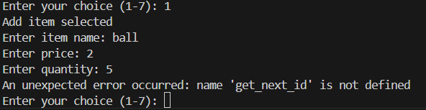 | Fail | Add get_next_item function  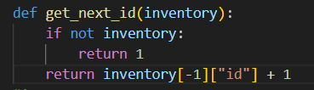
Testing adding item again | Enter item to the add function | User enters item, price and quantity | The program adds the item and all data to the json file | It runs correctly | pass | N/A
Check if item is added to json | Enter item to the add function | User enters item, price and quantity | The program adds the item and all data to the json file | The item isn’t added to the file | fail | Fix function to add item  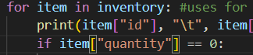  Stock had to be changed to quantity in view_stock and update_item
Check if item is added to json | Enter item to the add function | User enters item, price and quantity then press 5 to save item | The program adds the item and all data to the json file | The data is added to the file | pass | N/A
Testing view stock | Enter menu option to display items and their stock | Press 2 on main menu | The stock and items names are displayed | The stock and item names are displayed  But so is the total amount of all stock added which isn’t needed | pass | Delete total stock from the function
Testing view stock | Enter menu option to display items and their stock | Press 2 on main menu | The stock and items names are displayed and no total stock | The stock and item names are displayed  Total stock isn’t displayed | pass | N/A
Test update item | Enter menu option 3 to update the stock | Press 3 on main menu then enter product id, price update and stock amount then press 5 to save | The product id entered should be found, price should then be updated based on amount entered, same with stock. | The items are updated after save is pressed | pass | N/A

