Group 9: Erin, Jack, Rhys, Harrison, Charlie

Architecture Design
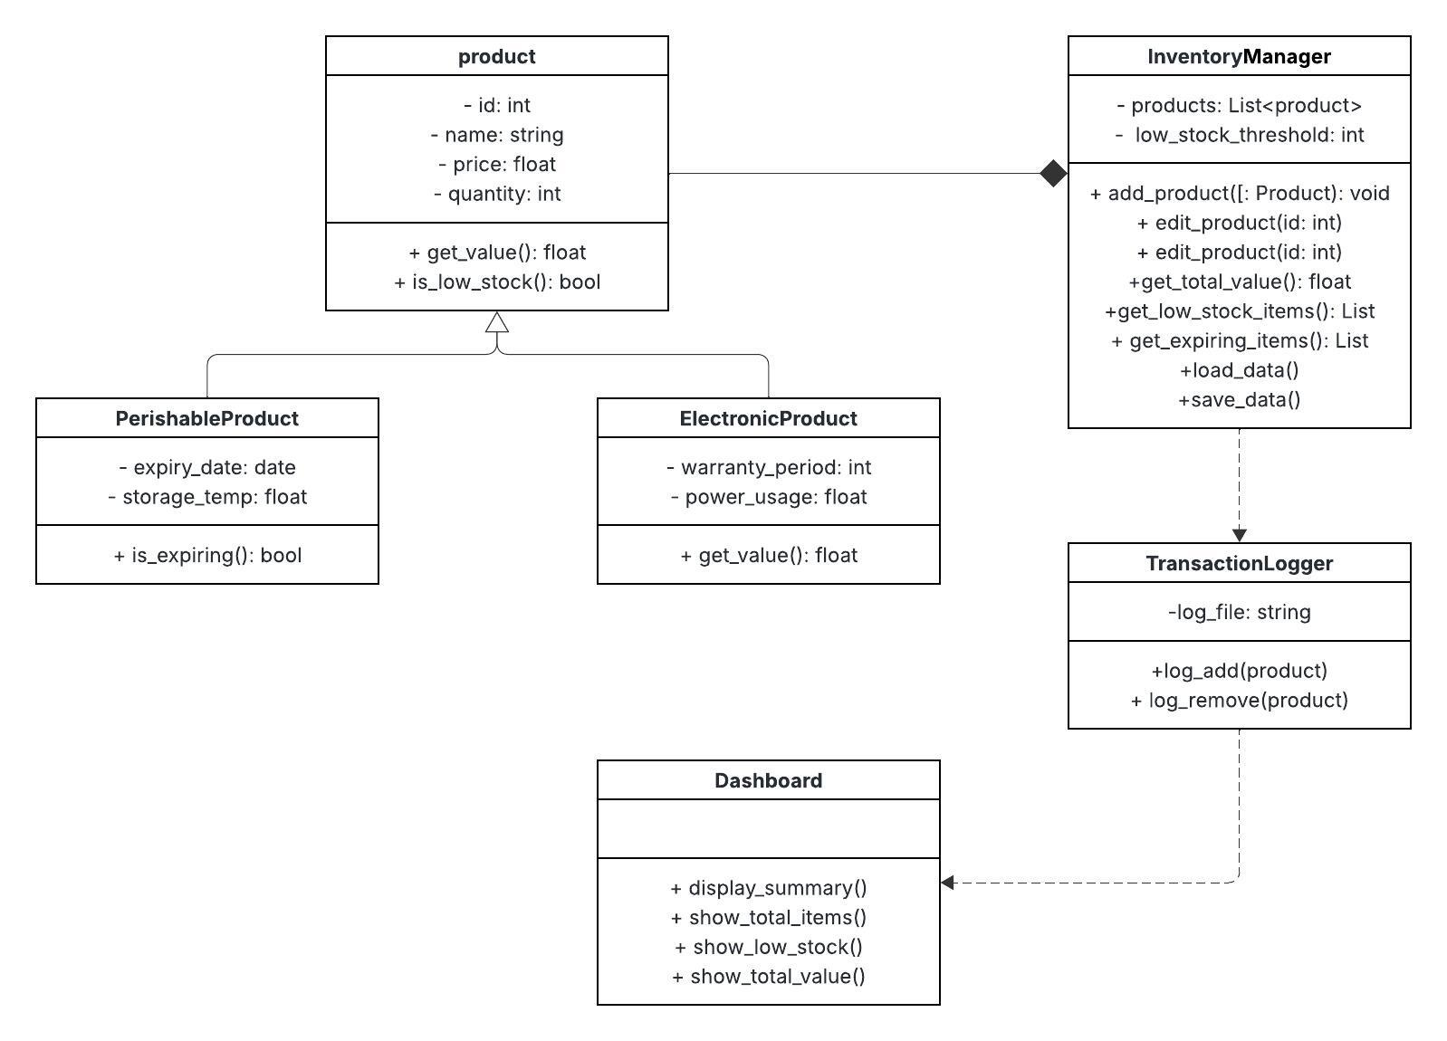
  - Inheritance
Inheritance is used in this system to model the relationship between general products and more specific product types. The product class acts as a base class and contains shared attributes such as product ID, name, price and quantity. these attributes are common to all products, se defining them once in a base class avoids unnecessary repetition. The perishable product and electronic product classes inherit from the product class, meaning they automatically gain these shared attributes and behaviours without needing to redefine them.
Each subclass then extends the base class by adding its own specific properties. For example, the perishable product class includes attributes such as expiry date and storage temperature. While electronic product class includes warranty period and power usage. This allows each product type to store additional relevant information while still maintaining a consistent structure across the system.
The use of inheritance improves the maintainability of the program. If a change needs to be made a shared attribute, it only needs to be updated in one place. It also supports scalability, as new product types can be added easily by creating new subclasses without modifying the existing code. This design reflects real-world relationships between products and helps keep the system organised and efficient.
  - Polymorphism
Polymorphism is used to allow different types of products to be treated in the same way while still behaving differently when required. In this system, all products are stored in a single list within the inventory, regardless of whether they are standard, perishable, or electronic. This allows the program to process all products using the same structure.
For example, the to_dict() method is used to convert product objects into a format suitable for saving in a JSON file. This method can be called on any product object without checking its type. Each class provides its own version of the method, meaning the output will vary depending on the type of product. A basic product will only include standard attributes, while a perishable or electronic product will include additional fields.
This approach simplifies the code and reduces the need for conditional statements. Instead of writing separate logic for each product type, the same method can be applied to all objects. This makes the system more flexible and easier to extend. If a new product type is added in the future, it can implement its own behaviour without requiring changes to existing logic.
  - Encapsulation
Encapsulation is used in this system to keep data and the methods that work on that data together within each class. Each product type stores its own information, such as product ID, name, price, and quantity, inside the class, and methods like to_dict() are used to control how that data is accessed and saved. This means the internal details of how a product works are contained within the class itself, rather than being handled across multiple parts of the program.
Encapsulation helps to protect the data from being changed in unintended ways. For example, instead of directly modifying product data throughout the program, changes are made through controlled methods such as updating values in the update page. This reduces the risk of errors and keeps the system more stable.
It also improves code organisation by grouping related data and behaviour together. Each class is responsible for managing its own data, which makes the program easier to understand and maintain. If changes need to be made, they can be done within the relevant class without affecting other parts of the system.
Overall, encapsulation makes the system more secure, organised, and easier to manage as it grows.
  - Overall justification
Overall, using inheritance and polymorphism makes the program simpler and more organised. Inheritance reduces repeater code by sharing common features, while polymorphism allows different products to be handled in the same way. Together they make the system easier to build, easier to understand and easier to improve in the future. The decision to use inheritance rather than separate unrelated classes was made to reflect real-world relationships between products. This allows shared behaviour to be reused while still supporting specialised features. An alternative approach could have been using separate classes with no inheritance, but this would lead to duplicated code and reduced maintainability.

HCI Analysis
The system includes a graphical user interface designed to be simple and easy to use. A sidebar navigation menu allows users to switch between different sections, such as adding products, searching, viewing data and alerts. This improves usability by providing a consistent layout across all pages.
Input fields are clearly labelled, which helps users understand what information is required. Buttons such as add, remove and search are placed near the relevant input areas, making the system intuitive. Feedback is provided through pop up messages when actions are completed, such as adding or removing items. This ensures users are aware of system status.
Usability is an important factor in the success of any system. If a system is difficult to use, users are more likely to make mistakes or avoid using it altogether. By applying Nielsen’s heuristics, the interface was designed to reduce confusion and improve efficiency. Features such as clear feedback, simple navigation, and consistent layouts help users’ complete tasks quickly and with minimal errors. This makes the system more accessible, especially for users with limited technical knowledge.
Error handling is also included, with messages displayed when invalid input is entered. This helps users recognise and correct mistakes. The overall design is simple and uncluttered, making it accessible for users with little technical experience.

  - interface
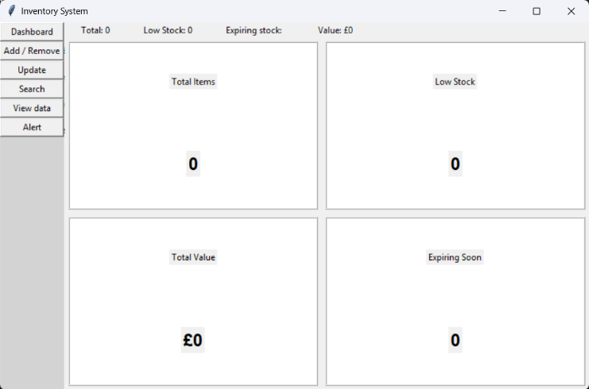 | 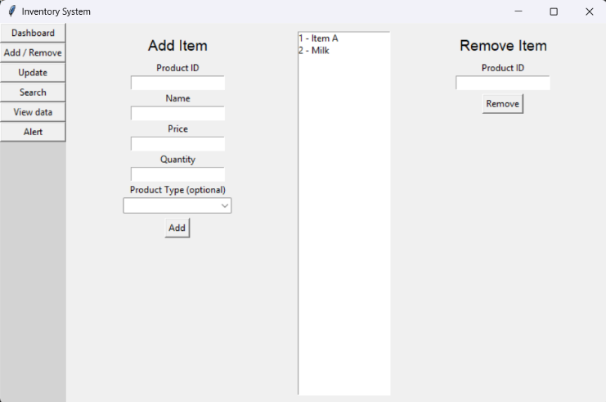
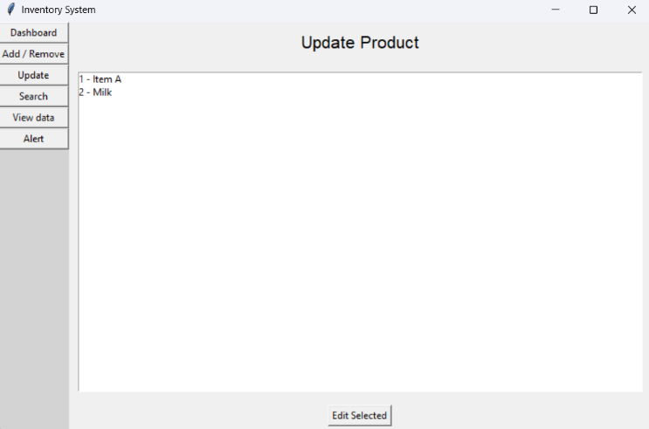 | 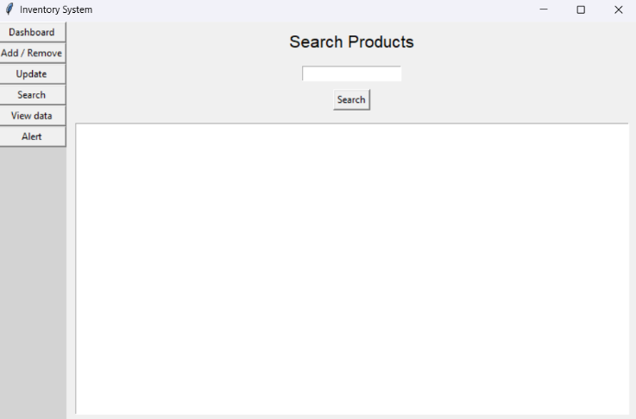
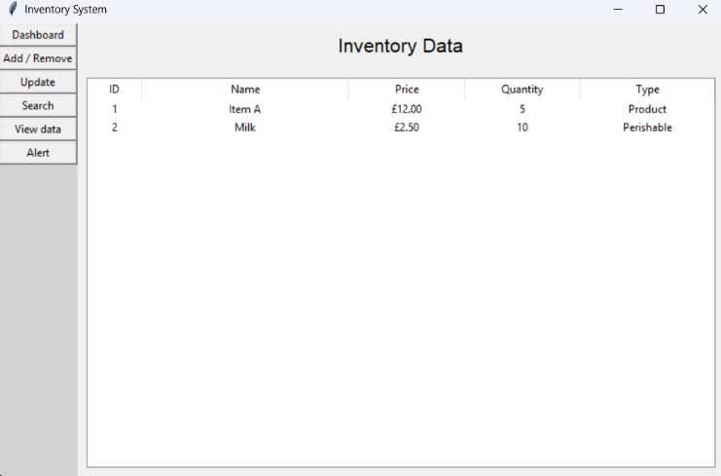 | 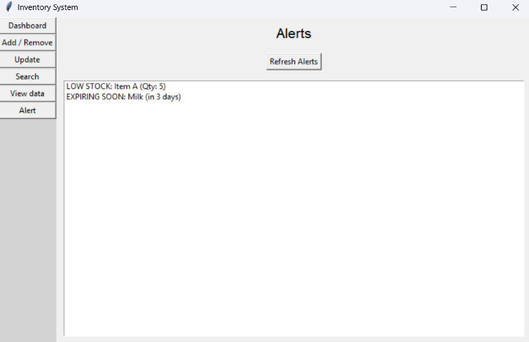

  - Neilson’s 10 heuristics
Visibility of system status | When items added, removed and edited the system notifies the user
Match between system and real world | Simple terms such as “Price”, “Quality” etc are used to not confuse the user
User control and freedom | Users can remove of update products if they make mistakes
Consistency and standards | Buttons and layout are consistent across all pages
Error prevention | Input fields guide users with labels to reduce mistakes
Recognition rather than recall | User can view product lists instead of remembering details
Flexibility and efficiency | Search feature allows quick access to products
Aesthetic and minimalist design | Interface is simple and not cluttered
Help users recognise errors | Error messages appear when invalid input is entered
Help and documentation | Labels and layout act as guidance for the user

Robustness Evidence
The system was tested using several edge cases to ensure it does not crash under unusual conditions. Most cases were handled correctly, such as invalid input and incorrect date formats. However, some issues were identified, such as duplicate product IDs not being prevented and expired items not displaying correctly in alerts. These issues highlight areas for improvement. The system also handles invalid input by displaying error messages instead of crashing.

Feature | Test description | action | Expected result | Actual result
Load data | Load existing file | Start app with valid data. Json | Products appear in system | Products appear in system
Add product | Add normal product | ID = 1,  Name = Chair,  Price = 10,  Quantity = 5 | Product added to the system and saved | Product added to the system
Add product | Add perishable product | Type = perishable and expiry | Product saved with extra fields | Product saved with extra fields
Add product | Add electronic product | Type electronic and warranty | Product saved with extra fields | Product added with extra fields
Add product | Invalid input | Price = “ABC” | Error message shown | Error message is shown
Remove product | Remove existing product | Enter valid ID | Product is removed | Product is removed
Remove product | Remove non-existing product | Enter invalid ID | No crash list is unchanged
Update product | Update name / price and quantity | Edit select item | Changes saved correctly | Changed saved correctly
Update product | No selection | Click update without selecting | Error message shown | Error message shown
Search | Search by name | Enter partial name | Matching products shown | Matching products are shown
Search | Search by ID | Enter product ID | Correct products shown | Correct products are shown
Search | No result | Enter random text | No results shown | No results shown
View data | Display all products | Open view data page | Table shows all products | Table shows all products
View data | Data formatting | Check price format | Shows £ with 2 decimal places | Show £ with 2 decimal places
alerts | Low stock detection | Qty < 5 | Low stock shown | Low stock shown
alerts | Expiring soon | Expiry < 3 days | Expiring soon shown | Expiring soon shown
Alerts | Expiring item | Expiry < today | Expired shown | Expired not shown
Alerts | Invalid date | Enter bad date format | Error message | Error message shown in alerts list
Alerts | No alerts | All items normal | No alerts shown | No alerts shown
Navigation | Switch pages | Click sidebar buttons | Correct page displays | Correct page displays
Save Data | Data persistence | Restart app | Data still present | Data still present

Test ID | Edge case | input | Expected result | Actual result | result
EC1 | Invalid price | ABC | Error message | Error shown | pass
EC2 | Empty fields | No input | Error message | Error shown | Pass
EC3 | Expired item | Date < today | Show expired alert | Not shown | Fail
EC4 | Duplicate ID | Same ID twice | Prevent duplicate | allowed | Fail
EC5 | Invalid date | 2025/99/99 | Error handled | Error shown | Pass

This shows that the system is generally robust, as it handles most invalid inputs without crashing. However, some improvements are needed. For example, the system does not prevent duplicate product IDs, which could cause data issues. Additionally, expired products are not displayed correctly in the alerts system.
Overall, the program demonstrated good reliability but could be improved with additional validation and error handling.

Project management
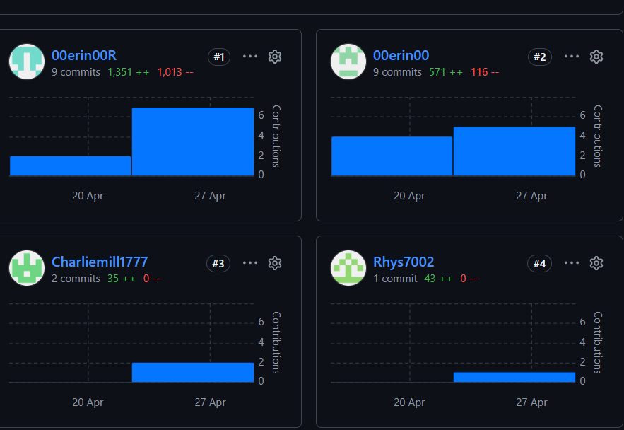
the project was developed as a group, with tasks shared between members. Each member contributed to different parts of the system. For example, jack was responsible for developing the add and remove functionality, as well as implementing dashboard value calculations. He also contributed to merging different parts of the code to ensure the system worked correctly.
The GitHub contribution graph shows that some members made more commits than others. However, this does not fully represent the work completed. One member was unable to commit directly due to technical difficulties but still contributed by completing tasks and sharing their work with another team member, who then uploaded it to the repository. This ensured all contributions were included.
Communication between team members was important throughout the project. Tasks were discussed but could have been assigned to each member so things got done properly without people waiting for last minute. This helped ensure that the project stayed on track and that any issues were resolved.
  - Meeting Minutes
Meeting 1
Discussion: project idea and roles
Actions: set up GitHub
Meeting 2
Discussion: progress and interface design
Actions: develop features such as add/ remove
Meeting 3
Discussion: testing and improvements
Actions: fix bugs and finalise system

  - Evaluation
The system successfully meets its main objective of managing an inventory through a user-friendly interface. Users can add, remove, update, and search for products efficiently. The alert system also provides useful feedback for low stock and expiring items.
One strength of the system is its use of object-oriented programming, which makes the code well-structured and easy to maintain. The graphical interface also improves usability, making the system accessible to users with different levels of technical experience. Clear navigation, labelled inputs, and feedback messages help users understand how to interact with the system effectively.
During the development of this system, the team gained a better understanding of object-oriented programming and how it can be applied to real-world problems. Concepts such as inheritance and polymorphism helped improve the structure of the program and made it easier to manage different types of products. The use of a graphical user interface also highlighted the importance of usability and designing systems that are simple and intuitive. This project reflects a real-world inventory system that could be used in small businesses to track stock levels, manage products, and reduce waste.
However, there are some limitations. The system does not prevent duplicate product IDs, which could lead to data inconsistencies. Additionally, the alert system does not fully handle expired items, meaning some important warnings may not be displayed. The dashboard could also be improved to update values dynamically in real time rather than requiring manual refresh.
Future improvements could include adding validation to prevent duplicate IDs, improving the alert system to correctly handle expired products, and enhancing the dashboard with automatic updates. Additional features such as automated notifications, better error handling, and improved visual design could further increase the overall quality and usability of the system.

Conclusion
In conclusion, the inventory system was successfully developed using object-oriented programming principles and a graphical interface. The system allows users to manage products efficiently and includes useful features such as search and alerts. While there are some areas for improvement, the system provides a strong foundation for future development.

