A SYNOPSIS ON
Random Quote Generator

Submitted by
M.David Santhan 1AT19CS064
Navya C N 1AT19CS074
S.R.Deepika 1AT19CS100

Synopsis Overview
Table of contents:
Introduction
Scope
Problem Statement
Objectives
Methodologies
Possible Outcomes
Conclusion
Introduction:
In this project, random famous quotes will be displayed each time when a button is clicked. The Quote Generator is a simple project developed using HTML,CSS, JAVASCRIPT. When you click on Show another quote button, then you will see different inspirational quotes at each click. A Random Quote Generator is capable of pulling quotes randomly from an API, a database, or simply from an array. We will be designing a Random Quote Generator from scratch using HTML,CSS,JAVASCRIPT. The webpage displays a random quote from a collection upon the click of a button, it randomly generates a new quote.

Scope:
In this project, you'll create a website that displays random famous quotes each time a button is clicked. You can display a quote from a famous athlete, politician, or historical figure:
"The only thing we have to fear is fear itself." — Franklin Delano Roosevelt.
You'll need to use your knowledge of basic JavaScript syntax, including variables, loops and object literals, to complete this project.
This project is a fun and effective way for you to practice fundamental JavaScript skills. It also gives you a simple interactive portfolio piece to show off your understanding of JavaScript.

Problem Statement:
Random Quote Generator using HTML,CSS,Javascript.

Objectives:

1.Create Array of Objects

2.Quote Object

3.GetRandomQuote function

4.PrintQuote function

Given basic HTML and CSS files, write JavaScript to create a random quote generator which will display a new quotation on the screen after a button on the page is clicked.
The project incorporates knowledge of basic JavaScript syntax including variables, loops and object literals.
1.Selects a random quote OBJECT from the quotes array.
2.Returns the randomly selected quote object.

Methodologies:

HTML
CSS
JAVASCRIPT

Possible Outcomes:
- Quotes are multiple strings that need to be stored in an array.
- Every time the button gets pressed, a random quote needs to be generated.

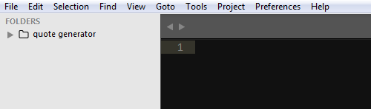
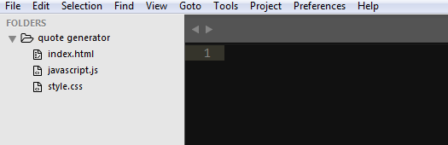

Conclusion:
In conclusion,we have created a random quote generator application using HTML,CSS,and Javascript.You will have access to thousands of quotes from the array of quotes that may include all type of quotes like inspirational quotes,motivational quotes and more random quotations.

