SQL

Create and insert table

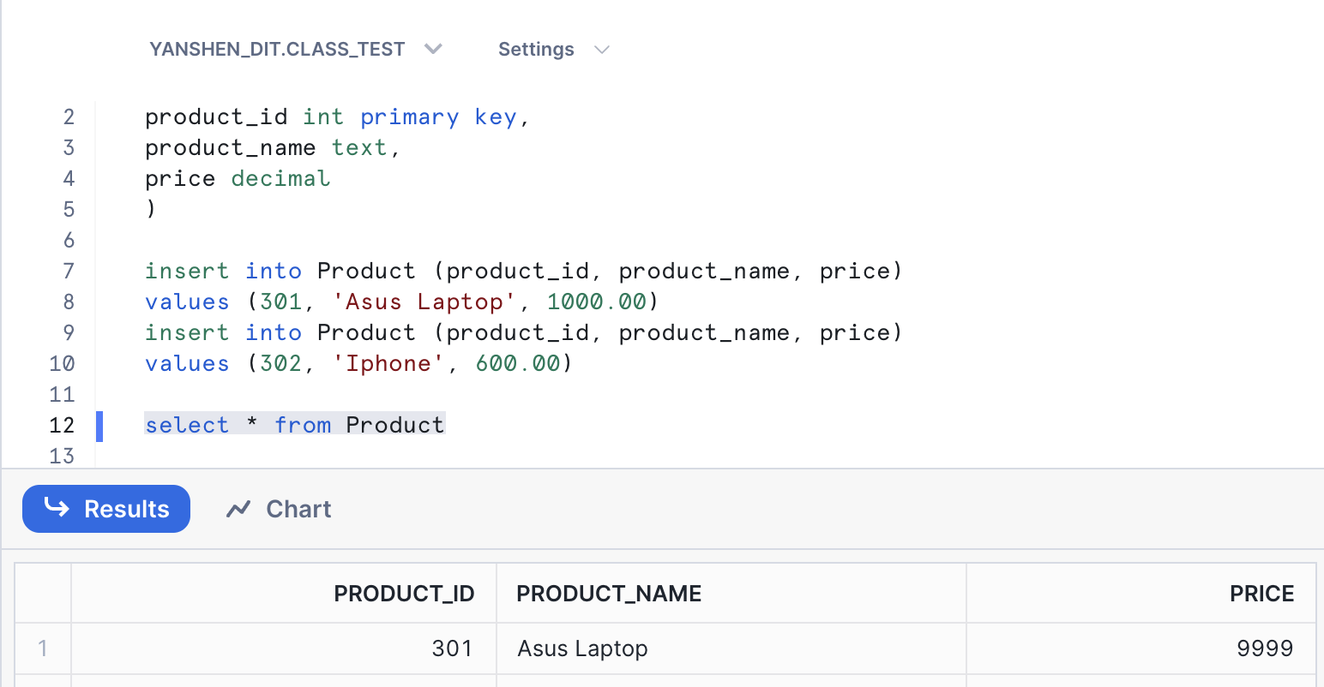

1)

2)

3)

4)

5)

MongoDB

Data

1. an average order total for each customer for the of first of May 2023 in descending order

1. you set the price of order_003 to 600.

