Default (100, 50)

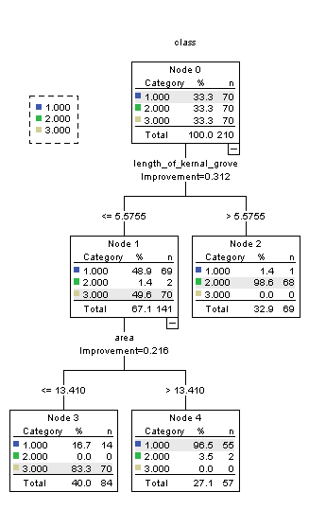

Configuration 2 (20, 12)



Configuration 3 (25, 20, 12)



Configuration 4 (25, 10, 5)

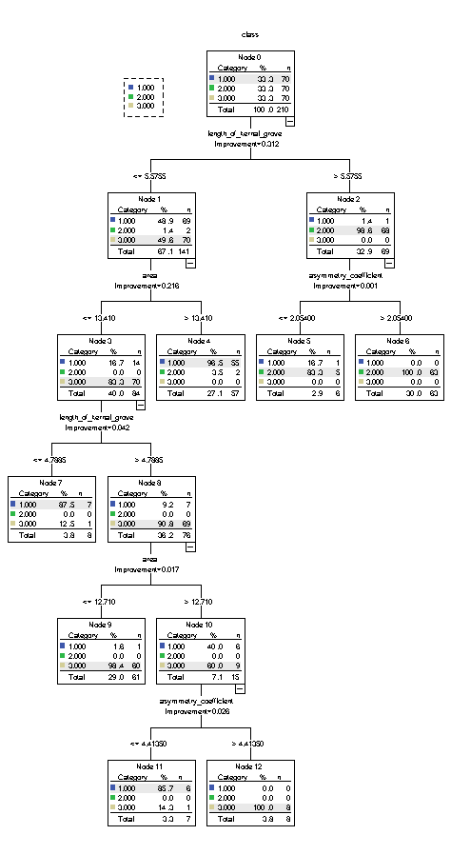

Configuration 5 (25, 9, 4)



Configuration 6 (25, 8, 3)

