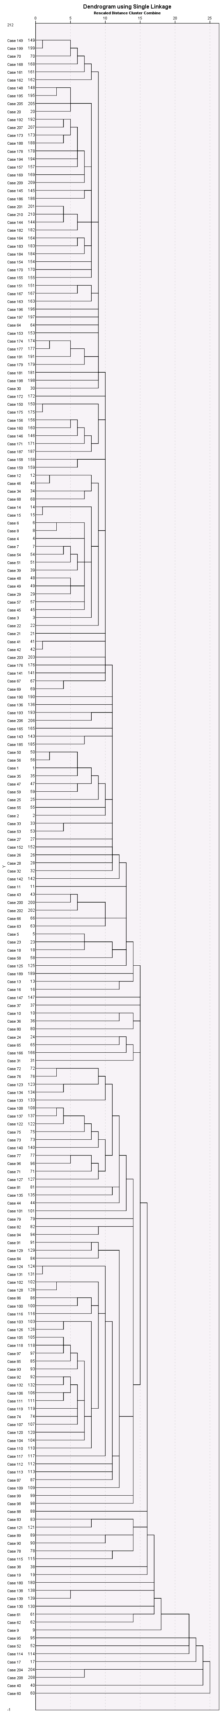Single (nearest neighbor) linkage

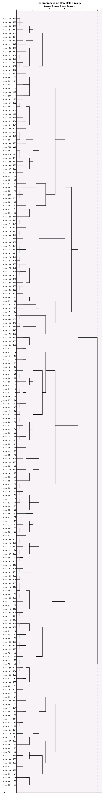Complete (farthest) linkage