

1. 登錄界面

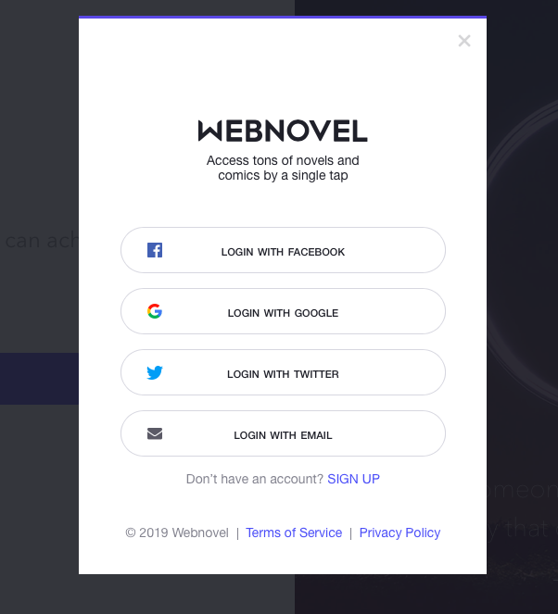

1. Log in with Email

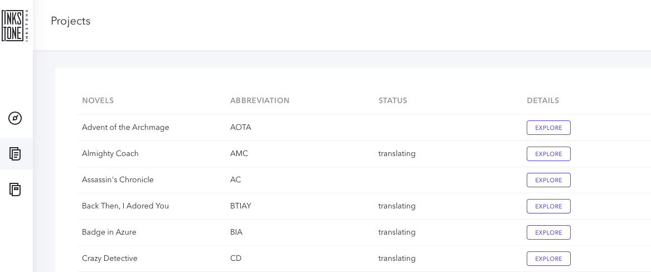

1. 進入書籍總表

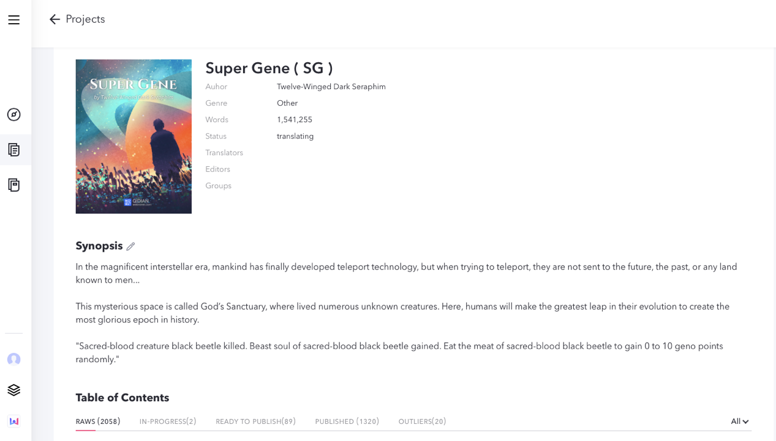

1. 進入具體書籍，上方URL中含有此書的ID（CBID）<https://inkstone.webnovel.com/book/detail/cbid/8022472105002805>

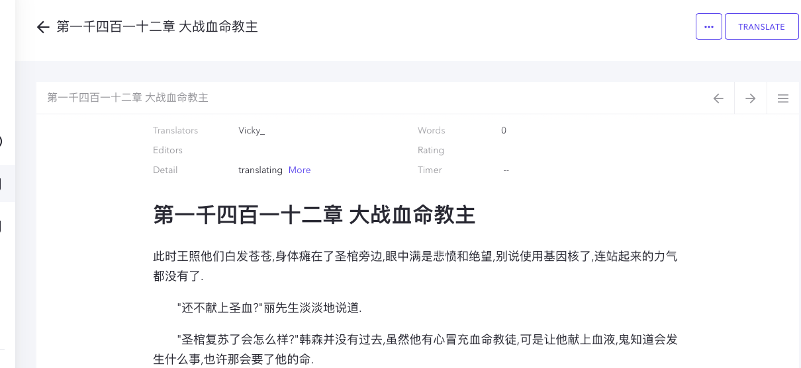

1. 打開raw的具體章節，開始translate-edit-done/publish，URL含有此章節的ID（CCID）https://inkstone.webnovel.com/chapter/view/cbid/8022472105002805/ccid/36033140925453936