|  |  |  |
| --- | --- | --- |
| 三化平台 | | Thingsboard |
| 属性 | 属性值 | 是否满足需求 |
| 设备编号 |  | × |
| 设备名称 |  | √ |
| 所属业务系统 | 智慧管廊、智慧水务等等 |  |
| 通信协议 | MQTT、Modbus、华瀚私有协议 | × |
| 上报类型 | 被动上报、主动上报 | × |
| 上报周期 | XX秒 | × |
| 传感器 | 传感器名称  传感器ID  传感器数据类型（数值型、开关型可操作、开关型不可操作、定位型）  小数位  单位  位置信息（高度和经纬度）  传感器数值 | × |
| 设备型号 |  | √ |
| 设备硬件编号 | 烧录在硬件Flash中的唯一标识此设备编码字符串 | × |
| 设备通讯地址 |  | × |
| 设备工作状态 | 正常、异常 | × |
| 设备在线状态 | 在线、离线 | × |
| 备注 |  | √ |

## 设备编号、硬件编号、通讯地址、工作状态、在线状态

这些属性由设备上传到平台，通过mqtt上传的属性为：

{"firmware_version":"1.0.1", "serial_number":"SN-001","ip":"127.0.0.3","hardware_id":"1234567890","online":true,"status":true}

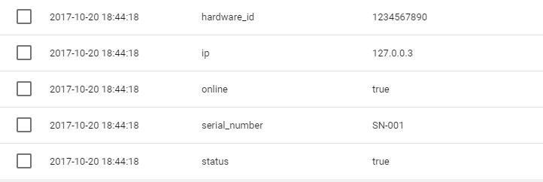

## 通信协议、上报类型、上报周期

这些属性由用户接入设备时指定，设置他们的值为:

protocol = "MQTT"

upload_type = "Active"

upload_period = 5



id | tenant_id | customer_id | type | additional_info | hardware_id | ip | name | online | protocol | search_text | sensor | serial_number | status | upload_period | upload_type

--------------------------------------+--------------------------------------+--------------------------------------+------+---------------------+-------------+-----------+--------+--------+----------+-------------+--------+---------------+--------+---------------+-------------

d4328050-b575-11e7-8670-1567cc345bca | 97b50120-b3f9-11e7-8f98-65520e1c9207 | 13814000-1dd2-11b2-8080-808080808080 | 1 | {"description":"1"} | 1234567890 | 127.0.0.3 | SN-001 | True | MQTT | sn-001 | null | SN-001 | True | 5 | Active

## 传感器

传感器属性由设备上传的数据决定

格式为：

{"temperature":{"sensor_value":21.8,"sensor_type":"NUMERICAL"},"humidity":{"sensor_value":57.4,"sensor_type":"NUMERICAL"}}



id | tenant_id | customer_id | type | additional_info | hardware_id | ip | name | online | protocol | search_text | sensor | serial_number | status | upload_period | upload_type

--------------------------------------+--------------------------------------+--------------------------------------+------+---------------------+-------------+------+--------+--------+----------+-------------+----------------------------------------------------------------------------------------------------------------------------+---------------+--------+---------------+-------------

d4328050-b575-11e7-8670-1567cc345bca | 97b50120-b3f9-11e7-8f98-65520e1c9207 | 13814000-1dd2-11b2-8080-808080808080 | 1 | {"description":"1"} | 1234567890 | null | SN-001 | null | MQTT | sn-001 | {"temperature":{"sensor_value":18.7,"sensor_type":"NUMERICAL"},"humidity":{"sensor_value":70.6,"sensor_type":"NUMERICAL"}} | null | null | 5 | Active