Local Events Application

Post Project Documentation

gitHub: https://github.com/00savethepandas/Casus.git

Team Members: Jennifer Soh || Brian Chin

Introduction

* 1. **Foreword**

This application provides a single resource for discovering local events that people might be interested in. This application is meant to serve people who are looking for something to do or just want to try something new. This service would be similar t to Meetup in that people can find local events to participate in. The differences between our application and Meetup are that a membership is not required, there are no groups that you would have to join or request to join, and you can produce a list of local events based on interests or just location and participate in any of them.

Building the application involves coding the application in JavaScript, creating a user interface with jQuery Mobile, connecting the application to the Eventful API and then packaging it using PhoneGap.

# 2. Project Organization

## 2.1 Development Model

(Photo Guide: Left: Mobile PhoneGap, Right: Desktop)

## Home Page:

The homepage displays a quick introduction to the application and how to use it.

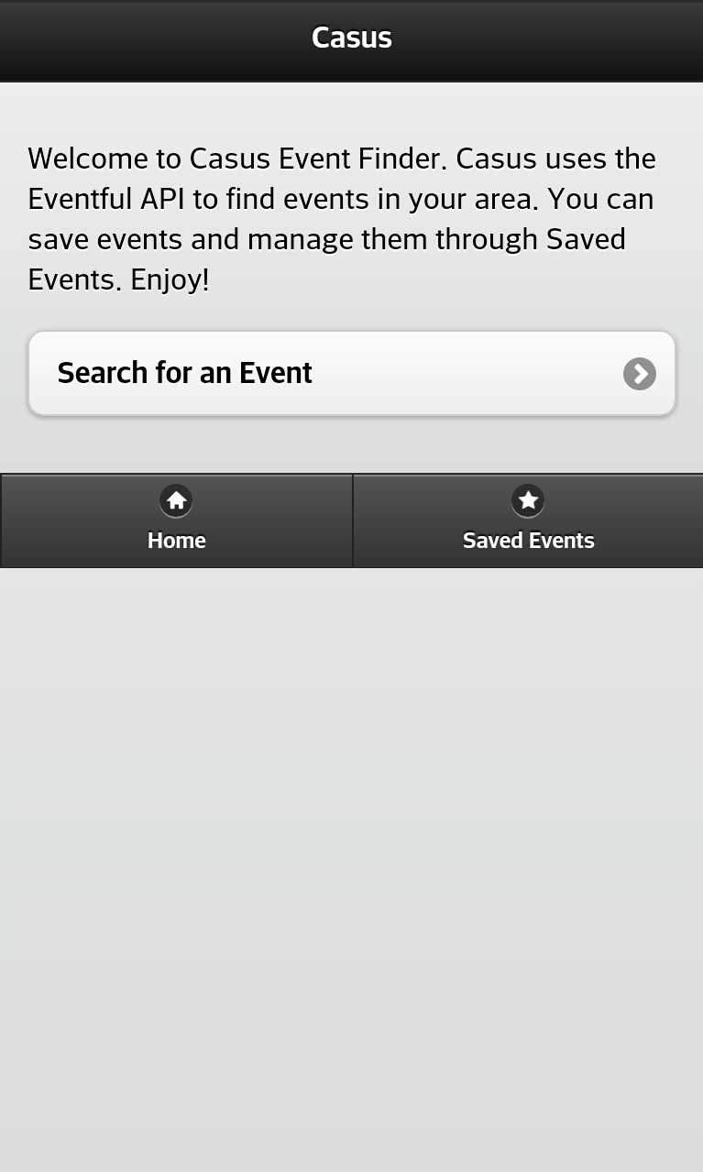 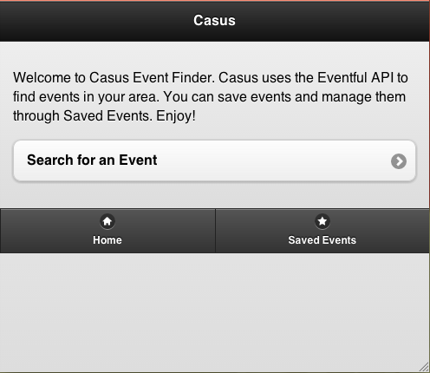

**Search for Events**

Contains a text input field to enter a location and another input field for type of event. Bottom navigation consists of a Home button, Saved Events button, and Back button. When you click on the Submit button, the search results are returned in list form. You can then click on a link that will take you to the **Event Information** page to view all the event details. You can then save the event to you

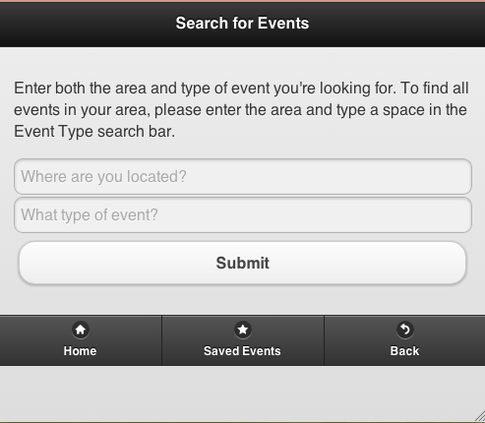

**Search Events List**

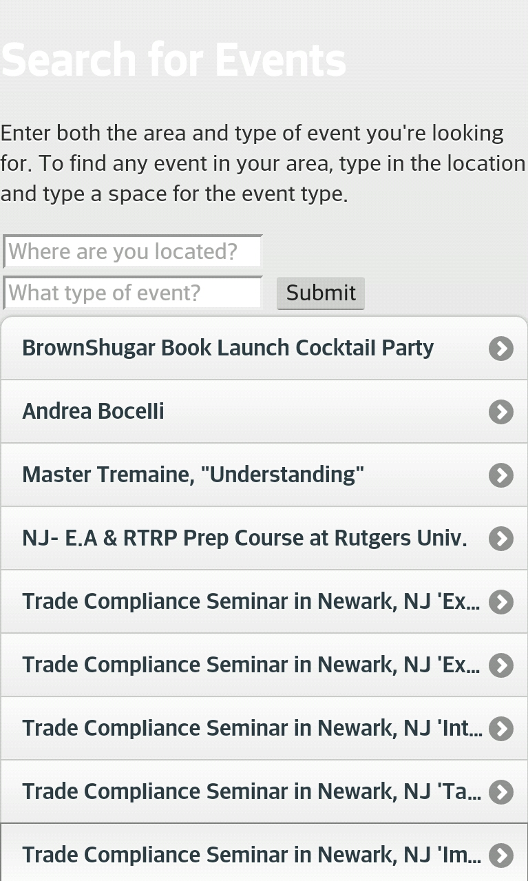 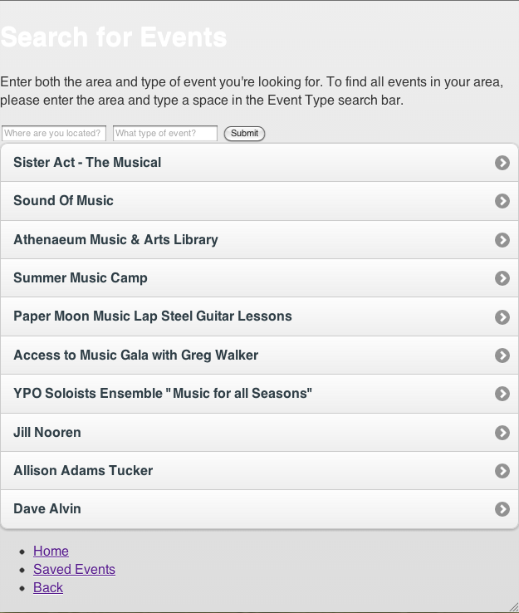

**Event Information**

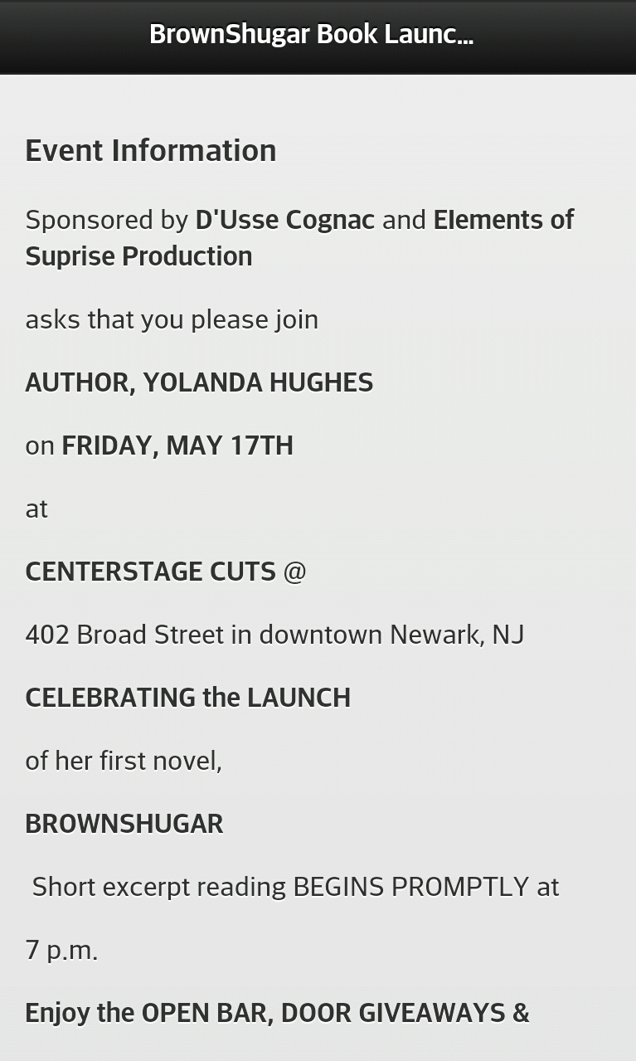 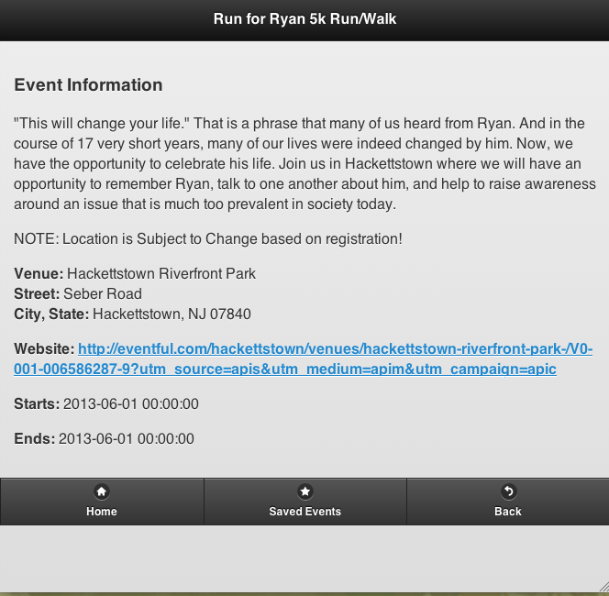

**Saved Events**

The saved events page works much like the event search result list except all of the

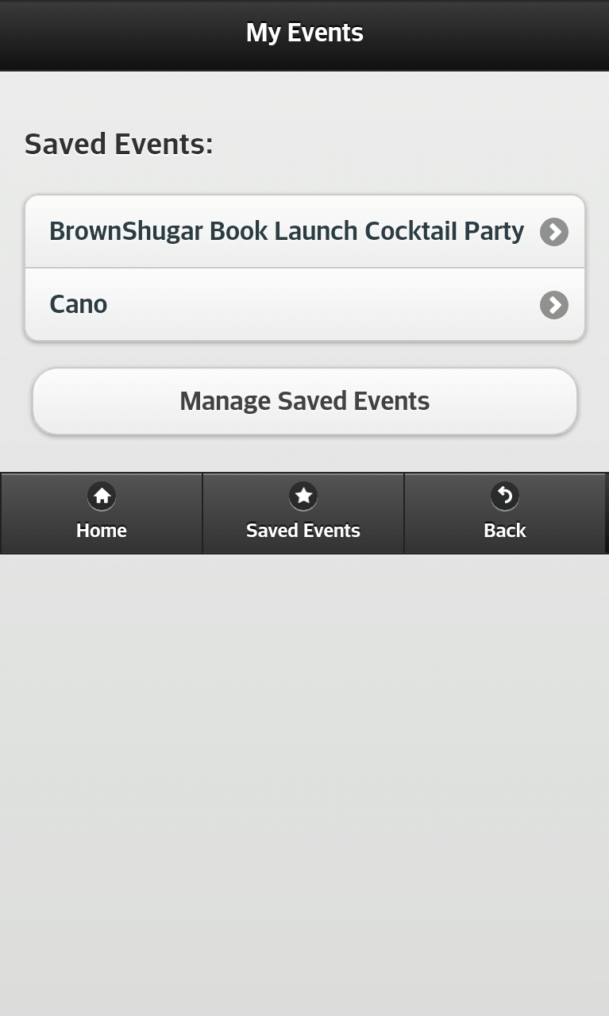 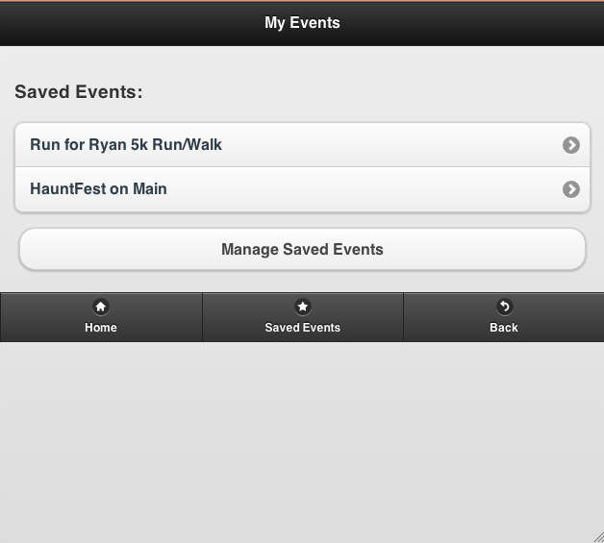

## 2.2 Project Team

## 

The table below lists the members of the EVENTS project team. The project Team consists of 2 members, Jennifer Soh and Brian Chin.

3.1 Work Breakdown

|  |
| --- |
| **Project Team** |
| User Interface: Brian / Jennifer |
| Architecture: Brian /Jennifer |
| Backbone.js: Jennifer |
| Mobile devices Tester: Brian |
| Desktop tester: Jennifer |
| jQuery Prototype: Brian |
| PhoneGap: Brian |

­­

To execute this project, Brian and Jennifer agreed on the basic structure on for the prototype and the fields necessary to make it functional. Brian created a complete prototype coded in jQuery and integrated into a jQuery Mobile template that he created. Jennifer then took the prototype and integrated it into the Backbone.js structure using the Recilist project created by another group as a template. The design was modified slightly from the prototype as a result. The mobile application was built on a desktop and tested in a sandbox online. Once integrated into Backbone, Brian then put the application into PhoneGap and tested it on his mobile device.

3.2 Problems Encountered

Some of the issues that we struggled with were getting the API to work and learning jQuery and JavaScript well enough to integrate it into the Backbone.js MVC structure. While the program was moved into the Backbone structure, Jennifer was unsuccessful in getting the models to destroy in the Manage Events section.