Python Script Documentation

Title: Automated Directory Hashing Script with Jira Integration – Documentation
Prepared by: Vineeth M
Date: 17/11/2025
Tools used: Python 3, Virtual Environment, Cron, Jira API, Required Libraries ( hashlib, os, jira, datetime,sys)

1. Objective
To create an automated directory monitoring system that detects file changes using hashing, logs all activity, uses cron to run the script on a scheduled basis, and integrates with Jira to automatically create tickets whenever modifications are found.

2. Introduction
This project focuses on automating the process of monitoring a directory for file changes by using hashing techniques. Hash values help detect modifications, additions, or deletions in files accurately. The script runs on a scheduled basis using cron, ensuring continuous monitoring without manual effort. When a change is detected, the system automatically creates a Jira ticket through API integration, allowing proper tracking, reporting, and follow-up of file integrity issues. This solution improves security, simplifies monitoring, and ensures timely identification of unauthorized or unexpected file changes.

3. Setup / Prerequisites

i. Install Python3
Verify Python3 is installed on your system:
python3 –version

ii. Create a Virtual Environment
Setup a virtual enviroment to manage required packages:
python3 -m venv new_venv
Activate the virtual environment
source new_venv/bin/activate

iii. Install Required Python Libraries
Inside vitual environment, install necessary modules:
pip install jira

iv. Prepare Directory Structure
Create folders for logs and script outputs (if not present):
mkdir -p /home/eva/Desktop/cron

v. Set Up Jira Account and API Token
This information is required for creating tickets programmatically.

- Jira base URL

- Email/username
- Jira API token
- Project key

vi. Ensure Script Permissions
Make your Python script executable:
chmod +x dir_hashing.py

4.Configuration

i. Directory to Monitor
The script is configured to scan a specific target directory for file changes.
/home/eva/Desktop/tools/task3_dir
This path can be modified inside the script depending on your requirement.

ii. Log File Location
All detected changes and script activities are saved in a log file.
Crone logs:
/home/eva/Desktop/cron/hash_log.txt
Hash Storage File:
/home/eva/Desktop/tools/task3/hash_log.txt
The script stores previous hash values in a file (e.g., CSV or text file).
This allows the system to compare current and previous states each time the script runs.

iii. Jira API Configuration
To enable Jira ticket creation, the script requires:
jira URL, Username(email), API Token, Project key
These are usually added inside the script or stored securely
Example configuration:
jira_server = "https://your-domain.atlassian.net"
jira_user = "your-email"
jira_token = "your-api-token"
jira_project = "YOURPROJECTKEY"
iv. Cron Scheduling Settings
Cron is used to run the script automatically at regular intervals.
Example schedule:
0 * * * * /home/eva/Desktop/tools/new_venv/bin/python /home/eva/Desktop/tools/task3/dir_hashing.py >> /home/eva/Desktop/cron/hash_log.cst 2>&1
This cron line runs Python script every hour, using virtual environment’s Python, and saves all output and errors into the log file hash_log.cst.

5. Jira Integration

i. Requirements
Jira Cloud URL, Username(email), Jira API Token, Project key ,that we alleady configured
ii. Establishing Connection
The script uses the Jira Python library:
from jira import JIRA

from jira import JIRA

jira = JIRA(
server=jira_server,
basic_auth=(jira_user, jira_token)
)

This authenticates your script with Jira using your credentials.

6. Cron Job Setup

i. Open the Cron Editor

Use the following command:
crontab -e

ii. Add the Cron Job Entry

Insert this line into the cron file:
0 * * * * /home/eva/Desktop/tools/new_venv/bin/python /home/eva/Desktop/tools/task3/dir_hashing.py >> /home/eva/Desktop/cron/hash_log.txt 2>&1

iii. Explanation

**0 * * * *** → Runs the script at the 0th minute of every hour
/home/eva/Desktop/tools/new_venv/bin/python → Uses the virtual environment Python
dir_hashing.py → Executes your hashing script
>> hash_log.txt → Saves the output to the log file
2>&1 → Captures errors and output together

iv. Verifying the Cron Job
crontab -l

7. Full Python Script

#!/usr/bin/env python3

import hashlib
import os
from datetime import datetime
from jira import JIRA
import sys

file_dir = '/home/eva/Desktop/tools/task3_dir'
hashlog_dir = "/home/eva/Desktop/tools/task3/hash_log.csv"
hash_value = None

# 1. Jira Configuration
EMAIL = "e3630946@gmail.com"
API_TOKEN = "ATATT3xFfGF0nqajnJl1EkoPAi43sSXmag40E0rMGXnjFMVAs5zSjw4NPZV26URS5z481FLUWQNMoHpDj-EIdNckdXJ8WSp7T4Fy_maEy7BFiU3Xg_VLK_aXvydSyvCrBZ4BxnPQAeOoArBbC5CZI6XSp4wPsIisdtTiw8r1ILN5mG--N7ZuUeY=922B711F"
SERVER_URL = "https://e3630946hash-alert.atlassian.net"
PROJECT_KEY = "KAN"
ISSUE_TYPE = "Incident"

jira = JIRA(server=SERVER_URL, basic_auth=(EMAIL, API_TOKEN))

#Check Directory is exists or not.
if not os.path.isdir(file_dir):
print(f"Error: Directory {file_dir} does not exist.")
sys.exit(1)

# 2. Function to calculate file hash
def hashDirectory():
sha256_hash = hashlib.sha256()

for root, dirs, files in os.walk(file_dir):
for filename in sorted(files):
file_path = os.path.join(root, filename)

with open(file_path, "rb") as f:
while chunk :=f.read(8192):
sha256_hash.update(chunk)
global hash_value
hash_value = sha256_hash.hexdigest()
current_time = datetime.now().strftime("%Y-%m-%d %H:%M:%S")
print(f"{current_time} Successfully Scanned the directory & Generated hash value.")

hashDirectory()

#3. Compare current hash with saved hash
def change_detection():
new_hash = hash_value

if not os.path.exists(hashlog_dir) or os.stat(hashlog_dir).st_size == 0:
return False

with open(hashlog_dir, "r") as retrive:
lines = retrive.readlines()
if lines:
last_line = lines[-1].strip()
parts = last_line.split()
old_hash = parts[2]
if new_hash != old_hash:
return True
return False

#4. Create Jira Incident when change detected
def creating_jira_ticket():
issue_data = {
"project": {"key": PROJECT_KEY},
"summary": f"Hash Change Detected {file_dir}",
"description": f"The file has changed. \nInvestigation Required.",
"issuetype": {"name": ISSUE_TYPE}
}

issue = jira.create_issue(fields=issue_data)
current_time = datetime.now().strftime("%Y-%m-%d %H:%M:%S")
print(f"{current_time} Incident Created: ",issue.key)

flag = 0
if change_detection():
flag=1
creating_jira_ticket()
current_time = datetime.now().strftime("%Y-%m-%d %H:%M:%S")
print(f"{current_time} File Hash Change Detected")
else:
current_time = datetime.now().strftime("%Y-%m-%d %H:%M:%S")
print(f"{current_time} No errors were observed, Everything Normal")

def savehash():
current_time = datetime.now().strftime("%Y-%m-%d %H:%M:%S")
if flag == 1:
detected = "Change_Detected."
log_line = f"{current_time} {hash_value} {detected}\n"
else:
log_line = f"{current_time} {hash_value}\n"
with open(hashlog_dir, "a") as out:
out.write(log_line)

savehash()

8. Testing Results

The script and its components were tested to ensure proper functionality. The following results confirm that each part of the system works as expected.

i. File Stability Verification Test
The script was run manually using:
python3 dir_hashing.py

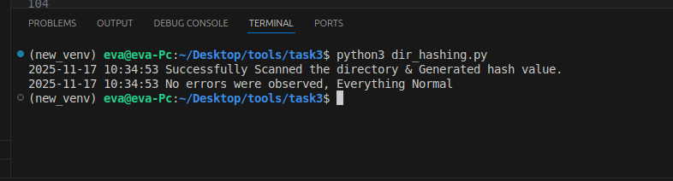
The directory was scanned successfully, the hash values were generated, and no errors or file changes were detected.

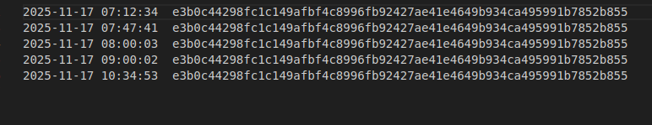
Hash values were generated correctly, the output was logged to the log file, and no errors were observed

ii. File Change Detection Test

A file inside the monitored directory was modified and the script was executed again.

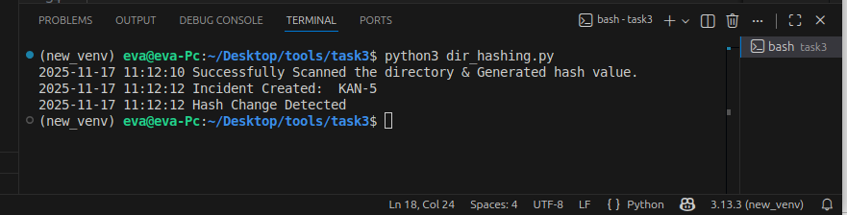
The script successfully detected a file modification, updated its stored hash value, marked the file as changed in the log, and automatically created a corresponding Jira ticket for the detected change. This confirms that the hashing, logging, and Jira integration features are all functioning correctly.

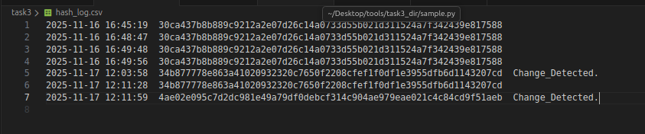
The script detected a file change and updated hash_log.csv, marking the file hash as 'Change Detected

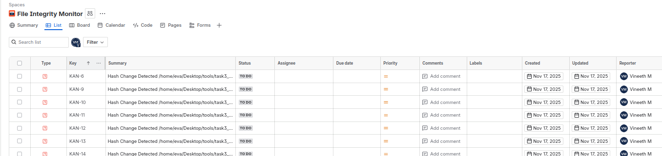
In the Jira web interface, the monitor table was updated automatically

iii. Cron Job Execution

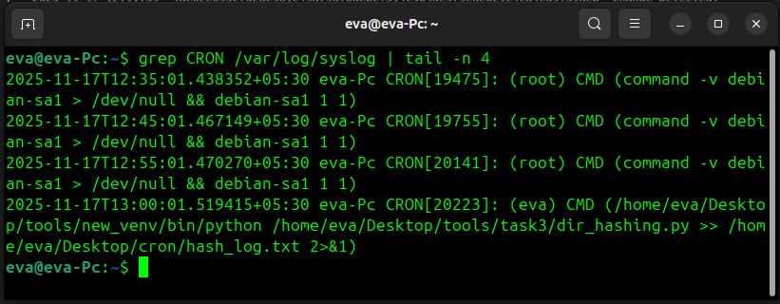

The cron job executed successfully at the scheduled time, and all its activities were properly recorded in the syslog for verification.

9. Conclusion

The script was designed to continuously monitor files within the specified directory by tracking their hash values, ensuring that any modifications are detected immediately. During testing, it successfully identified all file changes, updated the corresponding hash values, and marked the files as changed in the monitoring logs. Additionally, it automatically raised Jira tickets for each detected change, providing a clear record for further investigation and tracking. Overall, the testing confirmed that the script is reliable, efficient, and valuable for maintaining file integrity and supporting proactive monitoring in the project environment.

