Network Traffic Analysis Report

Title : Poisoned Credentials Lab Report
Tools Used : Wireshark
Prepared by: Vineeth M
Date: 31/10/2025

1. Objective

To analyze network traffic and logs to detect LLMNR/NBT-NS poisoning attacks, identify the rogue machine, find compromised accounts, and list affected systems.

2. Tools and Technique’s Used

Wireshark:
For analyzing Captured LLMNR,NetBIOS, and SMB packets.

Protocol Filters:
i. llmnr
ii. ip.src and ip.dst filters
iii. Smb2 and ntlmssp inspection

3. Investigation Workflow

1. Identified Mistyped Queries

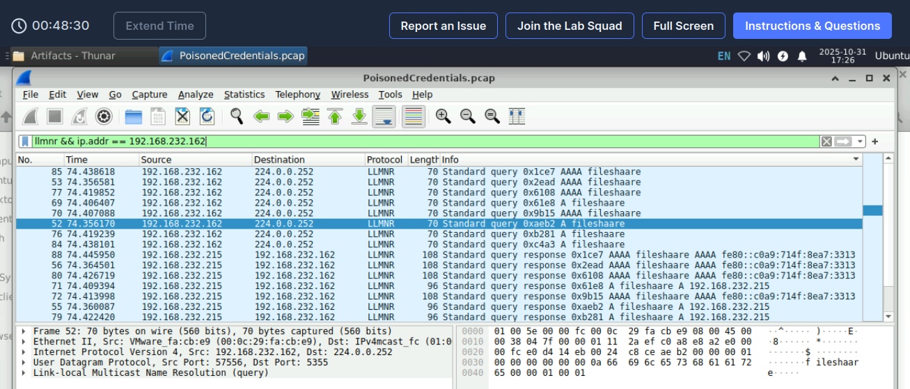
filter used: llmnr && ip.addr == 192.168.232.162
Observation: The IP address 192.168.232.215 responded to the FileShaare LLMNR query.
1.Queried Name: fileshare
2.Interpretation: The query was a misspelling of “fileshare.”

2.Identified the Rogue Responder

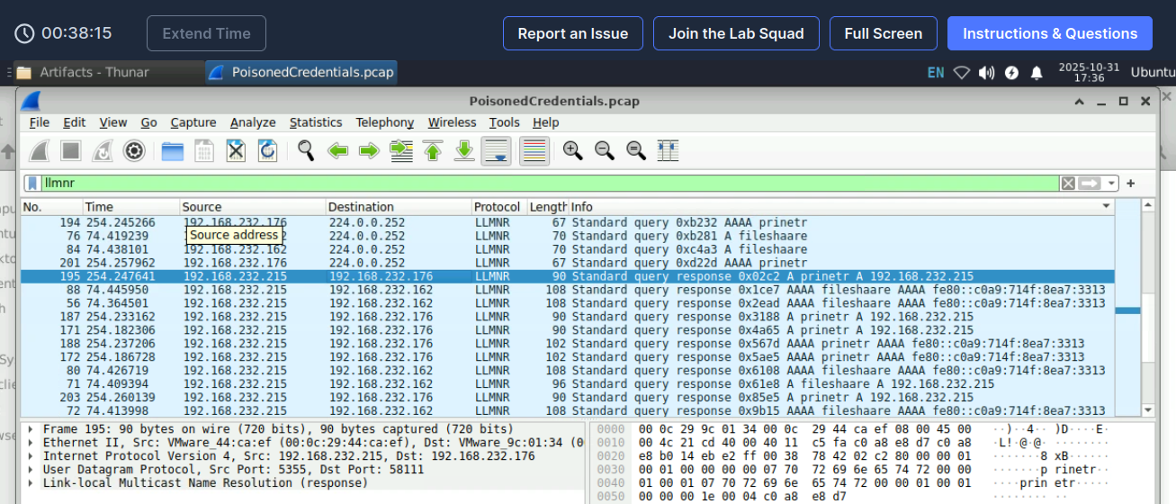

The machine with IP address 192.168.232.215 responded to the FileShaare LLMNR query. This unauthorized response indicates that it is the rogue device impersonating the poisoned name.

3.Determine Second Victim.

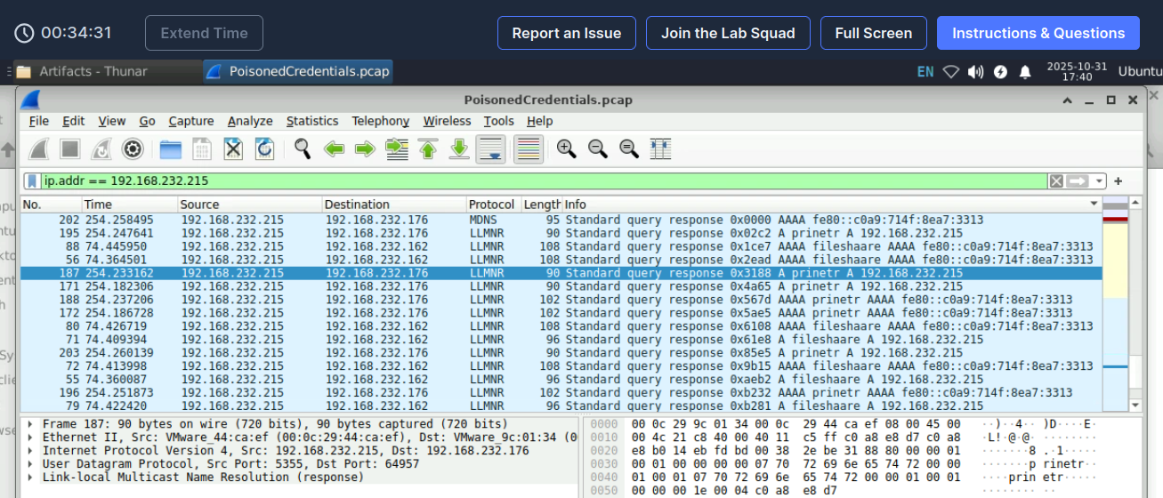

filter used: ip.addr == 192.168.232.215

Observation: Another machine with IP address 192.168.232.176 also accepted the poisoned response. This system was later compromised, confirming the spread of the attack.

4.Retrieve Compromised Credentials
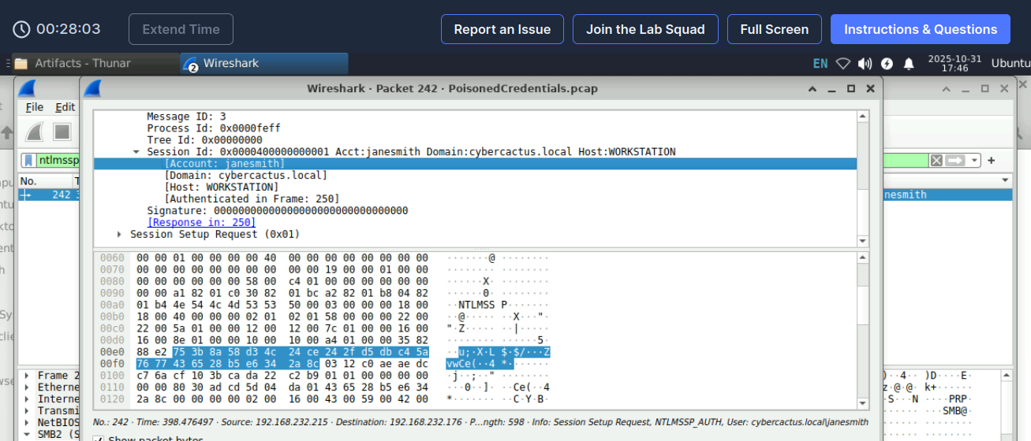
filter : smb2 and ip.addr == 192.168.232.215
Observation:
1.Username: janesmith
2.Domain: cybercactus.local

5.Identified the victim’s host name.

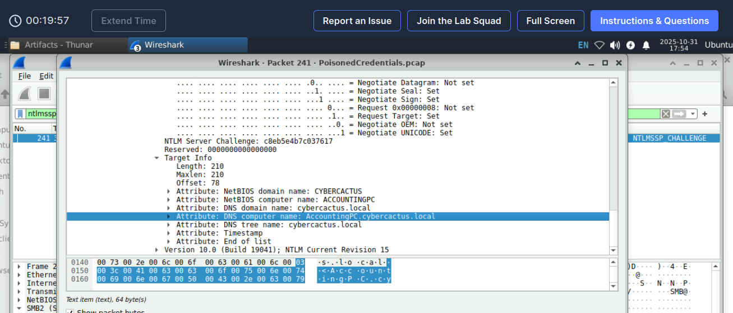

Method: Inspected the NTLM authentication blob
Hostname Detected: ACCOUNTINGPC

Investigation Summary

Finding | Observation
Mistyped hostname | fileshaare
Rogue responder IP | 192.168.232.215
Affected/secondary IP | 192.168.232.176
Compromised account | janesmith
Victim hostname | ACCOUNTINGPC

Security Implications
This lab clearly demonstrates:
- How LLMNR can be exploited by attackers using tools like Responder or Inveigh.
- The exposure of hashed NTLM credentials through poisoned SMB authentication.
- The weakness of legacy name resolution protocols in modern enterprise environments.

Recommendations
- Disable LLMNR and NetBIOS on all Windows systems via GPO.
- Use DNS exclusively for name resolution.
- Enforce SMB signing and NTLMv2 minimum authentication.
- Implement network segmentation to limit lateral movement.
- Deploy endpoint detection agents to monitor for suspicious LLMNR responses.

