Understanding HTTPS, TLS 1.2, and QUIC Handshake Processes

Author: Vineeth M
Date: 06/11/2025

1. HyperText Transfer Protocol Secure - HTTPS
HTTPS stands for HyperText Transfer Protocol Secure. It is the most commonly used protocol for transferring data between a web browser and a web server. HTTPS is the secure version of HTTP. The main purpose of HTTPS is to ensure that the communication between the user and the website is encrypted, so that the data cannot be read or tampered with by unauthorized parties. This makes browsing safer, especially when entering sensitive information such as passwords, credit card details, or personal data.

1.1. How HTTPS Works
HTTPS works just like the regular HTTP protocol for sending and receiving web data. The main difference is that HTTPS adds a security layer known as SSL/TLS. This security layer ensures that the communication between the browser and the server is protected.
The SSL/TLS layer is responsible for securing the data. It performs three main functions.
First, encryption, which makes the data unreadable to anyone who tries to intercept it.
Second, decryption, so that the browser and the server can understand each other’s messages.
Third, authentication, which verifies that the browser is actually communicating with the real website and not an imposter.
When a user enters a website that uses HTTPS, the browser and the server start a process called the TLS Handshake. During this handshake, the server sends a digital certificate to prove its identity. After the identity is confirmed, both the browser and server create a secure session key. This key is then used to encrypt all the data exchanged in that session.
From that point on, every message sent between the browser and the server is encrypted, ensuring a safe and private communication channel.

TLS handshake process

The TLS 1.2 handshake is the process that allows a browser and a web server to establish a secure connection. The main purpose of this handshake is to first authenticate the server, ensuring that the client is communicating with the real and trusted website. Next, both sides agree on a shared session key, which will be used to encrypt all data during the communication. Once these steps are completed, the browser and server begin secure encrypted data exchange, protecting the information from being read or altered by attackers.

Detailed step-by-step explanation

1. Client Hello
The client sends:
- Supported TLS version (e.g., TLS 1.2)
- List of supported cipher suites and compression methods
- Client random (32 bytes)
- Optional extensions (SNI, supported groups, signature algorithms, etc.)

2. Server Hello
The server replies with:
- Chosen TLS version and chosen cipher suite
- Server random (32 bytes)
- Server extensions (may include renegotiation info, SNI acknowledgement)
3. Certificate (server authentication)
The server sends its X.509 certificate chain. The client validates:
- Trusted CA signature
- Certificate validity dates
- Domain name matches (SNI vs cert CN/SAN)
4. (Optional) Server Key Exchange
Sent when certificate alone is insufficient for key agreement (e.g., ephemeral Diffie-Hellman). Contains server’s DH/ECDH parameters and a signature.
5. Server Hello Done
Server signals it has finished initial messages.

6. Client Key Exchange
Client generates the Pre-Master Secret (for RSA: random blob encrypted with server public key; for (EC)DHE: client’s DH public value). Sends it to server.
7. (Optional) Certificate Verify
If client authentication is used, client signs a handshake transcript to prove ownership of its private key.
8. Change Cipher Spec (client)
Client tells server it will start using the negotiated cipher and keys.
9. Finished (client)
Client sends a cryptographic hash (MAC) of the entire handshake, encrypted with the new keys. Server verifies it to ensure handshake integrity.

10. Change Cipher Spec & Finished (server)
Server switches to encrypted mode, sends its Finished message. After verification both sides begin encrypted application data exchange.
11. Application Data
All HTTP (or other protocol) data flows encrypted with the negotiated symmetric keys and algorithms.
12. Connection Close
Either side sends close_notify alerts to close the TLS session cleanly.

TLS handshake Processes

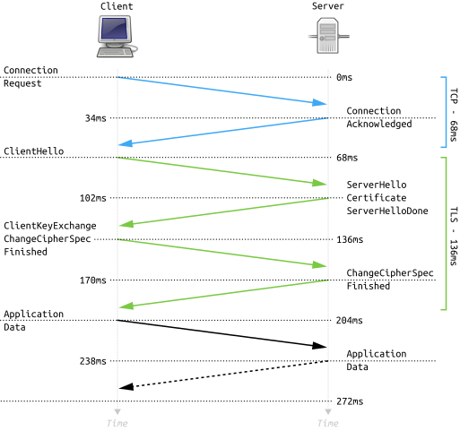

Quic Protocol (Quick UDP Internet Connections)
QUIC is a modern, encrypted transport protocol developed by Google and standardized by the IETF. It is built on top of UDP and designed to combine the speed and low latency of UDP with the reliability and security features traditionally provided by TCP and TLS. Unlike older internet protocols where encryption and authentication are handled by higher layers (such as TLS running over TCP), QUIC integrates these features directly into the transport layer. This integration allows QUIC to establish secure connections much faster—often in just one round trip or even instantly when resuming a previous session. Once connected, QUIC supports multiple independent, encrypted data streams over a single connection, preventing delays caused by packet loss and improving performance. It also supports connection migration, so a session can continue seamlessly even if a device’s IP address changes (for example, when switching from Wi-Fi to mobile data). Because of its speed, efficiency, and built-in security, QUIC has become the foundation for HTTP/3, the latest version of the web protocol used to load most modern websites.

QUIC handshake

The purpose of the QUIC handshake is to quickly and securely establish communication between a client and a server. It is designed to create a secure encryption context using TLS 1.3, which is built directly into QUIC rather than operating as a separate layer like in traditional protocols. During this process, the client and server also exchange important transport parameters, such as stream limits, connection IDs, and other configuration details needed for smooth communication. One of the key advantages of the QUIC handshake is its speed—it allows encrypted data to be sent almost immediately, often within a single round trip (1-RTT), and in some cases, even zero round trips (0-RTT) if a previous secure session exists. This efficient design significantly reduces latency and makes connections faster and more responsive, especially for modern web applications.

The 1-RTT QUIC handshake is the standard process used when a client connects to a server for the first time. It combines the setup of the transport layer and the TLS 1.3 encryption process into a single, fast exchange that takes only one round trip between the client and the server.

Step 1
In Step 1, the client begins by sending an Initial QUIC packet that includes a TLS 1.3 ClientHello message. This message lists the cryptographic algorithms the client supports, session information, and the QUIC transport parameters such as connection IDs and stream limits. Although this packet is not yet fully encrypted, it is protected with an Initial key derived from the QUIC version number to prevent tampering.

Step 2
In Step 2, the server responds with its own handshake messages. It sends a ServerHello, which contains the chosen cryptographic parameters, along with EncryptedExtensions, its digital certificate, and a Finished message — all encrypted using handshake keys. After sending these, the server generates 1-RTT encryption keys, which will be used to protect all future application data.

Step 3
Finally, in Step 3, the client verifies the server’s certificate to confirm authenticity and then sends back a TLS Finished message. At this point, both sides have derived the same 1-RTT encryption keys, meaning the handshake is complete and the connection is fully secure. From this moment on, the client and server can begin transmitting encrypted application data, such as HTTP/3 requests and responses, without any additional setup. This efficient 1-RTT handshake process makes QUIC connections significantly faster and more secure than traditional TCP+TLS handshakes.

