**DATA STRUCTURES AND ALGORITHMS ASSIGNMENT**

**Name:P.vijayaragunathan**

**Reg no:RA2311003050321**

**Year & Branch: II B.Tech CSE - F Section**

**Assignment No: 1**

**Link : https://github.com/01-vijayaragunathan-01**

**Structures and Pointers**

1. Implementation of Structures (Define a structure named Friends with members:

name, pet name, phone number, and a nested structure named Type with members:

Type of friend (School, College or Area friend), name of common friends and places

visited together. Write a C program to input atleast 3 friends data and display the

details in proper time format.)

**ANSWER:**

#include <stdio.h>

#include <string.h>

struct friends {

char name[50];

char pet_name[50];

int phone_number;

};

struct type {

char type_of_friends[50];

char common_friends[50];

char places_visited_together[150];

struct friends fr;

};

int main() {

int n;

printf("Number of friends: ");

scanf("%d", &n);

struct type t[n];

for (int i = 0; i < n; i++) {

printf("Enter details for friend %d:\n", i + 1);

printf("Enter your name: ");

scanf("%s", t[i].fr.name);

printf("Enter your pet's name: ");

scanf("%s", t[i].fr.pet_name);

printf("Enter your phone number: ");

scanf("%d", &t[i].fr.phone_number);

printf("Enter common friends: ");

scanf("%s", t[i].common_friends);

printf("Enter type of friends: ");

scanf("%s", t[i].type_of_friends);

printf("Enter places visited together: ");

scanf("%s", t[i].places_visited_together);

printf("\n");

}

printf("Details of friends:\n");

printf("%-20s %-20s %-15s %-30s %-20s %-30s\n",

"Name", "Pet Name", "Phone Number", "Common Friends", "Type of Friends", "Places Visited Together");

for (int i = 0; i < n; i++) {

printf("%-20s %-20s %-15d %-30s %-20s %-30s\n",

t[i].fr.name,

t[i].fr.pet_name,

t[i].fr.phone_number,

t[i].common_friends,

t[i].type_of_friends,

t[i].places_visited_together);

}

FILE *file = fopen("friends_data.csv", "w");

if (file == NULL) {

printf("\n");

return 1;

}

fprintf(file, "Name,Pet Name,Phone Number,Common Friends,Type of Friends,Places Visited Together\n");

for (int i = 0; i < n; i++) {

fprintf(file, "%s,%s,%d,%s,%s,%s\n",

t[i].fr.name,

t[i].fr.pet_name,

t[i].fr.phone_number,

t[i].common_friends,

t[i].type_of_friends,

t[i].places_visited_together);

}

fclose(file);

printf("Data successfully written to friends_data.csv\n");

return 0;

}

**OUTPUT:**

Details of friends:

Name Pet Name Phone Number Common Friends Type of Friends Places Visited Together

vijayaragunathan jonny 2088647712 ajay good kerala

vijayaragunathan tommy 1362558147 ramesh good delhi

vijayaragunathan gimmy 1362558147 alex good ladak

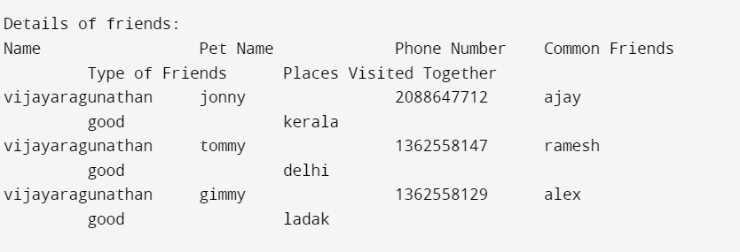

2. Implementation of Structures using Pointers (Create a structure named Product to

store details of the product like name, ID and price. Write a C program to input details

for at least 5 products, find the Total cost of all products, the most expensive and the

lowest priced product, and display their information.)

**ANSWER:**

#include <stdio.h>

#include <string.h>

struct product {

char name[150];

char id[150];

float price;

};

int main() {

int n;

float totalcost = 0.0;

struct product* mostexpensive;

struct product* lowestpriced;

printf("Enter number of the products: ");

scanf("%d", &n);

struct product p[n];

for (int i = 0; i < n; i++) {

printf("Product %d:\n", i + 1);

printf("Product name: ");

scanf("%s", p[i].name);

printf("Product ID: ");

scanf("%s", p[i].id);

printf("Price: ");

scanf("%f", &p[i].price);

totalcost += p[i].price;

if (i == 0) {

mostexpensive = &p[i];

lowestpriced = &p[i];

} else {

if (p[i].price > mostexpensive->price) {

mostexpensive = &p[i];

}

if (p[i].price < lowestpriced->price) {

lowestpriced = &p[i];

}

}

printf("\n");

}

for (int i = 0; i < n; i++) {

printf("Product %d details:\n", i + 1);

printf("Product name: %s\n", p[i].name);

printf("Product ID: %s\n", p[i].id);

printf("Price: %.2f\n", p[i].price);

printf("\n");

}

printf("Total cost: %.2f\n", totalcost);

printf("Most expensive product: %s (%.2f)\n", mostexpensive->name, mostexpensive->price);

printf("Lowest priced product: %s (%.2f)\n", lowestpriced->name, lowestpriced->price);

return 0;

}

**OUTPUT:**

