[1] Login Screen

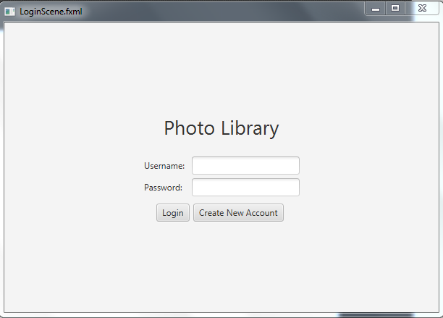

Pop-up to create new user

**[2] Go to album view**

[2] AlbumView

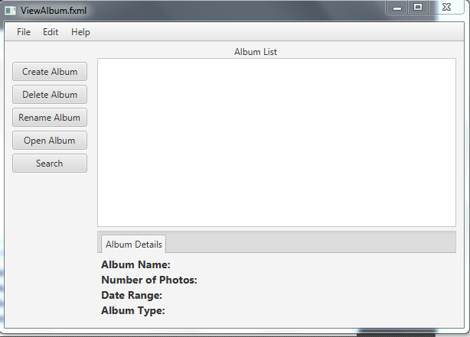

**[4] Go to search**

Pop up for name

Pop up for confirmation

**[3] View selected album**

Fields updated with selection

[3] PictureView

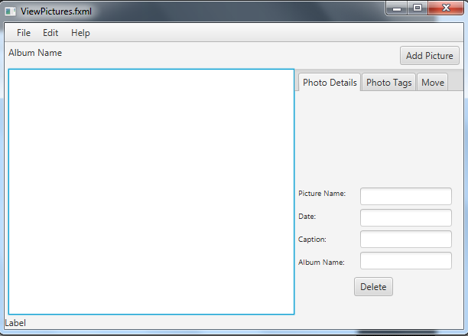

Image thumbnail

Fields updated with selection

Populate all pictures

Browse pop up initiated

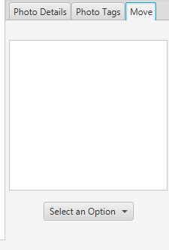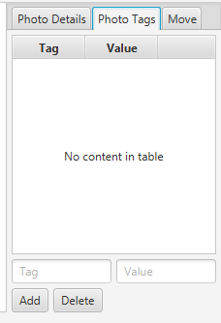

Choose from above list of albums to move pictures

Add to above table with applied text

[4] Search

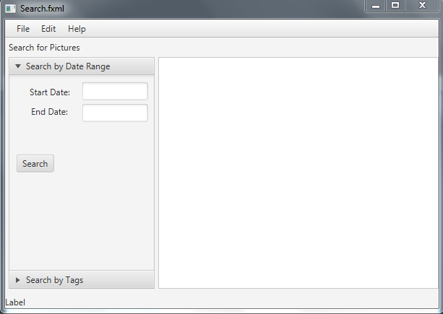

Right hand side listed updated with start and end