Lab 3 - Upload & Install a Blueprint

The purpose of this lab is to upload a sample blueprint to the manager you bootstrapped in the previous step and install it on the same VM.

Before starting, make sure you have the IP address of the manager you bootstrapped in the previous lab.

## Step 1: Download the nodecellar blueprint

In a terminal window (where you installed the CLI) execute the following command:

wget https://github.com/cloudify-cosmo/cloudify-nodecellar-example/archive/3.1.zip

unzip 3.1.zip

cd cloudify-nodecellar-example-3.1/

## Step 2: Configure the inputs file

cp inputs/singlehost.json.template inputs/singlehost.json

vi inputs/singlehost.json

Fill in the host IP (your instance's private IP), agent user (ubuntu), as well as the path of the keyfile on the manager **as written below:**

{

"host_ip": "YOUR INSTANCE'S PRIVATE IP",

"agent_user": "ubuntu",

"agent_private_key_path": "/home/ubuntu/.ssh/agent_key.pem"

}

## Step 3: Upload the blueprint

cd to the same directory you bootstrapped the manager previously and type:

cfy blueprints upload -p <path to unzipped nodecellar>/singlehost-blueprint.yaml -b   
 nodecellar

You should see the following output:

Validating cloudify-nodecellar-example-3.1/singlehost-blueprint.yaml

Blueprint validated successfully

Uploading blueprint cloudify-nodecellar-example-3.1/singlehost-blueprint.yaml to management server 54.91.114.221

Uploaded blueprint, blueprint's id is: nodecellar

Go to the web UI and make sure you see a blueprint named 'nodecellar' in the blueprints screen.

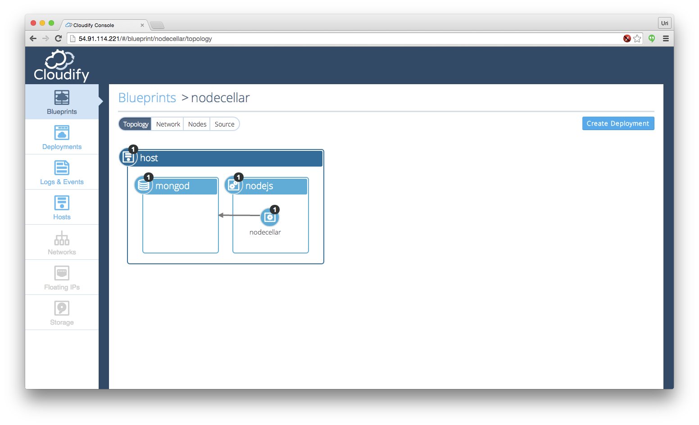

**Step 4: Create a deployment**

cfy deployments create -b nodecellar -i cloudify-nodecellar-example-3.1/inputs/singlehost.json -d nodecellar

You should see the output similar to the following, make sure all components are running:

Creating new deployment from blueprint nodecellar at management server 54.91.114.221

Deployment created, deployment's id is: nodecellar

**Step 5: Execute the install workflow**

Trigger the install workflow by typing:

cfy executions start -d nodecellar -w install

You should see the events being printed to the screen. You can also go to the deployments screen in the UI and see the events there.

Executing workflow 'install' on deployment 'nodecellar' at management server 54.91.114.221 [timeout=900 seconds]

2015-01-21T02:11:53 CFY <nodecellar> Starting 'install' workflow execution

2015-01-21T02:11:53 CFY <nodecellar> [host_ff674] Creating node

2015-01-21T02:11:54 CFY <nodecellar> [host_ff674] Configuring node

2015-01-21T02:11:54 CFY <nodecellar> [host_ff674] Starting node

2015-01-21T02:11:54 CFY <nodecellar> [host_ff674] Installing worker

2015-01-21T02:11:54 CFY <nodecellar> [host_ff674.install] Sending task 'worker_installer.tasks.install'

...

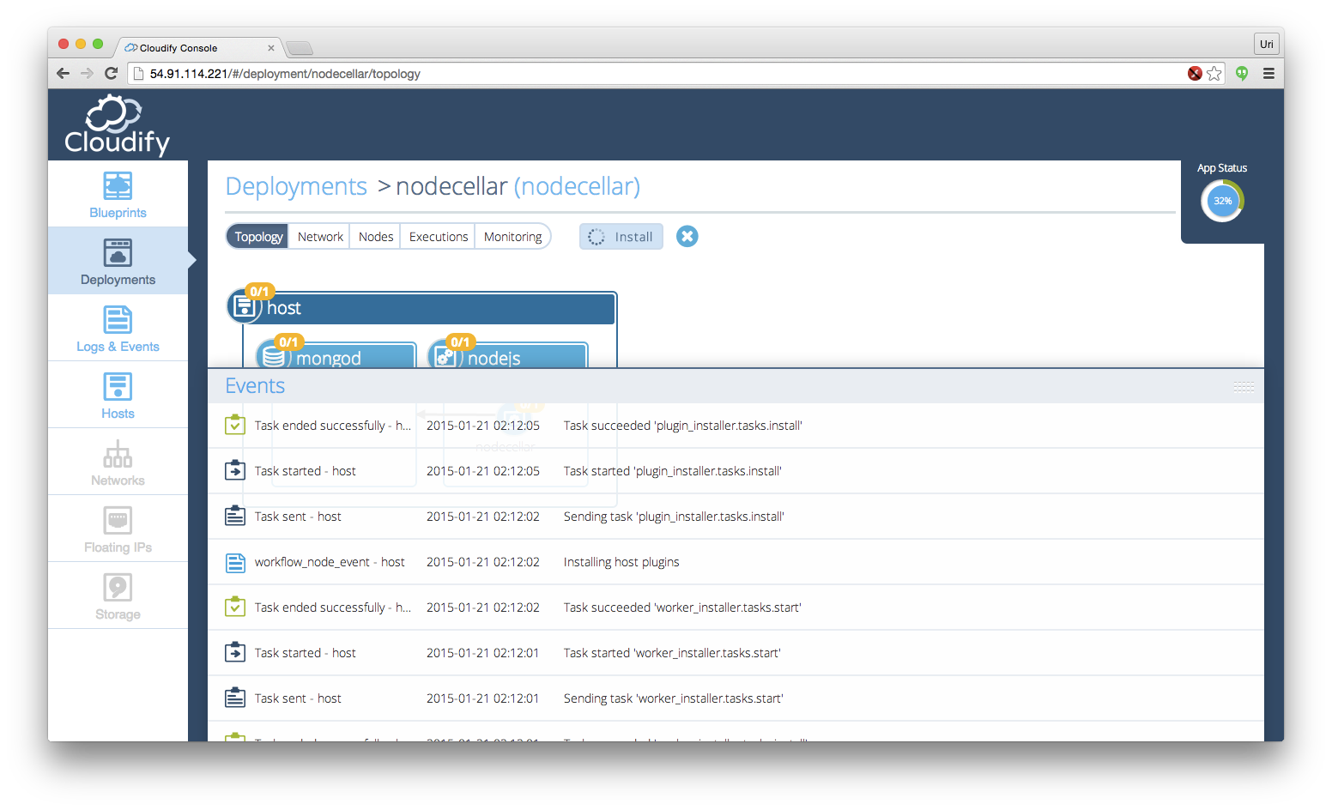

At the end of this process you should see output similar to the following:

2015-01-21T02:14:58 CFY <nodecellar> 'install' workflow execution succeeded

Finished executing workflow 'install' on deployment'nodecellar'

**Step 5: Access the application**

Point your browser to your managers public ip, port 8080. You should now see the nodecellar application. click the "Start browsing nodecellar" button and see the list of wines that is retrieved from the mongo database.

