**Lab 5 - Add Monitoring to Your Blueprint**

The purpose of this lab is to add monitoring to your tomcat blueprint

**Step 1: Replace the placeholders**

You need to replace **all** the occurrences of the placeholders (“REPLACE_THIS_WITH”) in tomcat.json and in the blueprint file to add monitoring to the blueprint

**Step 2: Upload and install the blueprint**

cfy blueprints upload -p <path to your blueprint file> -b hellotomcat  
cfy deployments create -b hellotomcat -d hellotomcat -i <inputs_json_file>

cfy executions start -d hellotomcat -w install

**Step 3: Review monitoring in the UI**

* In the web UI, go to the deployment screen.
* Click your deployment.
* Click the monitoring tab: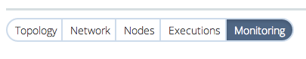
* Now you can see the grafana dashboard, with a few default metrics defined. This dashboard is dynamically created for every deployment when you click the monitoring tab.

**Step 4: Ådd a new graph to the dashboard**

Now let's add a new graph to the dashboard:

* Click the add a row button at the bottom right part of the screen   
  
* Click the right handle button, and then add panel → graph  
  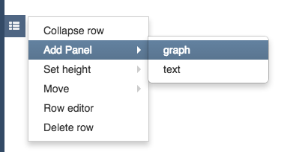
* Click the graph title → edit   
  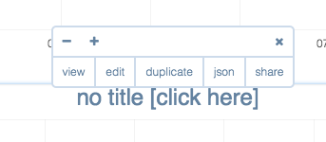
* Type 'cpu' in the 'series' field:   
  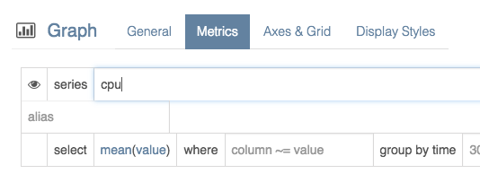  
  You should see a list of series names available in influx (these were pushed into influx by the CPU collector you installed in your blueprint. Choose one of them.
* Go to the 'General' tab and give a meaningful title to your graph. You can also change the 'span' attribute to control the witht of the graph you just created (12 being 100% of the dashboard width). Feel free to play around with the other tabs as well to define your graph.
* You can also control other aspects of the dashboard, e.g. the resolution, auto-refresh rate, etc.   
    
  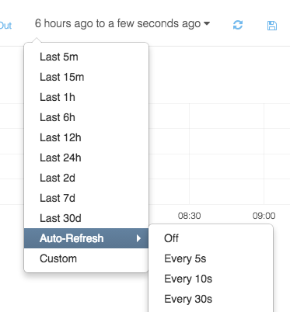
* You can also export your dashboard to JSON by clicking save → export dashboard   
  