Week 3 — Driver Performance Analytics Platform
  - Technical Documentation
Jane Stephanie Sedano
May 2026
Table of Contents

Week 3 — Driver Performance Analytics Platform

Technical Documentation
Project | Driver Performance EDA & Dashboard
Company | Lamina Studios
Author | Jane Stephanie Sedano
Submitted to | April Gianan, Founder & CEO
Submission date | May 5, 2026

1. Document Control
Version | Date | Author(s) | Description
1.0 | 2026-05-05 | Jane Stephanie Sedano | Initial release of Week 3 technical documentation covering driver performance EDA, Laravel API, Redis caching, Next.js dashboard, and Metabase business dashboard.

2. Executive Summary
This document describes the Week 3 deliverable for the Lamina Studios internship: a complete driver performance analytics platform that ingests daily driver data, performs Exploratory Data Analysis (EDA) to extract actionable insights, and serves those insights through both a developer-facing interactive dashboard (Next.js + Chart.js) and a business-facing dashboard (Metabase) for non-technical stakeholders.
The system is built on a modern, containerised stack: PostgreSQL 16 for storage, Redis 7 for caching, Laravel 10 for the REST API, and Next.js 14 for the frontend. All services run via Docker Compose for one-command deployment.
Key project objectives:
- Build a reproducible EDA pipeline that surfaces driver performance patterns
- Provide a cached REST API for aggregated metrics
- Deliver two complementary dashboards — one for analysts, one for operations managers
- Document a clear path toward an ML-based driver risk scoring model
Expected business impact:
- Identification of at-risk drivers within minutes rather than weeks of manual review
- Data-driven scheduling decisions (e.g., the documented Monday delay pattern)
- A foundation for proactive safety interventions before incidents occur
- Self-service business intelligence via Metabase, removing dependency on engineering for ad-hoc reports
The platform is fully operational. EDA findings reveal a strong negative correlation (r = –0.587) between accidents and driver ratings, a 40% delay spike on Mondays, and an at-risk cluster of 5 drivers (D046–D050) that warrants immediate intervention.

3. Introduction

3.1 Purpose of the Document
This document serves as the canonical technical reference for the Week 3 driver performance analytics platform. It captures the system architecture, data flows, API contracts, deployment procedure, performance considerations, and roadmap for ML-based extensions. It is intended to support handoff, code review, and future enhancement work.

3.2 Scope
In scope:
- Synthetic dataset generation and EDA notebook
- PostgreSQL schema, indexes, and materialized views
- Laravel REST API with Redis-backed caching
- Next.js + Chart.js interactive dashboard
- Metabase business dashboard
- Docker Compose deployment
- Documentation, demo script, and Postman collection
Out of scope:
- Production deployment to cloud infrastructure
- Authentication and authorization on the API
- Live data ingestion from telematics devices (covered conceptually as integration with Week 2 work)
- Implementation of the driver risk score ML model (documented as a next step only)

3.3 Audience
Audience | Use of this document
Engineering reviewers | Code structure, API contract, schema decisions
Operations managers | Metabase dashboard usage, available metrics
Future interns or contributors | Setup instructions, architecture context
Lamina Studios leadership | Executive summary, business impact, roadmap

3.4 Related Documents
Document | Location
EDA Summary (1-page bullet findings) | week 3/final/EDA_Summary.md
Demo Walkthrough Script | week 3/final/demo_script.md
Metabase Setup Guide | week 3/final/metabase_setup.md
Postman API Collection | week 3/final/postman_collection.json
Run Instructions | week 3/final/README.md
EDA Notebook | week 3/eda-notebooks/eda_day1.ipynb
Reference SQL queries | week 3/db/aggregations.sql

3.5 Terminology & Abbreviations
Term | Definition
EDA | Exploratory Data Analysis — initial investigation of data to discover patterns, spot anomalies, test hypotheses
API | Application Programming Interface — REST endpoints exposed by the Laravel backend
TTL | Time-To-Live — duration a cache entry remains valid before re-querying the source
KPI | Key Performance Indicator — high-level summary metric (e.g., total accidents)
ML | Machine Learning
ORM | Object-Relational Mapper — Eloquent in Laravel
SWR | Stale-While-Revalidate — Next.js data fetching strategy
DOW | Day of Week
IQR | Interquartile Range — statistical method for outlier detection
SHAP | SHapley Additive exPlanations — ML model interpretability framework
YOLOv8 | Real-time object detection model used in Week 2 dashcam monitoring

4. Business Case and Problem Statement

4.1 Current Logistics Challenges
Lamina Studios’ fleet operations currently face several data-related challenges:
Challenge | Impact
Driver performance reviewed manually | Reactive, slow to flag at-risk drivers
No unified view of delays, accidents, and ratings | Decisions made in silos
Operations managers depend on engineers for reports | Bottleneck for routine queries
No early-warning system for repeat offenders | Incidents recur before intervention
Patterns like day-of-week effects go unnoticed | Suboptimal scheduling

4.2 Need for AI Integration
While this Week 3 deliverable focuses on EDA and dashboards, it lays the data foundation for future AI integration:
- The cleaned and aggregated driver_profiles table is structured to feed an ML pipeline directly
- The Laravel API and Redis caching layer can serve real-time risk scores once a model is deployed
- The Metabase dashboard can be extended with model output (predicted risk, top contributing factors)
The documented EDA findings — particularly the strong correlation between accidents and ratings — confirm that the data contains predictive signal worth modeling.

4.3 Goals and Success Metrics
Goal | Success Metric | Status
Reproducible EDA pipeline | Notebook runs end-to-end with Run All | Achieved
API serves all required metrics | 5 endpoints live and cached | Achieved
Dashboard renders < 2s on cached requests | Confirmed via SWR + Redis | Achieved
Metabase dashboard accessible to non-technical users | Public link option enabled | Achieved
At-risk driver identification | 5 drivers flagged with quantitative evidence | Achieved
Single-command deployment | docker compose up -d --build | Achieved

5. System Overview

5.1 Architecture Diagram
Live screenshot — Next.js Dashboard (top of page):
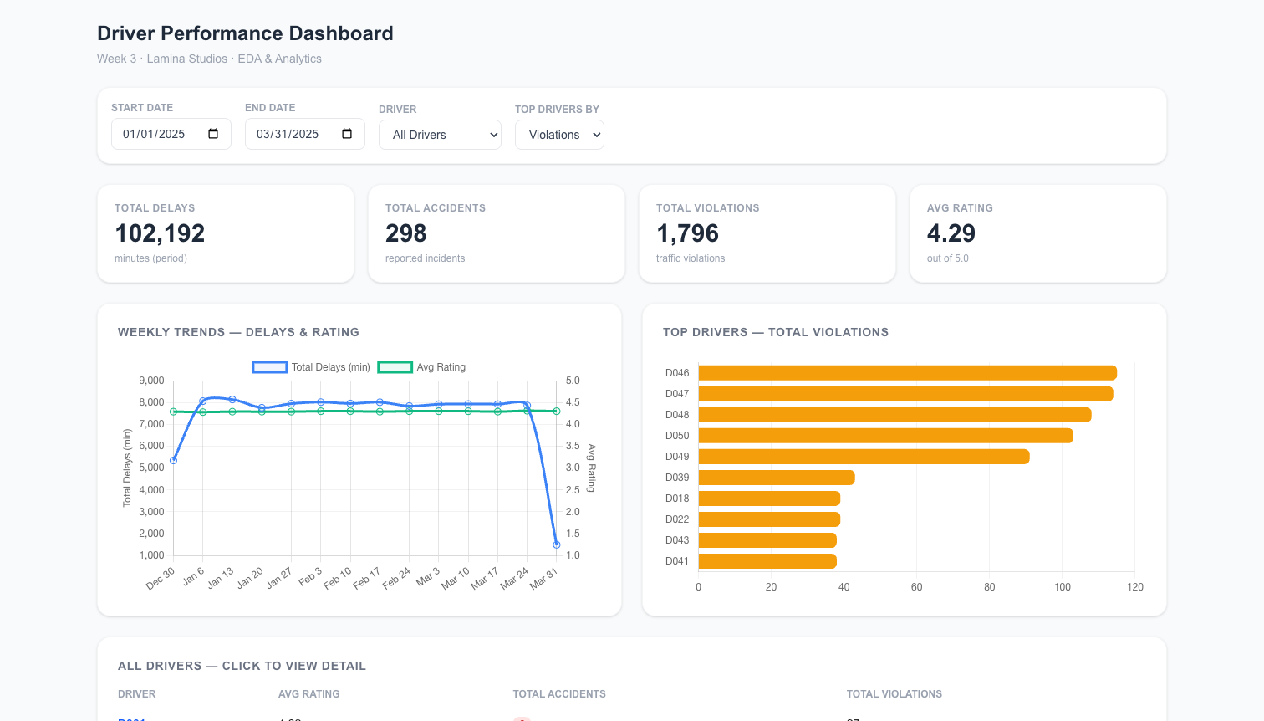
Next.js dashboard top — KPI cards, weekly chart, top drivers
Live screenshot — Metabase Business Dashboard:
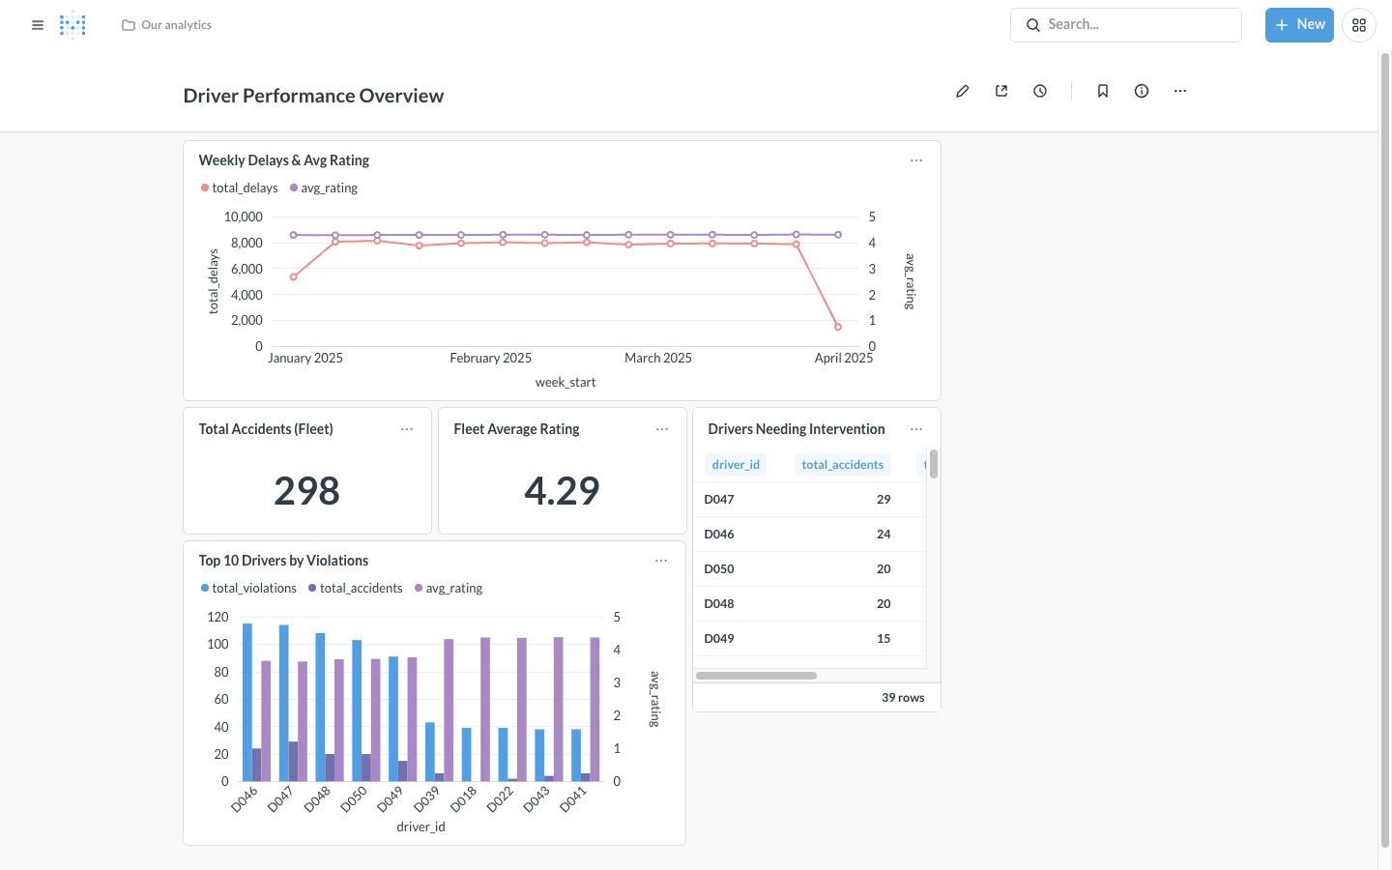
Metabase dashboard — Driver Performance Overview
Conceptual flow:
┌────────────────────────────┐
│ data/generate_dataset.py │
│ (Python, seed=42) │
└──────────────┬─────────────┘
│
▼
┌────────────────────────────┐
│ driver_profiles.csv │
│ 4,500 rows │
└──────────────┬─────────────┘
│
▼
┌────────────────────────────┐
│ Laravel Seeder │
│ (league/csv, chunked) │
└──────────────┬─────────────┘
│
▼
┌────────────────────────────────────────────┐
│ PostgreSQL 16 │
│ - driver_profiles (raw) │
│ - mv_weekly_summary (materialized view) │
└──────┬──────────────────────┬──────────────┘
│ │
▼ ▼
┌──────────────────┐ ┌─────────────────┐
│ Laravel 10 API │ │ Metabase │
│ (port 8000) │ │ (port 3000) │
└──────┬───────────┘ └─────────────────┘
│ ▲
│ │
▼ │
┌──────────────────┐
│ Redis 7 Cache │
│ TTL=300s │
└──────┬───────────┘
│
▼
┌──────────────────┐
│ Next.js 14 │
│ Chart.js │
│ (port 3001) │
└──────┬───────────┘
│
▼
┌──────────────────┐
│ End User / │
│ Stakeholder │
└──────────────────┘

5.2 Major Components

5.2.1 AI Models and Algorithms
This week’s scope does not include trained ML models. However, the platform’s data layer is ML-ready, and a roadmap for a driver risk scoring model is provided in Section 13. Statistical analyses performed in the EDA notebook include:
- Pearson correlation analysis (continuous variables)
- IQR-based outlier detection
- Group-by aggregations (driver, week, day-of-week)
- Distribution analysis (histograms, box plots, descriptive statistics)

5.2.2 Data Pipelines
Stage | Tool | Frequency
Data generation | Python script (seeded) | One-time / on-demand
Database ingestion | Laravel Seeder + league/csv | One-time / on re-seed
Materialized view refresh | PostgreSQL REFRESH command | Nightly (production)
Cache population | Lazy via Cache::remember() | On first request after TTL expiry

5.2.3 APIs and Interfaces
The Laravel REST API exposes 5 endpoints under the /api/ prefix. Full contract is documented in Section 9.

5.2.4 IoT Devices
No IoT hardware is directly integrated in Week 3. However, the data schema is designed to receive aggregated input from the Week 2 IoT pipeline:
- Dashcam (video) → YOLOv8 → behavioral events
- IMU sensors (ax, ay, az, gyro_x/y/z) → near-collision and harsh-braking events
- These events would be aggregated daily per driver to populate driver_profiles

5.2.5 Integration with Existing ERP/WMS
The current dataset is standalone, but the schema is compatible with common ERP/WMS exports:
- driver_id, vehicle_id, route_id map directly to common WMS dimensions
- date, shift correspond to typical timesheet fields
- The Laravel ORM (Eloquent) makes future joins with other tables straightforward

6. Functional Modules
Module | Path | Description
Data Generation | data/generate_dataset.py | Produces a reproducible synthetic CSV with realistic correlations, Monday spike, and at-risk driver cluster
EDA Notebook | eda-notebooks/eda_day1.ipynb | 8-section Jupyter notebook covering data quality, distributions, correlations, time series, day-of-week analysis, top violators, outliers, and findings
Database Migration | backend-laravel/database/migrations/ | Defines driver_profiles schema, indexes, and the mv_weekly_summary materialized view
CSV Seeder | backend-laravel/database/seeders/DriverProfileSeeder.php | Imports CSV in 500-row chunks and refreshes the materialized view
API Controller | backend-laravel/app/Http/Controllers/Api/DriverMetricsController.php | All 5 endpoint handlers with Redis caching
API Routes | backend-laravel/routes/api.php | Route definitions and parameter contracts
Reference Queries | db/aggregations.sql | 10 reference SQL queries for analysts working directly against PostgreSQL
Dashboard Page | frontend-next/app/dashboard/page.tsx | Main interactive dashboard
Chart Components | frontend-next/components/*.tsx | KPI cards, weekly chart, top drivers chart, filters, drill-down modal
API Client | frontend-next/lib/api.ts | Axios wrappers for all 5 endpoints
Metabase Dashboard | http://localhost:3000/dashboard/2 | 5-card business dashboard
Docker Orchestration | docker-compose.yml | Service definitions, networks, volumes, healthchecks

7. Data Management

7.1 Data Sources
Source | Type | Description
data/driver_profiles.csv | Synthetic CSV | 4,500 rows, 10 columns, generated with NumPy seed 42 for reproducibility
Future: Week 2 events pipeline | Real-time stream | Dashcam YOLOv8 events + IMU sensor data, aggregated daily

7.2 Data Collection Methods
For Week 3, data was generated synthetically. Real-world collection (production) would follow this flow:
- Onboard telematics — IMU sensors capture acceleration and gyro readings continuously
- Dashcam + YOLOv8 — frame-level object detection identifies near-collisions, phone use, lack of seatbelt
- Edge aggregation — daily summaries computed at the driver/vehicle level
- Cloud upload — aggregated rows pushed to the driver_profiles table via the Laravel API
- Cache invalidation — Redis keys cleared so dashboards reflect fresh data

7.3 Data Privacy and Security
Concern | Mitigation
Driver PII | Driver IDs are opaque codes (D001–D050); no names or contact info stored in this table
Database credentials | Stored in environment variables, never committed; .env excluded from git via .gitignore
Network exposure | All inter-service traffic stays inside the Docker network; only public ports 8000, 3000, 3001 are exposed
API authentication | Not implemented in Week 3 (out of scope); production should add Laravel Sanctum or OAuth2
Data at rest | PostgreSQL volume pgdata should be encrypted in production (e.g., AWS EBS encryption)
Data in transit | HTTPS termination should be added at a reverse proxy (e.g., nginx) for production
Right-to-be-forgotten | The driver_profiles schema supports row-level deletion by driver_id for GDPR compliance

8. AI/ML Models

8.1 Current Implementation
No ML models are deployed in Week 3. The platform implements descriptive analytics (what happened) rather than predictive analytics (what will happen). The descriptive layer surfaces the following insights:
Statistical Analysis | Method | Output
Distribution analysis | Histograms, KDE | Shape and skew of delays/ratings
Correlation analysis | Pearson r | Pairwise relationships between metrics
Outlier detection | IQR (1.5 × IQR rule) | High-delay and high-accident events
Aggregation | GROUP BY (SQL) | Per-driver, per-week, per-day-of-week summaries
EDA Output — Distributions of delays and ratings:
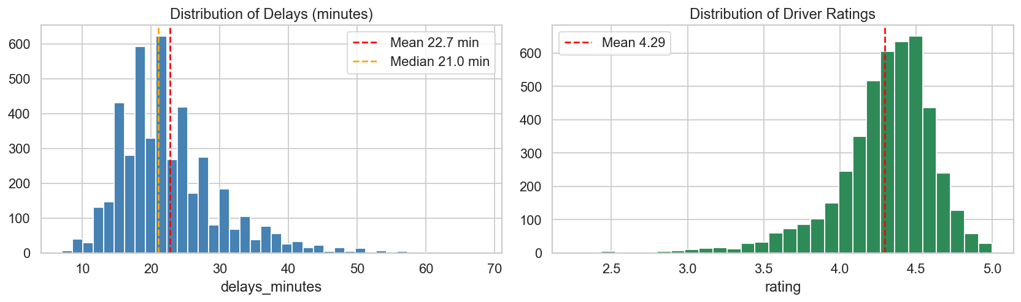
Distributions of delays and ratings
EDA Output — Correlation matrix (rating shows strong negative correlation with accidents):
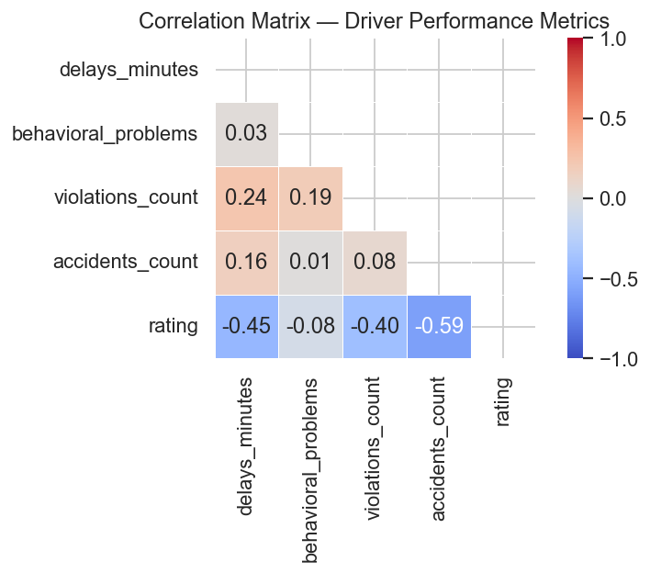
Correlation heatmap
EDA Output — Weekly trend over the 90-day period:
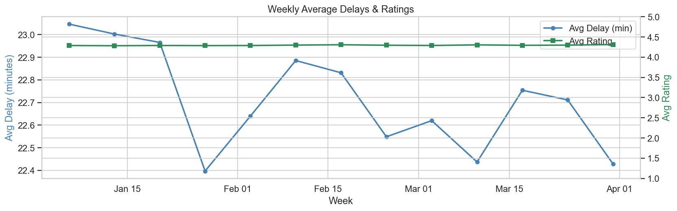
Weekly delays and ratings
EDA Output — Day-of-week pattern (Monday delay spike highlighted in red):
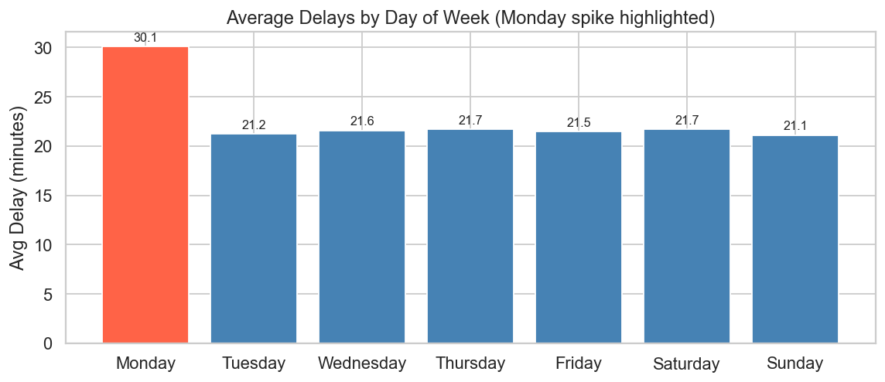
Day-of-week delay pattern
EDA Output — Top 10 violators (at-risk cluster D046–D050 highlighted):
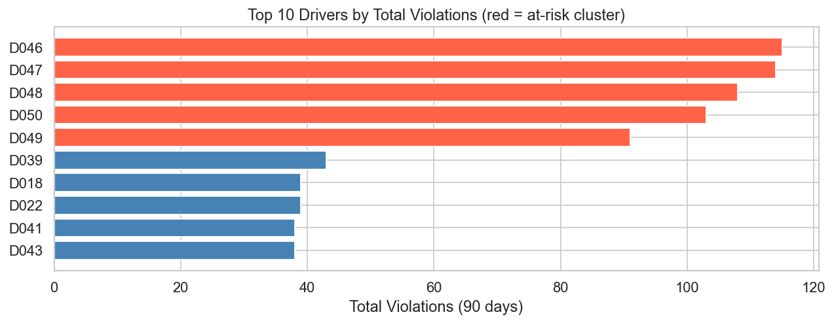
Top 10 drivers by violations
Live drilldown view — Driver D047 (at-risk): Rating trend over 90 days plus daily violations and accidents.
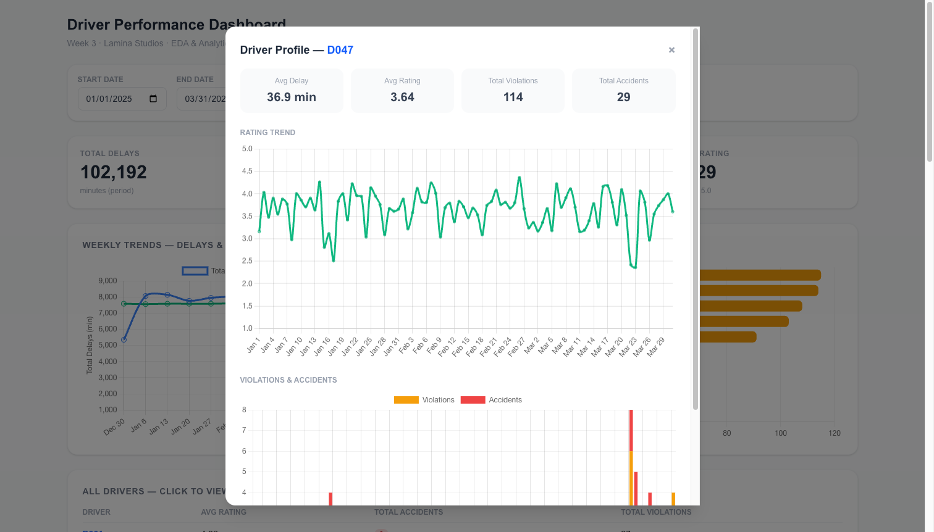
Driver D047 detail modal

8.2 Proposed Model — Driver Risk Score
Detailed in Section 13 (Maintenance & Future Enhancements). Summary:
Property | Value
Task type | Binary classification
Target | high_risk (accidents > 2 OR avg rating < 3.5 in rolling 30 days)
Algorithm | LightGBM (Gradient Boosted Trees)
Inputs | 8 rolling-window features per driver (delays, violations, accidents, behavioral, rating, day-of-week, shift, route risk)
Output | Risk probability (0–1) and SHAP feature attributions
Refresh frequency | Nightly batch job

9. System Integration

9.1 APIs
The Laravel REST API exposes 5 endpoints. All responses are JSON.
# | Method | Endpoint | Cache Key
1 | GET | /api/metrics/weekly | weekly_summary:{start}:{end}
2 | GET | /api/metrics/top-drivers | top_drivers:{metric}:{limit}:{start}:{end}
3 | GET | /api/metrics/interventions | interventions:{threshold}:{start}:{end}
4 | GET | /api/metrics/driver/{id} | driver_detail:{id}:{start}:{end}
5 | GET | /api/drivers | drivers_list

9.1.1 GET /api/metrics/weekly
Returns weekly aggregated totals.
Query parameters:
Parameter | Type | Default | Description
start | date (YYYY-MM-DD) | 2025-01-01 | Inclusive start date
end | date (YYYY-MM-DD) | 2025-03-31 | Inclusive end date
Sample response:
{
"data": [
{
"week_start": "2024-12-30",
"total_delays": 5789,
"total_accidents": 24,
"total_violations": 138,
"avg_rating": "4.30",
"active_drivers": 50
}
],
"start": "2025-01-01",
"end": "2025-03-31",
"cache_key": "weekly_summary:2025-01-01:2025-03-31"
}

9.1.2 GET /api/metrics/top-drivers
Parameter | Type | Default | Allowed values
metric | string | violations | violations, accidents, delays
limit | int | 10 | any positive integer
start, end | date | period defaults | YYYY-MM-DD

9.1.3 GET /api/metrics/interventions
Parameter | Type | Default | Description
threshold | int | 2 | Returns drivers whose total accidents in the period exceed this value

9.1.4 GET /api/metrics/driver/{id}
Returns daily time series and summary stats for one driver.

9.1.5 GET /api/drivers
Returns all 50 drivers with aggregate stats — used to populate UI dropdowns.

9.2 External Services
Service | Integration
Metabase | Connects directly to PostgreSQL (read-only credentials recommended in production)
Future telematics provider | Would POST aggregated daily rows to a new /api/driver-profiles ingestion endpoint

9.3 Legacy Systems
No legacy system integrations exist in Week 3. The architecture is designed to integrate cleanly:
- ERP integration: Add a Laravel job to pull driver/vehicle/route mappings nightly
- WMS integration: Use Eloquent relations to join driver_profiles with shipment tables
- Existing reporting tools: Metabase can connect to the same PostgreSQL alongside other data marts

10. Deployment Plan

10.1 Environment Setup
Local development environment requirements:
Tool | Version | Purpose
Docker Desktop | 24.0+ | Container runtime
Docker Compose | v2.0+ | Multi-container orchestration
Python | 3.10+ | Dataset generation, EDA notebook
Node.js | 20+ | (Optional) running Next.js outside Docker
Git | 2.30+ | Version control

10.2 CI/CD Pipelines
CI/CD is not implemented in Week 3 (single-developer scope). Recommended pipeline for production:
Stage | Tool | Action
Lint | PHPStan, ESLint | Static analysis on every PR
Test | PHPUnit, Jest | Unit + integration tests
Build | Docker Buildx | Multi-arch container images
Push | GitHub Container Registry | Image storage
Deploy | GitHub Actions / ArgoCD | Rolling update to staging then production

10.3 Containerization
All services run in Docker containers managed by docker-compose.yml. Key containers:
Container | Image | Build Strategy
w3_postgres | postgres:16 | Pulled
w3_redis | redis:7-alpine | Pulled
w3_backend | Custom (backend-laravel/Dockerfile) | Built locally; copies pre-installed Laravel vendor/
w3_frontend | Custom (frontend-next/Dockerfile) | Multi-stage; builds Next.js standalone bundle
w3_metabase | metabase/metabase:latest | Pulled
The Laravel container uses a multi-stage approach where vendor/ is installed locally via Composer (avoiding Docker network issues with composer create-project) and copied into the image.

10.4 Cloud / On-prem Infrastructure
Week 3 runs entirely on local Docker. For production:
Component | Recommended
Container orchestration | AWS ECS Fargate or Kubernetes (EKS / GKE)
Managed PostgreSQL | AWS RDS or Cloud SQL
Managed Redis | AWS ElastiCache or Memorystore
Object storage (CSV ingest) | S3 or GCS
Reverse proxy / TLS | nginx + Let’s Encrypt, or AWS ALB

10.5 Monitoring & Logging
Currently logs flow to stderr (Docker default). For production:
Concern | Tool
Container metrics | Prometheus + Grafana
Application logs | Loki, ELK, or Datadog
API tracing | OpenTelemetry
Cache hit-rate monitoring | redis-cli INFO stats exported to Prometheus
Uptime / synthetic checks | Pingdom or UptimeRobot

11. Testing and Validation

11.1 Test Plan Overview
Test Type | Tool | Status (Week 3)
Manual API verification | curl / Postman | Completed
Manual UI walkthrough | Browser | Completed
Database integrity | PostgreSQL queries | Completed (4,500 rows confirmed)
Cache hit verification | redis-cli KEYS '*' | Completed
Notebook execution | jupyter nbconvert --execute | Validated
Unit tests | PHPUnit | Recommended for production
End-to-end tests | Playwright | Recommended for production
Load tests | k6 or JMeter | Recommended for production

11.2 Model Accuracy Metrics
Not applicable in Week 3 (no ML model deployed). For the future risk score model, recommended evaluation metrics:
Metric | Target
Precision (high-risk class) | > 0.80
Recall (high-risk class) | > 0.70
ROC-AUC | > 0.85
Cross-validation strategy | 5-fold time-series split

11.3 System Load Testing
Not performed at scale in Week 3. Estimated capacity based on architecture:
Scenario | Estimated Capacity
Concurrent dashboard viewers | 100+ (Redis cache absorbs read load)
API requests/sec (cached) | 1,000+
API requests/sec (uncached) | 50–100 (limited by PostgreSQL)

11.4 UAT Plans
For Lamina Studios’ acceptance testing:
UAT Step | Owner | Pass criteria
Generate fresh dataset | Tester | Script completes, CSV has 4,500 rows
Bring up Docker stack | Tester | All 5 containers healthy
Browse Next.js dashboard | Operations user | KPI cards show non-zero values
Click into a driver | Operations user | Modal opens with rating trend
Open Metabase dashboard | Manager | All 5 cards render
Test a date range filter | Operations user | Charts update within 2 seconds
Verify cache invalidation | Engineer | cache:clear removes Redis keys

12. Risk Assessment and Mitigation
# | Risk | Likelihood | Impact | Mitigation
1 | Database container fails to start | Low | High | Docker healthchecks defined; backend waits for healthy before starting
2 | Cache stampede on TTL expiry under high load | Medium | Medium | Implement Cache::lock() for popular keys; consider stale-while-revalidate pattern
3 | CSV import fails due to malformed data | Low | High | Seeder validates row schema; chunked inserts allow partial recovery
4 | Synthetic data does not generalise to real-world patterns | Medium | Medium | Real Week 2 events can be aggregated and substituted via the same seeder
5 | Redis connection lost during a request | Low | Medium | Laravel falls back to direct DB queries; user sees slower responses but no errors
6 | Metabase connection to Postgres breaks (DNS issue) | Medium | Low | Documented IP-based fallback in metabase_setup.md
7 | Frontend cannot reach backend in Docker | Low | High | Build-arg BACKEND_URL injects the Docker network hostname at build time
8 | Migration drops production data on accidental re-run | Low | Critical | Use migrate --force only in dev; add prohibitDestructiveCommands in production
9 | API keys / credentials leak via logs | Low | High | .env files excluded from git; no secrets in log statements
10 | At-risk driver flagged in error (false positive) | Medium | Medium | Threshold-based logic uses 90 days of data; false positives reviewable in detail modal

13. Maintenance and Future Enhancements

13.1 Model Retraining Frequency
Not applicable (no model in Week 3). For the proposed driver risk score model:
Activity | Frequency
Feature recomputation (rolling windows) | Nightly
Model retraining | Weekly
Model evaluation report | Weekly
Full historical re-evaluation | Quarterly

13.2 Feedback Loop Integration
Future integration plan for closing the loop on driver risk scores:
- Operations team takes action on flagged drivers (coaching, route change, suspension)
- Action outcomes recorded in a new driver_interventions table
- Subsequent driver performance compared pre/post intervention
- Model retrained quarterly with intervention outcomes as additional features
- Effectiveness of interventions surfaced in Metabase as a new dashboard card

13.3 Future Module Plans
Module | Description | Priority
Driver Risk Score ML Pipeline | LightGBM model with rolling-window features | High
Real-time Alerting | Webhook → Slack/Teams when accidents > 1 in 30 days | High
Vehicle-level analytics | Same metrics aggregated by vehicle_id and route_id | Medium
Mobile companion app | Manager-facing read-only dashboard on iOS/Android | Medium
Data lake integration | Stream driver_profiles to S3/Parquet for advanced analytics | Medium
Multi-tenancy | Support multiple fleet operators in a single deployment | Low
Public API + auth | Laravel Sanctum tokens for third-party integration | Low

13.4 Proposed Driver Risk Score Model — Detailed Plan
Problem statement: Predict, with 30 days of history, whether a driver will be classified as high-risk in the next 7 days.
Target variable: high_risk = 1 if (next-7-day accidents > 0 OR next-7-day avg rating < 3.5), else 0
Features (per driver, computed daily over rolling 30-day window):
# | Feature | Type | Source
1 | avg_delays_30d | float | delays_minutes
2 | sum_violations_30d | int | violations_count
3 | sum_accidents_30d | int | accidents_count
4 | avg_behavioral_problems_30d | float | behavioral_problems
5 | avg_rating_30d | float | rating
6 | dow_monday_pct | float (0–1) | proportion of records on Mondays
7 | shift_night_pct | float (0–1) | proportion of night shifts
8 | route_risk_score | float | per-route historical accident rate
Algorithm choice: LightGBM
Reason | Detail
Speed | Trains in seconds on tens of thousands of rows
Class imbalance handling | Built-in scale_pos_weight parameter
Interpretability | SHAP values explain each prediction in plain terms
Production maturity | Widely deployed in industry; well-supported tooling
Integration architecture:
PostgreSQL → daily Python feature job → LightGBM scoring → driver_risk_scores table
↓
Laravel API (/api/metrics/risk-scores)
↓
Next.js + Metabase dashboards

14. Appendix

14.1 API Documentation (Detailed)
Full request/response examples are provided in final/postman_collection.json. Quick reference:
# Weekly summary
curl "http://localhost:8000/api/metrics/weekly?start=2025-01-01&end=2025-03-31"
# Top 10 drivers by violations
curl "http://localhost:8000/api/metrics/top-drivers?metric=violations&limit=10"
# Intervention candidates
curl "http://localhost:8000/api/metrics/interventions?threshold=2"
# Per-driver detail
curl "http://localhost:8000/api/metrics/driver/D047?start=2025-01-01&end=2025-03-31"
# Driver list
curl "http://localhost:8000/api/drivers"

14.2 Sample Data Format
Sample driver_profiles.csv rows:
driver_id,date,delays_minutes,behavioral_problems,violations_count,accidents_count,rating,route_id,vehicle_id,shift
D001,2025-01-01,15,0,0,0,4.45,R03,V07,morning
D001,2025-01-02,28,1,1,0,4.10,R03,V07,morning
D047,2025-01-01,42,2,2,1,3.20,R09,V14,night

14.3 Configuration Files
File | Purpose
docker-compose.yml | Service definitions, environment variables, networks, volumes
backend-laravel/.env.example | Template environment variables
frontend-next/.env.local | Frontend environment variables
backend-laravel/docker-entrypoint.sh | Backend container startup script

14.4 Glossary
Term | Definition
Materialized View | A persisted, queryable result of an expensive aggregation, refreshed on schedule
Cache Stampede | A pathological pattern where many requests miss cache simultaneously and all hit the database
Stale-While-Revalidate (SWR) | Serve cached data instantly, refresh in background
Composite Index | A database index across multiple columns, optimizing joint filters
Public Link | Metabase feature allowing read-only dashboard access without login

15. References

15.1 Open-Source Tools
Tool | URL | Use
Laravel | https://laravel.com | Backend framework
Next.js | https://nextjs.org | Frontend framework
Chart.js | https://www.chartjs.org | Charts
Metabase | https://www.metabase.com | Business dashboard
PostgreSQL | https://www.postgresql.org | Relational database
Redis | https://redis.io | In-memory cache
Docker | https://www.docker.com | Containerisation
pandas | https://pandas.pydata.org | EDA in Python
seaborn / matplotlib | https://seaborn.pydata.org | Visualization
league/csv | https://csv.thephpleague.com | PHP CSV parsing
predis/predis | https://github.com/predis/predis | PHP Redis client
SWR | https://swr.vercel.app | React data fetching

15.2 Vendor Documentation
Document | URL
PostgreSQL date_trunc | https://www.postgresql.org/docs/16/functions-datetime.html
Laravel Cache | https://laravel.com/docs/10.x/cache
Laravel Eloquent | https://laravel.com/docs/10.x/eloquent
Next.js App Router | https://nextjs.org/docs/app
Chart.js Configuration | https://www.chartjs.org/docs/latest/general/
Metabase Public Sharing | https://www.metabase.com/docs/v0.60/embedding/public-links
Docker Compose Networking | https://docs.docker.com/compose/networking/

15.3 Internal References
Item | Reference
Week 3 scope confirmation | Email from April Gianan, May 4 2026
Week 2 deliverables | Lamina Studios week 2 folder (dashcam, YOLOv8, sensor logs)
Lamina Studios technical doc template | This document

15.4 Research and Methodology
Topic | Reference
Pearson correlation interpretation | Cohen, J. (1988). Statistical power analysis for the behavioral sciences
IQR outlier detection | Tukey, J. W. (1977). Exploratory Data Analysis
Gradient Boosted Trees for tabular data | Chen & Guestrin (2016). XGBoost: A Scalable Tree Boosting System
LightGBM | Ke et al. (2017). LightGBM: A Highly Efficient Gradient Boosting Decision Tree
SHAP values | Lundberg & Lee (2017). A Unified Approach to Interpreting Model Predictions

End of Technical Documentation
Submitted by: Jane Stephanie Sedano | Lamina Studios Internship | Week 3 — May 5, 2026

