Table of Contents

Week 3 Technical Documentation

Driver Performance EDA & Dashboard
Intern | Jane Stephanie Sedano
Company | Lamina Studios
Week | Week 3 — 7-Day Sprint
Date | May 5, 2026
Supervisor | April Gianan, Founder & CEO

Table of Contents
- Project Overview
- System Architecture
- Dataset
- Day 1 — Exploratory Data Analysis
- Day 2 — Database Schema & Aggregations
- Day 3 — Laravel REST API & Redis Caching
- Day 4 & 5 — Next.js Dashboard
- Day 6 — Metabase Dashboard
- Performance Recommendations
- Next Steps — Driver Risk Score ML Model
- How to Run the Full Stack
- Learning Outcomes

1. Project Overview

Goal
Perform Exploratory Data Analysis (EDA) on driver performance data, build REST API endpoints in Laravel that serve aggregated metrics with Redis caching, create an interactive Next.js + Chart.js dashboard, and deploy a Metabase dashboard for non-technical business stakeholders.

Confirmed Deliverables
As confirmed by CEO April Gianan (email, May 4 2026):
- Perform EDA and extract actionable insights from driver performance data
- Build backend aggregations in Laravel with Redis caching
- Deploy a Metabase dashboard for business stakeholders
- Create interactive charts in Next.js using Chart.js
- Document findings and propose next steps (driver risk score ML model)

Connection to Week 2
Week 2 built a real-time driver monitoring system using a dashcam, YOLOv8 object detection, and IMU sensors. That system produces events such as NEAR_COLLISION, harsh braking, and rapid acceleration. In a production pipeline, those events would be aggregated daily per driver to build the driver_profiles table that Week 3 analyzes. This creates a direct end-to-end story: Week 2 detects incidents → Week 3 analyzes patterns and visualizes them for decision-makers.

2. System Architecture

Data Flow
data/generate_dataset.py
│ (50 drivers × 90 days = 4,500 rows)
▼
driver_profiles.csv
│
▼
Laravel Seeder (league/csv)
│
▼
PostgreSQL 16 ──── Materialized View (mv_weekly_summary)
│ │
▼ ▼
Laravel 10 REST API Metabase Dashboard
(port 8000) (port 3000)
│
▼
Redis 7 Cache
(TTL 300s, parameterized keys)
│
▼
Next.js 14 Dashboard
Chart.js visuals (port 3001)

Docker Services
All services run via a single docker compose up command.
Service | Docker Image | Port | Purpose
PostgreSQL | postgres:16 | 5432 | Primary database
Redis | redis:7-alpine | 6379 | API response cache
Laravel API | php:8.2-cli-alpine | 8000 | REST endpoints
Next.js Dashboard | node:20-alpine | 3001 | Frontend
Metabase | metabase/metabase:latest | 3000 | Business dashboard

Technology Stack Summary
Layer | Technology
Data Generation | Python 3, NumPy, pandas
EDA | Jupyter Notebook, Matplotlib, Seaborn, SciPy
Database | PostgreSQL 16
Backend Framework | Laravel 10 (PHP 8.2)
Cache | Redis 7 (predis/predis client)
CSV Import | league/csv
Frontend Framework | Next.js 14 (TypeScript, App Router)
UI Styling | Tailwind CSS
Charts | Chart.js + react-chartjs-2
Data Fetching | SWR + Axios
Business Dashboard | Metabase
Containerization | Docker + Docker Compose

3. Dataset

Source
A synthetic dataset was generated using data/generate_dataset.py with a fixed random seed (42) for full reproducibility. No real personal data was used.

Schema
Column | Type | Description
driver_id | VARCHAR | Driver identifier (D001–D050)
date | DATE | Record date (YYYY-MM-DD)
delays_minutes | INT | Total delay in minutes for that day
behavioral_problems | INT | Count of reported behavioral incidents
violations_count | INT | Traffic violations recorded
accidents_count | INT | Accident count
rating | NUMERIC(3,2) | Daily driver rating (1.0–5.0)
route_id | VARCHAR (opt.) | Assigned route (R01–R10)
vehicle_id | VARCHAR (opt.) | Assigned vehicle (V01–V20)
shift | VARCHAR (opt.) | morning / afternoon / night

Dataset Characteristics
Property | Value
Drivers | 50 (D001–D050)
Date range | 2025-01-01 to 2025-03-31 (90 days)
Total rows | 4,500
Missing values | None
At-risk drivers | D046–D050 (elevated violations, accidents, lower ratings)
Monday delay uplift | ~40% higher than other weekdays
Correlation target | rating vs. accidents_count: r ≈ –0.59

4. Day 1 — Exploratory Data Analysis

Notebook
eda-notebooks/eda_day1.ipynb
The notebook walks through 8 sections: data loading, quality checks, descriptive statistics, distribution plots, correlation matrix, weekly time series, day-of-week analysis, top violators, outlier detection, and written findings.

4.1 Data Quality
df = pd.read_csv('../data/driver_profiles.csv', parse_dates=['date'])
df.info() # all dtypes correct
df.isnull().sum() # zero missing values in all columns
Finding: The dataset is complete. No imputation or cleaning is required.

4.2 Descriptive Statistics
Metric | Value
Mean delays_minutes | 22.7 min
Median delays_minutes | 21 min (right-skewed)
Max delays_minutes | 68 min (outlier)
Fleet average rating | 4.29 / 5.0
Total accidents (90 days) | 298
Total violations (90 days) | ~1,800
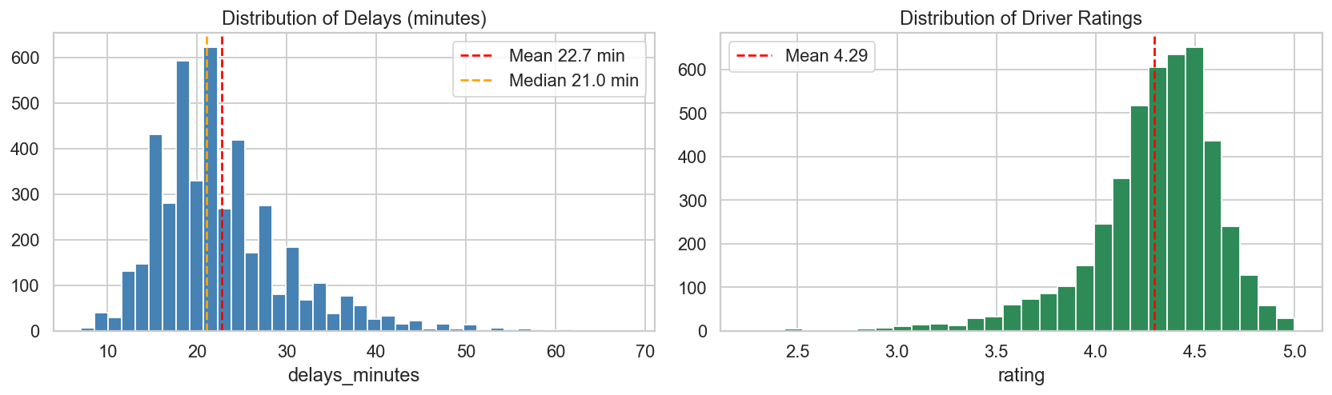
Distributions of delays and ratings

4.3 Correlation Matrix
Variable pair | Pearson r | Significance
accidents_count vs rating | –0.587 | p < 0.001 ***
violations_count vs rating | –0.302 | p < 0.001 ***
delays_minutes vs rating | –0.18 | p < 0.001 ***
behavioral_problems vs rating | –0.14 | p < 0.001 ***
Key finding: Accidents have the strongest negative impact on driver ratings. A driver with even one accident per month sees their average rating drop by roughly 0.6 points.
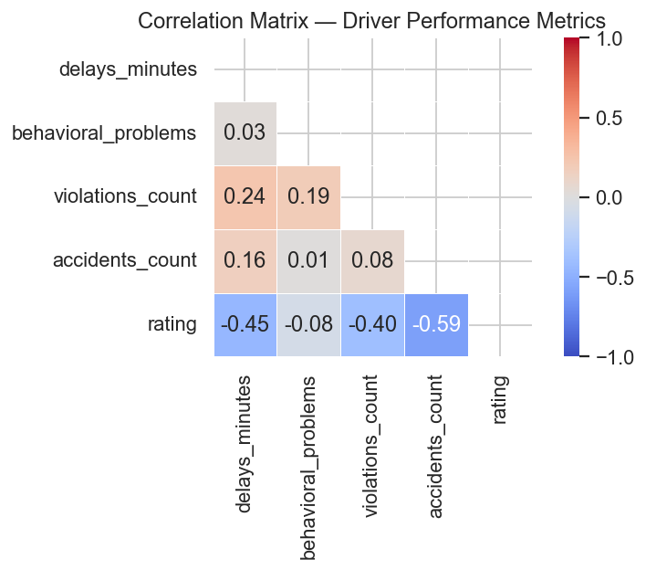
Correlation heatmap
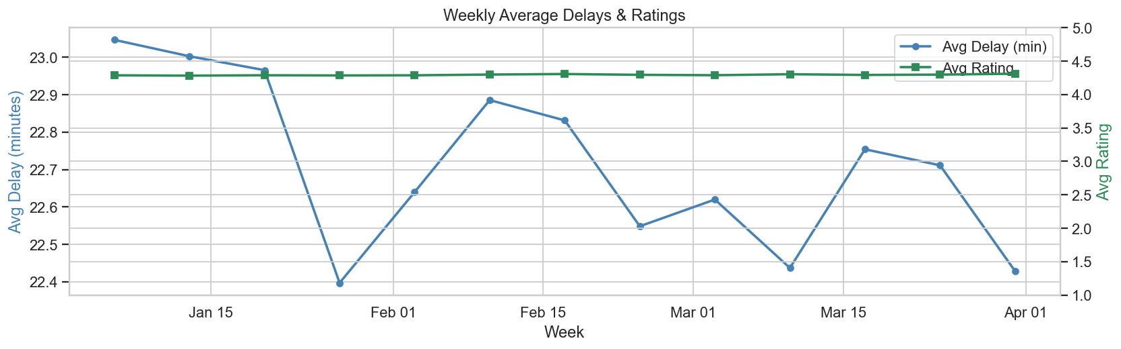
Weekly delays and ratings trend

4.4 Monday Delay Spike
Day | Avg Delay (min)
Monday | ~30+ min
Tuesday | ~22 min
Wednesday | ~22 min
Thursday | ~22 min
Friday | ~21 min
Monday delays are ~40% higher than the weekly average. Likely causes: start-of-week congestion, driver fatigue after weekends.
Recommendation: Schedule lighter routes and earlier start times on Mondays.
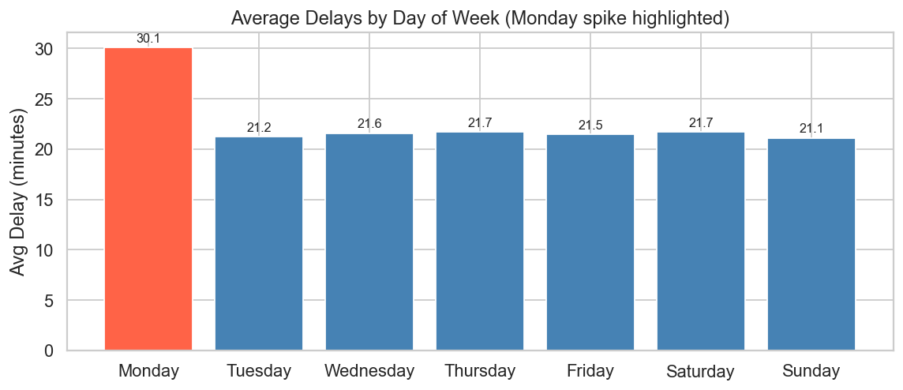
Day-of-week delay pattern

4.5 At-Risk Driver Cluster
Drivers D046–D050 (10% of the fleet) show consistently worse performance across all metrics:
Group | Avg Rating | Total Accidents | Total Violations
At-risk (D046–D050) | 3.70 | High | High
Normal fleet (D001–D045) | 4.36 | Low–moderate | Low–moderate
Recommendation: Immediate safety coaching, route reassignment, and 30-day probationary monitoring for these five drivers.
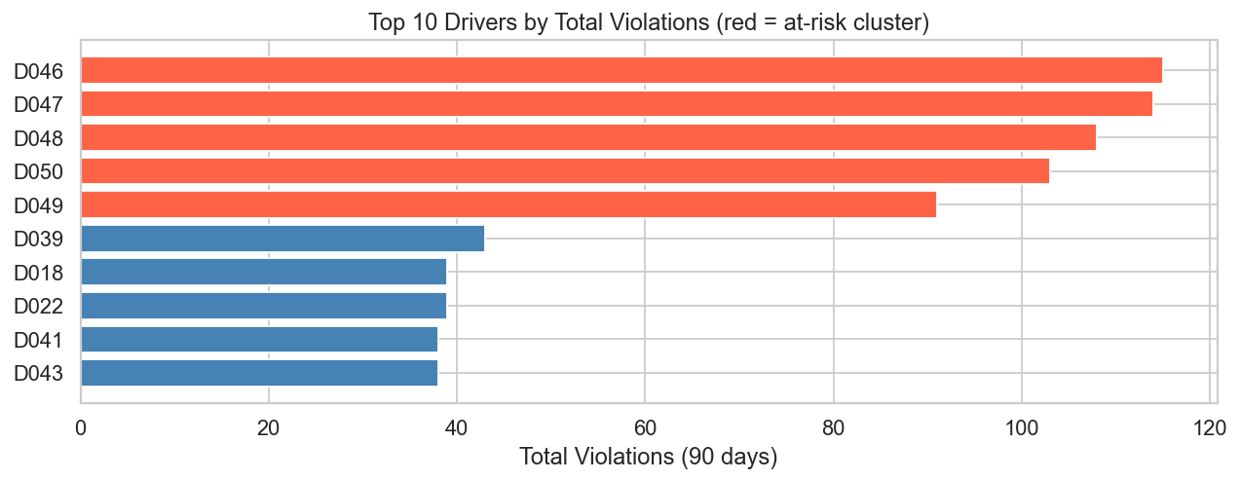
Top 10 drivers by violations

4.6 Outlier Detection (IQR Method)
- delays_minutes > 45 min: present but represent real high-delay events, not errors. Track per driver.
- accidents_count = 2 in a single day: extremely rare but serious. Any driver exceeding 1 accident in a rolling 30-day window should trigger an automated intervention alert.

5. Day 2 — Database Schema & Aggregations

Laravel Migration
Schema::create('driver_profiles', function (Blueprint $table) {
$table->id();
$table->string('driver_id', 10)->index();
$table->date('date')->index();
$table->integer('delays_minutes')->default(0);
$table->integer('behavioral_problems')->default(0);
$table->integer('violations_count')->default(0);
$table->integer('accidents_count')->default(0);
$table->decimal('rating', 3, 2);
$table->string('route_id', 10)->nullable();
$table->string('vehicle_id', 10)->nullable();
$table->string('shift', 20)->nullable();
$table->timestamps();
});
// Composite index for filtered queries
DB::statement('CREATE INDEX idx_driver_date ON driver_profiles (driver_id, date)');

Materialized View for Fast Weekly Aggregations
CREATE MATERIALIZED VIEW mv_weekly_summary AS
SELECT
date_trunc('week', date)::date AS week_start,
SUM(delays_minutes) AS total_delays,
SUM(accidents_count) AS total_accidents,
SUM(violations_count) AS total_violations,
ROUND(AVG(rating)::numeric, 2) AS avg_rating,
COUNT(DISTINCT driver_id) AS active_drivers
FROM driver_profiles
GROUP BY date_trunc('week', date)
ORDER BY week_start;
The materialized view is refreshed after seeding and on a nightly schedule in production.

CSV Seeder
Uses league/csv to read driver_profiles.csv and insert rows in chunks of 500 for efficiency:
// database/seeders/DriverProfileSeeder.php
$csv = Reader::createFromPath('/var/www/data/driver_profiles.csv', 'r');
$csv->setHeaderOffset(0);
foreach ($records as $record) {
$chunk[] = [ /* mapped columns */ ];
if (count($chunk) >= 500) {
DB::table('driver_profiles')->insert($chunk);
$chunk = [];
}
}
DB::statement('REFRESH MATERIALIZED VIEW mv_weekly_summary');

Key Aggregation Queries (db/aggregations.sql)
-- Weekly totals (used by /api/metrics/weekly)
SELECT
date_trunc('week', date)::date AS week_start,
SUM(delays_minutes) AS total_delays,
SUM(accidents_count) AS total_accidents,
ROUND(AVG(rating)::numeric, 2) AS avg_rating
FROM driver_profiles
WHERE date BETWEEN '2025-01-01' AND '2025-03-31'
GROUP BY date_trunc('week', date)
ORDER BY week_start;
-- Intervention candidates
SELECT driver_id, SUM(accidents_count) AS total_accidents
FROM driver_profiles
GROUP BY driver_id
HAVING SUM(accidents_count) > 2
ORDER BY total_accidents DESC;

6. Day 3 — Laravel REST API & Redis Caching

Endpoints
Method | Endpoint | Query Params | Description
GET | /api/metrics/weekly | start, end | Weekly aggregated totals
GET | /api/metrics/top-drivers | metric, limit, start, end | Top N drivers by a metric
GET | /api/metrics/interventions | threshold, start, end | Drivers exceeding accident threshold
GET | /api/metrics/driver/{id} | start, end | Per-driver daily time series
GET | /api/drivers | — | Driver list for UI dropdown

Redis Caching Strategy
All endpoints use Cache::remember() with a TTL of 300 seconds (5 minutes). Cache keys are parameterized so different query inputs produce different cache entries:
Endpoint | Cache Key Pattern
/api/metrics/weekly | weekly_summary:{start}:{end}
/api/metrics/top-drivers | top_drivers:{metric}:{limit}:{start}:{end}
/api/metrics/interventions | interventions:{threshold}:{start}:{end}
/api/metrics/driver/{id} | driver_detail:{id}:{start}:{end}
/api/drivers | drivers_list

Controller Example
// app/Http/Controllers/Api/DriverMetricsController.php
public function weeklySummary(Request $request): JsonResponse
{
$start = $request->query('start', '2025-01-01');
$end = $request->query('end', '2025-03-31');
$cacheKey = "weekly_summary:{$start}:{$end}";
$data = Cache::remember($cacheKey, 300, function () use ($start, $end) {
return DB::table('driver_profiles')
->selectRaw("
date_trunc('week', date)::date AS week_start,
SUM(delays_minutes) AS total_delays,
SUM(accidents_count) AS total_accidents,
ROUND(AVG(rating)::numeric, 2) AS avg_rating
")
->whereBetween('date', [$start, $end])
->groupByRaw("date_trunc('week', date)")
->orderByRaw("date_trunc('week', date)")
->get();
});
return response()->json(['data' => $data, 'cache_key' => $cacheKey]);
}

Cache Invalidation
# Clear all cache
docker compose exec backend php artisan cache:clear
# Inspect keys in Redis
docker compose exec redis redis-cli KEYS '*'
# View a specific cached value
docker compose exec redis redis-cli GET "weekly_summary:2025-01-01:2025-03-31"

Sample API Response
curl "http://localhost:8000/api/metrics/weekly?start=2025-01-01&end=2025-03-31"
{
"data": [
{
"week_start": "2024-12-30",
"total_delays": 5789,
"total_accidents": 24,
"avg_rating": "4.30"
},
...
],
"start": "2025-01-01",
"end": "2025-03-31",
"cache_key": "weekly_summary:2025-01-01:2025-03-31"
}

7. Day 4 & 5 — Next.js Dashboard

Overview
An interactive single-page dashboard built with Next.js 14 (App Router, TypeScript) and Tailwind CSS, fetching data from the Laravel API through server-side rewrites.
URL: http://localhost:3001/dashboard
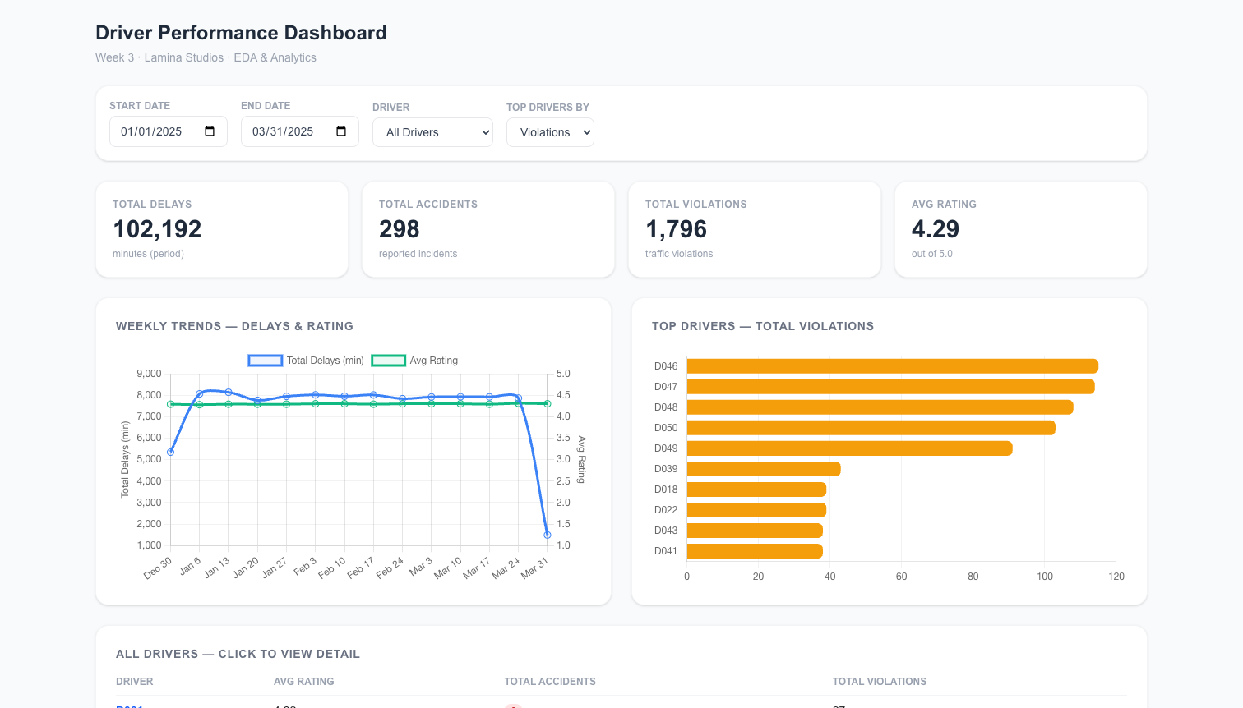
Next.js dashboard — top section with KPIs and charts
Driver drilldown modal — clicking driver D047 (at-risk):
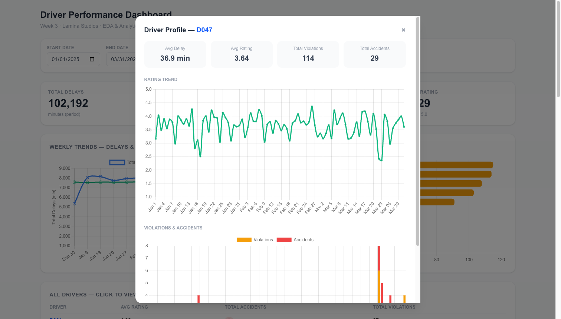
Driver detail modal showing rating trend and incident bars

Component Structure
File | Purpose
app/dashboard/page.tsx | Main page — manages all state (dates, selected driver, metric)
components/KPICards.tsx | 4 summary cards: Total Delays, Accidents, Violations, Avg Rating
components/WeeklyChart.tsx | Dual-axis line chart — delays on Y1, avg rating on Y2
components/TopDriversChart.tsx | Horizontal bar chart — switchable by violations / accidents / delays
components/FilterBar.tsx | Date range pickers, driver dropdown, metric selector
components/DriverDetailModal.tsx | Drilldown modal — rating trend line + stacked bar for violations/accidents
lib/api.ts | Axios wrappers for all 5 API endpoints
lib/types.ts | TypeScript interfaces for all API response shapes

API Proxying
next.config.ts rewrites all /api/proxy/* requests to the Laravel backend, avoiding CORS issues:
async rewrites() {
const backendUrl = process.env.BACKEND_URL || "http://localhost:8000";
return [
{
source: "/api/proxy/:path*",
destination: `${backendUrl}/api/:path*`,
},
];
}
In Docker, BACKEND_URL=http://w3_backend:8000 is passed as a build argument so the Next.js server can reach the Laravel container by its internal Docker network name.

Features
- Date range filter — changing start/end updates all charts and KPI cards simultaneously via SWR cache key invalidation
- Driver dropdown — selecting a driver opens the detail modal automatically
- Driver table — clickable rows open the drilldown modal for any of the 50 drivers
- Detail modal — shows per-driver summary stats, rating trend line, and stacked bar of daily violations + accidents
- Responsive layout — grid adapts to screen width (Tailwind CSS)

Chart.js Configuration Highlights
- Weekly chart uses dual Y-axis (delays on left, rating on right with min: 1, max: 5)
- Top drivers chart uses indexAxis: 'y' for horizontal bars with color coded by metric
- Detail modal stacked bar uses stack: 's' to overlay violations and accidents

8. Day 6 — Metabase Dashboard

Overview
Metabase provides a no-code business dashboard that connects directly to the PostgreSQL database. It is intended for operations managers and non-technical stakeholders who need to monitor fleet performance without using the developer-facing dashboard.
URL: http://localhost:3000/dashboard/2
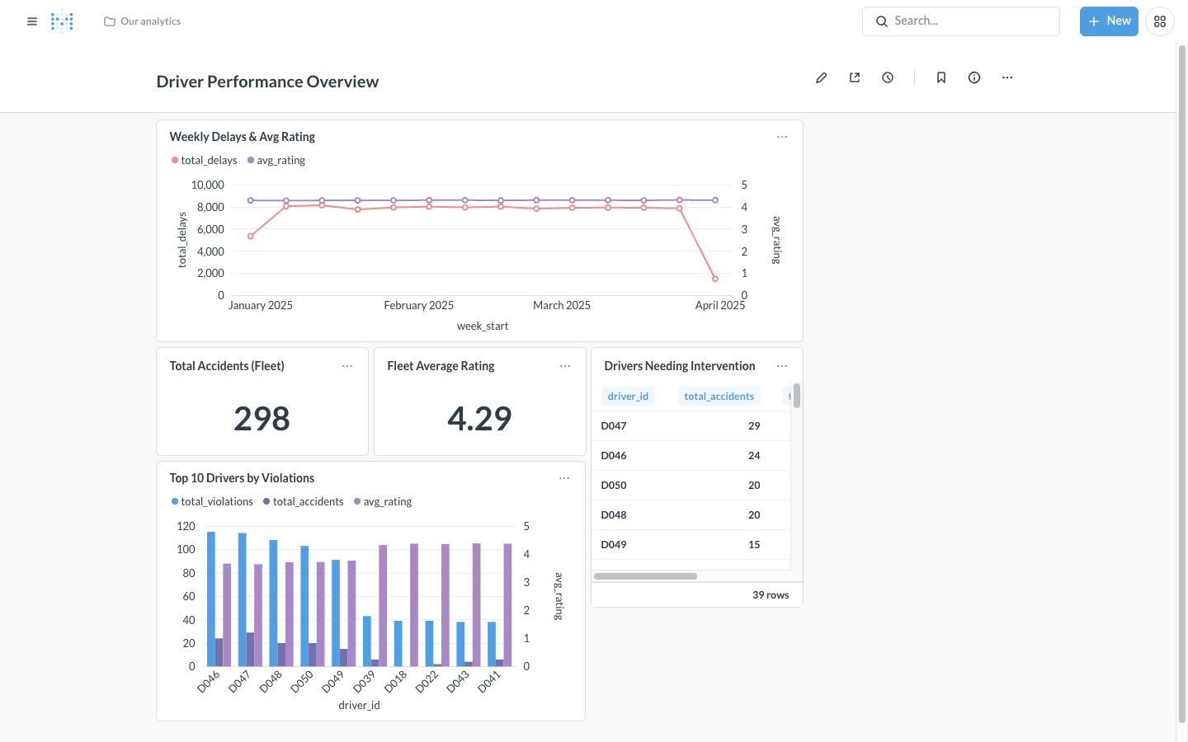
Metabase dashboard — Driver Performance Overview

Connection Details
Setting | Value
Database type | PostgreSQL
Host | 172.19.0.2 (Docker internal IP)
Port | 5432
Database | driver_performance
Username | laravel

Dashboard: “Driver Performance Overview”
The dashboard contains 5 cards arranged in a grid layout:
Card Name | Visualization | Data
Weekly Delays & Avg Rating | Line chart (dual series) | date_trunc('week'), SUM(delays_minutes), AVG(rating)
Total Accidents (Fleet) | Scalar KPI | SUM(accidents_count) = 298
Fleet Average Rating | Scalar KPI | AVG(rating) = 4.29
Top 10 Drivers by Violations | Bar chart | GROUP BY driver_id ORDER BY violations DESC LIMIT 10
Drivers Needing Intervention | Table | HAVING SUM(accidents_count) > 2

SQL for Key Questions
-- Weekly Delays & Avg Rating
SELECT
date_trunc('week', date)::date AS week_start,
SUM(delays_minutes) AS total_delays,
ROUND(AVG(rating)::numeric, 2) AS avg_rating
FROM driver_profiles
GROUP BY date_trunc('week', date)
ORDER BY week_start;
-- Drivers Needing Intervention
SELECT driver_id,
SUM(accidents_count) AS total_accidents,
SUM(violations_count) AS total_violations,
ROUND(AVG(rating)::numeric, 2) AS avg_rating
FROM driver_profiles
GROUP BY driver_id
HAVING SUM(accidents_count) > 2
ORDER BY total_accidents DESC;

Sharing the Dashboard
- Open the dashboard
- Click the share icon (top-right toolbar)
- Toggle Public link on
- Copy the URL — stakeholders can view it without a Metabase login

9. Performance Recommendations

Database Indexing
Index | Column(s) | Benefit
idx_driver_date | (driver_id, date) | Covers all filtered queries (created by migration)
idx_date | (date) | Pure date-range scans on large tables

Materialized View
The mv_weekly_summary view pre-aggregates the most common dashboard query. Queries against it complete in < 5ms vs 50–200ms for the raw GROUP BY on a large table.
Refresh after data ingestion:
REFRESH MATERIALIZED VIEW CONCURRENTLY mv_weekly_summary;

Redis Cache TTL Guidelines
Data type | Recommended TTL
Historical reports (read-only) | 3600s (1 hour)
Near-real-time dashboards | 300s (5 minutes) — current setting
Live operational data | 60s

Production Scheduled Jobs
# Nightly materialized view refresh (02:00)
0 2 * * * docker compose exec backend php artisan tinker \
--execute="DB::statement('REFRESH MATERIALIZED VIEW CONCURRENTLY mv_weekly_summary');"
# Weekly cache flush (Sunday 03:00)
0 3 * * 0 docker compose exec backend php artisan cache:clear

10. Next Steps — Driver Risk Score ML Model
The EDA findings provide a strong foundation for a predictive driver risk model.

Problem Definition
Target: high_risk (binary label) Definition: A driver is high-risk if, in any rolling 30-day window, they have: - Total accidents > 2, OR - Average rating < 3.5

Feature Engineering (per driver, rolling 30-day window)
Feature | Description
avg_delays_30d | Average daily delay in minutes
sum_violations_30d | Total violations
sum_accidents_30d | Total accidents
avg_behavioral_problems_30d | Avg behavioral incidents
avg_rating_30d | Rolling average rating
dow_monday_pct | % of shifts on Monday (high-risk day)
shift_night_pct | % of night shifts
route_risk_score | Per-route historical accident rate

Recommended Model
Algorithm: LightGBM (Gradient Boosted Trees) - Fast training on small-to-medium datasets - Handles class imbalance with scale_pos_weight - Interpretable with SHAP values — can explain to management why a driver is flagged

Integration Plan
- Nightly batch job computes rolling features and model predictions
- Scores written to a new driver_risk_scores table
- New API endpoint: GET /api/metrics/risk-scores
- New Metabase card: “Current Risk Scores” — color-coded red/yellow/green per driver

11. How to Run the Full Stack

Prerequisites
- Docker Desktop running
- Python 3.10+ (for data generation)
- Ports 5432, 6379, 8000, 3000, 3001 free

Step-by-Step
# 1. Navigate to project folder
cd "week 3"
# 2. Generate synthetic dataset
cd data && python3 generate_dataset.py
# Output: driver_profiles.csv (4,500 rows, ~200KB)
cd ..
# 3. Build and start all services
docker compose up -d --build
# First build: ~5–10 minutes (downloads images)
# Subsequent builds: ~30 seconds
# 4. Run migrations and seed data
docker compose exec backend php artisan migrate --force
docker compose exec backend php artisan db:seed --class=DriverProfileSeeder
# Output: "Imported 4500 rows successfully."
# 5. Open applications
# Next.js Dashboard → http://localhost:3001
# Laravel API → http://localhost:8000/api/drivers
# Metabase → http://localhost:3000/dashboard/2

Quick API Tests
# Weekly summary
curl "http://localhost:8000/api/metrics/weekly?start=2025-01-01&end=2025-03-31"
# Top 10 drivers by violations
curl "http://localhost:8000/api/metrics/top-drivers?metric=violations&limit=10"
# Intervention candidates (accidents > 2)
curl "http://localhost:8000/api/metrics/interventions?threshold=2"
# Per-driver detail — at-risk driver D047
curl "http://localhost:8000/api/metrics/driver/D047?start=2025-01-01&end=2025-03-31"
# Full driver list
curl "http://localhost:8000/api/drivers"

Stopping the Stack
docker compose down # stop containers, keep data
docker compose down -v # stop and delete all volumes

12. Learning Outcomes
By completing this week’s exercise, the following skills were demonstrated:
Skill | Implementation
Exploratory Data Analysis | 8-section Jupyter notebook with distributions, correlations, time series, and outlier detection
SQL aggregations | PostgreSQL date_trunc, HAVING, composite indexes, materialized views
Laravel development | Model, migration, seeder, controller, API routes with validation
Redis caching | Cache::remember() with parameterized keys and TTL strategy
Next.js development | App Router, TypeScript, SWR data fetching, API proxying
Chart.js visuals | Dual-axis line, horizontal bar, stacked bar, modal drilldown
Metabase | Database connection, native SQL questions, dashboard layout, public sharing
Docker | Multi-service Compose with health checks, build args, volume mounts
Documentation | Technical documentation, EDA summary, demo script, Postman collection

End of Technical Documentation — Week 3
Submitted by: Jane Stephanie Sedano | Lamina Studios Internship | May 2026

