

**Yocto & BeagleBone Black**

**A Mini Getting Started Guide**

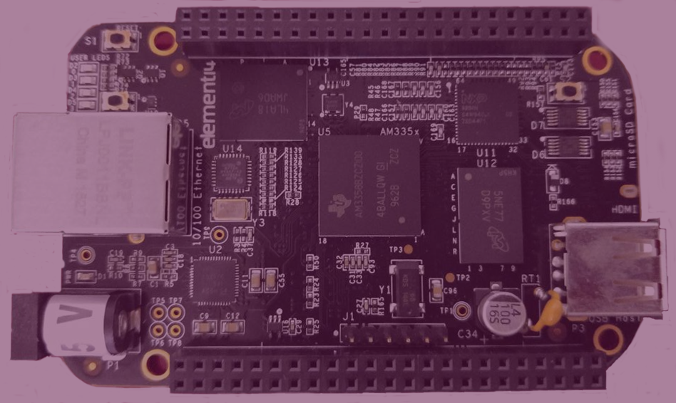



**Before You Begin**

**Beaglebone Black Meets Yocto:**

Beaglebone Black

The Beaglebone Black is a low cost, community supported computing model for developers and hobbyists. This features a AM335x 1GHz ARM[®](https://www.ti.com/product/am3358) Cortex-A8 processor,512MB DDR3 RAM, 4GB 8-bit eMMC on-board flash storage, 3D graphics accelerator, NEON floating-point accelerator and 2x PRU 32-bit microcontrollers. This also uses USB, Ethernet, HDMI and 2x 46 pin headers. The Beaglebone Black is compatible with Debian, Android, Ubuntu, Cloud 9 and much more. For more information, please visit: <http://beagleboard.org/black>.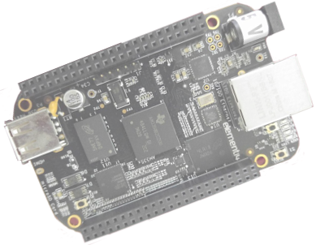

What is the Yocto Project™?

Yocto is an open source project that enables users to create custom GNU Linux® systems on embedded. This project began in 2010 as a collaboration of hardware vendors. The development environment includes debuggers, Application Toolkit Generator and emulation environments. The core system recipies are available from the OpenEmbedded project. The Yocto kernel and build profiles have been community test and include architectures for:

ARM PPC

MIPS x86

x86-64 An Eclipse plugin is also available.

Covered in this Document

Setting up the Workstation

Building Images

Partition and Copy Image to SD Card

Boot from SD Card

**What You'll Need**

Beaglebone Black

Ubuntu 14.04

microSD card and adapter

Beyond that you may need a microHDMI to HDMI cable

Mini USB Cable

The Beaglebone board can be powered and controlled over USB, and uses at least one mini USB connector.

A computer with an available SD card slot and an available USB slot.

**Setting Up the Workstation**

**Ubuntu**

You will need at least 50 Gb of free disk space that is running Ubuntu 14.04 or greater

**Build Host**

BUILD HOST is based on the OpenEmbedded Project. This project uses bitbake to construct images.

Reference Build Host POKY = Bitbake + OpenEmbedded

The OpenEmbedded build system is able to run on Ubuntu that has the following versions for Git, tar, and Python.

**Dependencies – OpenEmbedded**

Git 1.7.8 or greater

tar 1.24 or greater

Python 2.7.3 or greater excluding Python 3.x, which is not supported.

**Dependencies - Build Host Packages¶**

These packages installed on the build host using an **Ubuntu System**

|  |  |
| --- | --- |
| bc | libsdl1.2-dev |
| build-essential | pkg-config |
| chrpath | socat |
| diffstat | subversion |
| gawk | texi2html |
| git | texinfo |
| libncurses5-dev | u-boot-tools |

$ sudo apt-get install bc build-essential chrpath diffstat gawk git libncurses5-dev pkg-config socat subversion texi2html texinfo u-boot-tools

**Repositories**

**YOCTO RELEASE**

Clone the Yocto Project repository poky jethro. Below is an example from an Ubuntu build host that clones the poky repository and then checks out the latest Yocto Project Release:

$ git clone -b jethro git://git.yoctoproject.org/poky.git poky-jethro

**META-OPENEMBEDDED**

Clone the OpenEmbedded repo.

$ git clone -b jethro git://git.openembedded.org/meta-openembedded

**META-BEAGLEBOARD repository**

Clone the official Beagleboard repo. Before cloning, create a sub directory and change to that directory.

mkdir bbb

cd bbb

$ git clone git://github.com/beagleboard/meta-beagleboard

**Building Images¶**

Now that you have your system requirements in order, you can give the Yocto Project a try. This section presents steps that let you do the following:

**Initialize the Build Directory**

The build directory can be either manually created or created using the oe-init-build-env script.

1. Manually - Configure these paths to the meta layers per your standards.

2. With the script oe-init-build-env

**Customize the config files**

When using oe-init-build-env to create the build directory, some configuration files are generated in the build/conf directory.

Editing bblayers.conf

The directory structure in bblayers.conf should look like this

~/poky-jethro/

meta-openembedded

~/bbb/

meta-beagleboard

build/

conf/

Editing local.conf

There are 3 variables to edit in local.conf

Editing these are not necessary but optional.

DL_DIR – Where downloaded sources are stored

SSTATE_DIR – This is usually 5gb and can be moved from home

TMP_DIR – Where the temporary build and final binaries are found

**Initialize the Build Environment:**

Run the oe-init-build-env environment setup script to use bitbake. This defines the OpenEmbedded build environment for the build host and will not overwrite the customized conf files.

$ source oe-init-build-env

**Note:** Use bitbake in the build directory.

**Run the Build**

**core-image-sato**

Change directory to the build directory to use bitbake.

To build the core-image, run the command:

$bitbake core-image-sato

Note: Depending on your workstation specifications and internet connect, this could take awhile.

**Build Errors**

If you have build errors due to package download failure, clean the failed package and rerun the build.

$bitbake -c cleanstate.file

$bitbake file

Resume the full or long build

$bitbake core-image-sato

The cleansstate command works for image recipes also.

**Copy to the SD card**

The core or long build can take some time, depending on your internet speed and hardware. There is a difference when copying a long build or a minimal build to the SD card, as well.

Partition the SD card

Partition the SD card with at least 2 partitions using gparted, fdisk, or another tool.

$ sudo apt-get install gparted

Insert the SD card into the workstation.

$ sudo gparted

Use lsblk or df -h to find the microSD card.

**Warning:** This will format any disk on your workstation. Select the specified SD card listed when using lsblk or df -h. In some cases, the SD card may be mmcblk0 or sdb. Double check to make sure the correct device is being formatted.

**Partition 1:**

Set the “boot” flag for the first partition.

type: FAT32

size: around 30MB

label: BOOT

flags: boot and lba

**Partition2:**

type: ext4

size: around 200MB, or remaining SD-card space

label: ROOT

After partitioning is completed, we are ready to copy the files to the SD-card.

Long Build

After completing the build, the following images are the most important found in the <TMPDIR>/deploy/images/beaglebone:

bootloader kernel rootfs

* **MLO-beaglebone**  
  The second stage bootloader (the first stage bootloader is implemented in ROM code on the AM335x chip and can not be altered in software)
* **u-boot-beaglebone.img**  
  The third stage u-boot bootloader (the “main” bootloader)

Copy the boot loaders. The media or SD may be something like /media/bbb/BOOT/MLO. Check your system for the location to copy to the SD.

$ sudo cp -v MLO-beaglebone /media/bbb/BOOT/MLO

$ sudo cp -v u-boot-beaglebone.img /media/bbb/BOOT/u-boot.img

* **zImage**

The Linux kernel image (zImage is a special format used with u-boot bootloader) zImage is found in root/boot/

* **core-image-base-begalebone.tar.bz2 or something similar**  
  This archive contains the root file system.

$ sudo tar x -C /media/root -f core-image-sato-beaglebone.tar.bz2 /media/bbb/root

After completing the copying process, unmount the SD partitions. Then, insert the micro SD card into the Beaglebone. and continue to the section below on how to boot the Beaglebone.

*Minimal RootFS Instructions

If you build a minimal rootfs:

* Install modules-beaglebone.tgz.

$ sudo tar x -C /media/root -f modules-beaglebone.tgz /media/bbb/root

* If you used core-image-base, rootfs already includes the kernel, modules and Device tree files needed to work with the u-boot default configuration
* Install the kernel uImage to /boot in rootfs and install the device tree files into rootfs /boot. Include zImage-4.4-r4am335x-boneblack-xxx.dtb

$ sudo cp uImage-beaglebone.bin /media/root/boot/uImage

$ sudo cp uImage-am335x-bone.dtb /media/root/boot/am335x-bone.dtb

$ sudo cp uImage-am335x-boneblack.dtb /media/root/boot/am335x-boneblack.dtb

After completing the copying process, unmount the SD partitions. Then, insert the micro SD card into the Beaglebone. and continue to the section below on how to boot the Beaglebone.

Reference: <https://www.yoctoproject.org/downloads/bsps/daisy16/beaglebone>

**Boot from the SD card**

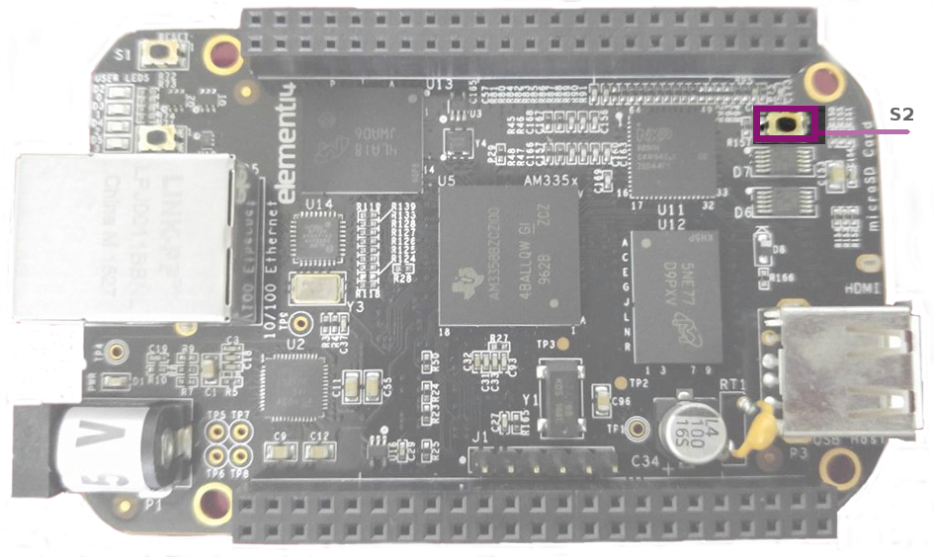

The Beaglebone Black has Debian preloaded. You can flash the image to the onboard eMMC so the SD will boot or boot holding down the S2 switch. There are 4 different ways of booting up: eMMC boot, SD boot, Serial boot, and USB boot.

For SD boot, hold the **S2** switch on the Beaglebone Black for at least 5 seconds. The lights on the Beagleboard will indicate the BBB is booting.

Login

To login, use the keypad and type the username at the prompt.

**Username**: root

**Password**:

The Yocto default username is root. By default, there is no password. After entering root as the username, select the enter key to login.

**Conclusion**By using Yocto, you can create customized images using recipes. Once your customization is complete, your images can be used across multiple platforms using Yocto.

Linux® is a registered trademark of Linus Torvalds.

Yocto Project™ is a registered trademark of the Linux Foundation.