|  |  |
| --- | --- |
| Team Number : | apmcm24207428 |
| Problem Chosen : | A |

2024 APMCM summary sheet

**Underwater Image Enhancement Model Based on Image Processing and Generative Adversarial Networks**

With the development of technology, human exploration of the ocean has become increasingly frequent. Underwater imaging, as an important method of marine scientific research, plays an indispensable role in ocean research. However, due to various factors, underwater images are prone to color cast, low light, and blur. Therefore, an underwater image enhancement model becomes particularly important. This article proposes an underwater image enhancement model based on image processing and adversarial training, aimed at optimizing underwater images.

For Question 1, this article extracts image features by calculating the HSV color space features, Lab color space features, and Laplacian transform of grayscale images, which are then used to classify graphics. Finally, the image features were successfully extracted and the provided image data was classified according to color cast, low light, and blur.

For Question 2, this article develops specific models for three areas: shallow water, deep water, and turbid water. This article is based on Jaffe McGlamery's underwater imaging model[1], which divides the underwater images captured by the camera into two parts to represent, the direct transmission component and the background scattering component. Then, by analyzing the reasons for the degradation of underwater images captured from different scenes, the model is optimized in a targeted manner. Finally, analyze the similarities and differences among these degradation models.

For Question 3, this article proposes underwater image enhancement methods for color cast, low light, and blur. For images with color cast, this article uses white balance adjustment to make the image more uniform and natural. For low light images, this article converts the image from RGB color space to HSV color space and enhances the low light effect of the image through Gamma correction. For blurry images, this article uses USM sharpening technology to address the issue of image blurring. Finally, this article calculated the peak signal-to-noise ratio (PSNR), underwater image color quality assessment (UCIQE), and underwater image quality measurement index (UIQM) to comprehensively evaluate the processing results of the images, and obtained good processing results.

For Question 4, this article adopts an encoder decoder structure similar to U-Net and a GAN architecture for adversarial training, successfully applying machine learning and deep learning to the field of underwater image processing, making the underwater image enhancement model more robust and adaptable, and can effectively complete underwater image enhancement tasks. From PSNR, UCIQE, UIQM and other evaluation indicators, it can be seen that.

For Question 5, this article compares the general underwater image enhancement model with the specialized scene underwater enhancement model, analyzes their respective advantages and disadvantages in detail, and proposes feasible suggestions for underwater image enhancement models in practical applications based on the advantages and disadvantages of the models.

**Key words:** Underwater image processing, USM sharpening, U-net architecture, GAN adversarial training architecture

**Contents**

1 Introduction 1

1.1 Question Background 1

1.2 Question Restatement 1

2 Problem Analysis 2

2.1 For Question 1 2

2.2 For Question 2 4

2.3 For Question 3 5

2.3.1 Underwater image enhancement method 6

2.3.2 Calculate evaluation indicators 7

2.4 For Question 4 7

2.5 For Question 5 8

3 Model Hypothesis 9

4 Problem Analysis 9

4.1 For Question 1 9

4.1.1 Criteria for determining color deviation 9

4.1.2 Judgment criteria for low light 10

4.1.3 Fuzzy judgment criteria 10

4.2 For Question 2 10

4.2.1 Basic Image Degradation Model 10

4.2.2 Model optimization in different scenarios 11

4.2.3 Differences and Similarities between Models 13

4.3 For Question 3 13

4.3.1 Enhancement methods for color cast 13

4.3.2 Enhancement methods for low light 14

4.3.3 Enhancement methods for fuzziness 14

4.3.4 Calculation of evaluation indicators 15

4.4 For Question 4 15

4.4.1 Generator 15

4.4.2 Discriminator 16

4.5 For Question 5 16

5 Problem Analysis 17

5.1 Dataset 17

5.2 Result verification 17

6 Evaluation Of The Model 20

6.1 Meri 20

6.2 Shortcoming 20

7 Reference 20

**1 Introduction**

**1.1 Question Background**

With the development of science and technology, human exploration has turned to the ocean. Driven by curiosity about the unknown and the search for resources, the demand for human exploration of the ocean has become increasingly urgent. From scientific research to economic development, from national strategic resource security to the expansion of human civilization, the path of ocean exploration is full of infinite possibilities. For ocean exploration, clear and high-quality underwater images are crucial for deep-sea terrain measurement and undersea resource investigation. However, in the complex underwater environment, the image quality deteriorates due to the absorption and scattering of light in water, resulting in blurriness, low contrast, and color distortion. These situations are called underwater image degradation, which seriously affects visual recognition and analysis.

Therefore, properly handling the problem of underwater image degradation would be of great help to ocean exploration tasks, and customized underwater scene enhancement algorithms tailored for complex scenarios are very important for subsequent tasks in underwater vision.

**1.2 Question Restatement**

Question 1：Please use image statistical analysis techniques similar to those mentioned in the above text to perform multi-angle analysis on the underwater image provided in Attachment 1. Classify the image provided in Attachment 1 into three categories: color cast, low light, and blur, and fill in the filenames in the three positions in the "Answer.xls" attachment. Also, explain the reasons for such classification.

Question 2：Based on the types of degradation proposed in Question 1, using the underwater imaging model provided in the problem, construct an underwater scene image degradation model with the images attached. Analyze the degradation reasons of underwater images captured from different scenes (including but not limited to color cast, low light, etc.). Analyze the similarities or differences of these degradation models (for example, categorize from perspectives such as color, lighting, clarity, etc.).

Question 3：Based on the underwater scene image degradation model established in Question 2, propose an underwater image enhancement method tailored for a single scene (such as color cast, blur, low light), and validate the proposed enhancement method using the image data provided in the attachment. Include the enhanced results of the test images from Attachment 2 and their corresponding evaluation metrics in the paper, calculate and present the PSNR, UCIQE, UIQM, and other evaluation metrics for the output images, and fill them in the table Attachment 1 results provided in "Answer.xls".

Question 4：The modeling adaptability of existing underwater image enhancement models varies across different scenarios. Please, in conjunction with the above question and the images provided in the attachment, propose an underwater image enhancement model tailored for complex scenarios. This model should be capable of enhancing underwater image degradation issues across a variety of complex scenes. Include the enhanced results of the test images from attachment 2 and their corresponding evaluation metrics in the paper for display, calculate and output the PSNR, UCIQE, UIQM, and other evaluation metrics of the output image, and fill them in the table Attachment 2 results provided in "Answer.xls".

Question 5: Compare various enhancement techniques for specific scenarios with a single enhancement technique for complex scenarios, and propose feasibility suggestions for underwater visual enhancement in practical applications.

**2 Problem Analysis**

**2.1 For Question 1**

According to the instructions, you need to analyze the underwater images provided in Attachment 1 from multiple angles and classify them into three categories: tinted, low-light, and blurred. You should then record the information in the specified file and explain the reasons for the classification.

To achieve this goal, image analysis techniques will be used. First, image files from a specified folder are read and pre-processed to make them easier to process. Then, underwater image features are extracted. Image feature extraction is mainly based on visual features of the image. Specifically, image features are extracted by calculating the HSV color space features, Lab color space features, and Laplacian transform of the grayscale image, which are used to classify the image.

Regarding color cast analysis, this paper uses the processing method of HSV color space, where the standard deviation and saturation of the color channels in the image are calculated to determine whether the picture is color cast. Therefore, the RGB color space needs to be converted to the HSV color space, and the desired hue and saturation need to be extracted. The calculation of saturation is as follows:

From this, it can be seen that the lower the minimum value in RGB values, the higher the saturation. Or, in other words, the greater the difference between the maximum and minimum values in RGB, the higher the saturation. The calculation of color tone is relatively complex, and the specific formula is as follows:

The color tone formula may seem complex, but the truth is actually very simple. Just divide the 360 degree angle into three parts, with RGB each occupying one-third of the area. The maximum value in RGB is located in the corresponding region; In this region, the larger of the two remaining values in RGB tends to lean towards that side. From this, we can calculate the color tone and then determine whether the image is biased.

Regarding the analysis of low light, this article uses LAB color space to extract brightness information from images for judgment. In the Lab color space, there are three dimensions that form three mutually perpendicular axes. They are the L axis representing brightness from top to bottom, the A axis representing red and green from left to right, and the B axis representing yellow and blue from inside to outside. To express it in formula is:

According to the formula, the smaller the L value, the lower the brightness of the image, so it can be determined whether the image is low light.

Regarding the analysis of blurring, this article first processes the image into a grayscale image for easier analysis. Afterwards, the Laplacian operator is used to sharpen the image and determine whether it is blurry. This article uses a common Laplacian filter for calculation, which can be expressed as:

When applying Laplace filters, this article uses convolution operations to process images, which can be represented as:

Then, we calculate the variance of the Laplace transform , When the variance is below the threshold, it can be determined whether the image is blurry, which can be expressed as:

Finally, based on the analysis of image features above, the images are classified into three categories: color cast, low light, and blur. And save the results to the 'answer. xls' file.

**2.2 For Question 2**

According to the requirements of the question, it is necessary to construct an underwater imaging model for the degradation types proposed in question 1 to process the provided underwater images. And it is necessary to analyze the reasons for the degradation of underwater images in different scenarios. Meanwhile, it is also necessary to analyze the similarities and differences among these degradation models.

To understand the reasons for underwater image degradation, we need to start with the imaging principle of the camera. Generally speaking, camera imaging is the process of transforming a three-dimensional scene into a two-dimensional plane, using optical lenses and photosensitive elements to map light into a planar photosensitive material and convert it into a digital signal. This process is a linear model, which can be represented by a pinhole imaging model, as shown in Figure 1.

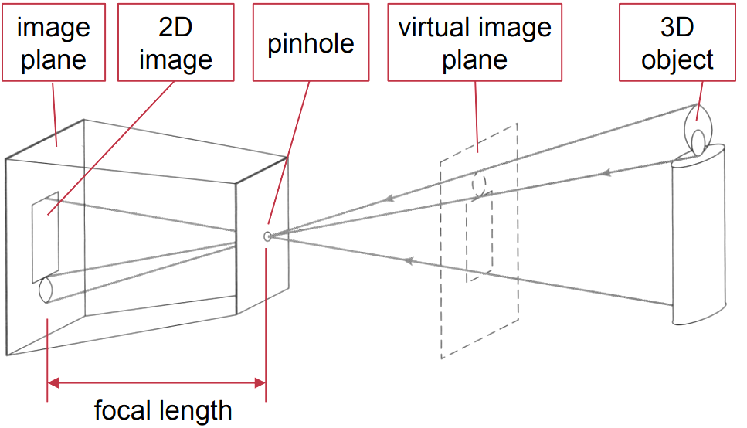

Figure 1. Camera imaging principle

When imaging underwater, the distance between the object and the camera is usually closer, so the influence of forward scattering components can be ignored. The basic model of underwater imaging can be represented by the following formula:

Where represents the original image, represents a clear image, represents direct transmission of components, represents the backscatter component, B represents the underwater ambient light, represents the light transmittance of the scene. As shown in Figure 2 specifically。

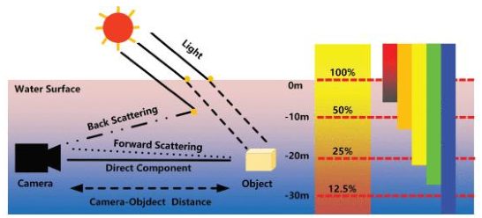

Figure 2. Imaging principle of underwater camera

Afterwards, we will create specific models for the shallow water area, deep water area, and turbid water area. In shallow water areas, the color of underwater images is well preserved, the scattering effect is small, and the clarity is high. Therefore, it is necessary to make certain modifications to the basic model, such as reducing scattering coefficients and minimizing backscattering. In deep water areas, underwater images will show obvious blue-green tones, which is due to the severe attenuation of red light by deep seawater and its strong scattering effect. Therefore, it is necessary to enhance the scattering effect when processing images. In the turbid water area, underwater images may exhibit severe blurring, low contrast, and strong scattering effects. Therefore, it is necessary to enhance the scattering attenuation of the image and add additional blurring effects.

Finally, the model is used to complete the processing of all images.

**2.3 For Question 3**

According to the requirements of the question, it is necessary to construct a targeted underwater image enhancement model based on the degradation model proposed in question 2, taking into account the issues of color cast, low light, and blur generated by the images, to process the provided underwater images. Finally, the enhancement results of the test images and their corresponding evaluation metrics are evaluated. The PSNR, UCIQE, UIQM, and other evaluation metrics of the output images are calculated and presented, and filled in the "Answer. xls" field.

**2.3.1 Underwater image enhancement method**

At the beginning, this article applies the classification results of problem one to initially classify the images, in order to apply specific algorithms to the images later. Then, the underwater image enhancement model established in this article is used to process the images accordingly.

Enhancement methods for color cast. Firstly, we adjust the white balance of the image by calculating the average brightness value of each channel (red, green, blue) in the image. Then, we calculate the maximum and minimum differences between the average brightness values of each color channel, as well as the ratio of these differences to the maximum brightness value. The intensity of white balance was adjusted based on the degree of color deviation. If the color deviation is large, the white balance intensity will decrease to avoid excessive color adjustment. Finally, based on the adjusted white balance intensity, each color channel is weighted and adjusted. The brightness value of each color channel will be adjusted based on the ratio of its average brightness value to the overall average brightness value. After completing these tasks, the image can be made more uniform and natural.

Enhancement methods for low light. Firstly, the code converts the image from RGB color space to HSV color space and extracts the brightness channel (i.e. V channel). Then, the code adjusted the Gamma correction parameters based on the brightness information. If the image is very dark, the parameters for gamma correction will decrease; If the image is very bright, the parameters for gamma correction will increase. Next, use Gamma correction technique to correct the image. Gamma correction is a commonly used image enhancement method that enhances the contrast of an image by adjusting its brightness value. Finally, apply the corrected image to the original image to enhance the low light effect of the image.

Regarding fuzzy enhancement methods. This article uses the technique of USM sharpening to address the issue of image blurring. Firstly, the degree of blur of the image is calculated using the Laplacian operator, and then the sharpening parameters are adjusted based on the degree of blur. If the image is very blurry, the sharpening parameter will increase; If the image is very clear, the sharpening parameter will be reduced. Next, use USM sharpening technique to sharpen the image. USM sharpening is a commonly used image sharpening method that highlights the edges and details of an image by overlaying a blurred version of the image onto the original image and then subtracting the blurred version. Finally, the code applies the sharpened image to the original image to enhance its clarity. In this way, the edges and details of the image can be made clearer.

**2.3.2 Calculate evaluation indicators**

According to the requirements of the title, this article calculates the evaluation indicators of image quality by calculating PSNR (peak signal-to-noise ratio), UCIQE (color quality index), and UIQM (visual quality index).

Calculate PSNR. This article calculates the mean square error (MSE) between the original image and the enhanced image, and then calculates the PSNR based on the MSE. PSNR is a commonly used image quality assessment metric that reflects the clarity and degree of detail preservation of an image. The higher the calculated value, the better the image quality.

Calculate UCIQE. This article converts images from the RGB color space to the LAB color space, and then extracts the luminance channel (L channel) and chrominance channel (A and B channels). Next, the mean, standard deviation, and maximum values of the chromaticity channel, as well as the maximum and minimum values of the luminance channel, were calculated. Finally, UCIQE was calculated based on these values. UCIQE is a commonly used image quality assessment metric that reflects the color quality and contrast of an image. The higher the calculated value, the better the image quality.

Calculate UIQM. This article converts images from the RGB color space to the HSV color space, and then extracts the chromaticity channel (S channel) and brightness channel (V channel). Next, calculate the mean of the chromaticity channel, the variance of the Laplacian operator, and the standard deviation. Finally, UIQM was calculated based on these values. UIQM is a commonly used image quality assessment metric that reflects the visual quality of an image. The higher the calculated value, the better the image quality.

These indicators complement each other and together provide a comprehensive assessment of underwater image quality.

**2.4 For Question 4**

This article proposes an underwater image enhancement model tailored for different complex scenes. To achieve this goal, this article incorporates machine learning and deep learning frameworks on the basis of existing physical models, in order to improve the robustness and adaptability of the models.

Firstly, the model utilizes an encoder decoder structure similar to U-Net, which is a symmetric network structure as shown in Figure 3. Blue or white boxes represent feature maps; The blue arrow represents 3x3 convolution, used for feature extraction; Gray arrows indicate skip connections, used for feature fusion; The red arrow represents pooling, which is used to reduce dimensionality; The green arrow represents upsampling, which is used to recover dimensions; The blue arrow represents 1x1 convolution, used to output the result.

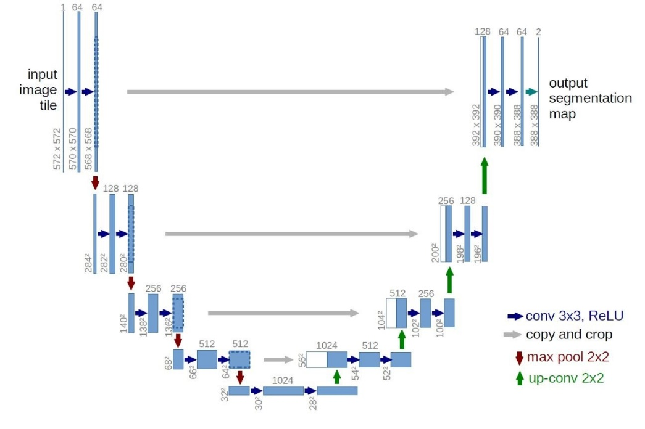

Figure 3. Detailed Explanation of U-Net Structure

On the basis of using an encoder decoder structure similar to U-Net, the model adopts GAN architecture for adversarial training, as shown in Figure 4. Compared to traditional methods, GAN architecture can generate high-quality new data and handle complex data distributions. In feature learning, GAN can automatically extract features and learn more representative features. GAN is suitable for various tasks and fields, and has strong flexibility. Therefore, this article chooses GAN architecture instead of traditional methods to complete the work.

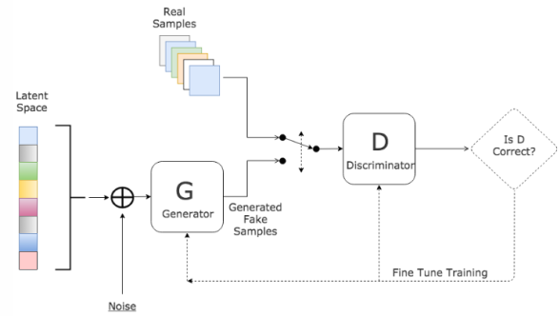

Figure 4. Detailed Explanation of GAN Structure

The reason for choosing the combination of U-Net and GAN is that this architecture is particularly suitable for image enhancement tasks. This model can preserve the detailed information of the original image, learn complex image transformations, improve generation quality through adversarial training, and ensure that the basic content remains unchanged for pixel level loss.

**2.5 For Question 5**

According to the requirements of the title, this article first compares underwater image enhancement techniques for specific scenes with single enhancement techniques for complex scenes, and analyzes their respective advantages and disadvantages. Underwater image enhancement technology for specific scenarios has the characteristics of high accuracy and efficiency, but it has poor universality, high development costs, and strong dependence on data. The single enhancement technique for complex scenes has the advantages of strong generalization ability and high model reusability, but it has low processing accuracy and consumes large computational resources. Based on these advantages and disadvantages, this article proposes feasible suggestions for underwater visual enhancement in practical applications.

**3 Model Hypothesis**

1. Assuming that the underwater image provided in attachment only shows color cast, low light, and blur.

**4 Problem Analysis**

**4.1 For Question 1**

According to the requirements of the title, this article needs to classify the underwater images provided in Attachment 1, mainly into three parts: color cast, low light, and blur. To achieve this goal, this article first performs feature extraction operations on underwater images. Image feature extraction is mainly based on the visual features of images. Specifically, image features are extracted by calculating the HSV color space features, Lab color space features, and Laplacian transform of grayscale images, which are then used to classify graphics.

**4.1.1 Criteria for determining color deviation**

This article uses the HSV color space to extract image information for judgment. The HSV color space is a way of decomposing colors into hue, saturation, and brightness. By calculating the standard deviation of the color tone in the image, it is possible to determine whether the image has color cast. To ensure accurate judgment, this article further uses saturation to determine. Saturation represents the purity of a color, which is the proportion of grayscale components in the color. By calculating the average saturation value in the image, t is also possible to determine whether the image has color cast. If and are greater than their respective thresholds, the image is considered to be color cast. The color cast judgment function is:

**4.1.2 Judgment criteria for low light**

This article uses LAB color space to extract image information for judgment. LAB color space is a way of decomposing colors into brightness, red, green, and blue (a and b). Brightness represents the degree of brightness of a color, and by calculating the average brightness of the image , it can be determined whether the image is low light. If  is less than the set threshold, the image is considered low light. The judgment function for low light is:

**4.1.3 Fuzzy judgment criteria**

For the convenience of image processing, this article first processes the image into a grayscale image. Then, this article uses the Laplacian operator as an edge detector to sharpen the grayscale image. The Laplacian operator is a second-order derivative filter used to detect image edges, which can highlight edges and details in the image. By calculating the variance of the Laplacian transform of the grayscale image it is possible to determine whether the image is blurry. When the variance is less than the set threshold, the image is considered blurry. The judgment function for blur is:

**4.2 For Question 2**

According to the requirements of the title, this article proposes an underwater image degradation model aimed at simulating the degradation process of underwater images in order to better analyze the degradation effect. Then, this article analyzes the problems of color cast, low light, and blur in underwater images from three scenarios: shallow water, deep water, and turbid water, and makes corresponding model optimization processing.

**4.2.1 Basic Image Degradation Model**

According to Jaffe McGlamery's underwater imaging model [1], this paper divides the underwater image captured by the camera into two parts to represent, the direct transmission component and the background scattering component, which are represented by formula (11)：

Where representing the original image, express clear images, represents direct transmission of components, represents the backscatter component, B represents underwater ambient light,represents scene light transmittance.

Directly transmit components and transmittance. The direct transmission component is obtained by multiplying the radiation and transmittance of the non degraded scene. And the transmittance is calculated through an exponential decay function, which can better simulate the optical attenuation phenomenon in reality. The formula for calculating the transmittance is:

Where is the attenuation coefficient, is the distance between the scene and the camera. According to the formula, the larger the attenuation coefficient, the greater the brightness loss of the image.

Background scattering component. The backscatter component is calculated based on the distance between the scene and the camera and the total attenuation coefficient . The backscatter intensity decreases with increasing propagation distance. The formula for calculating the backscatter intensity is:

Where is atmospheric light, which is the background light intensity observed when the transmittance is 0。

**4.2.2 Model optimization in different scenarios**

In shallow water areas, light is mainly affected by surface reflection and refraction. At this point, the water surface will reflect some light like a filter, and the reflectivity of light of different wavelengths will vary. In most cases, the reflection of blue light on the water surface is usually stronger than other colors of light. In addition, suspended particles, algae and other substances in water also absorb and scatter light, changing the color composition of light. When these altered light rays enter the camera lens, they can easily cause color cast in the photo. The absorption of light by water causes the intensity of light to decrease with increasing depth. Even in shallow waters, some light is still absorbed by the water, resulting in the camera receiving less light than in the air, causing low light in the photo. The water flow in shallow waters and the activities of aquatic organisms can cause suspended particles in the water to constantly move, which can interfere with the propagation of light, scatter light, and cause blurry images to be captured. Moreover, the movement of the subject itself (such as swimming and drifting) can also increase the difficulty of shooting, causing the position of the subject to change at the moment of pressing the shutter, resulting in blurry images. Therefore, when processing this type of image, we weakened the image scattering effect processing, as shown in the following formula:

Deep Water. In deep water areas, as the depth increases, the difference in the absorption of different wavelengths of light by water becomes more pronounced. Red light is heavily absorbed at shallower depths, while blue light can penetrate deeper waters. So in deep water areas, the light received by the camera is mainly blue light, and the photo often presents a color deviation phenomenon of blue tone or slightly cool tone. In addition, pressure and temperature changes in deep water areas may also affect the state of chemicals and plankton in the water, thereby affecting the propagation and color of light. According to Lambert Beer's law, the degree of light absorption is directly proportional to the optical path length. In deep water areas, the camera can receive very little light, which leads to serious low light problems. The water flow velocity in deep water areas is usually faster than in shallow water areas, and suspended particles and biological activities in the water can also cause more severe light scattering. At the same time, the high water pressure in deep water areas may affect the camera's autofocus system, and darker lighting may prevent the camera's autofocus function from working accurately. These factors work together to make the captured images easily blurry. Therefore, when processing this type of image, we enhanced the image scattering effect processing, as shown in the following formula:

Muddy water area. Muddy water contains a large amount of suspended particles such as sediment and organic matter. These particles strongly scatter and absorb light. Different colors of light are affected differently during the scattering process, and the particles themselves may also have a certain color, which leads to color cast in the photo. Suspended particles in turbid water can block and absorb a large amount of light. When light passes through turbid water, it is constantly reflected and absorbed by particles, greatly reducing the intensity of the light that can reach the camera, resulting in low light problems. Suspended particles in turbid water are in constant motion, causing scattering and refraction of light. The irregular propagation of this light can cause the captured image to become blurry. Therefore, when processing this type of image, we need to add additional blurring effects and strengthen the image scattering effect processing, as shown in the following formula:

**4.2.3 Differences and Similarities between Models**

Brightness. In terms of image brightness, all scenes have low light issues, especially in deep and muddy water areas where it is more severe. This is not difficult to understand, because water absorbs some wavelengths of light, which reduces the amount of light that the camera can receive, resulting in the problem of low light. The difference is that shallow water areas have relatively abundant sunlight on sunny days, but are still greatly affected by rainy weather or turbid water bodies.

Color. From the perspective of image color, all scenes have varying degrees of color cast, which is due to the different absorption rates of water for light of different wavelengths, resulting in color cast phenomenon. But because red light is heavily absorbed at shallower depths, while blue light can penetrate deeper waters. Therefore, the color deviation may vary in different scenes. Moreover, the color shift in shallow and turbid water areas is more caused by floating substances in the water, while the color shift in deep water areas is caused by the absorption of red light by seawater.

Definition. In terms of image clarity, there is a problem of decreased clarity in all scenes. Shallow and turbid water areas are mainly generated by scattering and suspended particles in the water, while deep water areas are caused by a decrease in contrast due to weakened light.

**4.3 For Question 3**

**4.3.1 Enhancement methods for color cast**

Here, this article performs white balance adjustment on the original image to improve the problem of color cast in underwater images. The input original image is an image in the RGB color space, which can be represented by the following formula:

Then, calculate the average value of each color channel (red, green, blue), which can be expressed using the following formula:

Next, calculate the color deviation. This step calculates in detail the maximum and minimum differences between the average brightness values of each color channel, as well as the ratio of these differences to the maximum brightness value:

Then, adjust the intensity of white balance based on the degree of color deviation and weight each color channel accordingly:

Finally, merge the channels of the three colors into the original image to obtain the processed image:

**4.3.2 Enhancement methods for low light**

Here, this article discusses the use of Gamma correction technology to improve the problem of low light in underwater images. Firstly, convert the image from the RGB color space to the HSV color space, and then extract the brightness channel (V channel):

Then, apply Gamma correction to the image:

Where is Gamma value, default is 2.2. Finally, apply the corrected image to the original image.

**4.3.3 Enhancement methods for fuzziness**

Here, this article discusses the use of USM sharpening technology to improve underwater image blur. Specifically, it is to first apply Gaussian blur to the original image, then subtract a coefficient from the original image and multiply it by the Gaussian blur to obtain the image, and then unify the values within the RGB pixel range of 0-255. The method based on USM sharpening can remove some small interfering details and noise, which is more realistic and reliable than the image sharpening results obtained directly by using convolution sharpening operator. Here is a two-dimensional Gaussian function applied to the original image, with the specific formula as follows:

The USM sharpening technique can be represented by the following formula:

where w represents the weight, ranging from 0.1 to 0.9, with a default value of 0.6.

**4.3.4 Calculation of evaluation indicators**

Firstly, calculate the Peak Signal to Noise Ratio (PSNR) metric using the following formula:

Where is the mean square error, is the original image, is the enhanced image, is the maximum pixel value of the image.

Next is the calculation of underwater image color quality assessment (UCIQE) [4], with the specific formula as follows:

Where is the chromaticity standard deviation of the processed image, is the brightness contrast of the processed image, is the average saturation value, . and are their respective weights, default is c₁=0.4680, c₂=0.2745, c₃=0.2576。

Next is the calculation of the Underwater Image Quality Metric (UIQM) [3], with the specific formula as follows:

where UICC is a color metric for underwater images, UISM is a sharpness metric for underwater images, and UIConM is a contrast metric for underwater images, . and are their respective weights, default is c₁=0.0282, c₂=0.2953, c₃=0.6765.

**4.4 For Question 4**

**4.4.1 Generator**

After conducting prior analysis on the image [2], it is imported into the model. Firstly, the width, height, and number of channels of the image are extracted and labeled with respectively. The output image is labeled with the corresponding latitude using . The generator model is generally represented by the following formula:

The model here receives an input image with a shape of w × h × 3, which is then passed through a series of convolutional layers, using Conv2d. Next is the batch normalization layer, which uses BatchNorm2d. Next is the activation function, which uses LeakyReLU and ReLU. The final output will be an image of size w × h × 3. Finally, use the Tanh activation function to control the output range within [-1,1]. To express it in formula is:

where G is the generator function.

**4.4.2 Discriminator**

The discriminator is mainly used to evaluate the probability of whether the input image is a real sample or a sample generated by the generator. The discriminator model is represented by the formula:

The model processes the input image through a series of convolutional layers, batch normalization, and activation functions, and finally outputs a scalar value using the Sigsoid function. This value is used as the probability that the input image is a real image, expressed mathematically as:

Where represents the probability that the input image is a real image, is the discriminator function.

**4.5 For Question 5**

Based on the model presented in this article, underwater image enhancement models are mainly divided into scene specific enhancement models and single enhancement models for complex scenes. The enhanced model for specific scenarios adopts different parameters and strategies for different scenarios, with strong targeting of parameters and high processing efficiency. It can also be optimized according to the characteristics of the scenario, resulting in good processing effects. However, compared to single underwater image enhancement models for complex scenes, specialized models have lower adaptability, greater development difficulty, and strong dependence on data. A single enhancement model for complex scenarios is simple to implement, has low maintenance costs, strong model adaptability, and strong generalization ability. However, compared to enhancement models for specific scenarios, a single underwater image enhancement model for complex scenes has lower processing accuracy and consumes more computational resources, resulting in weaker performance than specialized underwater image enhancement models.

In practical applications, an adaptive parameter adjustment mechanism can be used to adaptively adjust parameters based on the characteristics of underwater images. Multi scale processing capabilities can also be added to process underwater images at multiple scales. At the same time, a quality evaluation feedback system can be added to evaluate the processed images. When poor processing is encountered, targeted parameter adjustments can be made to continue enhancing the image. In terms of model performance, GPU can be used for acceleration processing, and caching mechanisms can also be added to improve the computational performance of the model. Finally, this article suggests using a multi class image processing model to enhance underwater images. Firstly, the scene of the image is distinguished, using specialized enhancement techniques for simple scenes, optimized models based on general enhancement for complex scenes, and hybrid enhancement strategies for dynamic scenes to achieve better image processing results.

**5 Test Of The Mode**

**5.1 Dataset**

When training the model, in addition to using the dataset provided in the title attachment, this article also utilized the following dataset:

* The EUVP dataset[5] (including 11670 pieces of Underwater Dark data, 8670 pieces of Underwater ImageNet data, and 4500 pieces of Underwater Scenes data, from which 3658+2697+322=6677 pieces of data were selected in this article)
* Realworld Underwater Image Enhancement (RUIE) Benchmark[6] (which includes 3920 data points, of which 1323 underwater image data points were randomly selected in this article)

**5.2 Result verification**

In Question 1, this article will classify the provided images into three categories: low light, color cast, and blur, and save the classification results of the images in the "Question 1 Classification" section of the "Answer. xls" file in the attachment. This article uses "Y" to indicate that the image belongs to the category, and "N" to indicate that the image does not belong to the category. An image may have multiple categories.

In Question 2, this article focuses on three types of areas: shallow water, deep water, and turbid water. In order to present optimization strategies for different scenarios more intuitively, this article selects the same image and forcibly applies targeted algorithms for each scenario separately, as shown in Figure 5.

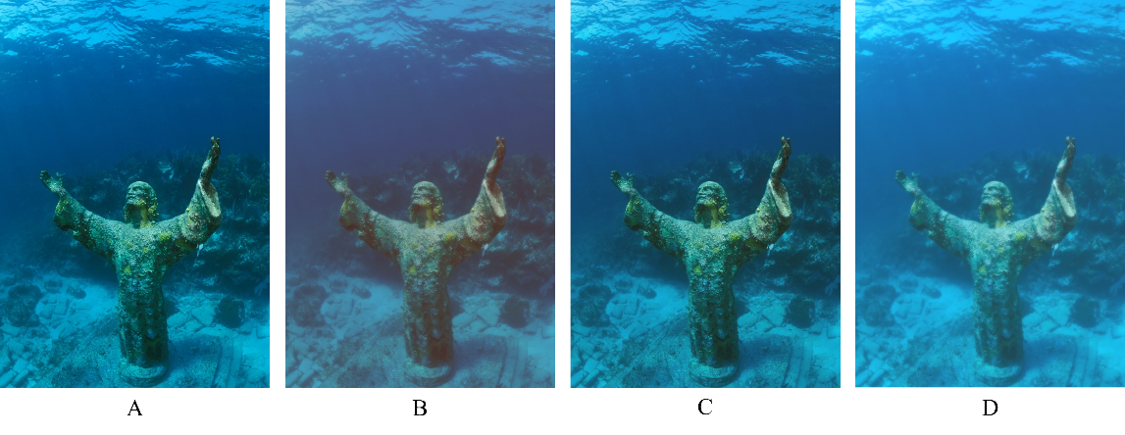

Figure 5. Comparison of processing effects in different scenarios. Where A is the original image, B is the deep water area, C is the shallow water area, and D is the turbid water area.

In Question 3, this article uses the proposed model to enhance the provided test images and calculates their respective PSNR, UCIQE, and UIQM evaluation metrics for testing, as shown in Table 1.

Table 1. Evaluation indicators for specific scenario models.

|  |  |  |  |  |
| --- | --- | --- | --- | --- |
| image file name | Degraded Image Classification | PSNR | UCIQE | UIQM |
| test_p0_.jpg | Blur | 18.57 | 67.1681 | 574.4661 |
| test_p109_.jpg | Low Light + Blur | 19.8055 | 65.9599 | 509.212 |
| test_p110_.jpg | Blur | 100 | 69.2625 | 125.8822 |
| test_p112_.jpg | Blur | 12.3122 | 63.8096 | 862.0009 |
| test_p113_.jpg | Blur | 13.2625 | 64.3058 | 658.1719 |
| test_p12_.jpg | Blur | 13.0419 | 55.5609 | 895.9001 |
| test_p13_.jpg | Blur | 100 | 70.6389 | 133.0238 |
| test_p20_.jpg | Blur | 18.0288 | 64.9066 | 381.2669 |
| test_p21_.jpg | Blur | 12.5794 | 65.4429 | 962.8975 |
| test_p22_.jpg | Blur | 100 | 66.0134 | 124.8204 |
| test_p256_.jpg | Blur | 100 | 67.1026 | 80.5362 |
| test_p258_.jpg | Blur | 12.4123 | 66.3388 | 462.3489 |
| test_p266_.jpg | Low Light + Blur | 19.6628 | 68.5377 | 1825.749 |
| test_p26_.jpg | Blur | 14.2608 | 64.5149 | 1447.6 |
| test_p276_.jpg | Blur | 19.9401 | 68.1361 | 353.1784 |
| test_p27_.jpg | Blur | 100 | 64.0685 | 90.5076 |
| test_p28_.jpg | Blur | 100 | 73.6847 | 105.2032 |
| test_p349_.jpg | Low Light + Blur | 18.3864 | 68.5348 | 2082.473 |
| test_p350_.jpg | Blur | 16.3048 | 66.9796 | 869.7584 |
| test_p403_.jpg | Blur | 13.3562 | 64.2101 | 972.876 |
| test_p404_.jpg | Blur | 13.3665 | 58.936 | 605.6751 |
| test_p479_.jpg | Blur | 11.7334 | 63.878 | 662.7872 |
| test_p50_.jpg | Blur | 15.4382 | 65.7749 | 278.5442 |
| test_p52_.jpg | Blur | 11.9321 | 57.1737 | 858.9569 |
| test_p596_.jpg | Blur | 100 | 68.9841 | 118.1281 |
| test_p598_.jpg | Blur | 14.357 | 65.9372 | 511.4764 |
| test_p6_.jpg | Blur | 14.3535 | 67.3771 | 525.7986 |
| test_p9_.jpg | Blur | 16.622 | 66.6406 | 548.2189 |

In Question 4, this article uses the proposed complex scene underwater image enhancement model to enhance the provided images, and calculates their respective PSNR, UCIQE, and UIQM evaluation metrics for testing, as shown in Table 2. The enhancement effect is shown in Figure 6.

Table 2. Evaluation indicators for underwater image enhancement models in complex scenes.

|  |  |  |  |
| --- | --- | --- | --- |
| image file name | PSNR | UCIQE | UIQM |
| test_p0_.jpg | 12.4103 | 73.2765 | 565.5822 |
| test_p109_.jpg | 12.7353 | 72.5256 | 333.7823 |
| test_p110_.jpg | 12.9214 | 73.6135 | 1876.4177 |
| test_p112_.jpg | 13.9231 | 72.8925 | 969.4 |
| test_p113_.jpg | 14.3026 | 73.59 | 484.7729 |
| test_p12_.jpg | 13.9744 | 72.8808 | 976.2724 |
| test_p13_.jpg | 12.3461 | 73.6935 | 1953.657 |
| test_p20_.jpg | 11.8764 | 73.2794 | 533.362 |
| test_p21_.jpg | 13.7584 | 72.9042 | 1033.1277 |
| test_p22_.jpg | 13.7409 | 73.4112 | 1440.0545 |
| test_p256_.jpg | 14.1795 | 73.2197 | 1360.7932 |
| test_p258_.jpg | 17.3569 | 73.7277 | 310.4086 |
| test_p266_.jpg | 13.402 | 72.1902 | 1352.0622 |
| test_p26_.jpg | 13.2684 | 73.1309 | 2814.3192 |
| test_p276_.jpg | 15.7779 | 73.6017 | 335.1975 |
| test_p27_.jpg | 13.6625 | 72.8378 | 1144.0152 |
| test_p28_.jpg | 12.9127 | 73.7209 | 1254.1653 |
| test_p349_.jpg | 13.6269 | 73.337 | 1487.9299 |
| test_p350_.jpg | 12.4812 | 73.5842 | 902.4123 |
| test_p403_.jpg | 14.1004 | 73.463 | 1226.8627 |
| test_p404_.jpg | 14.4343 | 73.4268 | 475.9718 |
| test_p479_.jpg | 13.953 | 72.9228 | 1048.6167 |
| test_p50_.jpg | 17.6475 | 73.42 | 93.8583 |
| test_p52_.jpg | 15.3726 | 72.8671 | 611.6844 |
| test_p596_.jpg | 11.6286 | 73.6252 | 1942.511 |
| test_p598_.jpg | 13.8052 | 73.6232 | 634.6828 |
| test_p6_.jpg | 15.4502 | 73.7043 | 343.6554 |
| test_p9_.jpg | 12.1957 | 73.5763 | 845.8486 |

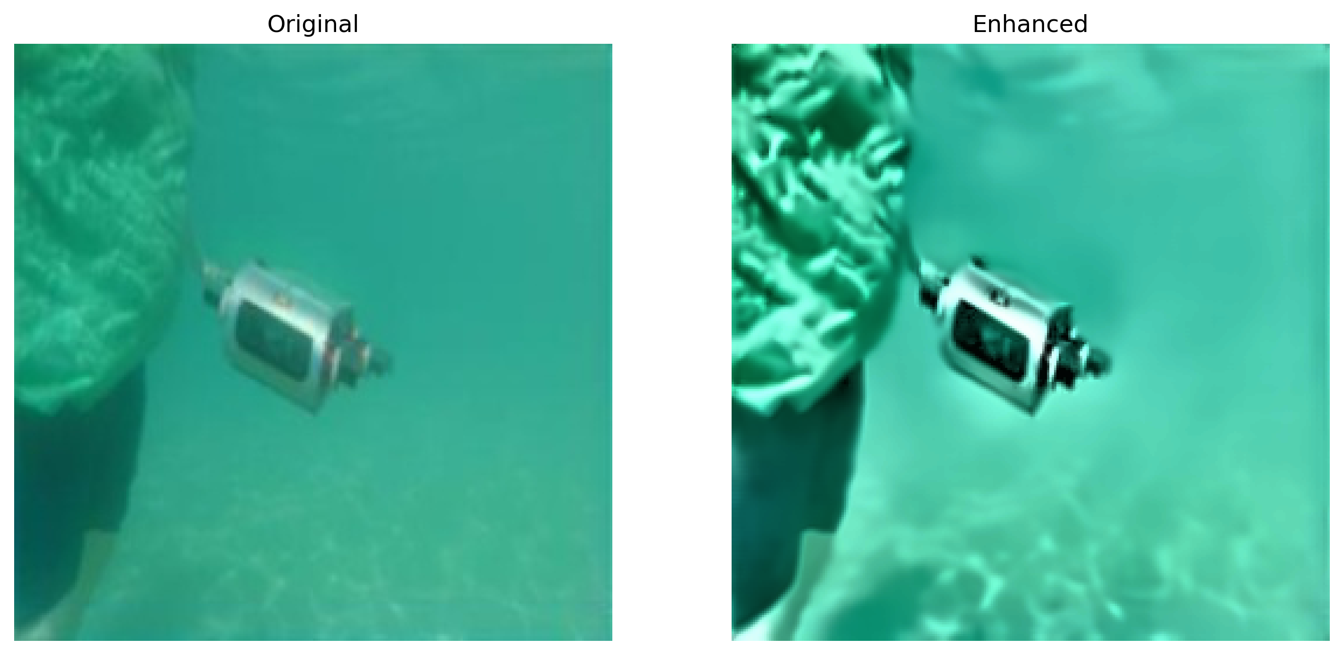

Figure 6. Enhanced effect demonstration.

**6 Evaluation Of The Model**

**6.1 Meri**

1. The classification of underwater images uses multiple methods to classify problems in the images, which improves the accuracy of the model's targeted processing of underwater images in the future.

2. A underwater image enhancement model was proposed, which successfully processed and optimized underwater images, solving the long-standing problems of color cast, low light, and blur in underwater images.

3. Multiple datasets were used for comprehensive model training, which improved the accuracy of the model.

**6.2 Shortcoming**

1. The model has low processing accuracy for complex images, and in extreme cases, stripes may appear.

2. The model does not explicitly provide targeted processing for complex scenarios.

**7 Reference**

[1]. Cong Runmin, Zhang Yumo, Zhang Chen, Li Chongyi, Zhao Yao. Research Progress of Deep Learning Driven Underwater Image Enhancement and Restoration[J]. JOURNAL OF SIGNAL PROCESSING, 2020, 36(9): 1377-1389. DOI: 10.16798/j. issn.1003-0530.2020.09.001

[2]. Li C, Anwar S, Porikli F. Underwater scene prior inspired deep underwater image

and video enhancement[J]. Pattern Recognition, 2020, 98: 107038.

[3]. K. Panetta, C. Gao and S. Agaian, "Human-Visual-System-Inspired Underwater

Image Quality Measures," in IEEE Journal of Oceanic Engineering, vol. 41, no. 3, pp.

541-551, July 2016, doi: 10.1109/JOE.2015.2469915

[4]. M. Yang and A. Sowmya, "An Underwater Color Image Quality Evaluation Metric,"in IEEE Transactions on Image Processing, vol. 24, no. 12, pp. 6062-6071, Dec. 2015, doi:10.1109/TIP.2015.2491020.

[5]. University of Minnesota, The EUVP dataset, <https://irvlab.cs.umn.edu/resources/euvp-dataset>, 20241122.

[6]. Bond007, Realworld Underwater Image Enhancement (RUIE) Benchmark, <https://gitcode.com/open-source-toolkit/4e919/overview>, 20241122.