PRACTICAL 4A
Multiple Block Generation

Aim: To create a blockchain with multiple interconnected blocks in Python using SHA-256 hashing and previous hash linking.

Code:
import hashlib
import json
import time

def create_transaction(sender, recipient, amount):
return {
"sender": sender,
"recipient": recipient,
"amount": amount
}

def compute_hash(block):
block_string = json.dumps(block, sort_keys=True).encode()
return hashlib.sha256(block_string).hexdigest()

def create_block(index, transactions, previous_hash):
block = {
'index': index,
'timestamp': time.time(),
'transactions': transactions,
'previous_hash': previous_hash,
}

block['hash'] = compute_hash(block)
return block

def generate_blockchain(num_blocks, tx_per_block=2):
blockchain = []

# Genesis Block
genesis_block = create_block(0, [], "0")
blockchain.append(genesis_block)

for i in range(1, num_blocks):
transactions = [
create_transaction(f"User{i}", f"User{i+1}", i * 10 + j)
for j in range(tx_per_block)
]

previous_hash = blockchain[-1]['hash']
new_block = create_block(i, transactions, previous_hash)
blockchain.append(new_block)

return blockchain

if __name__ == "__main__":
chain = generate_blockchain(5, tx_per_block=3)

for block in chain:
print(json.dumps(block, indent=4), "\n")

OUTPUT: 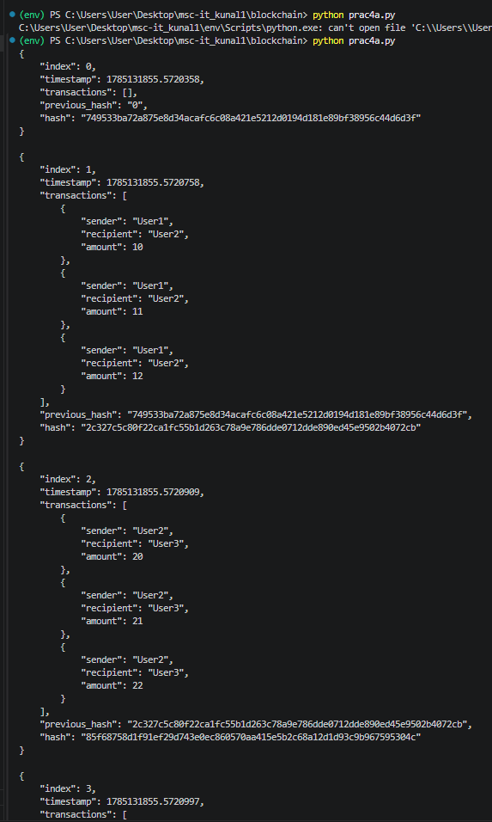
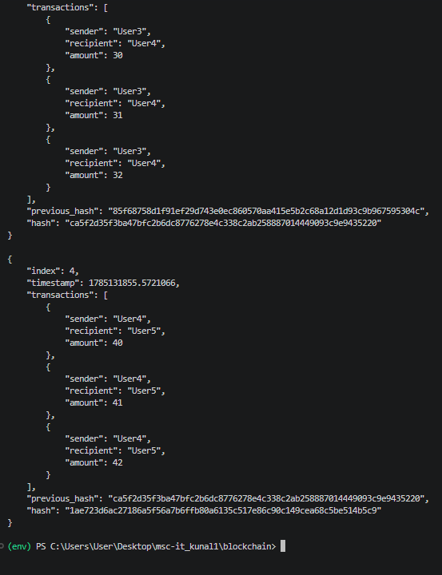

PRACTICAL 4B
Blockchain with Multiple Blocks & Validation

Aim: To create a blockchain consisting of multiple linked blocks using Python. To validate the integrity of the blockchain by verifying block hashes and previous hash references.

Code:

# Blockchain with Multiple Blocks & Validation
import hashlib
import json
import time

def hash_block(block):
block_string = json.dumps(block, sort_keys=True).encode()
return hashlib.sha256(block_string).hexdigest()

def create_block(index, previous_hash, transactions):
block = {
"index": index,
"timestamp": time.time(),
"transactions": transactions,
"previous_hash": previous_hash
}

block["hash"] = hash_block(block)
return block

def is_valid_block(block, previous_block):

if block["index"] != previous_block["index"] + 1:
print("Invalid index")
return False

if block["previous_hash"] != previous_block["hash"]:
print("Previous hash mismatch")
return False

recalculated_hash = hash_block(
{k: block[k] for k in block if k != "hash"}
)

if recalculated_hash != block["hash"]:
print("Hash mismatch")
return False

return True

def is_valid_chain(chain):

for i in range(1, len(chain)):
if not is_valid_block(chain[i], chain[i - 1]):
print(f"Block {i} is invalid")
return False

return True

chain = []

chain.append(create_block(0, "0", []))

for i in range(1, 3):
transactions = [
f"User{i} pays User{i+1} {10*j}"
for j in range(1, 4)
]

chain.append(
create_block(i, chain[-1]["hash"], transactions)
)

for block in chain:
print(json.dumps(block, indent=4))
print()

print("Is blockchain valid?", is_valid_chain(chain))

OUTPUT:
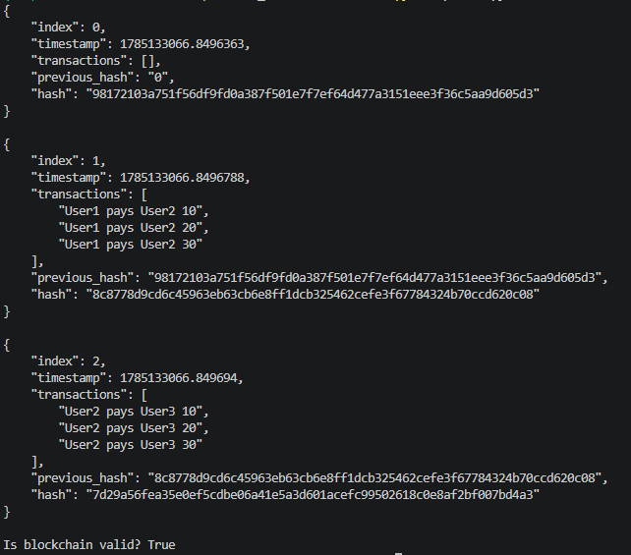

PRACTICAL 4C
Multiple Block Generation with Proof of Work (PoW)

Aim: To implement multiple block generation in a blockchain using Python.
To secure the blockchain by applying the Proof of Work (PoW) mining algorithm.

Code:
import hashlib
import json
import time

DIFFICULTY = 4

def create_transaction(sender, recipient, amount):
return {
"sender": sender,
"recipient": recipient,
"amount": amount
}

def compute_hash(block):
"""
Calculate SHA-256 hash including nonce.
"""
block_string = json.dumps(block, sort_keys=True).encode()
return hashlib.sha256(block_string).hexdigest()

def mine_block(block):
"""
Increment nonce until hash has required leading zeros.
"""
block['nonce'] = 0
computed_hash = compute_hash(block)

while not computed_hash.startswith('0' * DIFFICULTY):
block['nonce'] += 1
computed_hash = compute_hash(block)

return computed_hash

def create_block(index, transactions, previous_hash):
block = {
'index': index,
'timestamp': time.time(),
'transactions': transactions,
'previous_hash': previous_hash,
'nonce': 0
}

block['hash'] = mine_block(block)
return block

def generate_blockchain(num_blocks, tx_per_block=2):
blockchain = []

# Genesis Block
genesis_block = create_block(0, [], "0")
blockchain.append(genesis_block)

for i in range(1, num_blocks):
transactions = [
create_transaction(f"User{i}", f"User{i+1}", i * 10 + j)
for j in range(tx_per_block)
]

previous_hash = blockchain[-1]['hash']

new_block = create_block(
i,
transactions,
previous_hash
)

blockchain.append(new_block)

return blockchain

if __name__ == "__main__":

chain = generate_blockchain(3, tx_per_block=3)

for block in chain:
print(json.dumps(block, indent=4), "\n")

OUTPUT:
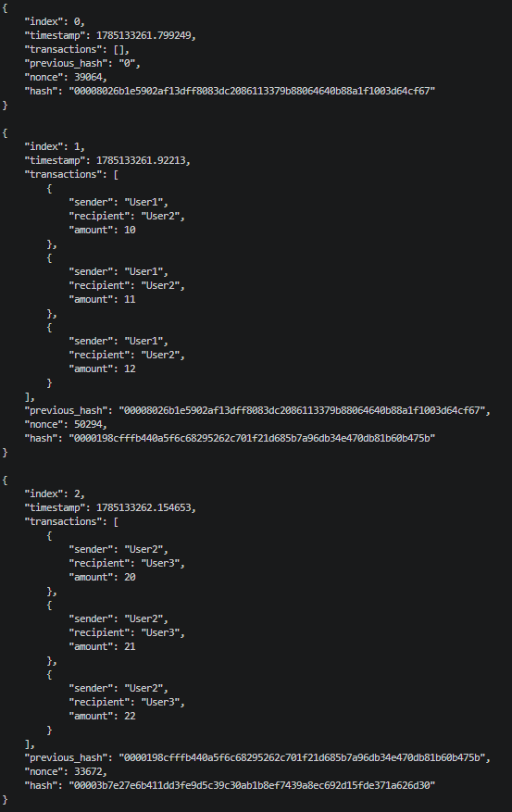

PRACTICAL 4D
Multiple Block Generation with Proof of Work (PoW) Using User Input

Aim: To implement a blockchain that generates multiple linked blocks using Python with user-provided transaction details.
To secure each block using the Proof of Work (PoW) mining algorithm before adding it to the blockchain.

Code:
import hashlib
import json
import time

DIFFICULTY = 4

# Create a transaction
def create_transaction(sender, recipient, amount):
return {
"sender": sender,
"recipient": recipient,
"amount": amount
}

# Compute SHA-256 hash of a block
def compute_hash(block):
block_string = json.dumps(block, sort_keys=True).encode()
return hashlib.sha256(block_string).hexdigest()

# Mine a block using Proof of Work
def mine_block(block):
block['nonce'] = 0
computed_hash = compute_hash(block)

while not computed_hash.startswith('0' * DIFFICULTY):
block['nonce'] += 1
computed_hash = compute_hash(block)

return computed_hash

# Create a block
def create_block(index, transactions, previous_hash):
block = {
'index': index,
'timestamp': time.time(),
'transactions': transactions,
'previous_hash': previous_hash,
'nonce': 0
}

block['hash'] = mine_block(block)
return block

# Generate blockchain with user input
def generate_blockchain():
blockchain = []

num_blocks = int(input("Enter number of blocks: "))
tx_per_block = int(input("Enter transactions per block: "))

# Genesis Block
genesis_block = create_block(0, [], "0")
blockchain.append(genesis_block)

# Create remaining blocks
for i in range(1, num_blocks):
print(f"\n----- Block {i} -----")
transactions = []

for j in range(tx_per_block):
print(f"\nTransaction {j + 1}")
sender = input("Sender: ")
recipient = input("Recipient: ")
amount = float(input("Amount: "))

transactions.append(
create_transaction(sender, recipient, amount)
)

previous_hash = blockchain[-1]['hash']
new_block = create_block(i, transactions, previous_hash)
blockchain.append(new_block)

return blockchain

# Main Program
if __name__ == "__main__":

chain = generate_blockchain()

print("\n========== BLOCKCHAIN ==========\n")

for block in chain:
print(json.dumps(block, indent=4))
print()

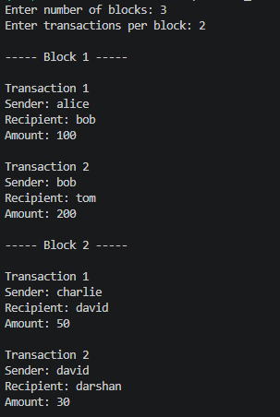
OUTPUT:
