PRACTICAL NO:5
Decision Tree

Aim: To implement a Decision Tree Classifier using Python's scikit-learn library to predict machine maintenance requirements, and evaluate its performance using classification metrics and a Receiver Operating Characteristic (ROC) curve.
CODE:
import pandas as pd
from sklearn.model_selection import train_test_split
from sklearn.tree import DecisionTreeClassifier , plot_tree
from sklearn.metrics import ( accuracy_score, confusion_matrix, precision_score, recall_score, roc_curve, auc )

import matplotlib.pyplot as plt
import numpy as np
file_path = "C:/Users/Kunal/OneDrive/Desktop/MSCIT/DATASCIENCE/ds/file/diabetes_100_rows.csv"
data = pd.read_csv(file_path)
print("Data set loaded succesfully")

data['Outcome'] = data['Outcome'].apply(lambda x: 1 if x >= 0.5 else 0)
X = data.drop(columns= ['Outcome'])
y = data['Outcome']

X_train, X_test, y_train, y_test = train_test_split(
X, y, test_size=0.2, random_state=42
)

clf = DecisionTreeClassifier(random_state=42)

clf.fit(X_train, y_train)

y_pred = clf.predict(X_test)
y_pred_prob = clf.predict_proba(X_test)[:, 1]

accuracy = accuracy_score(y_test, y_pred)
conf_matrix = confusion_matrix(y_test, y_pred)
precision = precision_score(y_test, y_pred, zero_division=0)
sensitivity = recall_score(y_test, y_pred, zero_division=0)
TN = conf_matrix[0, 0]
FP = conf_matrix[0, 1]
specificity = TN / (TN + FP)

standard_error = np.sqrt(
(accuracy * (1 - accuracy)) / len(y_test)
)

fpr, tpr, _ = roc_curve(y_test, y_pred_prob)
roc_auc = auc(fpr, tpr)

plt.figure()
plt.plot(
fpr,
tpr,
color='darkorange',
lw=2,
label='ROC curve (area = %0.2f)' % roc_auc
)

[<matplotlib.lines.Line2D at 0x22244f11310>]

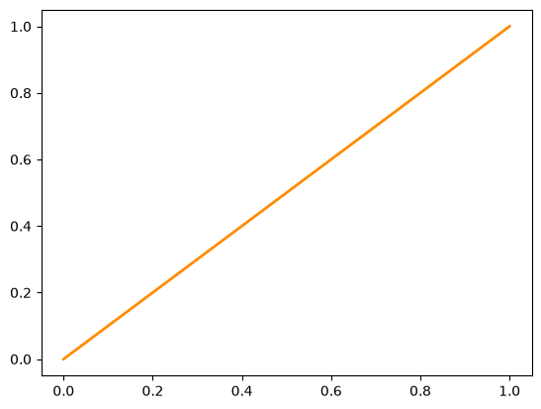

plt.plot(
[0, 1],
[0, 1],
color='navy',
lw=2,
linestyle='--'
)
plt.xlabel('False Positive Rate')
plt.ylabel('True Positive Rate')
plt.title('Receiver Operating Characteristic')
plt.legend(loc="lower right")
plt.show()

plt.figure(figsize=(18, 20))
plot_tree(
clf,
feature_names=X.columns,
class_names=['0', '1'],
filled=True,
max_depth=3
)
plt.title("Decision Tree (Max Depth = 3)")
plt.show()

print("Predictions:", y_pred)
print("Accuracy:", accuracy)
print("Confusion Matrix:\n", conf_matrix)
print("Standard Error:", standard_error)
print("Precision:", precision)
print("Sensitivity (Recall):", sensitivity)
print("Specificity:", specificity)
print("AUC:", roc_auc)

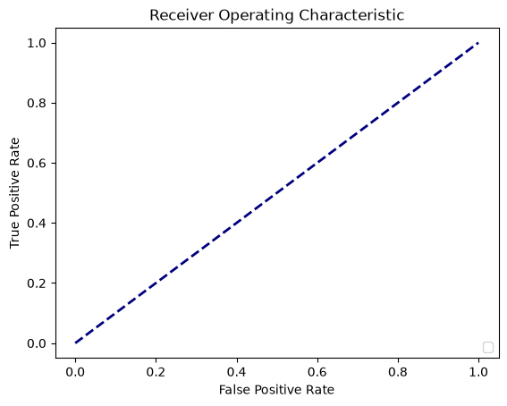
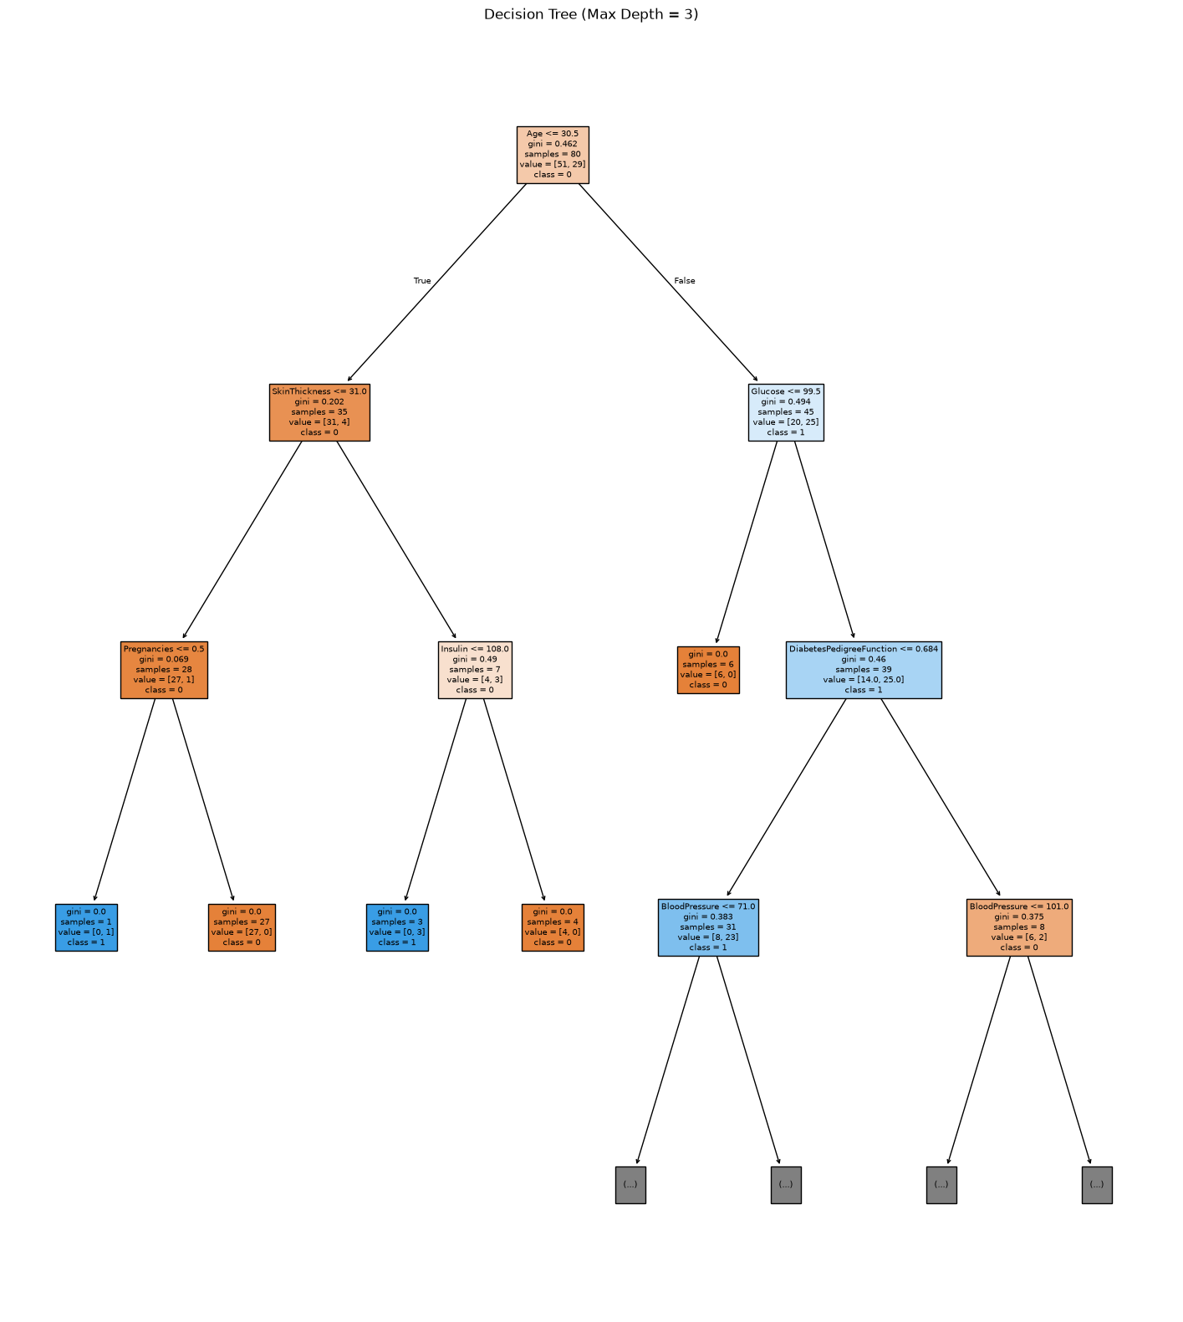
Predictions: [1 1 0 1 1 0 1 0 0 1 1 1 0 0 0 0 0 1 1 0]
Accuracy: 0.5
Confusion Matrix:
[[6 6]
[4 4]]
Standard Error: 0.11180339887498948
Precision: 0.4
Sensitivity (Recall): 0.5
Specificity: 0.5
AUC: 0.5

