Practical 08: User and Auth Services

1. Create the project
Open PowerShell:
mkdir campus-auth-service
cd campus-auth-service
npm init -y

Install the required packages:
npm install express mysql2 bcryptjs jsonwebtoken dotenv
Install nodemon for development:
npm install --save-dev nodemon

2. Create the project structure
Create these files:
campus-auth-service/
│
├── server.js
├── db.js
├── .env
├── package.json
└── middleware/
└── auth.js
In VS Code, your Explorer should look like:
campus-auth-service
│
├── middleware
│ └── auth.js
│
├── .env
├── db.js
├── package.json
└── server.js

3. Create the MySQL database
Open MySQL Workbench or MySQL command line.
Create the database:
CREATE DATABASE campus_auth;
Select it:
USE campus_auth;
Create the users table:
CREATE TABLE users (
id INT AUTO_INCREMENT PRIMARY KEY,
name VARCHAR(100) NOT NULL,
email VARCHAR(150) UNIQUE NOT NULL,
password VARCHAR(255) NOT NULL,
role VARCHAR(50) DEFAULT 'student',
google_id VARCHAR(255) UNIQUE NULL,
created_at TIMESTAMP DEFAULT CURRENT_TIMESTAMP
);
Check it:
DESCRIBE users;

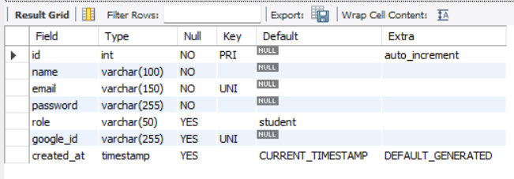

4. Configure .env
Create .env:
PORT=5000

DB_HOST=localhost
DB_USER=root
DB_PASSWORD=YOUR_MYSQL_PASSWORD
DB_NAME=campus_auth

JWT_SECRET=my_super_secret_key_12345
Replace:
YOUR_MYSQL_PASSWORD
with your actual MySQL password.

5. Create db.js
Put this inside db.js:
const mysql = require("mysql2");

const pool = mysql.createPool({
host: process.env.DB_HOST,
user: process.env.DB_USER,
password: process.env.DB_PASSWORD,
database: process.env.DB_NAME
});

module.exports = pool.promise();
This creates a connection pool to MySQL.

6. Create authentication middleware
Create:
middleware/auth.js
Put this inside:
const jwt = require("jsonwebtoken");

function authenticateToken(req, res, next) {
const authHeader = req.headers["authorization"];

const token = authHeader && authHeader.split(" ")[1];

if (!token) {
return res.status(401).json({
message: "Access token required"
});
}

jwt.verify(token, process.env.JWT_SECRET, (err, user) => {
if (err) {
return res.status(403).json({
message: "Invalid or expired token"
});
}

req.user = user;
next();
});
}

module.exports = authenticateToken;
This is what protects /profile.

7. Create server.js
Now put this into server.js:
require("dotenv").config();

const express = require("express");
const bcrypt = require("bcryptjs");
const jwt = require("jsonwebtoken");

const db = require("./db");
const authenticateToken = require("./middleware/auth");

const app = express();

app.use(express.json());

// REGISTER
app.post("/register", async (req, res) => {
try {
const { name, email, password, role } = req.body;

if (!name || !email || !password) {
return res.status(400).json({
message: "Name, email and password are required"
});
}

const [existingUsers] = await db.execute(
"SELECT id FROM users WHERE email = ?",
[email]
);

if (existingUsers.length > 0) {
return res.status(409).json({
message: "User already exists"
});
}

const hashedPassword = await bcrypt.hash(password, 10);

const [result] = await db.execute(
"INSERT INTO users (name, email, password, role) VALUES (?, ?, ?, ?)",
[
name,
email,
hashedPassword,
role || "student"
]
);

res.status(201).json({
message: "User registered successfully",
userId: result.insertId
});

} catch (error) {
console.error(error);

res.status(500).json({
message: "Server error"
});
}
});

// LOGIN
app.post("/login", async (req, res) => {
try {
const { email, password } = req.body;

const [users] = await db.execute(
"SELECT * FROM users WHERE email = ?",
[email]
);

if (users.length === 0) {
return res.status(401).json({
message: "Invalid email or password"
});
}

const user = users[0];

const passwordMatch = await bcrypt.compare(
password,
user.password
);

if (!passwordMatch) {
return res.status(401).json({
message: "Invalid email or password"
});
}

const token = jwt.sign(
{
id: user.id,
role: user.role
},
process.env.JWT_SECRET,
{
expiresIn: "1h"
}
);

res.json({
message: "Login successful",
token: token
});

} catch (error) {
console.error(error);

res.status(500).json({
message: "Server error"
});
}
});

// PROTECTED PROFILE
app.get("/profile", authenticateToken, async (req, res) => {
try {
const [users] = await db.execute(
"SELECT id, name, email, role, created_at FROM users WHERE id = ?",
[req.user.id]
);

if (users.length === 0) {
return res.status(404).json({
message: "User not found"
});
}

res.json({
user: users[0]
});

} catch (error) {
console.error(error);

res.status(500).json({
message: "Server error"
});
}
});

// MOCK GOOGLE OAUTH
app.post("/oauth/google", async (req, res) => {
try {
const { googleId, name, email } = req.body;

if (!googleId || !name || !email) {
return res.status(400).json({
message: "Google ID, name and email are required"
});
}

const [users] = await db.execute(
"SELECT * FROM users WHERE google_id = ? OR email = ?",
[googleId, email]
);

let user;

if (users.length === 0) {

const [result] = await db.execute(
`INSERT INTO users
(name, email, password, role, google_id)
VALUES (?, ?, ?, ?, ?)`,
[
name,
email,
"",
"student",
googleId
]
);

user = {
id: result.insertId,
name,
email,
role: "student"
};

} else {

user = users[0];

}

const token = jwt.sign(
{
id: user.id,
role: user.role
},
process.env.JWT_SECRET,
{
expiresIn: "1h"
}
);

res.json({
message: "Google OAuth login successful",
user: {
id: user.id,
name: user.name,
email: user.email,
role: user.role
},
token
});

} catch (error) {
console.error(error);

res.status(500).json({
message: "Server error"
});
}
});

// START SERVER
const PORT = process.env.PORT || 5000;

app.listen(PORT, () => {
console.log(`Auth service running on http://localhost:${PORT}`);
});

8. Modify package.json
Add this to your scripts section:
"scripts": {
"start": "node server.js",
"dev": "nodemon server.js"
}

9. Start the microservice
Run:
npm run dev
You should see:
Auth service running on http://localhost:5000
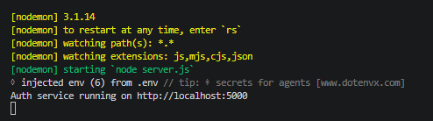
Your microservice is now running.

10. Test /register
Open Postman.
Create:
POST http://localhost:5000/register
Go to:
Body
→ raw
→ JSON
Send:
{
"name": "Kunal",
"email": "kunal@example.com",
"password": "password123",
"role": "student"
}
Click Send.
Expected:
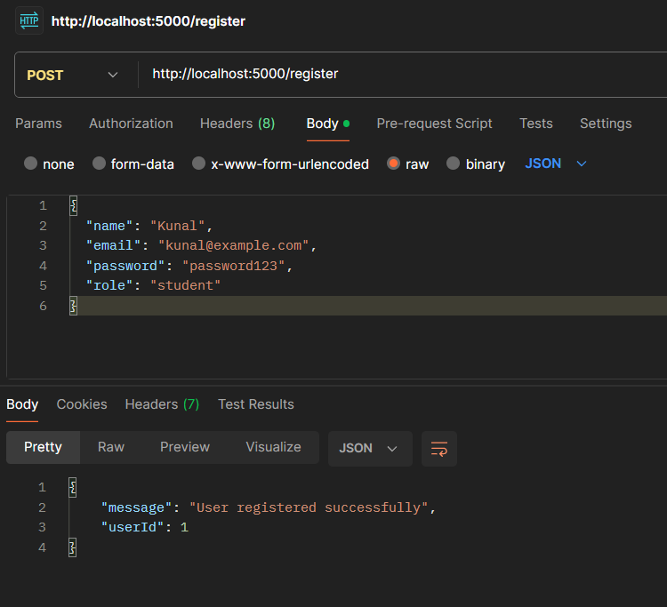

11. Check MySQL
Go back to MySQL:
USE campus_auth;

SELECT * FROM users;
You should see the user.
But the important thing is that the password should NOT look like:
password123
Instead, it should look something like:
$2b$10$...

12. Test /login
In Postman:
POST http://localhost:5000/login
Body:
{
"email": "kunal@example.com",
"password": "password123"
}

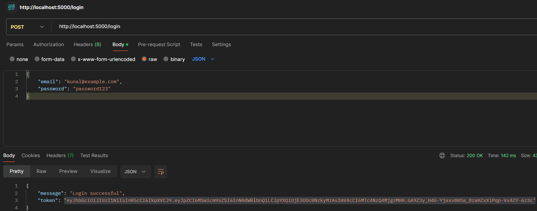
Expected response:

13. Test /profile
Now create:
GET http://localhost:5000/profile
Go to:
Authorization
Select:
Bearer Token
Paste the JWT you received from /login.
Send the request.
Expected:
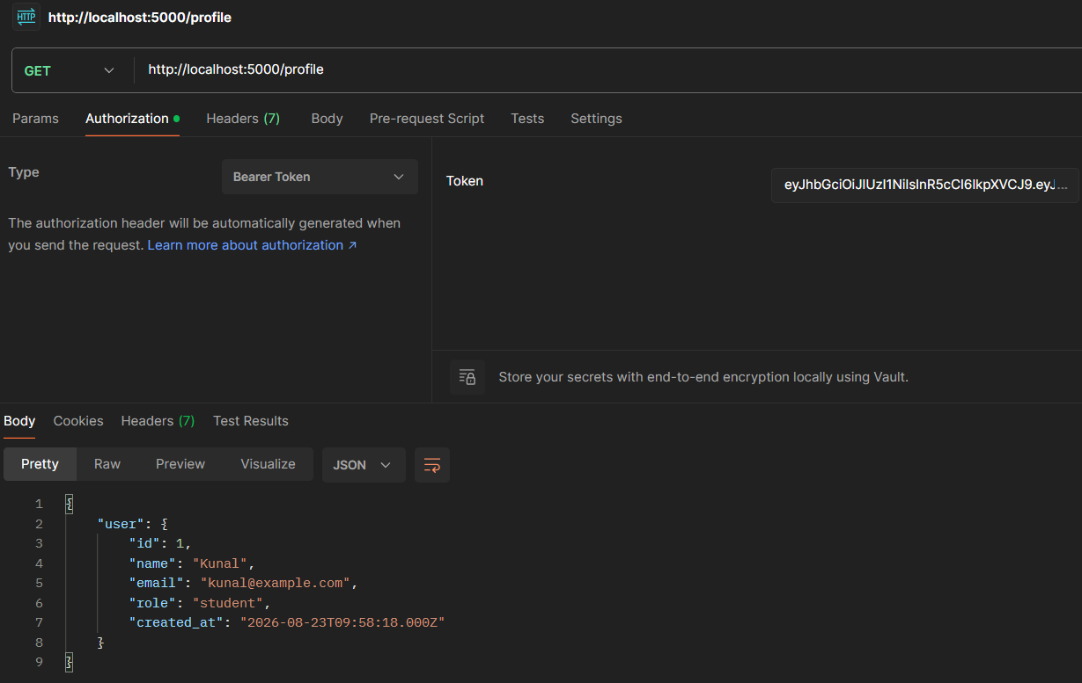

14. Test that /profile is actually protected
This is important for your practical demonstration.
Remove the token from Postman and send:
GET http://localhost:5000/profile
You should get:
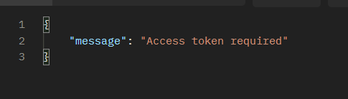
Then put an invalid token:
Bearer abc123
You should get:
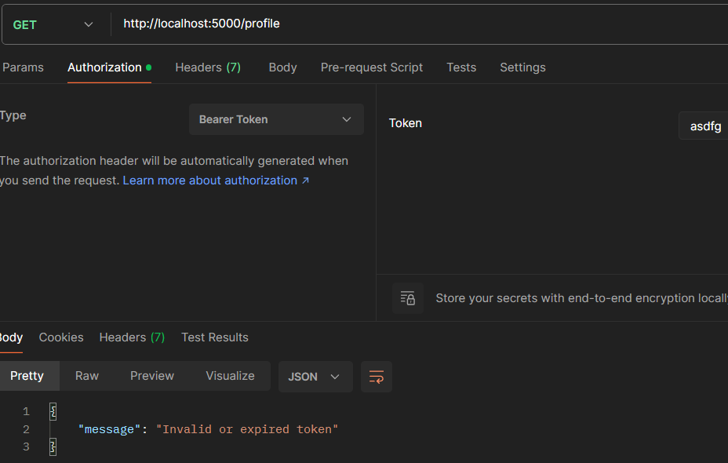

15. Test the Google OAuth mock
So our /oauth/google endpoint acts as the mock.
In Postman:
POST http://localhost:5000/oauth/google
Body:
{
"googleId": "google_123456",
"name": "Kunal Mhatre",
"email": "kunal@gmail.com"
}

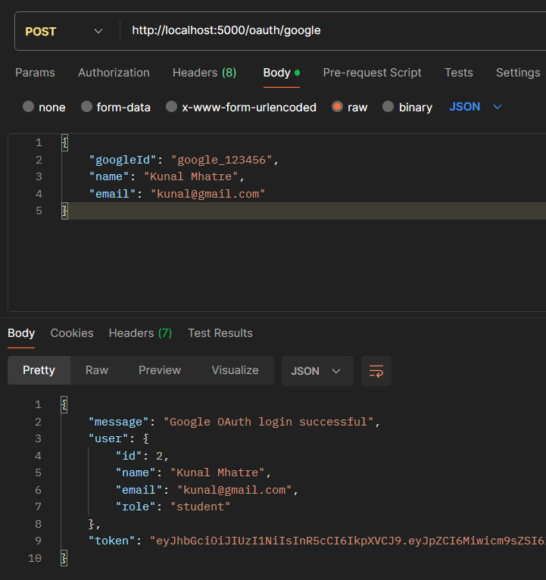
Expected:

And MySQL will contain:

