Practical : 9

Data Processing and AI Service Using Python, FastAPI and Docker

Aim
To develop a Python-based Data Processing and AI Service that processes bank transaction data using Pandas, provides an AI prediction using TensorFlow and FastAPI, and deploys the application using Docker.

Step 1: Create Project Directory
Create the following project structure:
prac9/
│
├── bank.csv
├── process_data.py
├── main.py
├── requirements.txt
├── Dockerfile
└── README.md

Step 2: Install Required Libraries
Open PowerShell/CMD and run:
pip install pandas numpy tensorflow fastapi uvicorn

Step 3: Process Bank Data Using Pandas
Create a file named process_data.py.
import pandas as pd

print("Loading bank.csv...")

# ---------------------------------------
# 1. LOAD DATA
# ---------------------------------------

df = pd.read_csv("bank.csv")

print("\nOriginal columns:")
print(df.columns.tolist())

print("\nOriginal Data:")
print(df.head())

# ---------------------------------------
# 2. CLEAN COLUMN NAMES
# ---------------------------------------

# Remove extra spaces and invisible spaces
df.columns = (
df.columns
.str.strip()
.str.replace("\xa0", " ", regex=False)
.str.replace(r"\s+", " ", regex=True)
)

print("\nCleaned columns:")
print(df.columns.tolist())

# ---------------------------------------
# 3. FIND WITHDRAWAL COLUMN
# ---------------------------------------

withdrawal_column = None
deposit_column = None

for column in df.columns:

column_clean = column.strip().upper()

if "WITHDRAWAL" in column_clean:
withdrawal_column = column

if "DEPOSIT" in column_clean:
deposit_column = column

if withdrawal_column is None:
raise Exception(
"WITHDRAWAL AMT column not found. "
f"Available columns: {df.columns.tolist()}"
)

if deposit_column is None:
raise Exception(
"DEPOSIT AMT column not found. "
f"Available columns: {df.columns.tolist()}"
)

print("\nWithdrawal column found:", withdrawal_column)
print("Deposit column found:", deposit_column)

# ---------------------------------------
# 4. CONVERT AMOUNTS TO NUMERIC
# ---------------------------------------

def clean_amount(value):

if pd.isna(value):
return None

# Remove commas
value = str(value).replace(",", "").strip()

# Remove extra characters except digits, decimal point and minus
value = (
value
.replace("₹", "")
.replace("'", "")
)

return value

df[withdrawal_column] = df[withdrawal_column].apply(clean_amount)
df[deposit_column] = df[deposit_column].apply(clean_amount)

df[withdrawal_column] = pd.to_numeric(
df[withdrawal_column],
errors="coerce"
)

df[deposit_column] = pd.to_numeric(
df[deposit_column],
errors="coerce"
)

# ---------------------------------------
# 5. HANDLE MISSING VALUES
# ---------------------------------------

# Assignment requirement:
# Replace missing withdrawal amounts
# using the median.

median_withdrawal = df[withdrawal_column].median()

print("\nMedian withdrawal amount:", median_withdrawal)

df[withdrawal_column] = df[withdrawal_column].fillna(
median_withdrawal
)

# Missing deposits are treated as zero
df[deposit_column] = df[deposit_column].fillna(0)

# ---------------------------------------
# 6. REMOVE DUPLICATES
# ---------------------------------------

before = len(df)

df = df.drop_duplicates()

after = len(df)

print("\nDuplicate rows removed:", before - after)

# ---------------------------------------
# 7. GROUP BY ACCOUNT NUMBER
# ---------------------------------------

summary = df.groupby("Account No").agg(
Total_Money_Spent=(withdrawal_column, "sum"),
Total_Money_Deposited=(deposit_column, "sum"),
Total_Transactions=("Account No", "count")
).reset_index()

# ---------------------------------------
# 8. SAVE REPORT
# ---------------------------------------

summary.to_csv(
"summary_report.csv",
index=False
)

print("\n---------------------------------------")
print("FINAL SUMMARY REPORT")
print("---------------------------------------")

print(summary.head(20))

print("\nTotal accounts:", len(summary))

print("\nsummary_report.csv created successfully!")

Step 4: Run the Data Processing Program
Run:
python process_data.py
The program performs:
- Loading of bank.csv
- Cleaning of column names
- Conversion of amount values
- Handling of missing values
- Removal of duplicate records
- Grouping by account number
- Calculation of total spending
- Calculation of total deposits
- Calculation of total transactions
- Calculation of average transaction
- Creation of summary_report.csv
The output file is:
summary_report.csv
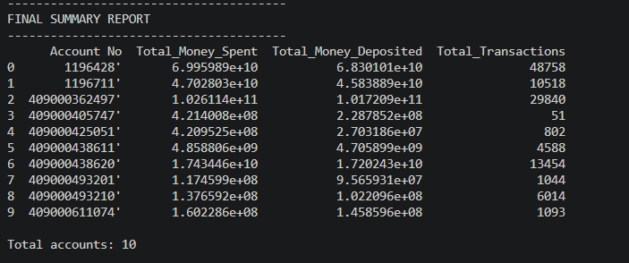

Step 5: Create FastAPI AI Service
Create a file named main.py.
from fastapi import FastAPI
from pydantic import BaseModel
import tensorflow as tf
import numpy as np

# ---------------------------------------
# CREATE FASTAPI APP
# ---------------------------------------

app = FastAPI(
title="AI Data Service",
description="Campus Transaction AI Prediction Service",
version="1.0"
)

# ---------------------------------------
# SIMPLE AI MODEL
# ---------------------------------------

model = tf.keras.Sequential([
tf.keras.layers.Input(shape=(3,)),
tf.keras.layers.Dense(8, activation="relu"),
tf.keras.layers.Dense(4, activation="relu"),
tf.keras.layers.Dense(1, activation="sigmoid")
])

# ---------------------------------------
# INPUT DATA FORMAT
# ---------------------------------------

class PredictionInput(BaseModel):
Total_Money_Spent: float
Total_Transactions: int
Average_Transaction: float

# ---------------------------------------
# HOME ROUTE
# ---------------------------------------

@app.get("/")
def home():

return {
"message": "AI Data Service is running"
}

# ---------------------------------------
# PREDICTION ROUTE
# ---------------------------------------

@app.post("/predict")
def predict(data: PredictionInput):

# Convert incoming data into NumPy array
input_data = np.array([
[
data.Total_Money_Spent,
data.Total_Transactions,
data.Average_Transaction
]
], dtype=np.float32)

# Send data through TensorFlow model
prediction_result = model.predict(
input_data,
verbose=0
)

# Get prediction score
# Sigmoid gives a value between 0 and 1
score = float(prediction_result[0][0])

# Convert score into prediction
if score >= 0.7:
prediction = "High"

elif score >= 0.4:
prediction = "Medium"

else:
prediction = "Low"

# Return prediction response
return {
"prediction_score": round(score, 4),
"prediction": prediction
}

Step 6: Start FastAPI Server
Run:
uvicorn main:app --reload
The server starts at:
http://127.0.0.1:8000
Test the home route:
GET http://127.0.0.1:8000/
Expected output:

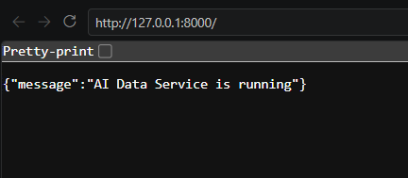

Step 7: Test API Using Postman
Open Postman.
Set:
Method: POST
URL: http://127.0.0.1:8000/predict
Select:
Body → raw → JSON
Enter:
{
"Total_Money_Spent": 50000,
"Total_Transactions": 10,
"Average_Transaction": 5000
}
Set the header:
Content-Type: application/json
Click Send.

Output:
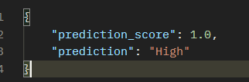

Step 9: Create Dockerfile
Create a file named Dockerfile:
FROM python:3.11-slim

# Set working directory
WORKDIR /app

# Copy required files
COPY process_data.py .
COPY main.py .
COPY bank.csv .
COPY requirements.txt .

# Install required libraries
RUN pip install --no-cache-dir -r requirements.txt

# Process CSV when building the image
RUN python process_data.py

# FastAPI port
EXPOSE 8000

# Start FastAPI server
CMD ["uvicorn", "main:app", "--host", "0.0.0.0", "--port", "8000"]

Step 10: Build Docker Image
Make sure Docker Desktop is running.
Open PowerShell in the project directory:
docker build -t ai-data-service .
The Docker image will be created with the name:
ai-data-service

Step 11: Run Docker Container
Run:
docker run -p 8000:8000 ai-data-service
The FastAPI server should display:
Uvicorn running on http://0.0.0.0:8000
This confirms that the application is running inside Docker.

Step 12: Test Dockerized API Using Postman
In Postman:
POST http://127.0.0.1:8000/predict
Body:
{
"Total_Money_Spent": 50000,
"Total_Transactions": 10,
"Average_Transaction": 5000
}
Expected response:
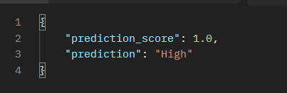

Result
The AI Data Service was successfully implemented using Pandas, TensorFlow and FastAPI. The bank transaction data was cleaned and processed to generate summary_report.csv. A FastAPI /predict endpoint was created to perform AI-based prediction, tested successfully using Postman, and the complete application was successfully containerized and executed using Docker.

