Practical 5A

Smart Contracts Basics

AIM: To create a smart contract that stores, update and retrieve a text message.

Code:

// SPDX-License-Identifier: UNLICENSED
pragma solidity ^0.8.0;
contract Message {
string message;

constructor(string memory newMessage)
{
message = newMessage;
}
function setMessage(string memory newMessage) public {
message = newMessage;
}
function getMessage() public view returns (string memory){
return message;
}
}

Output:
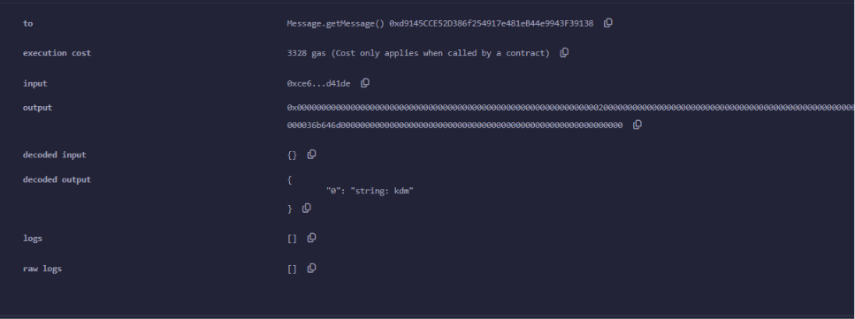

Practical 5B

Smart Contracts Basics

AIM: To develop a smart contract that perform basic arithmetic operations such as addition ,subtraction, multiplication and division.

Code:
// SPDX-License-Identifier: UNLICENSED
pragma solidity ^0.8.0;

contract n {
uint public na;
uint public nb;

constructor(uint _na, uint _nb) {
na = _na;
nb = _nb;
}

function add() public view returns (uint) {
return na + nb;
}

function sub() public view returns (uint) {
require(na >= nb, "Subtraction results in negative value");
return na - nb;
}

function mul() public view returns (uint) {
return na * nb;
}

function div() public view returns (uint) {
require(nb != 0, "Division by zero is not allowed");
return na / nb;
}

function getAllResults() public view returns (uint, uint, uint, uint) {
uint sum = na + nb;
uint diff = na >= nb ? na - nb : 0;
uint prod = na * nb;
uint quotient = nb != 0 ? na / nb : 0;
return (sum, diff, prod, quotient);
}

function setValues(uint _na, uint _nb) public {
na = _na;
nb = _nb;
}
}

OUTPUT:
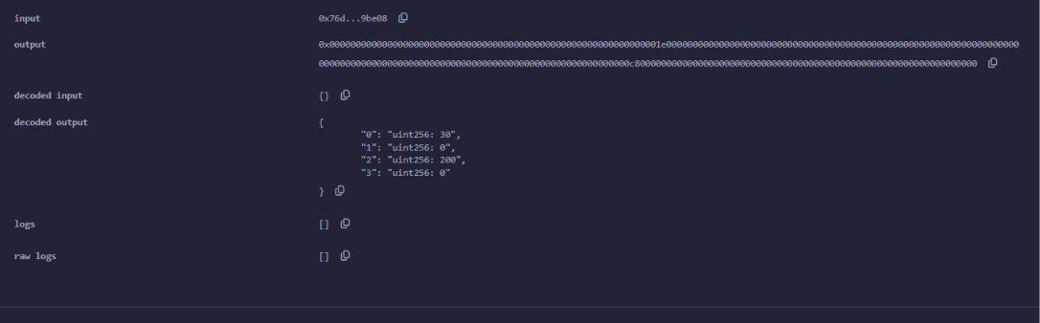

Practical 5C

Smart Contracts Basics

AIM: To create a smart contract that calculates factorial of a given number.
Code:
// SPDX-License-Identifier: UNLICENSED
pragma solidity ^0.8.0;
contract f {
uint public a;
constructor(uint _a) {
a = _a;
}
function fact() public view returns (uint256) {
uint256 r = 1;
for (uint256 i=1; i <= a; i++) {
r *=i;
}
return r;
}
}

Output:
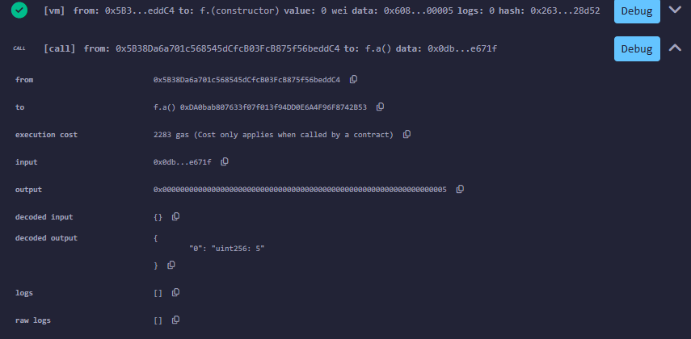
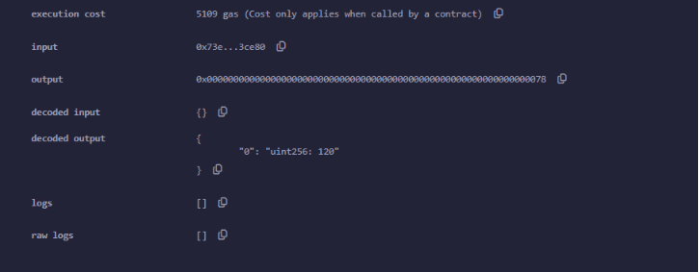

Practical 5D

Smart Contracts Basics

AIM: To develop a smart contract that checks whether the give number is prime or not.
CODE:
// SPDX-License-Identifier: UNLICENSED
pragma solidity ^0.8.0;
contract PrimeCheck {
uint public a;

constructor(uint _a) public {
a = _a;
}

function isPrime() public view returns (bool) {
if (a <= 1) {
return false;
}

for (uint256 i = 2; i * i <= a; i++) {
if (a % i == 0) {
return false;
}
}

return true;
}
}

OUTPUT:
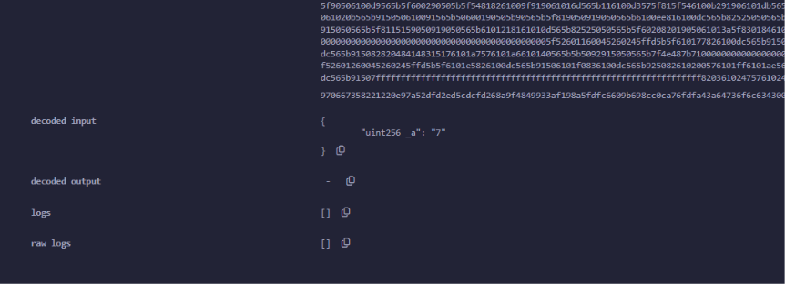
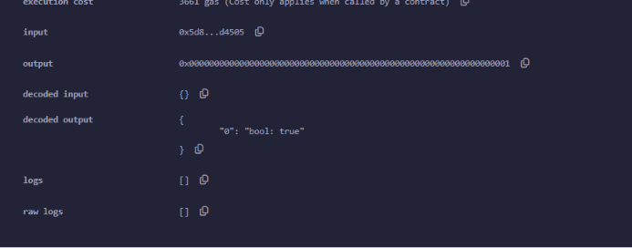

Practical 5E

Smart Contracts Basics

AIM: To create a smart contract that determines whether a given number is even or odd.
Code:
// SPDX-License-Identifier: UNLICENSED
pragma solidity ^0.8.0;

contract EvenOddCheck {
uint public a;

constructor(uint _a) public {
a = _a;
}

function isEven() public view returns (string memory) {
if (a % 2 == 0) {
return "Number is even";
} else {
return "Number is odd";
}
}
}
OUTPUT: EVEN
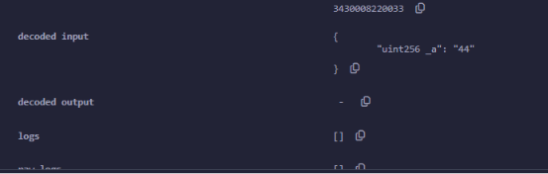
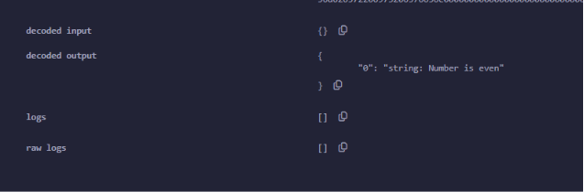

OUTPUT ODD:

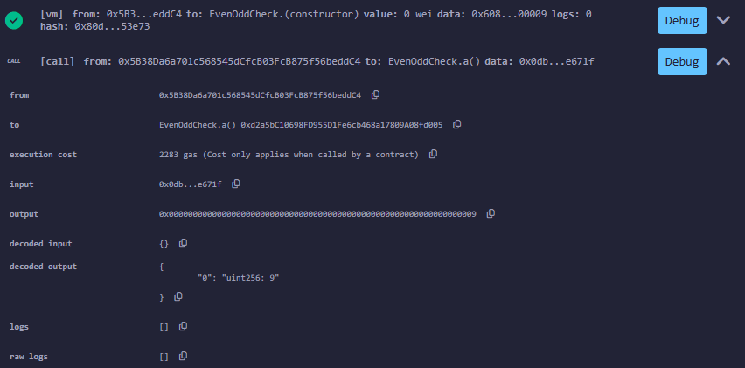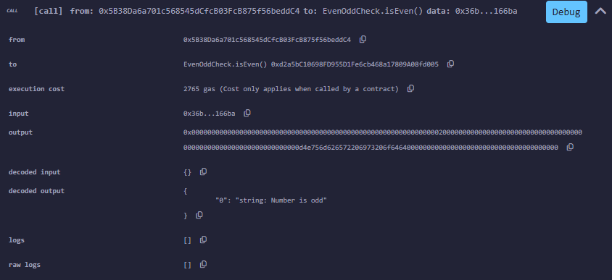

Practical 5F

Smart Contracts Basics

AIM: To develop a smart contract that displays the corresponding weekday based on the input number (1 to 7)
Code:
// SPDX-License-Identifier: UNLICENSED
pragma solidity ^0.8.0;

contract Weekday {

function getWeekday(uint8 day) public pure returns (string memory) {

if (day == 1) {
return "Monday";
} else if (day == 2) {
return "Tuesday";
} else if (day == 3) {
return "Wednesday";
} else if (day == 4) {
return "Thursday";
} else if (day == 5) {
return "Friday";
} else if (day == 6) {
return "Saturday";
} else if (day == 7) {
return "Sunday";
} else {
return "Invalid input";
}
}
}

OUTPUT:
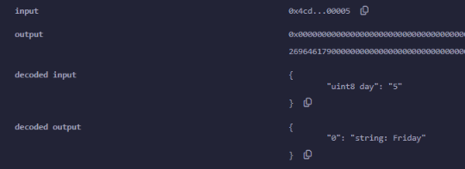

Practical 5G

Smart Contracts Basics

AIM: To implement a solidity structure for storing and retrieving a person details such as name and age.
Code:
// SPDX-License-Identifier: UNLICENSED
pragma solidity ^0.8.0;

contract SimpleStruct {
struct Person {
string name;
uint age;
}
Person public person;
function setPerson(string memory _name, uint _age) public {
person.name = _name;
person.age = _age;
}

function getPerson() public view returns (string memory, uint) {
return (person.name, person.age);
}
}

OUTPUT: SetPerson
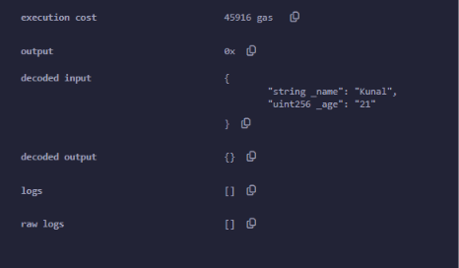

OUTPUT: GetPerson
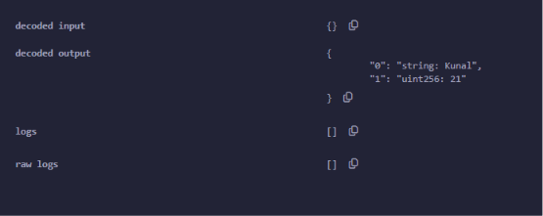

Practical 5G

Smart Contracts Basics

AIM: To create a smart contract that stores, retrieves and counts elements using a dynamic array in solidity.

CODE:
// SPDX-License-Identifier: UNLICENSED
pragma solidity ^0.8.0;

contract SimpleArray {

uint[] public numbers;

function addNumber(uint _number) public {
numbers.push(_number);
}

function getNumbers() public view returns (uint[] memory) {
return numbers;
}

function getNumberCount() public view returns (uint) {
return numbers.length;
}
}

OUTPUT:Inputted numbers:
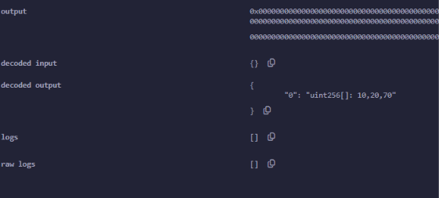
Number count:
