PRACTICAL 1A
(Installation of flask)
Aim: To install the Flask framework and set up the Python environment for developing web applications.

Steps to install flask:
- Check python version
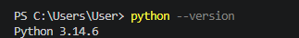

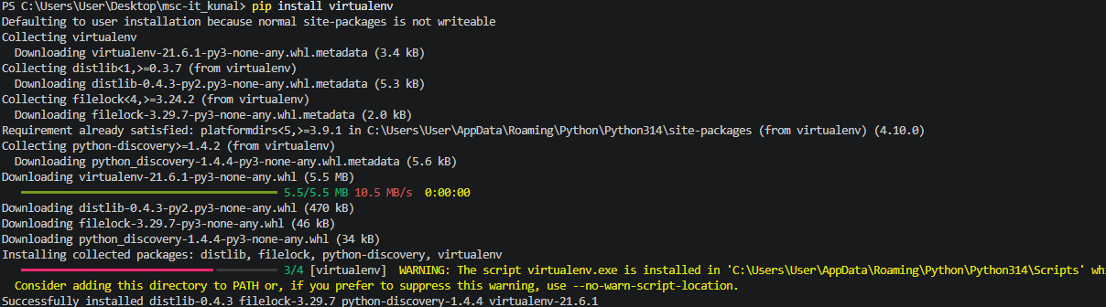
- Install virtual environment

- Run virtual environment
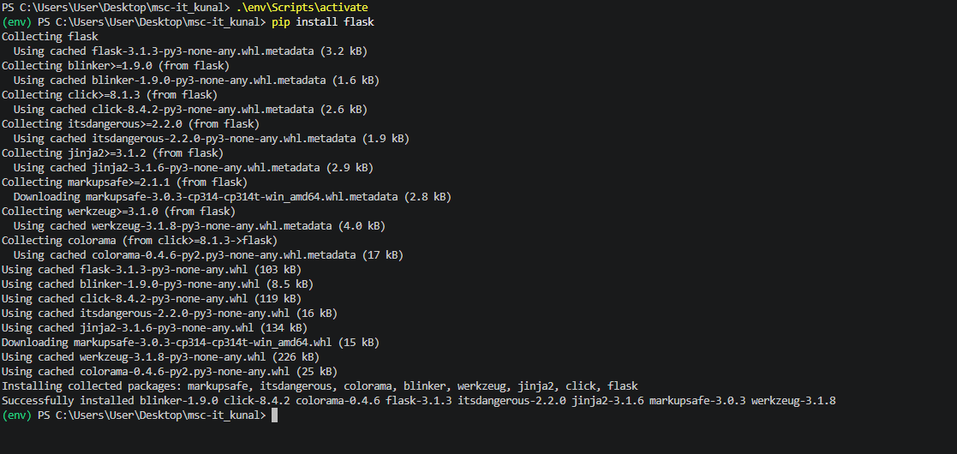
- Activate virtual environment & Install FLASK

Code: To check the flask version

import flask
print(flask.__version__)

OUTPUT:
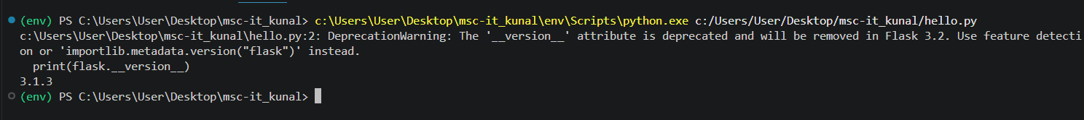

PRACTICAL 1B
(Creating a Simple Flask Web Application)

Aim:
To create a basic web application using the Flask framework that displays "Hello World" when the home page is accessed.

Code:
from flask import Flask

app = Flask(__name__)

@app.route('/')
def hello_world():
return "Hello World"

if __name__ == "__main__":
app.run(debug=True)

OUTPUT:
(env) PS C:\Users\User\Desktop\msc-it_kunal> & c:\Users\User\Desktop\msc-it_kunal\env\Scripts\python.exe c:/Users/User/Desktop/msc-it_kunal/hello_world.py
* Serving Flask app 'hello_world'
* Debug mode: on
WARNING: This is a development server. Do not use it in a production deployment. Use a production WSGI server instead.
* Running on http://127.0.0.1:5000
Press CTRL+C to quit
* Restarting with stat
* Debugger is active!
* Debugger PIN: 842-122-286
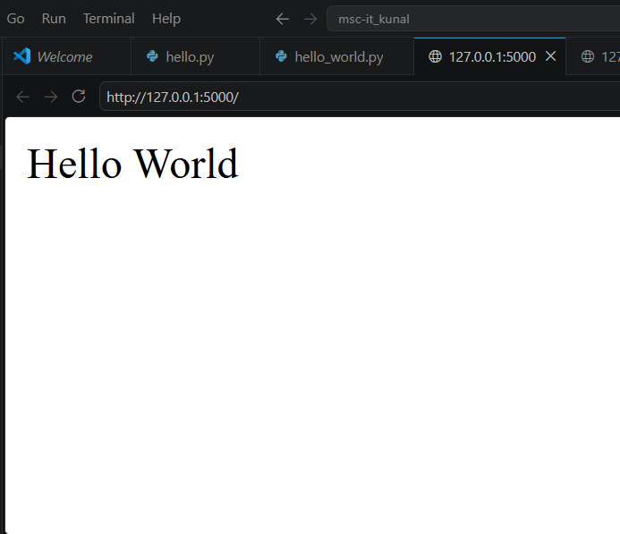
127.0.0.1 - - [13/Jul/2026 14:13:32] "GET / HTTP/1.1" 200 -

PRACTICAL 1B
(Age Calculator)

Aim: To create an Age Calculator web application using Flask that calculates and displays the user's age based on the entered date of birth.

Code:
Python File
from flask import Flask, render_template, request
from datetime import date, datetime

app = Flask(__name__)

@app.route('/', methods=['GET', 'POST'])
def age():
age = None

if request.method == 'POST':
dob = request.form['dob']

birth_date = datetime.strptime(dob, "%Y-%m-%d").date()
today = date.today()

age = today.year - birth_date.year

if (today.month, today.day) < (birth_date.month, birth_date.day):
age -= 1

return render_template('AGE.html', age=age)

if __name__ == "__main__":
app.run(debug=True)

Html File
<!DOCTYPE html>
<html lang="en">
<head>
<meta charset="UTF-8">
<meta name="viewport" content="width=device-width, initial-scale=1.0">
<title>Age Calculator</title>
<style>
body {
font-family: Arial, sans-serif;
background-color: #f2f2f2;
display: flex;
justify-content: center;
align-items: center;
height: 100vh;
}

.container {
background: white;
padding: 25px;
border-radius: 10px;
box-shadow: 0 0 10px rgba(0,0,0,0.2);
text-align: center;
width: 350px;
}

h2 {
color: #333;
}

input[type="date"] {
width: 100%;
padding: 10px;
margin: 15px 0;
font-size: 16px;
}

input[type="submit"] {
background-color: #007BFF;
color: white;
border: none;
padding: 10px 20px;
cursor: pointer;
border-radius: 5px;
font-size: 16px;
}

input[type="submit"]:hover {
background-color: #0056b3;
}

.result {
margin-top: 20px;
font-size: 20px;
color: green;
font-weight: bold;
}
</style>
</head>
<body>

<div class="container">
<h2>Age Calculator</h2>

<form method="POST">
<label>Select Your Date of Birth:</label><br>
<input type="date" name="dob" required><br>

<input type="submit" value="Calculate Age">
</form>

{% if age is not none %}
<div class="result">
Your Age is {{ age }} years.
</div>
{% endif %}
</div>

</body>
</html>

OUTPUT:
Follow the port link :
Running on http://127.0.0.1:5000
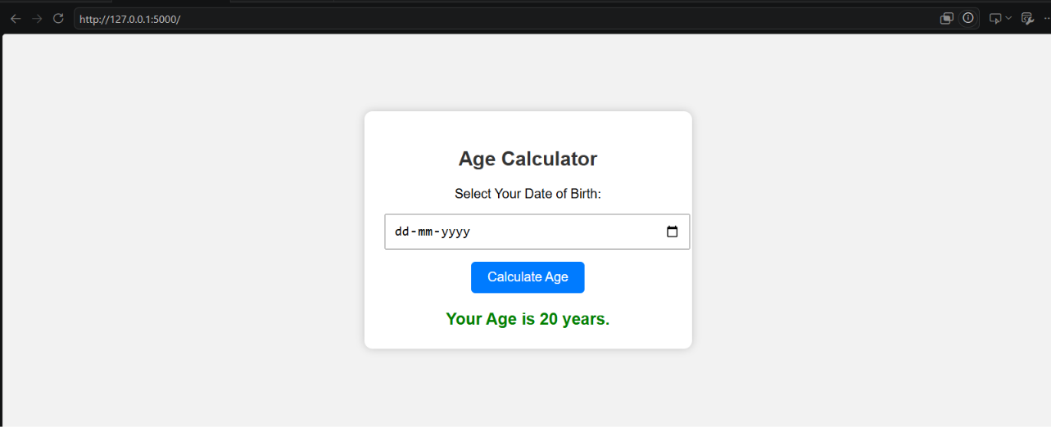

PRACTICAL 1C
(Emi Calculator)

Aim: To create an EMI Calculator web application using Flask that calculates and displays the monthly EMI based on the user's input.

Code:
Python File
from flask import Flask,render_template,request
app=Flask(__name__)

@app.route('/',methods=["GET","POST"])
def emi():
emi = None

if request.method == "POST":
principal = float(request.form["principal"])
rate = float(request.form["rate"])
years = int(request.form["years"])

monthly_rate = rate / (12 * 100)
months = years * 12

emi = (principal * monthly_rate * (1 + monthly_rate) ** months) / ((1 + monthly_rate) ** months - 1)

return render_template("index.html", emi=emi)

if __name__ == "__main__":
app.run(debug=True)

Html File

<!DOCTYPE html>
<html lang="en">
<head>
<meta charset="UTF-8">
<meta name="viewport" content="width=device-width, initial-scale=1.0">
<title>EMI Calculator</title>
<style>
body {
font-family: Arial, sans-serif;
background-color: #f2f2f2;
display: flex;
justify-content: center;
align-items: center;
height: 100vh;
}

.container {
background: white;
padding: 25px;
border-radius: 10px;
box-shadow: 0px 0px 10px rgba(0,0,0,0.2);
width: 350px;
text-align: center;
}

h2 {
color: #333;
}

input[type="number"] {
width: 100%;
padding: 10px;
margin: 10px 0;
font-size: 16px;
box-sizing: border-box;
}

input[type="submit"] {
background-color: #007BFF;
color: white;
border: none;
padding: 10px;
width: 100%;
cursor: pointer;
font-size: 16px;
border-radius: 5px;
}

input[type="submit"]:hover {
background-color: #0056b3;
}

.result {
margin-top: 20px;
font-size: 20px;
color: green;
font-weight: bold;
}
</style>
</head>
<body>

<div class="container">
<h2>EMI Calculator</h2>

<form method="POST">
<input type="number" name="principal" placeholder="Loan Amount" step="0.01" required>

<input type="number" name="rate" placeholder="Annual Interest Rate (%)" step="0.01" required>

<input type="number" name="years" placeholder="Loan Duration (Years)" required>

<input type="submit" value="Calculate EMI">
</form>

{% if emi is not none %}
<div class="result">
Monthly EMI: ₹{{ "%.2f"|format(emi) }}
</div>
{% endif %}
</div>

</body>
</html>

OUTPUT:
Follow the port link :
Running on http://127.0.0.1:5000

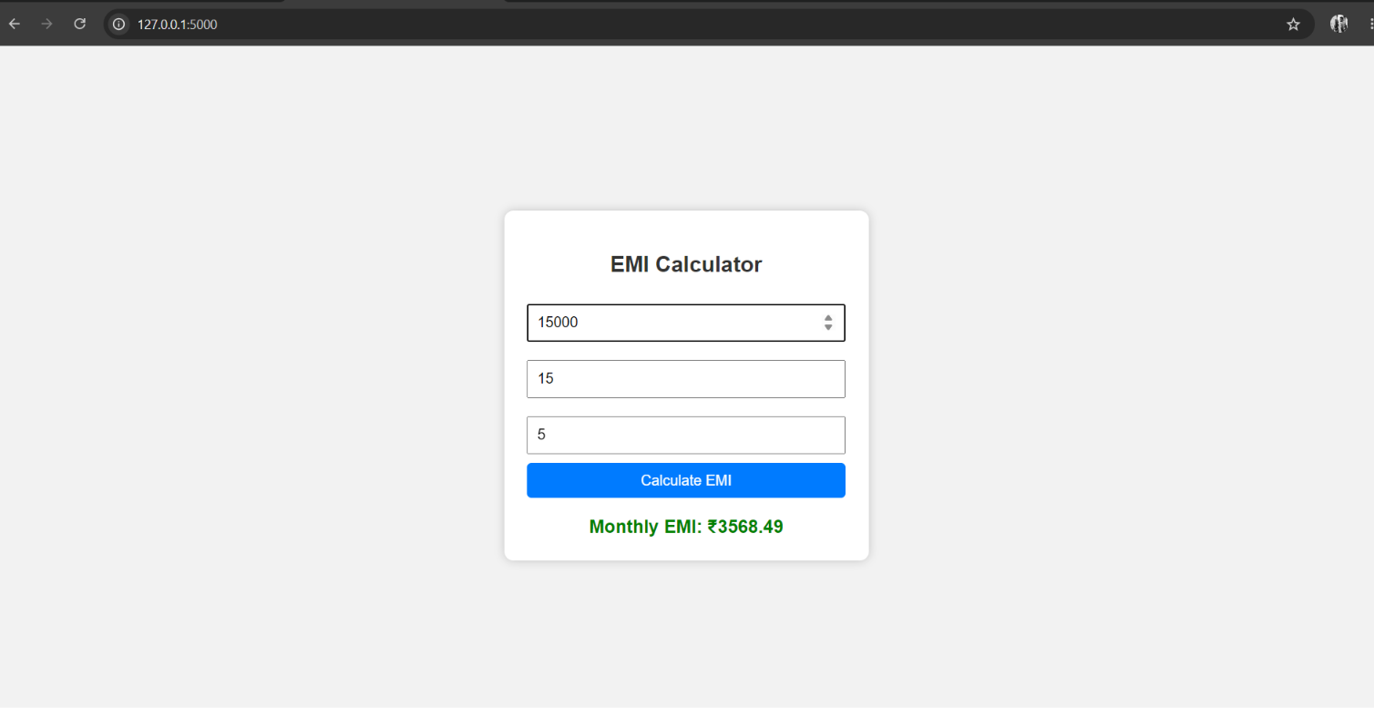
PRACTICAL 1C
(User Greeting Application Using Flask)
Aim: To create a Flask web application that takes a user's name as input and displays a personalized "Hello" greeting message.
Code:
Python File
from flask import Flask, request, render_template

app = Flask(__name__)

@app.route("/", methods=["GET", "POST"])
def home():
username = None

if request.method == "POST":
username = request.form.get("username", "")

return render_template("hellostring.html", username=username)

if __name__ == "__main__":
app.run(debug=True)

Html File
<!DOCTYPE html>
<html>
<head>
<title>Hello User</title>
</head>
<body>
<h2>Enter your Name</h2>

<form method="POST">
<input type="text" name="username" placeholder="Your name" required>
<button type="submit">Submit</button>
</form>

{% if username %}
<h1>Hello, {{ username }}!</h1>
{% endif %}
</body>
</html>

OUTPUT:
Follow the port link :
Running on http://127.0.0.1:5000

