PRACTICAL 7
TO CREATE VM USING VAGRANT
Aim: To create Virtual Machine using Vagrant
Step 1: Download Virtual Box
Go to official site.
https://www.virtualbox.org/wiki/Downloads
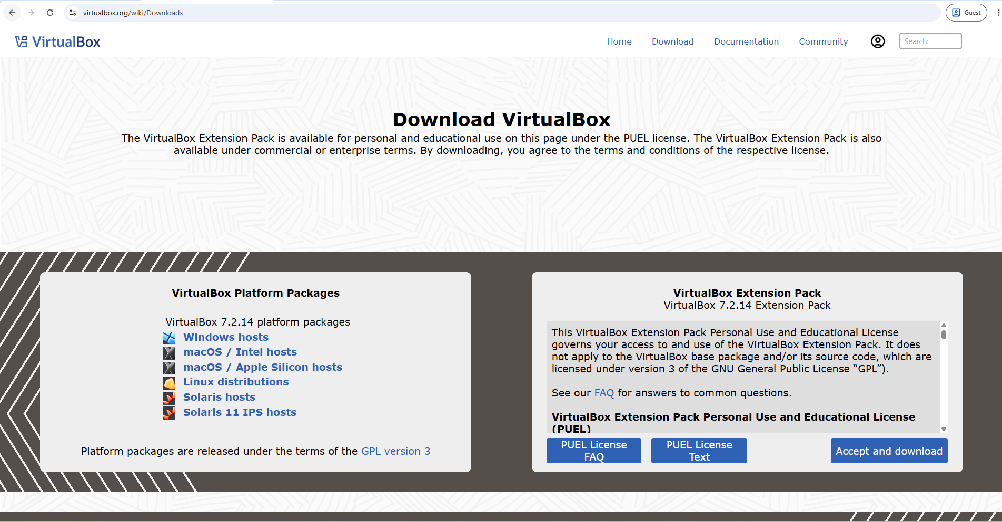
Accept and download virtual extension box.

Step 2: Download Vagrant
Install vagrant from official site
https://developer.hashicorp.com/vagrant/install
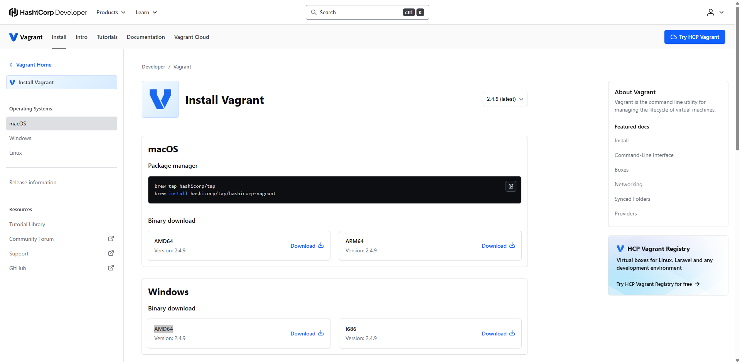
Get vagrant for windows

Step 3: Initialize vagrant
Create a folder for your VM Project e.g.,
‘mkdir vagrant_cm’
then
‘cd vagrant_cm’
Then to initialize vagrant project file in folder
‘vagrant init’
Step 4: Edit vagrant file and add this code in it.
Vagrant.configure("2") do |config|
config.vm.box = "ubuntu/bionic64"

config.vm.network "private_network", ip: "192.168.56.10"

config.vm.provider "virtualbox" do |vb|
vb.memory = 1024
vb.cpus = 2
end
end
Step 5: Launch the Virtual Machine
Run this command to create, configure and start Virtual Machine
‘vagrant up’
Step 6: Connect to the Virtual Machine
After the Virtual Machine starts, connect it using
‘vagrant ssh’
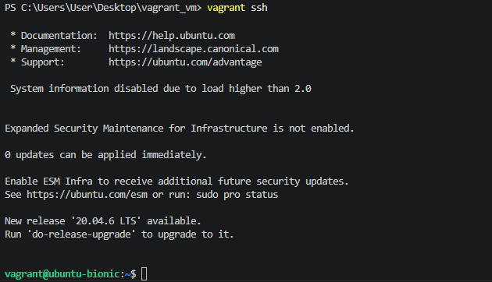
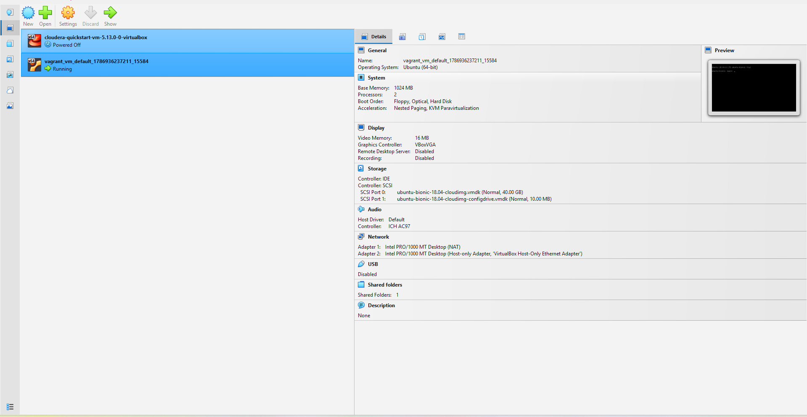
Step 7: Run exit to exit the Virtual Machine – exit

