Practical No. 1: Price Calculator (ES Modules)
Aim: To implement a Slab-based Price Calculator using JavaScript ES Modules (.mjs) demonstrating export and import statements in Node.js.
Main Logic Code:
// slab.mjs - Defines and exports rate slab definitions
export const slabs = [
{ name: 'Slab 1', minKm: 0, maxKm: 5, rate: 10 }, // 0–5 km: ₹10/km
{ name: 'Slab 2', minKm: 5, maxKm: 10, rate: 6 }, // 5–10 km: ₹6/km
{ name: 'Slab 3', minKm: 10, maxKm: Infinity, rate: 4 } // Above 10 km: ₹4/km
];

export default slabs;

// calc.mjs - Imports slab definitions and exports price calculation logic
import { slabs } from './slab.mjs';

export function calculatePrice(distance) {
const d = Number(distance) || 0;
let price = 0;

if (d <= 0) return 0;

// Slab 1: 0–5 km -> ₹10/km
if (d <= 5) {
price = d * slabs[0].rate;
}
// Slab 2: 5–10 km -> ₹6/km
else if (d <= 10) {
price = (5 * slabs[0].rate) + (d - 5) * slabs[1].rate;
}
// Slab 3: Above 10 km -> ₹4/km
else {
price = (5 * slabs[0].rate) + (5 * slabs[1].rate) + (d - 10) * slabs[2].rate;
}

return price;
}

export function getBreakdown(distance) {
const d = Number(distance) || 0;
if (d <= 0) return 'Distance must be greater than 0';

if (d <= 5) {
return `${d} km × ₹${slabs[0].rate} = ₹${d * slabs[0].rate}`;
} else if (d <= 10) {
return `(5 km × ₹${slabs[0].rate}) + (${d - 5} km × ₹${slabs[1].rate}) = ₹${calculatePrice(d)}`;
} else {
return `(5 km × ₹${slabs[0].rate}) + (5 km × ₹${slabs[1].rate}) + (${d - 10} km × ₹${slabs[2].rate}) = ₹${calculatePrice(d)}`;
}
}

// index.mjs - Main execution demonstrating ES Module imports
import { slabs } from './slab.mjs';
import { calculatePrice, getBreakdown } from './calc.mjs';

console.log('=========================================');
console.log(' Practical 1: Price Calculator (ESM .mjs)');
console.log('=========================================\n');

console.log('Rate Slabs Loaded from Module (slab.mjs):');
slabs.forEach((s) => {
const limit = s.maxKm === Infinity ? 'Above 10 km' : `${s.minKm}–${s.maxKm} km`;
console.log(` - ${s.name}: ${limit} @ ₹${s.rate}/km`);
});

console.log('\n--- Fare Calculations ---');
const testDistances = [3, 7, 15];

testDistances.forEach((distance) => {
console.log(`\nTrip Distance: ${distance} km`);
console.log(`Breakdown: ${getBreakdown(distance)}`);
console.log(`Total Price: ₹${calculatePrice(distance)}`);
});
Output:
The modular program is executed in Node.js ('node index.mjs'). The calculation logic in calc.mjs imports the rate slabs exported by slab.mjs, computes the fare based on distance brackets, and displays formatted breakdowns.

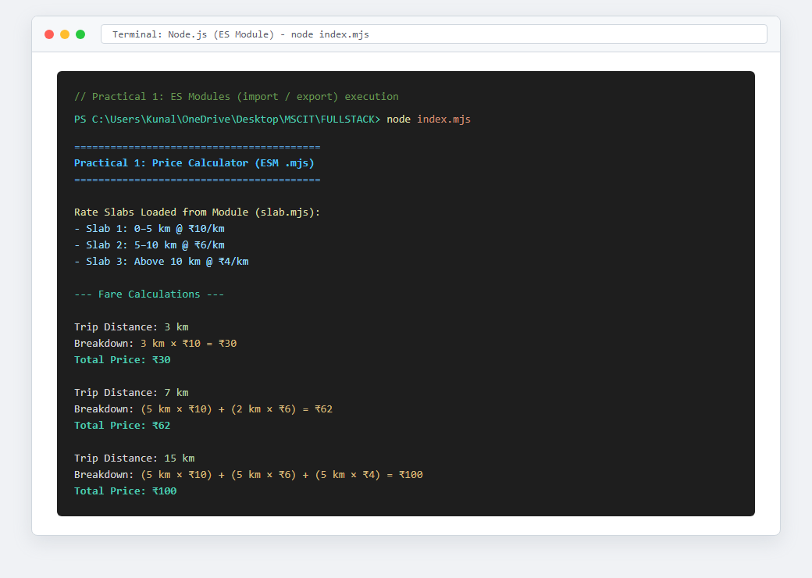
Figure: Execution Output of Practical 1

