Practical No. 2: Counter App
Aim: To demonstrate Text Interpolation, Event Handling, Custom Events, and 2-way data binding using a Counter App in Angular.
Main Logic Code:
// prac2-counter.ts
import { Component, EventEmitter, Output } from '@angular/core';
import { CommonModule } from '@angular/common';
import { FormsModule } from '@angular/forms';

@Component({
selector: 'app-prac2-counter',
standalone: true,
imports: [CommonModule, FormsModule],
templateUrl: './prac2-counter.html'
})
export class Prac2CounterComponent {
// 1. Text Interpolation
count: number = 0;
message: string = 'Counter initialized.';

// 2. Two-way Data Binding
step: number = 1;
threshold: number = 10;
customEventMsg: string = '';

// 3. Custom Event Output
@Output() thresholdReached = new EventEmitter<number>();

checkThreshold(): void {
if (Math.abs(this.count) >= this.threshold) {
this.customEventMsg = `Custom Event Fired: Count reached ${this.count} (Threshold: ${this.threshold})`;
this.thresholdReached.emit(this.count);
} else {
this.customEventMsg = '';
}
}

// 4. Event Handlers
increment(): void {
this.count += (Number(this.step) || 1);
this.message = `Incremented by ${this.step}`;
this.checkThreshold();
}

decrement(): void {
this.count -= (Number(this.step) || 1);
this.message = `Decremented by ${this.step}`;
this.checkThreshold();
}

reset(): void {
this.count = 0;
this.message = 'Counter reset to 0.';
this.customEventMsg = '';
}
}

<!-- prac2-counter.html -->
<h2>Practical 2: Counter App</h2>
<p>Concepts: Text Interpolation, Event Handling, Custom Events, and 2-Way Data Binding</p>
<hr>

<!-- 1. Text Interpolation -->
<h3>Current Count: {{ count }}</h3>
<p>Status: {{ message }}</p>
<p *ngIf="customEventMsg"><b>{{ customEventMsg }}</b></p>

<!-- 2. Event Handling -->
<div>
<button (click)="decrement()">Decrement (-{{ step }})</button>
<button (click)="reset()">Reset</button>
<button (click)="increment()">Increment (+{{ step }})</button>
</div>
<hr>

<!-- 3. Two-Way Data Binding -->
<h3>2-Way Data Binding Settings</h3>
<p>Step Value: <input type="number" [(ngModel)]="step"></p>
<p>Threshold Limit: <input type="number" [(ngModel)]="threshold"></p>
<p>Bound Step Value: <b>{{ step }}</b></p>
<p>Bound Threshold Limit: <b>{{ threshold }}</b></p>
Output:
The counter supports variable step increments and decrements via two-way data binding. When the count reaches or crosses the threshold of 10, the custom event is fired and displayed.

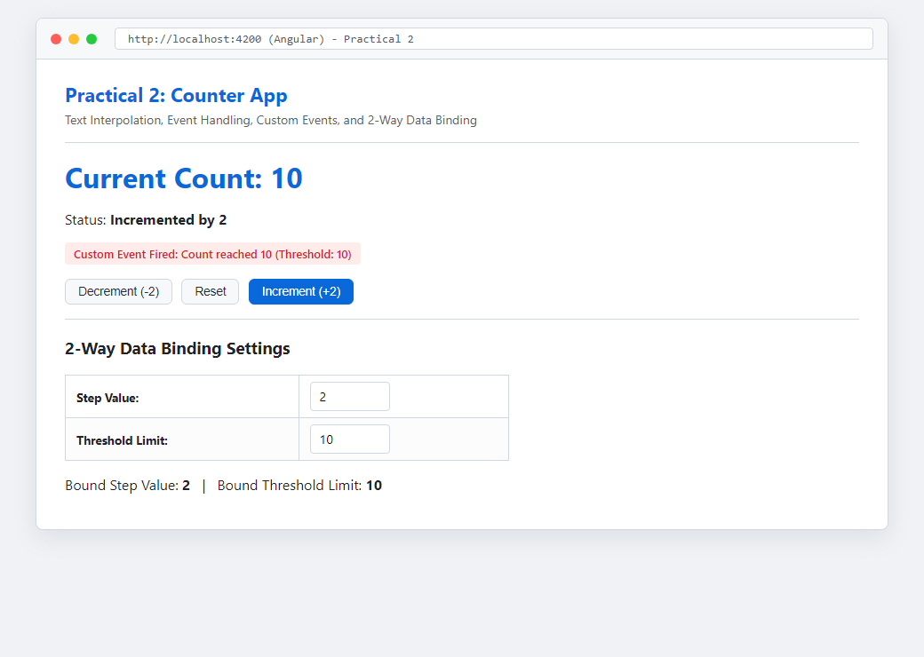
Figure: Execution Output of Practical 2

