Practical No. 3: Timer App
Aim: To implement Conditional Rendering (*ngIf) and List Rendering (*ngFor) using a Timer App in Angular.
Main Logic Code:
// prac3-timer.ts
import { Component, OnDestroy } from '@angular/core';
import { CommonModule } from '@angular/common';

interface LapItem {
lapNumber: number;
time: string;
}

@Component({
selector: 'app-prac3-timer',
standalone: true,
imports: [CommonModule],
templateUrl: './prac3-timer.html'
})
export class Prac3TimerComponent implements OnDestroy {
seconds: number = 0;
isRunning: boolean = false;
laps: LapItem[] = [];
private intervalId: any = null;

startTimer(): void {
if (!this.isRunning) {
this.isRunning = true;
this.intervalId = setInterval(() => {
this.seconds++;
}, 1000);
}
}

pauseTimer(): void {
if (this.isRunning) {
clearInterval(this.intervalId);
this.isRunning = false;
}
}

resetTimer(): void {
this.pauseTimer();
this.seconds = 0;
this.laps = [];
}

recordLap(): void {
if (this.seconds > 0) {
this.laps.push({
lapNumber: this.laps.length + 1,
time: `${this.seconds} seconds`
});
}
}

ngOnDestroy(): void {
if (this.intervalId) {
clearInterval(this.intervalId);
}
}
}

<!-- prac3-timer.html -->
<h2>Practical 3: Timer App</h2>
<p>Concepts: Conditional Rendering (*ngIf) and List Rendering (*ngFor)</p>
<hr>

<h2>Time: {{ seconds }} seconds</h2>

<!-- 1. Conditional Rendering using *ngIf -->
<div>
<p *ngIf="isRunning">Status: <b>Timer is Running...</b></p>
<p *ngIf="!isRunning && seconds > 0">Status: <b>Timer is Paused.</b></p>
<p *ngIf="!isRunning && seconds === 0">Status: <b>Timer is Reset (Idle).</b></p>
</div>

<!-- Controls -->
<div>
<button (click)="startTimer()" [disabled]="isRunning">Start</button>
<button (click)="pauseTimer()" [disabled]="!isRunning">Pause</button>
<button (click)="recordLap()" [disabled]="!isRunning">Lap</button>
<button (click)="resetTimer()">Reset</button>
</div>
<hr>

<!-- 2. List Rendering using *ngFor -->
<h3>Recorded Laps (List Rendering)</h3>
<p *ngIf="laps.length === 0">No laps recorded yet. Click 'Lap' while timer is running.</p>

<table border="1" cellpadding="5" *ngIf="laps.length > 0">
<thead>
<tr>
<th>Lap #</th>
<th>Recorded Time</th>
</tr>
</thead>
<tbody>
<tr *ngFor="let item of laps">
<td>Lap {{ item.lapNumber }}</td>
<td>{{ item.time }}</td>
</tr>
</tbody>
</table>
Output:
The timer demonstrates conditional state rendering (*ngIf for running/paused status) and dynamic list rendering (*ngFor for rendering recorded lap times in a table).

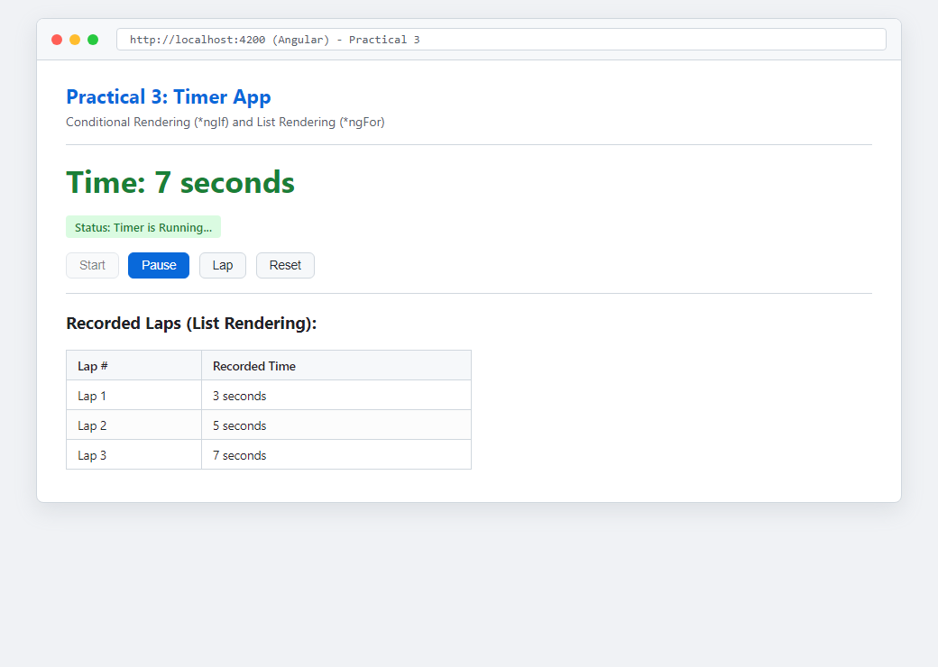
Figure: Execution Output of Practical 3

