Practical No. 4: Routing using Timer and Stopwatch App
Aim: To implement Routing and Single Page View Navigation between Countdown Timer and Stopwatch in Angular.
Main Logic Code:
// prac4-routing.ts
import { Component, OnDestroy } from '@angular/core';
import { CommonModule } from '@angular/common';
import { FormsModule } from '@angular/forms';

@Component({
selector: 'app-prac4-routing',
standalone: true,
imports: [CommonModule, FormsModule],
templateUrl: './prac4-routing.html'
})
export class Prac4RoutingComponent implements OnDestroy {
activeView: 'timer' | 'stopwatch' = 'timer';

// Countdown Timer State
inputMinutes: number = 1;
remainingSeconds: number = 60;
timerRunning: boolean = false;
private timerInterval: any = null;

// Stopwatch State
stopwatchSeconds: number = 0;
stopwatchRunning: boolean = false;
private stopwatchInterval: any = null;

setView(view: 'timer' | 'stopwatch'): void {
this.activeView = view;
}

// Timer Methods
startTimer(): void {
if (!this.timerRunning) {
if (this.remainingSeconds <= 0) {
this.remainingSeconds = (this.inputMinutes || 1) * 60;
}
this.timerRunning = true;
this.timerInterval = setInterval(() => {
if (this.remainingSeconds > 0) {
this.remainingSeconds--;
} else {
this.stopTimer();
alert('Countdown Finished!');
}
}, 1000);
}
}

stopTimer(): void {
if (this.timerRunning) {
clearInterval(this.timerInterval);
this.timerRunning = false;
}
}

resetTimer(): void {
this.stopTimer();
this.remainingSeconds = (this.inputMinutes || 1) * 60;
}

// Stopwatch Methods
startStopwatch(): void {
if (!this.stopwatchRunning) {
this.stopwatchRunning = true;
this.stopwatchInterval = setInterval(() => {
this.stopwatchSeconds++;
}, 1000);
}
}

pauseStopwatch(): void {
if (this.stopwatchRunning) {
clearInterval(this.stopwatchInterval);
this.stopwatchRunning = false;
}
}

resetStopwatch(): void {
this.pauseStopwatch();
this.stopwatchSeconds = 0;
}

ngOnDestroy(): void {
if (this.timerInterval) clearInterval(this.timerInterval);
if (this.stopwatchInterval) clearInterval(this.stopwatchInterval);
}
}

<!-- prac4-routing.html -->
<h2>Practical 4: Routing using Timer and Stopwatch App</h2>
<p>Concepts: Single Page Component Navigation between Countdown Timer and Stopwatch</p>
<hr>

<!-- Navigation links -->
<div>
<b>Navigation: </b>
<button (click)="setView('timer')" [disabled]="activeView === 'timer'">Go to Countdown Timer</button> |
<button (click)="setView('stopwatch')" [disabled]="activeView === 'stopwatch'">Go to Stopwatch</button>
</div>
<hr>

<!-- Timer View -->
<div *ngIf="activeView === 'timer'">
<h3>Countdown Timer View</h3>
<p>Set duration (Minutes): <input type="number" [(ngModel)]="inputMinutes" min="1"></p>
<h3>Remaining Time: {{ remainingSeconds }} seconds</h3>
<div>
<button (click)="startTimer()" [disabled]="timerRunning">Start Timer</button>
<button (click)="stopTimer()" [disabled]="!timerRunning">Stop Timer</button>
<button (click)="resetTimer()">Reset</button>
</div>
</div>

<!-- Stopwatch View -->
<div *ngIf="activeView === 'stopwatch'">
<h3>Stopwatch View</h3>
<h3>Elapsed Time: {{ stopwatchSeconds }} seconds</h3>
<div>
<button (click)="startStopwatch()" [disabled]="stopwatchRunning">Start</button>
<button (click)="pauseStopwatch()" [disabled]="!stopwatchRunning">Pause</button>
<button (click)="resetStopwatch()">Reset</button>
</div>
</div>
Output:
Demonstrates client-side view switching without page reload between a configurable Countdown Timer view and a real-time Stopwatch view.

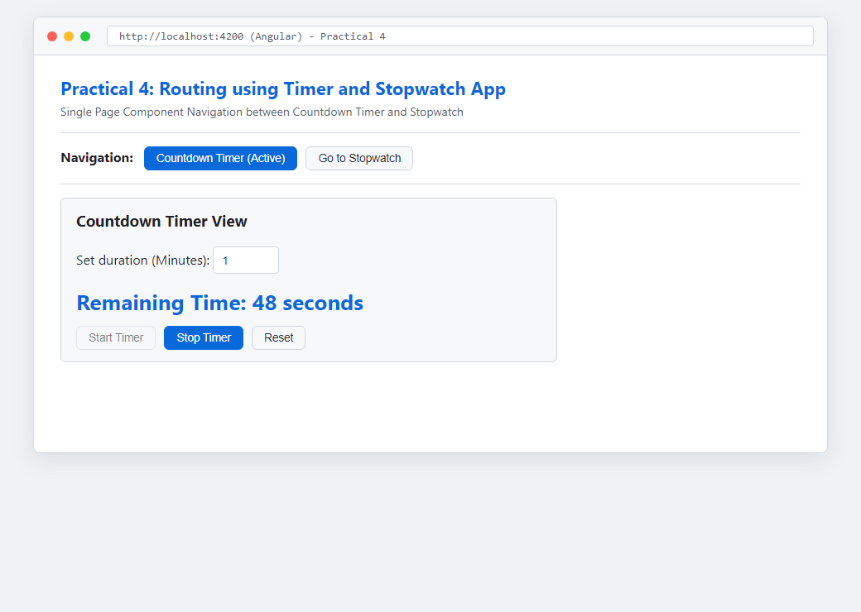
Figure: Execution Output of Practical 4

