Practical No. 5: HTTP Calls using REST API (Angular)
Aim: To fetch and display data from a REST API using HTTP GET calls with Angular HttpClient.
Main Logic Code:
// prac5-http.ts
import { Component, OnInit } from '@angular/core';
import { CommonModule } from '@angular/common';
import { HttpClient } from '@angular/common/http';

interface User {
id: number;
name: string;
email: string;
phone: string;
company: { name: string };
address: { city: string };
}

@Component({
selector: 'app-prac5-http',
standalone: true,
imports: [CommonModule],
templateUrl: './prac5-http.html'
})
export class Prac5HttpComponent implements OnInit {
users: User[] = [];
loading: boolean = false;
error: string | null = null;

constructor(private http: HttpClient) {}

ngOnInit(): void {
this.fetchUsers();
}

fetchUsers(): void {
this.loading = true;
this.error = null;

this.http.get<User[]>('https://jsonplaceholder.typicode.com/users')
.subscribe({
next: (data) => {
this.users = data;
this.loading = false;
},
error: (err) => {
this.error = err.message || 'Failed to fetch users';
this.loading = false;
}
});
}
}

<!-- prac5-http.html -->
<h2>Practical 5: HTTP Calls using REST API (Angular)</h2>
<p>Concepts: Consuming REST API using Angular HttpClient and Observable subscription</p>
<hr>

<button (click)="fetchUsers()">Refresh / Fetch Data</button>
<br><br>

<div *ngIf="loading">
<p><b>Loading data from API... Please wait.</b></p>
</div>

<div *ngIf="error" style="color: red;">
<p><b>Error: {{ error }}</b></p>
</div>

<div *ngIf="!loading && !error">
<h3>Users List ({{ users.length }} records):</h3>
<table border="1" cellpadding="5">
<thead>
<tr>
<th>ID</th>
<th>Name</th>
<th>Email</th>
<th>Phone</th>
<th>Company</th>
<th>City</th>
</tr>
</thead>
<tbody>
<tr *ngFor="let user of users">
<td>{{ user.id }}</td>
<td>{{ user.name }}</td>
<td>{{ user.email }}</td>
<td>{{ user.phone }}</td>
<td>{{ user.company.name }}</td>
<td>{{ user.address.city }}</td>
</tr>
</tbody>
</table>
</div>
Output:
The Angular component injects HttpClient, issues a GET request to JSONPlaceholder on initialization via ngOnInit, manages loading and error states, and renders records using *ngFor.

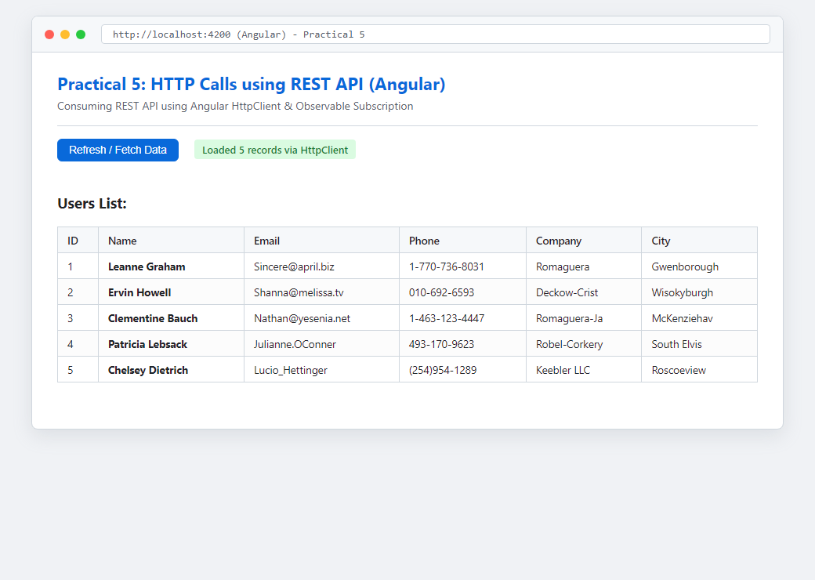
Figure: Execution Output of Practical 5

