Practical No. 6: Posting Data to REST API (Angular)
Aim: To submit user data to a REST API using HTTP POST in Angular with template-driven form handling.
Main Logic Code:
// prac6-post.ts
import { Component } from '@angular/core';
import { CommonModule } from '@angular/common';
import { FormsModule } from '@angular/forms';
import { HttpClient } from '@angular/common/http';

interface PostResponse {
id: number;
title: string;
body: string;
userId: number;
}

@Component({
selector: 'app-prac6-post',
standalone: true,
imports: [CommonModule, FormsModule],
templateUrl: './prac6-post.html'
})
export class Prac6PostComponent {
userId: number = 1;
title: string = '';
body: string = '';
loading: boolean = false;
statusMessage: string = '';
responseResult: PostResponse | null = null;
postsList: PostResponse[] = [];

constructor(private http: HttpClient) {}

handleSubmit(): void {
if (!this.title.trim() || !this.body.trim()) {
alert('Please fill all fields.');
return;
}

this.loading = true;
this.statusMessage = 'Posting data to REST API...';
this.responseResult = null;

const payload = {
title: this.title,
body: this.body,
userId: Number(this.userId)
};

this.http.post<PostResponse>('https://jsonplaceholder.typicode.com/posts', payload)
.subscribe({
next: (res) => {
this.loading = false;
this.statusMessage = 'Data posted successfully! (HTTP 201 Created)';
this.responseResult = res;
this.postsList.unshift(res);
this.title = '';
this.body = '';
},
error: (err) => {
this.loading = false;
this.statusMessage = 'Error: ' + (err.message || 'Failed to post data');
}
});
}
}

<!-- prac6-post.html -->
<h2>Practical 6: Posting Data to REST API (Angular)</h2>
<p>Concepts: Submitting Data using Angular HttpClient POST with Template-Driven Form</p>
<hr>

<h3>Create New Post</h3>
<form (ngSubmit)="handleSubmit()">
<table>
<tr>
<td>User ID:</td>
<td><input type="number" [(ngModel)]="userId" name="userId" min="1"></td>
</tr>
<tr>
<td>Post Title:</td>
<td><input type="text" [(ngModel)]="title" name="title" placeholder="Enter title" size="40"></td>
</tr>
<tr>
<td>Post Body:</td>
<td><textarea [(ngModel)]="body" name="body" placeholder="Enter body content" rows="4" cols="42"></textarea></td>
</tr>
<tr>
<td></td>
<td><button type="submit" [disabled]="loading">{{ loading ? 'Submitting...' : 'Post Data (Submit)' }}</button></td>
</tr>
</table>
</form>

<br>
<p *ngIf="statusMessage"><b>{{ statusMessage }}</b></p>

<div *ngIf="responseResult">
<hr>
<h3>API Response Received:</h3>
<pre style="background: #eee; padding: 10px;">{{ responseResult | json }}</pre>
</div>

<div *ngIf="postsList.length > 0">
<hr>
<h3>Recently Submitted Posts:</h3>
<table border="1" cellpadding="5">
<thead>
<tr>
<th>Assigned ID</th>
<th>Title</th>
<th>Body</th>
<th>User ID</th>
</tr>
</thead>
<tbody>
<tr *ngFor="let post of postsList">
<td>{{ post.id }}</td>
<td>{{ post.title }}</td>
<td>{{ post.body }}</td>
<td>{{ post.userId }}</td>
</tr>
</tbody>
</table>
</div>
Output:
Submits form data to the REST API via Angular HttpClient POST, receives HTTP 201 Created response containing the newly assigned ID, displays response JSON using Angular's json pipe, and appends the post into the submitted items list.

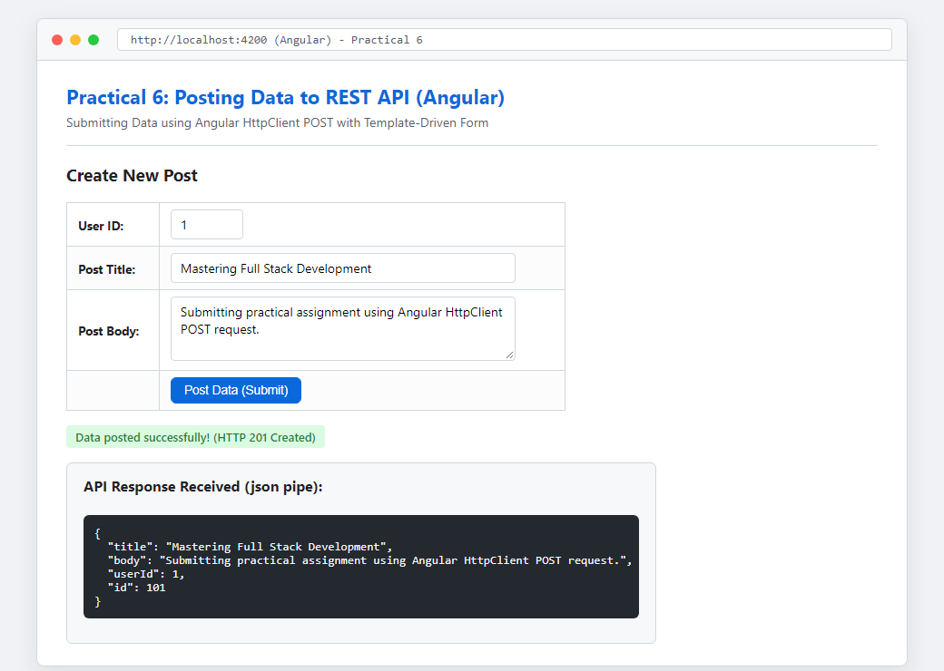
Figure: Execution Output of Practical 6

