Practical No. 7: React Counter Application
Aim: To demonstrate Components, Conditional Rendering, List Rendering, Text Interpolation, and Form Handling using the Counter App in React.
Main Logic Code:
// Practical7_ReactCounterApp.jsx
import React, { useState } from 'react';

// Subcomponent 1: Display
function CounterDisplay({ count }) {
return (
<div>
<h2>Current Count: {count}</h2>
{count > 0 && <p>Condition: <b>Count is Positive (+)</b></p>}
{count < 0 && <p>Condition: <b>Count is Negative (-)</b></p>}
{count === 0 && <p>Condition: <b>Count is Zero</b></p>}
{Math.abs(count) >= 20 && <p><b>Warning: Threshold of 20 exceeded!</b></p>}
</div>
);
}

// Subcomponent 2: Controls
function CounterControls({ onIncrement, onDecrement, onReset, step }) {
return (
<div>
<button onClick={onDecrement}>Decrement (-{step})</button>{' '}
<button onClick={onReset}>Reset</button>{' '}
<button onClick={onIncrement}>Increment (+{step})</button>
</div>
);
}

// Subcomponent 3: Form
function ConfigForm({ step, onStepChange, onAddNote }) {
const [note, setNote] = useState('');

const handleSubmit = (e) => {
e.preventDefault();
if (note.trim()) {
onAddNote(note);
setNote('');
}
};

return (
<form onSubmit={handleSubmit}>
<h3>Form Handling (Step & Log)</h3>
<p>
Step Size:
<input
type="number"
value={step}
onChange={(e) => onStepChange(Number(e.target.value) || 1)}
min="1"
/>
</p>
<p>
Activity Note:
<input
type="text"
value={note}
onChange={(e) => setNote(e.target.value)}
placeholder="e.g. Added 5"
/>{' '}
<button type="submit">Submit Note</button>
</p>
</form>
);
}

// Subcomponent 4: History list
function HistoryList({ history }) {
return (
<div>
<h3>Activity History (List Rendering)</h3>
{history.length === 0 ? (
<p>No activity recorded yet.</p>
) : (
<table border="1" cellPadding="5">
<thead>
<tr>
<th>#</th>
<th>Action</th>
<th>Value</th>
<th>Note</th>
<th>Time</th>
</tr>
</thead>
<tbody>
{history.map((item, idx) => (
<tr key={item.id}>
<td>{idx + 1}</td>
<td>{item.action}</td>
<td>{item.value}</td>
<td>{item.note}</td>
<td>{item.time}</td>
</tr>
))}
</tbody>
</table>
)}
</div>
);
}

// Main Component
export default function Practical7_ReactCounterApp() {
const [count, setCount] = useState(0);
const [step, setStep] = useState(1);
const [history, setHistory] = useState([]);

const logHistory = (action, val, note) => {
setHistory((prev) => [
{
id: Date.now() + Math.random(),
action,
value: val,
note: note || '-',
time: new Date().toLocaleTimeString(),
},
...prev,
]);
};

const handleIncrement = () => {
const next = count + step;
setCount(next);
logHistory('Increment', next, 'Added ' + step);
};

const handleDecrement = () => {
const next = count - step;
setCount(next);
logHistory('Decrement', next, 'Subtracted ' + step);
};

const handleReset = () => {
setCount(0);
logHistory('Reset', 0, 'Reset to 0');
};

const handleAddNote = (note) => {
logHistory('User Note', count, note);
};

return (
<div>
<h2>Practical 7: React Counter Application</h2>
<p>Components, Conditional Rendering, List Rendering, Text Interpolation & Form Handling</p>
<hr />

<CounterDisplay count={count} />
<br />
<CounterControls
onIncrement={handleIncrement}
onDecrement={handleDecrement}
onReset={handleReset}
step={step}
/>
<hr />
<ConfigForm step={step} onStepChange={setStep} onAddNote={handleAddNote} />
<hr />
<HistoryList history={history} />
</div>
);
}
Output:
Combines four subcomponents with state management: display with condition check, step controls, interactive form submission, and activity history table list rendering.

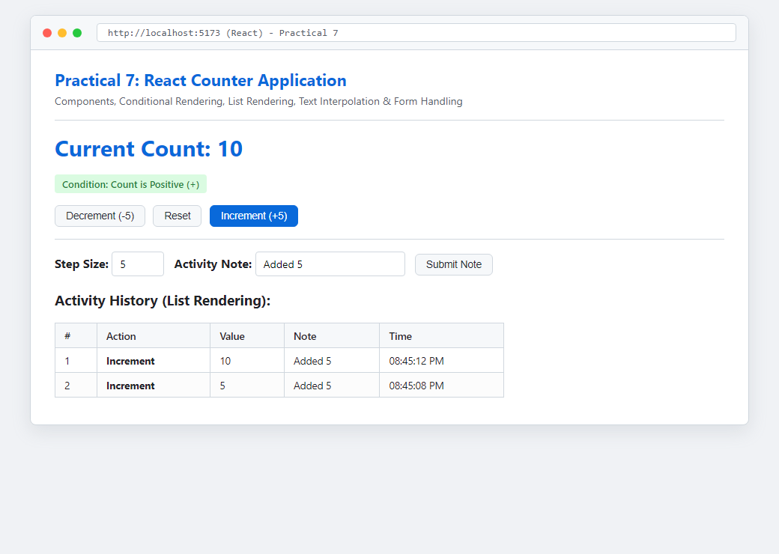
Figure: Execution Output of Practical 7

