Practical No. 8: HTTPS Calls in React Component
Aim: To implement secure HTTPS API calls using async/await, error handling, and query filters in a React Component.
Main Logic Code:
// Practical8_HttpsCallsReact.jsx
import React, { useState, useEffect } from 'react';

export default function Practical8_HttpsCallsReact() {
const [posts, setPosts] = useState([]);
const [filteredPosts, setFilteredPosts] = useState([]);
const [searchTerm, setSearchTerm] = useState('');
const [limit, setLimit] = useState(5);
const [loading, setLoading] = useState(false);
const [error, setError] = useState(null);

const fetchHttpsData = async (countLimit) => {
setLoading(true);
setError(null);

try {
const url = `https://jsonplaceholder.typicode.com/posts?_limit=${countLimit || limit}`;
const response = await fetch(url);

if (!response.ok) {
throw new Error(`HTTPS Request failed! Status: ${response.status}`);
}

const data = await response.json();
setPosts(data);
setFilteredPosts(data);
} catch (err) {
setError(err.message || 'HTTPS request failed');
} finally {
setLoading(false);
}
};

useEffect(() => {
fetchHttpsData(limit);
}, [limit]);

const handleSearch = (e) => {
const query = e.target.value;
setSearchTerm(query);

if (!query.trim()) {
setFilteredPosts(posts);
} else {
const filtered = posts.filter((post) =>
post.title.toLowerCase().includes(query.toLowerCase())
);
setFilteredPosts(filtered);
}
};

return (
<div>
<h2>Practical 8: HTTPS Calls in React Component</h2>
<p>Secure HTTPS endpoint with async/await, error handling & live filter</p>
<hr />

<p>
Fetch Records Count:
<select value={limit} onChange={(e) => setLimit(Number(e.target.value))}>
<option value="5">5 records</option>
<option value="10">10 records</option>
</select>
</p>
<p>
Search / Filter by Title:
<input
type="text"
value={searchTerm}
onChange={handleSearch}
placeholder="Filter fetched posts..."
/>
</p>

{loading && <p><b>[HTTPS] Connecting to secure endpoint... Please wait.</b></p>}
{error && <p><b>[HTTPS Error]: {error}</b></p>}

{!loading && !error && (
<div>
<h3>Fetched Results ({filteredPosts.length} of {posts.length} shown)</h3>
<table border="1" cellPadding="5">
<thead>
<tr>
<th>Post ID</th>
<th>User ID</th>
<th>Title</th>
<th>Body</th>
</tr>
</thead>
<tbody>
{filteredPosts.map((post) => (
<tr key={post.id}>
<td>{post.id}</td>
<td>{post.userId}</td>
<td><b>{post.title}</b></td>
<td>{post.body}</td>
</tr>
))}
</tbody>
</table>
</div>
)}
</div>
);
}
Output:
Demonstrates an asynchronous secure HTTPS GET call with async/await, try/catch/finally error handling, dynamic limit selection, and live client-side title search filtering.

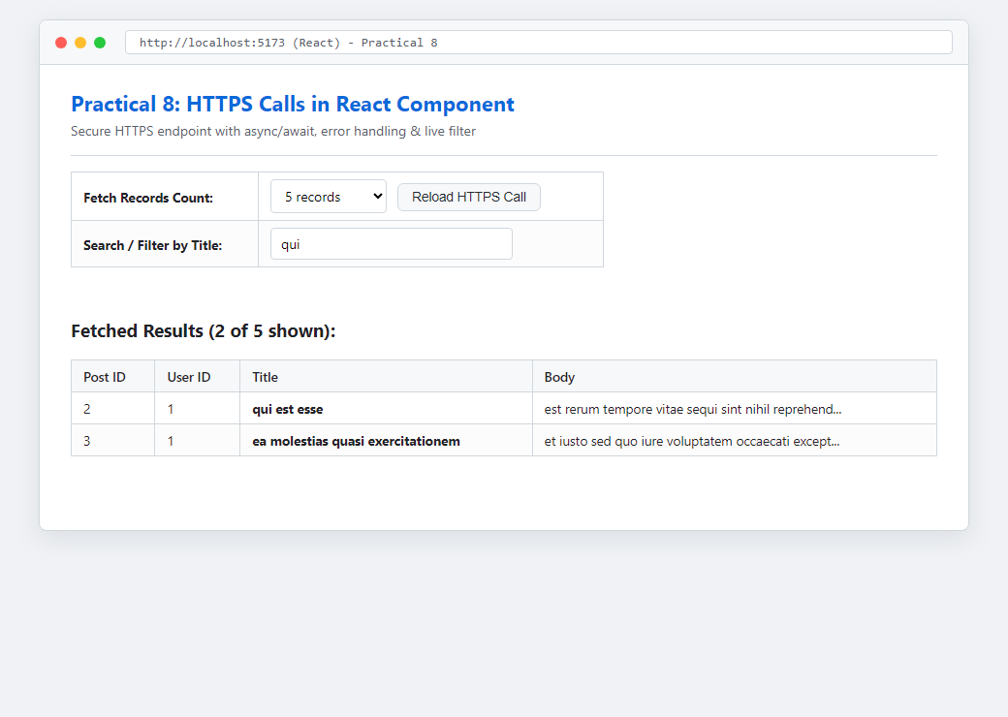
Figure: Execution Output of Practical 8

