PRACTICAL NO: 6
Comparing Algorithms

Aim: Comparing Different algorithms to check which give more accuracy score
NAIVE BAYES ALGORITHM
CODE:
import pandas as pd
from sklearn.model_selection import train_test_split
from sklearn.preprocessing import StandardScaler
from sklearn.naive_bayes import GaussianNB
from sklearn.metrics import (accuracy_score,confusion_matrix,precision_score,recall_score,roc_curve,auc)
import matplotlib.pyplot as plt
import numpy as np
file_path= "data (1).csv"
data = pd.read_csv(file_path)
X= data.drop(columns=['fail'])
y= data['fail']
scaler = StandardScaler()
X_scaled = scaler.fit_transform(X)
X_train, X_test, y_train, y_test = train_test_split(X_scaled, y, test_size=0.2, random_state=42)

nb_model = GaussianNB()

nb_model.fit(X_train,y_train)

y_pred = nb_model.predict(X_test)
y_pred_prob = nb_model.predict_proba(X_test)[:,1]
accuracy=accuracy_score(y_test,y_pred)
conf_matrix = confusion_matrix(y_test,y_pred)
precision=precision_score(y_test,y_pred)
sensitivity = recall_score(y_test,y_pred)
TN = conf_matrix[0,0]
FP = conf_matrix[0,1]
specificity = TN / (TN+FP)
standard_error = np.sqrt((accuracy*(1-accuracy))/len(y_test))

fpr,tpr,_=roc_curve(y_test,y_pred_prob)
roc_auc = auc(fpr, tpr)
plt.figure()
plt.plot(fpr, tpr, color='darkorange', lw=2, label=f'ROC curve (area = {roc_auc:.2f})')
plt.plot([0, 1], [0, 1], color='navy', lw=2, linestyle='--')
plt.xlabel('False Positive Rate')
plt.ylabel('True Positive Rate')
plt.title('Receiver Operating Characteristic - Naive Bayes')
plt.legend(loc="lower right")
plt.show()

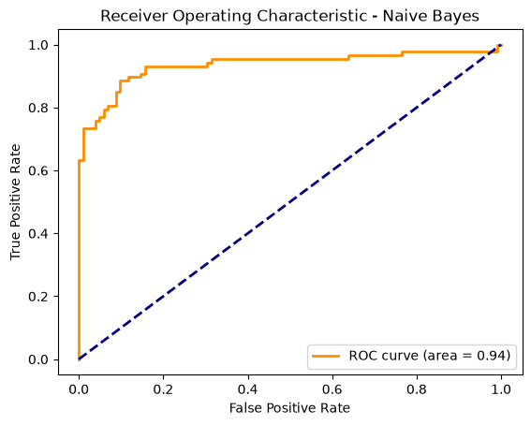

print("Predictions:",y_pred)
print("Accuracy:", accuracy)
print(f"Accuracy: {accuracy * 100:.7f}%")
print("Confusion Matrix:\n", conf_matrix)
print("Standard Error:", standard_error)
print("Precision:", precision)
print("Sensitivity (Recall):", sensitivity)
print("Specificity:", specificity)
print("AUC:", roc_auc)

Predictions: [1 0 1 1 0 0 0 0 1 0 1 0 1 0 1 0 1 0 0 0 1 1 1 0 0 1 1 1 1 1 0 1 1 0 1 1 0
0 0 0 1 1 0 0 1 0 0 0 1 0 1 0 0 1 0 1 0 1 1 0 0 1 0 0 0 0 0 0 1 1 1 1 1 1
0 0 1 0 0 1 1 0 1 1 0 0 0 1 1 0 0 0 0 1 1 0 0 1 1 1 1 1 1 1 1 0 1 0 1 1 1 1 1
0 0 0 1 1 1 0 0 1 0 0 0 1 1 1 0 0 0 1 0 1 0 1 0 1 1 0 1 0 0 1 0 1 1 1 1 1
1 0 0 1 1 0 1 1 1 1 0 0 1 0 0 0 0 1 1 1 0 0 1 0 0 1 0 1 1 0 0 0 0 1 0 0 1
0 0 0 1]
Accuracy: 0.873015873015873
Accuracy: 87.3015873%
Confusion Matrix:
[[86 16]
[8 79]]
Standard Error: 0.024218926360691187
Precision: 0.8315789473684211
Sensitivity (Recall): 0.9080459770114943
Specificity: 0.8431372549019608
AUC: 0.9353166553977912

PCA ANALYSIS
CODE:
import pandas as pd
from sklearn.preprocessing import StandardScaler
from sklearn.decomposition import PCA
from sklearn.model_selection import train_test_split
from sklearn.linear_model import LogisticRegression
from sklearn.metrics import accuracy_score
import matplotlib.pyplot as plt
import numpy as np

file_path= "data (1).csv"
data = pd.read_csv(file_path)
X= data.drop(columns=['fail'])
y= data['fail']
scaler = StandardScaler()
X_scaled = scaler.fit_transform(X)
n_components = 7
pca = PCA(n_components=n_components)
X_pca = pca.fit_transform(X_scaled)

explained_variance_ratio = pca.explained_variance_ratio_
total_variance_explained = np.sum(explained_variance_ratio)

print("Explained Variance Ratio:", explained_variance_ratio)
print("Total Variance Explained:", total_variance_explained)

Explained Variance Ratio: [0.22688645 0.17972591 0.14855753 0.1110099 0.10496955 0.07001106
0.06315933]
Total Variance Explained: 0.9043197278962516

plt.figure(figsize=(8, 5))
plt.bar(range(1, n_components + 1), explained_variance_ratio, alpha=0.7, align='center', label='Individual Explained Variance')
plt.step(range(1, n_components + 1), np.cumsum(explained_variance_ratio), where='mid', label='Cumulative Explained Variance')
plt.xlabel('Principal Component Index')
plt.ylabel('Explained Variance Ratio')
plt.title('PCA Explained Variance')
plt.legend(loc='best')
plt.show()

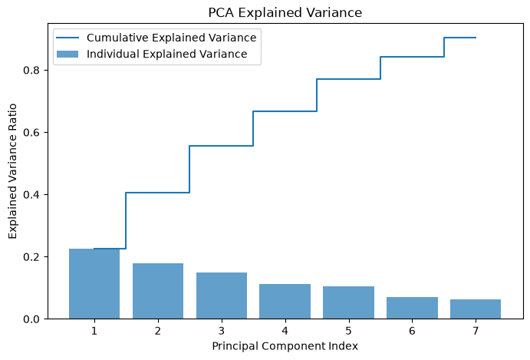

X_train, X_test, y_train, y_test = train_test_split(X_pca, y, test_size=0.2, random_state=42)
model = LogisticRegression()
model.fit(X_train, y_train)
y_pred = model.predict(X_test)
accuracy = accuracy_score(y_test, y_pred)
print("Accuracy:", accuracy)
print(f"Accuracy: {accuracy * 100:.7f}%")

Accuracy: 0.8571428571428571
Accuracy: 85.7142857%

Linear Regression
CODE:
import pandas as pd
from sklearn.preprocessing import StandardScaler
from sklearn.model_selection import train_test_split
from sklearn.linear_model import LinearRegression
from sklearn.metrics import mean_squared_error, r2_score, accuracy_score
import matplotlib.pyplot as plt
import numpy as np

file_path= "data (1).csv"
data = pd.read_csv(file_path)
X= data.drop(columns=['fail'])
y= data['fail']
scaler = StandardScaler()
X_scaled = scaler.fit_transform(X)
X_train, X_test, y_train, y_test = train_test_split(X_scaled, y, test_size=0.2, random_state=42)
lr_model = LinearRegression()
lr_model.fit(X_train, y_train)

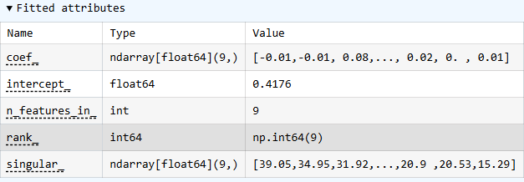
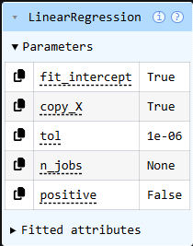

y_pred = lr_model.predict(X_test)
y_pred_binary = [1 if pred >= 0.5 else 0 for pred in y_pred]

mse = mean_squared_error(y_test, y_pred)
r2 = r2_score(y_test, y_pred)
accuracy = accuracy_score(y_test, y_pred_binary)
plt.figure(figsize=(10, 6))
plt.scatter(y_test, y_pred, color='blue', alpha=0.6, edgecolor='k')
plt.plot([y_test.min(), y_test.max()], [y_test.min(), y_test.max()], color='red', lw=2)
plt.xlabel('Actual Values')
plt.ylabel('Predicted Values')
plt.title('Actual vs Predicted Values - Linear Regression')
plt.show()

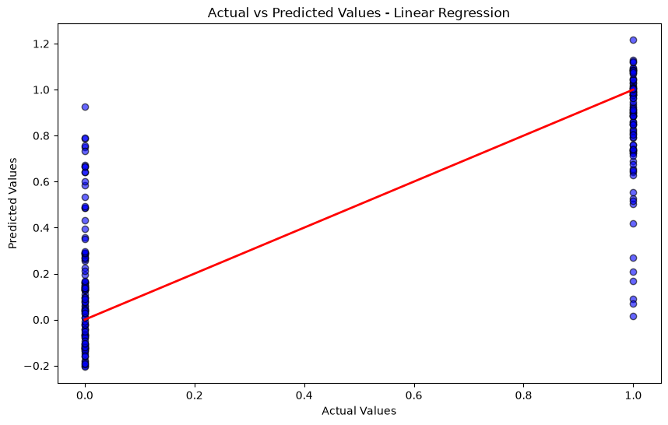
residuals = y_test - y_pred
plt.figure(figsize=(10, 6))
plt.scatter(y_pred, residuals, color='green', alpha=0.6, edgecolor='k')
plt.axhline(0, color='red', linestyle='--', lw=2)
plt.xlabel('Predicted Values')
plt.ylabel('Residuals')
plt.title('Residuals Plot - Linear Regression')
plt.show()

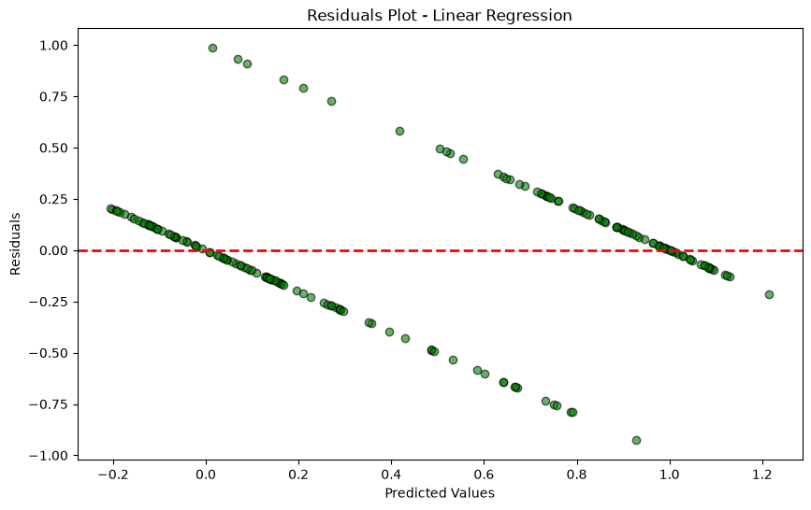

print("Mean Squared Error:", mse)
print("R-squared:", r2)
print("Accuracy:", accuracy)
print(f"Accuracy: {accuracy * 100:.7f}%")

Mean Squared Error: 0.09456646369460633
R-squared: 0.6193364154118738
Accuracy: 0.8888888888888888
Accuracy: 88.8888889%

Overall Conclusion:
Among all the types each have different accuracy and algorithm types to find the best output or result
The accuracy of each type…
Naive Bayes: 87%
PCA principal: 85%
Linear Regression: 88%

So based on the above accuracy level, Linear Regression is the best method to find the optimal best result or solution.

