PRACTICAL NO 6
(Smart Contracts)
1. Inheritance in Solidity
1.1 Single Inheritance
Aim:
Demonstrate single inheritance where Contract_B inherits from Contract_A.
Code:
pragma solidity ^0.5.0;

contract Contract_A {
uint value;
constructor(uint256 n) public {
value = n;
}

function incremetValue(uint256 x) public {
value += x;
}
}

contract Contract_B is Contract_A(22){
function getvalue() public view returns (uint){
return value;
}
}
OUTPUT:
Contract_B Deployed
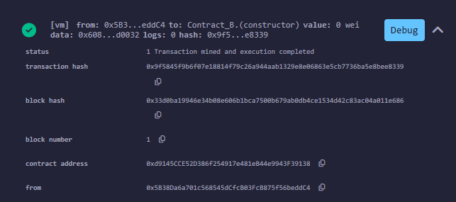

Get Value Function Called:
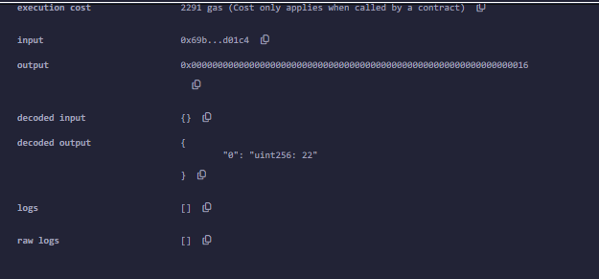
incrementValue by 5:
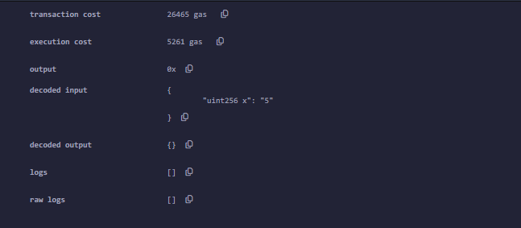
Get Value Function Called: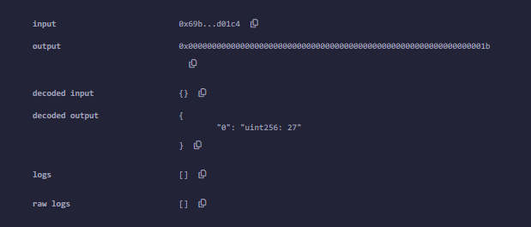
incrementValue by 10
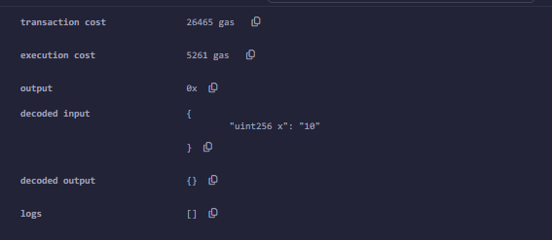
Get Value Function Called:
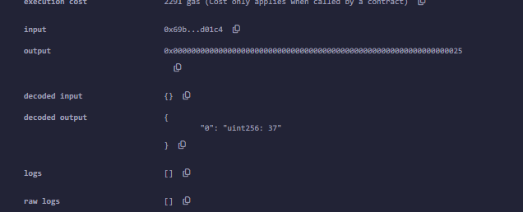

1.2 Multilevel Inheritance

Aim:
Demonstrate multilevel inheritance: Contract_C inherits from Contract_B, which inherits from Contract_A.
CODE:
pragma solidity >0.4.0 <0.6.0;
contract Contract_A {
uint256 value;
constructor(uint256 n) public {
value = n;
}
function incrementValue(uint256 x) public {
value += x;
}
}
contract Contract_B is Contract_A(22) {
function decrementValue(uint256 x) public {
value -= x;
}
}
contract Contract_C is Contract_B {
function getValue() public view returns (uint256) {
return value;

}
}

OUTPUT:
Deployed Contract_C :
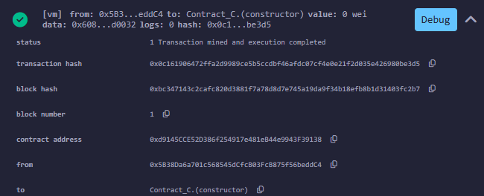
Get Value Function Called:
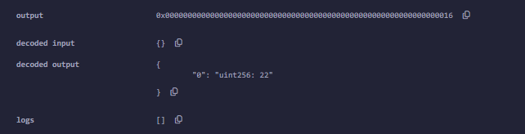
incrementValue by 5
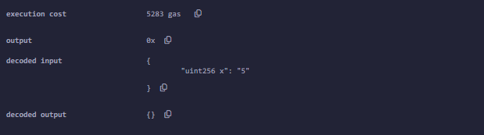

Get Value Function Called:
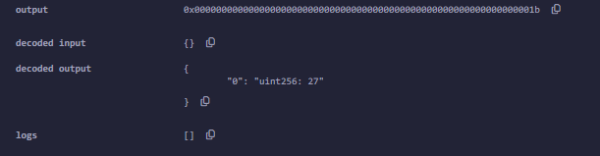

decrement Value by 7
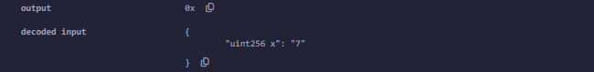

Get Value Function Called:
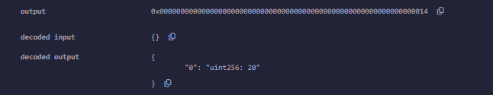

incrementValue by 10
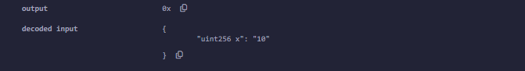
Get Value Function Called:
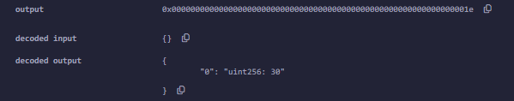

decrement Value by 8
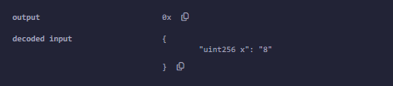

Get Value Function Called:
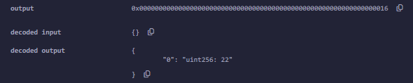

1.3 Hierarchical Inheritance
Aim:
Show hierarchical inheritance where multiple contracts inherit from the same base contract independently.

CODE:
pragma solidity >0.4.0 <0.6.0;
contract Contract_A {
uint256 value;
constructor(uint256 n) public {
value = n;
}
function getValue() public view returns (uint256) {
return value;
}
}
contract Contract_B is Contract_A(22) {
function incrementValue(uint256 x) public {
value += x;
}
}
contract Contract_C is Contract_A(25) {
function decrementValue(uint256 x) public {
value -= x;
}
}

OUTPUT:
Contract_B Deployed:
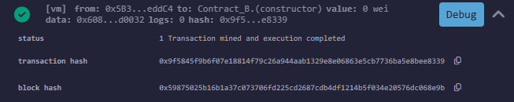

Get Value Function Called:
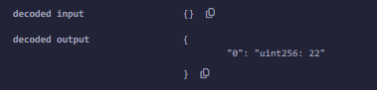

incrementValue by 5
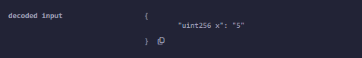

Get Value Function Called:
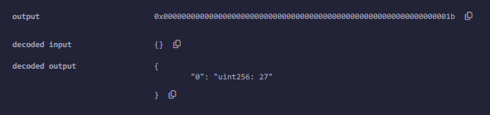

Contract_C Deployed:
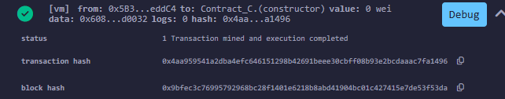

Get Value Function Called:
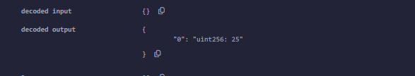

decrement Value by 5
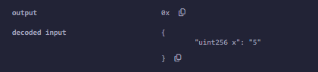

Get Value Function Called:
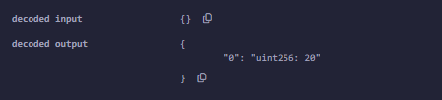

1.4 Multiple Inheritance
Aim:
Demonstrate multiple inheritance, where a contract inherits from more than one base contract.

CODE:
pragma solidity >0.4.0 <0.6.0;
contract Contract_A {
uint256 value;
constructor(uint256 n) public {
value = n;
}
function incrementValue(uint256 x) public {
value += x;
}
}
contract Contract_B is Contract_A {
function decrementValue(uint256 x) public {
value -= x;
}
}
contract Contract_C is Contract_A(25), Contract_B {
function getValue() public view returns (uint256) {
return value;
}
}
OUTPUT:
Contract_C Deployed:
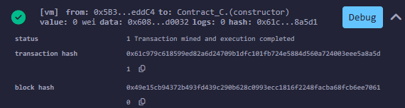

Get Value Function Called:
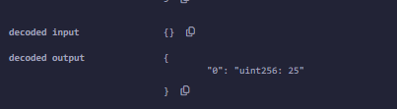

incrementValue by 10:
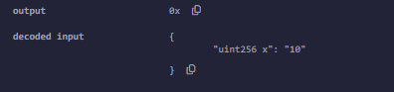
Get Value Function Called:
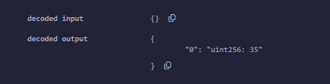

decrement Value by 5:
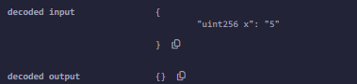
Get Value Function Called:
