FIFA PLAYER PERFORMANCE ANALYSIS
Exploratory Data Analysis (EDA) Report

1. Case Study Overview
This project performs Exploratory Data Analysis on a football player-performance dataset. The examines player demographics, positions, match results, preferred foot, performance scores, defensive contribution, passing, playing time, nationality, goals, assists, and tournament ratings.

2. Dataset Summary
Item | Value
Records | 54,600
Features | 75
Categorical Features | 14
Numerical Features | 61
Missing Values | 0
Duplicate Records | 0

3. Main Goals
- Understand the structure and quality of the dataset.
- Analyze player age, position, nationality, and preferred foot.
- Compare attacking and defensive performance across positions.
- Study passing and key-pass relationships.
- Analyze player utilization through tournament minutes.
- Identify top-performing players and goal scorers.
- Use charts and descriptive statistics to discover meaningful football-performance patterns.

4. Key Findings
- The dataset contains 54,600 records and 75 features.
- There are 14 categorical features and 61 numerical features.
- No missing values or duplicate records were found.
- Mean player age is approximately 26.30 years; median age is 26 and mode is 24.
- Forwards recorded the highest total tournament goals: 21,719.
- Midfielders recorded the highest total tournament assists: 17,800.
- The highest tournament rating is 9.5.
- The highest goal total shown is 10, belonging to Stuart McTominay.
- Match-result records are W = 20,124, L = 20,124 and D = 14,352.
- The penalty-loss search returned no records because match_result contains only W, L and D

5. Visualizations
The contains 12 rendered plots. The figures below are directly from the outputs.

1. Distribution of Player Age
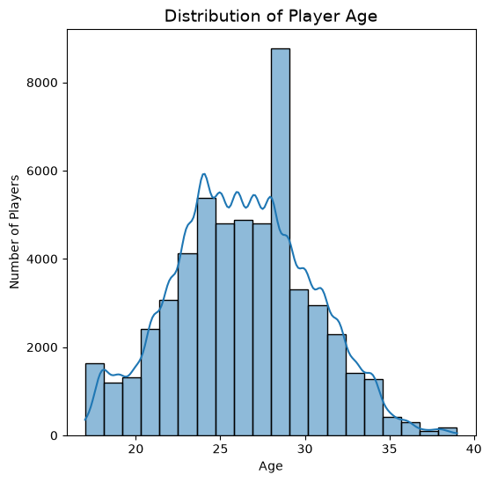
Observation: The age distribution is concentrated around the mid-twenties. The reports a mean age of about 26.30, median 26, and mode 24.
code:
plt.figure(figsize=(6,6))
sns.histplot(
data=df,
x="age",
bins=20,
kde=True
)
plt.title("Distribution of Player Age", fontsize=14)
plt.xlabel("Age")
plt.ylabel("Number of Players")
plt.show()

2. Player Position Distribution
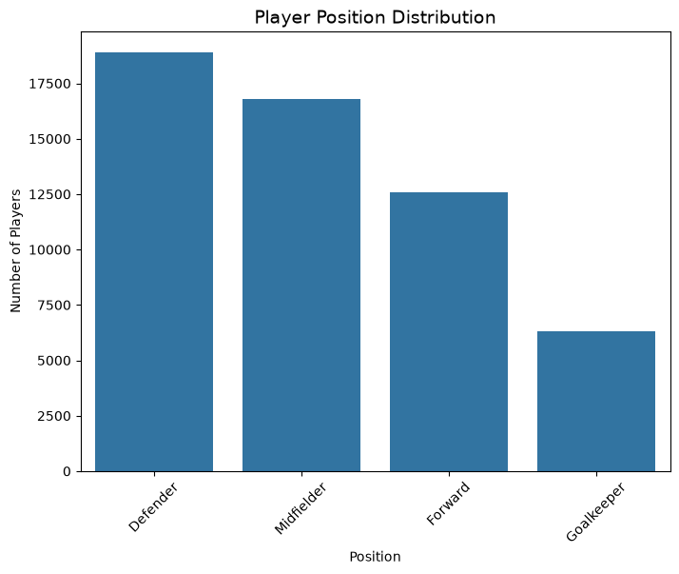
Observation: Midfielders and defenders make up a large share of the player records, while goalkeepers form the smallest group. This means the dataset contains more outfield players than goalkeepers.
code:
plt.figure(figsize=(8,6))
position_counts = df["position"].value_counts()
sns.barplot(
x=position_counts.index,
y=position_counts.values
)
plt.title("Player Position Distribution", fontsize=14)
plt.xlabel("Position")
plt.ylabel("Number of Players")
plt.xticks(rotation=45)
plt.show()

3. Preferred Foot Distribution
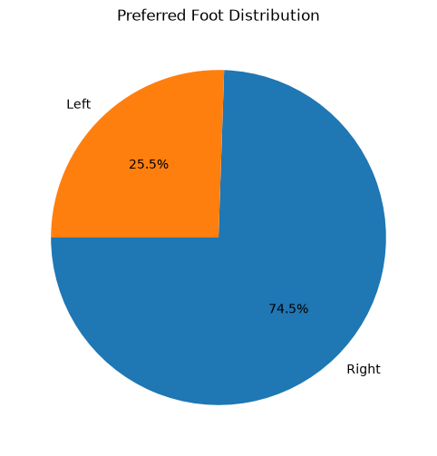
Observation: Right-footed players are more common than left-footed players in the dataset. The right-foot category therefore represents the larger share of players.
code:
plt.figure(figsize=(6,6))
df["preferred_foot"].value_counts().plot(
kind="pie",
autopct="%1.1f%%",
startangle=180
)
plt.ylabel("")
plt.title("Preferred Foot Distribution")
plt.show()

4. Match Result Distribution
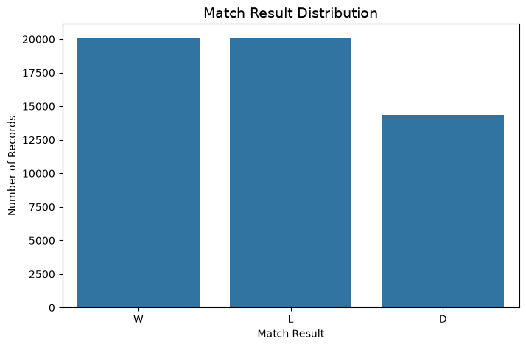
Observation: The records 20,124 W, 20,124 L and 14,352 D records. These are dataset records, not necessarily unique matches.
code:
plt.figure(figsize=(8, 5))
match_result = df["match_result"].value_counts()
sns.barplot(
x=match_result.index,
y=match_result.values
)
plt.title("Match Result Distribution", fontsize=14)
plt.xlabel("Match Result")
plt.ylabel("Number of Records")
plt.show()

5. Performance Score by Position
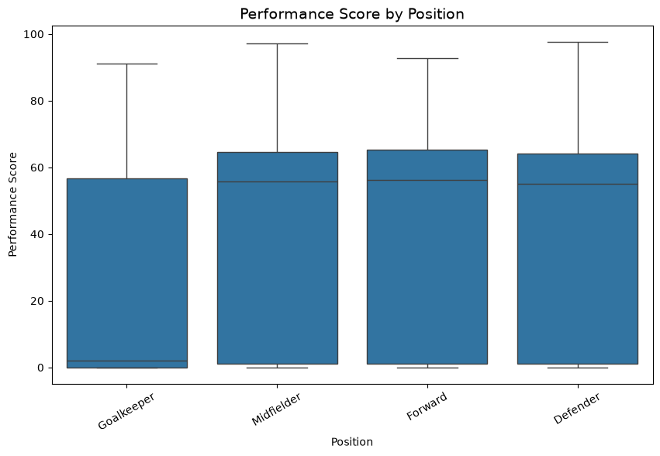
Observation: The box plot compares the spread and central tendency of performance scores across positions and helps reveal outliers.
code:
plt.figure(figsize=(10,6))
sns.boxplot(
data=df,
x="position",
y="performance_score"
)
plt.title("Performance Score by Position", fontsize=14)
plt.xlabel("Position")
plt.ylabel("Performance Score")
plt.xticks(rotation=30)
plt.show()

6. Defensive Contribution by Position
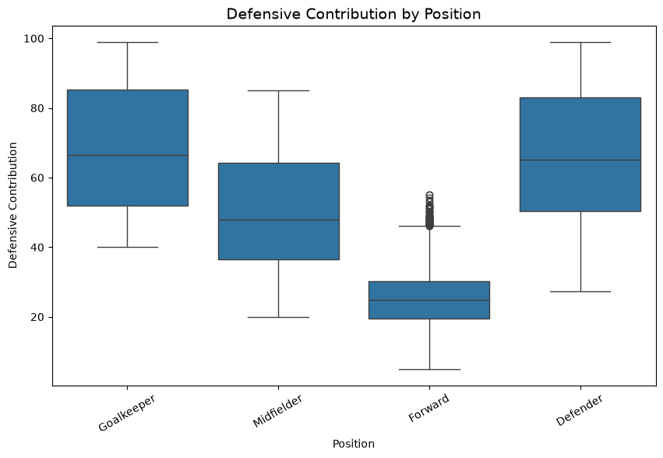
Observation: Defensive contribution varies by position, reflecting the different tactical roles of players.
code:
plt.figure(figsize=(10,6))
sns.boxplot(
data=df,
x="position",
y="defensive_contribution"
)
plt.title("Defensive Contribution by Position", fontsize=14)
plt.xlabel("Position")
plt.ylabel("Defensive Contribution")
plt.xticks(rotation=30)
plt.show()

7. Pass Accuracy vs Key Passes
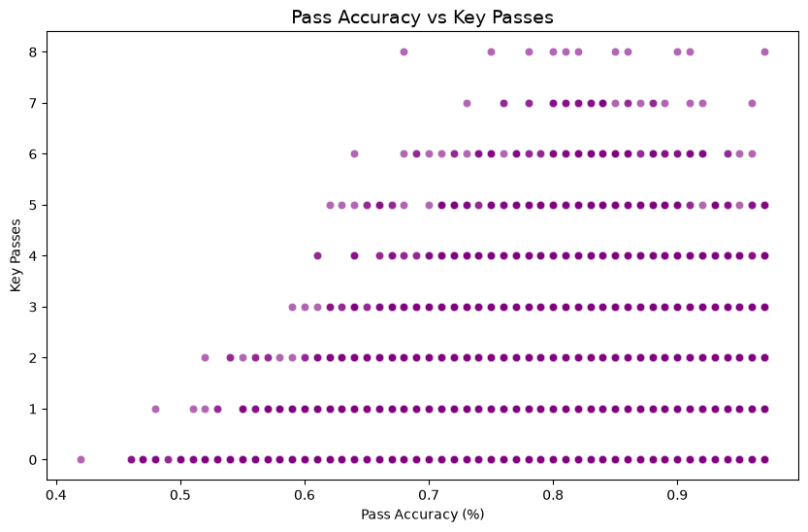
Observation: The scatter plot examines how key-pass counts vary with pass accuracy and shows the spread of individual records.
code:
plt.figure(figsize=(10,6))
sns.scatterplot(
data=df,
x="pass_accuracy",
y="key_passes",
alpha=0.6,
color= "purple"
)
plt.title("Pass Accuracy vs Key Passes", fontsize=14)
plt.xlabel("Pass Accuracy (%)")
plt.ylabel("Key Passes")
plt.show()

8. Age Distribution by Preferred Foot
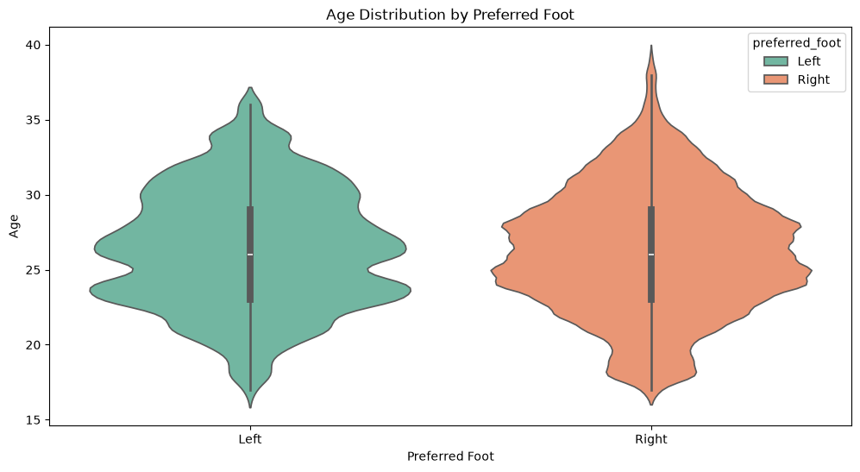
Observation: The violin plot compares the distribution and density of player ages across preferred-foot categories.
code:
plt.figure(figsize=(12,6))
sns.violinplot(
data=df,
x="preferred_foot",
y="age",
hue="preferred_foot",
palette="Set2",
legend=True,
inner="box"
)
plt.title("Age Distribution by Preferred Foot")
plt.xlabel("Preferred Foot")
plt.ylabel("Age")
plt.show()

9. Age Distribution by Preferred Foot
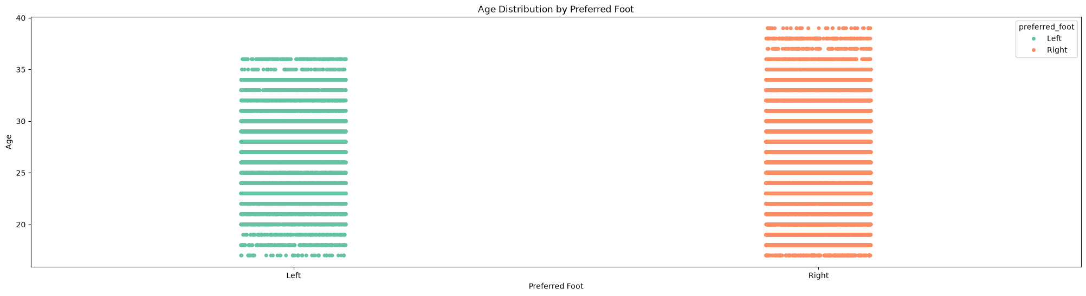
Observation: The violin plot compares the distribution and density of player ages across preferred-foot categories.
code:
plt.figure(figsize=(25, 6))
sns.stripplot(
data=df,
x="preferred_foot",
y="age",
hue="preferred_foot",
palette="Set2",
legend=True,
jitter=True,
alpha=1
)
plt.title("Age Distribution by Preferred Foot")
plt.xlabel("Preferred Foot")
plt.ylabel("Age")
plt.show()

10. Average Minutes Played by Position
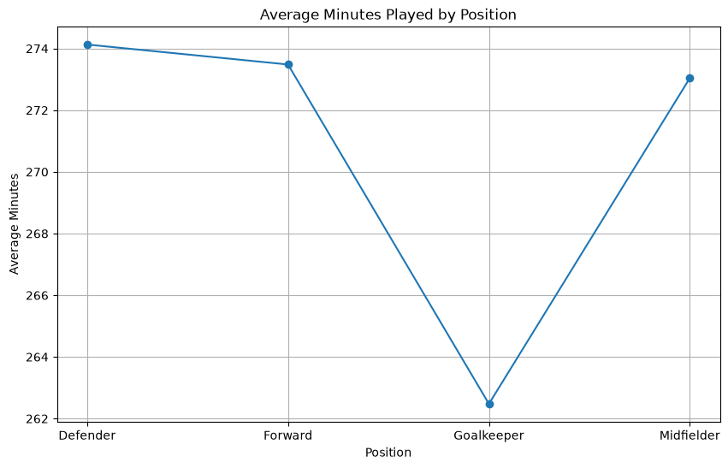
Observation: The line chart compares average tournament minutes across positions, showing differences in player utilization.
code:
avg_minutes = df.groupby("position")["total_minutes_tournament"].mean()
plt.figure(figsize=(10,6))
plt.plot(
avg_minutes.index,
avg_minutes.values,
marker='o'
)
plt.title("Average Minutes Played by Position")
plt.xlabel("Position")
plt.ylabel("Average Minutes")
plt.grid(True)
plt.show()

11. Top 10 Countries by Number of Players
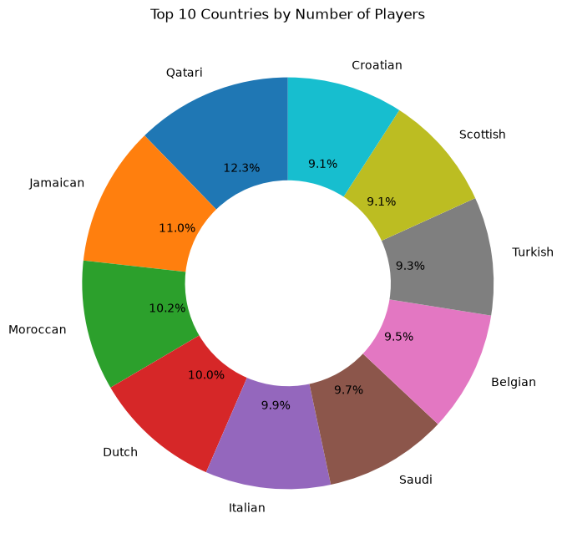
Observation: The donut chart highlights the nationalities with the largest representation among the top 10 countries.

code:
country_counts = df["nationality"].value_counts().head(10)
plt.figure(figsize=(8,8))
plt.pie(
country_counts,
labels=country_counts.index,
autopct="%1.1f%%",
startangle=90,
wedgeprops=dict(width=0.5)
)
plt.title("Top 10 Countries by Number of Players")
plt.show()

Top Goal Scorer
12. Goals vs Assists vs Tournament Rating
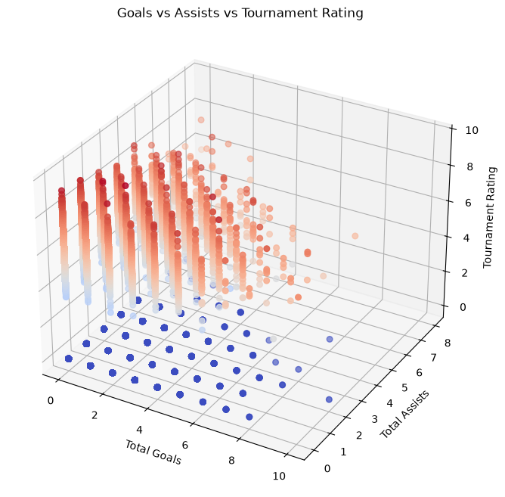
Purpose: To study three important player-performance measures together: total tournament goals, total tournament assists, and tournament rating.
How to read: Each point represents a player record. The X-axis represents goals, the Y-axis represents assists, and the Z-axis represents tournament rating. The position and color of each point help compare players across all three measures.
Observation: Most players are clustered at low goal and assist values. A smaller group records higher goals or assists, and the highest-rated players are not necessarily the same players who have the highest goal totals.
Interesting observation: The player with the highest number of goals is not necessarily the player with the highest tournament rating. This shows that overall player performance cannot be judged from goals alone.
Outcome / Conclusion: The 3D scatter plot provides a combined view of attacking contribution and overall performance, making it easier to identify standout players and understand differences between scoring, assisting and overall tournament performance.
Chart type and purpose: 3D Scatter Plot — used to visualize relationships among three numerical variables simultaneously.

6. Statistical Analysis and Results

Descriptive Statistics
The calculates mean, median, mode and skewness for numerical columns. The age example shows mean = 26.2965, median = 26, mode = 24 and skewness ≈ 0.099.
Top Goal Scorer
Stuart McTominay — Scotland — 10 tournament goals — tournament rating 7.3.

Best Player by Tournament Rating
Jackson Vukovic — Australia — Forward — tournament rating 9.5 — 2 tournament goals.

Goals by Position
Position | Total Goals
Forward | 21,719
Midfielder | 10,867
Defender | 2,576
Goalkeeper | 0

Assists by Position
Position | Total Assists
Midfielder | 17,800
Forward | 11,031
Defender | 4,292
Goalkeeper | 52

Penalty Analysis
This is the searched match result for penalty-related records. The unique values are only W, L and D, so the penalty-loss filter returned an empty result. Therefore, it does not support a separate count of matches lost by penalties.

7. Conclusion
This provides a broad EDA of football player performance using descriptive statistics and multiple visualization techniques. The analysis highlights positional differences, player age distribution, match-result records, defensive contribution, passing, playing time, nationality, goals, assists and tournament ratings. The strongest direct findings are that forwards lead total goal contribution, midfielders lead total assists, and the highest tournament rating shown is 9.5.

Appendix A — Cell Summary

Cell 0
import numpy as np
import pandas as pd
import matplotlib.pyplot as plt
import seaborn as sns

Cell 1
df = pd.read_csv( "C:/Users/Kunal/OneDrive/Desktop/MSCIT/DATASCIENCE/fifa_world_cup_2026_player_performance.csv")
print("Dataset Loaded Successfully")
print(f"Rows : {df.shape[0]:,}")
print(f"Columns : {df.shape[1]}")
df.head()
Output:
Dataset Loaded Successfully
Rows : 54,600
Columns : 75
player_id player_name age nationality team jersey_number \
0 P00055 Rodri Fati 26 Spanish Spain 3
1 P00070 Ansu Le Normand 19 Spanish Spain 18
2 P00066 Gavi Ramos 18 Spanish Spain 14
3 P00073 Pedro Cubarsi 20 Spanish Spain 21
4 P00059 Alvaro Oyarzabal 23 Spanish Spain 7
position height_cm weight_kg preferred_foot ... possession_impact \
0 Goalkeeper 195 75 Left ... 1.1
1 Midfielder 178 75 Right ... 3.5
2 Midfielder 177 72 Left ... 15.3
3 Forward 182 74 Right ... 1.2
4 Defender 191 81 Left ... 6.2
pressure_resistance creativity_score consistency_score \
0 44.2 55.9 42.0
1 38.2 43.7 31.1
2 99.0 99.0 83.4
3 19.8 42.3 40.9
4 44.1 33.5 60.0
clutch_performance_score total_goals_tournament total_assists_tournament \
0 51.8 0 0
1 52.7 0 3
2 54.8 1 1
3 78.5 5 3
4 56.6 0 0
total_minutes_tournament player_of_match_awards tournament_rating
0 242 0 5.8
1 342 0 5.5
2 245 0 8.4
3 422 0 6.7
4 440 0 5.7
[5 rows x 75 columns]

Cell 2
df.info()
Output:
<class 'pandas.DataFrame'>
RangeIndex: 54600 entries, 0 to 54599
Data columns (total 75 columns):
# Column Non-Null Count Dtype
--- ------ -------------- -----
0 player_id 54600 non-null str
1 player_name 54600 non-null str
2 age 54600 non-null int64
3 nationality 54600 non-null str
4 team 54600 non-null str
5 jersey_number 54600 non-null int64
6 position 54600 non-null str
7 height_cm 54600 non-null int64
8 weight_kg 54600 non-null int64
9 preferred_foot 54600 non-null str
10 club_name 54600 non-null str
11 market_value_eur 54600 non-null int64
12 match_id 54600 non-null str
13 match_date 54600 non-null str
14 stadium 54600 non-null str
15 city 54600 non-null str
16 opponent_team 54600 non-null str
17 tournament_stage 54600 non-null str
18 match_result 54600 non-null str
19 goals_team 54600 non-null int64
20 goals_opponent 54600 non-null int64
21 minutes_played 54600 non-null int64
22 goals 54600 non-null int64
23 assists 54600 non-null int64
24 shots 54600 non-null int64
25 shots_on_target 54600 non-null int64
26 expected_goals_xg 54600 non-null float64
27 expected_assists_xa 54600 non-null float64
28 key_passes 54600 non-null int64
29 successful_passes 54600 non-null int64
30 total_passes 54600 non-null int64
31 pass_accuracy 54600 non-null float64
32 dribbles_attempted 54600 non-null int64
33 successful_dribbles 54600 non-null int64
34 crosses 54600 non-null int64
35 successful_crosses 54600 non-null int64
36 tackles 54600 non-null int64
37 interceptions 54600 non-null int64
38 clearances 54600 non-null int64
39 blocks 54600 non-null int64
40 aerial_duels_won 54600 non-null int64
41 aerial_duels_lost 54600 non-null int64
42 recoveries 54600 non-null int64
43 defensive_actions 54600 non-null int64
44 fouls_committed 54600 non-null int64
45 fouls_suffered 54600 non-null int64
46 yellow_cards 54600 non-null int64
47 red_cards 54600 non-null int64
48 offsides 54600 non-null int64
49 saves 54600 non-null int64
50 save_percentage 54600 non-null float64
51 punches 54600 non-null int64
52 clean_sheet 54600 non-null int64
53 goals_conceded 54600 non-null int64
54 penalty_saves 54600 non-null int64
55 distance_covered_km 54600 non-null float64
56 sprint_distance_km 54600 non-null float64
57 top_speed_kmh 54600 non-null float64
58 accelerations 54600 non-null int64
59 decelerations 54600 non-null int64
60 stamina_score 54600 non-null float64
61 player_rating 54600 non-null float64
62 performance_score 54600 non-null float64
63 offensive_contribution 54600 non-null float64
64 defensive_contribution 54600 non-null float64
65 possession_impact 54600 non-null float64
66 pressure_resistance 54600 non-null float64
67 creativity_score 54600 non-null float64
68 consistency_score 54600 non-null float64
69 clutch_performance_score 54600 non-null float64
70 total_goals_tournament 54600 non-null int64
71 total_assists_tournament 54600 non-null int64
72 total_minutes_tournament 54600 non-null int64
73 player_of_match_awards 54600 non-null int64
74 tournament_rating 54600 non-null float64
dtypes: float64(18), int64(43), str(14)
memory usage: 31.2 MB

Cell 3
categorical_cols = df.select_dtypes(include=["object", "string"]).columns.tolist()
numerical_cols = df.select_dtypes(include=["int64", "float64"]).columns.tolist()
print("Data Summary")
print(f"Total Records : {df.shape[0]:,}")
print(f"Total Features : {df.shape[1]}")
print(f"Categorical Features : {len(categorical_cols)}")
print(f"Numerical Features : {len(numerical_cols)}")
print(f"Missing Values : {df.isnull().sum().sum()}")
print(f"Duplicate Records : {df.duplicated().sum()}")
Output:
Data Summary
Total Records : 54,600
Total Features : 75
Categorical Features : 14
Numerical Features : 61
Missing Values : 0
Duplicate Records : 0

Cell 4
plt.figure(figsize=(6,6))
sns.histplot(
data=df,
x="age",
bins=20,
kde=True
)
plt.title("Distribution of Player Age", fontsize=14)
plt.xlabel("Age")
plt.ylabel("Number of Players")
plt.show()

Cell 5
plt.figure(figsize=(8,6))
position_counts = df["position"].value_counts()
sns.barplot(
x=position_counts.index,
y=position_counts.values
)
plt.title("Player Position Distribution", fontsize=14)
plt.xlabel("Position")
plt.ylabel("Number of Players")
plt.xticks(rotation=45)
plt.show()

Cell 6
import numpy as np
num_cols = df.select_dtypes(include=[np.number]).columns
for col in num_cols:
mean_val = df[col].mean()
median_val = df[col].median()
mode_val = df[col].mode().iloc[0]
skew_val = df[col].skew()
print(f"Mean of {col}: {mean_val}")
print(f"Median of {col}: {median_val}")
print(f"Mode of {col}: {mode_val}")
print(f"Skew of {col}: {skew_val}")
if np.isclose(mean_val, median_val, atol=0.1):
print("Data is approximately symmetric")
elif skew_val > 0:
print("Data is right-skewed (positively skewed)")
else:
print("Data is left-skewed (negatively skewed)")
print("-" * 70)
Output:
Mean of age: 26.296483516483516
Median of age: 26.0
Mode of age: 24
Skew of age: 0.09924963983161143
Data is right-skewed (positively skewed)
----------------------------------------------------------------------
Mean of jersey_number: 13.5
Median of jersey_number: 13.5
Mode of jersey_number: 1
Skew of jersey_number: 0.0
Data is approximately symmetric
----------------------------------------------------------------------
Mean of height_cm: 181.65434065934065
Median of height_cm: 182.0
Mode of height_cm: 183
Skew of height_cm: -0.18455778077198856
Data is left-skewed (negatively skewed)
----------------------------------------------------------------------
Mean of weight_kg: 75.75485347985348
Median of weight_kg: 76.0
Mode of weight_kg: 76
Skew of weight_kg: -0.08951867556756829
Data is left-skewed (negatively skewed)
----------------------------------------------------------------------
Mean of market_value_eur: 20084451.764725275
Median of market_value_eur: 10271107.0
Mode of market_value_eur: 200000000
Skew of market_value_eur: 2.979185083654564
Data is right-skewed (positively skewed)
----------------------------------------------------------------------
Mean of goals_team: 1.3304761904761904
Median of goals_team: 1.0
Mode of goals_team: 1
Skew of goals_team: 0.9312821925430347
Data is right-skewed (positively skewed)
----------------------------------------------------------------------
Mean of goals_opponent: 1.3304761904761904
Median of goals_opponent: 1.0
Mode of goals_opponent: 1
Skew of goals_opponent: 0.9312821925430347
Data is right-skewed (positively skewed)
----------------------------------------------------------------------
Mean of minutes_played: 36.19981684981685
Median of minutes_played: 24.0
Mode of minutes_played: 0
Skew of minutes_played: 0.2597087918459158
Data is right-skewed (positively skewed)
----------------------------------------------------------------------
Mean of goals: 0.055384615384615386
Median of goals: 0.0
Mode of goals: 0
Skew of goals: 5.06379603219766
Data is approximately symmetric
----------------------------------------------------------------------
Mean of assists: 0.05236263736263736
Median of assists: 0.0
Mode of assists: 0
Skew of assists: 4.897270575167477
Data is approximately symmetric
----------------------------------------------------------------------
Mean of shots: 0.44705128205128203
Median of shots: 0.0
Mode of shots: 0
Skew of shots: 2.894489309034122
Data is right-skewed (positively skewed)
----------------------------------------------------------------------
Mean of shots_on_target: 0.048424908424908424
Median of shots_on_target: 0.0
Mode of shots_on_target: 0
Skew of shots_on_target: 5.9142258480216565
Data is approximately symmetric
----------------------------------------------------------------------
Mean of expected_goals_xg: 0.01611190476190476
Median of expected_goals_xg: 0.0
Mode of expected_goals_xg: 0.0
Skew of expected_goals_xg: 10.118416280632966
Data is approximately symmetric
----------------------------------------------------------------------
Mean of expected_assists_xa: 0.017741575091575094
Median of expected_assists_xa: 0.0
Mode of expected_assists_xa: 0.0
Skew of expected_assists_xa: 9.2048222297415
Data is approximately symmetric
----------------------------------------------------------------------
Mean of key_passes: 0.47183150183150185
Median of key_passes: 0.0
Mode of key_passes: 0
Skew of key_passes: 2.581684407335497
Data is right-skewed (positively skewed)
----------------------------------------------------------------------
Mean of successful_passes: 15.470091575091574
Median of successful_passes: 9.0
Mode of successful_passes: 0
Skew of successful_passes: 1.203139351351512
Data is right-skewed (positively skewed)
----------------------------------------------------------------------
Mean of total_passes: 19.177307692307693
Median of total_passes: 11.0
Mode of total_passes: 0
Skew of total_passes: 1.1046621419643994
Data is right-skewed (positively skewed)
----------------------------------------------------------------------
Mean of pass_accuracy: 0.8084404761904762
Median of pass_accuracy: 0.82
Mode of pass_accuracy: 0.83
Skew of pass_accuracy: -0.5492250770212044
Data is approximately symmetric
----------------------------------------------------------------------
Mean of dribbles_attempted: 0.6002930402930403
Median of dribbles_attempted: 0.0
Mode of dribbles_attempted: 0
Skew of dribbles_attempted: 2.52106983544512
Data is right-skewed (positively skewed)
----------------------------------------------------------------------
Mean of successful_dribbles: 0.16294871794871796
Median of successful_dribbles: 0.0
Mode of successful_dribbles: 0
Skew of successful_dribbles: 3.831864045959377
Data is right-skewed (positively skewed)
----------------------------------------------------------------------
Mean of crosses: 0.44778388278388276
Median of crosses: 0.0
Mode of crosses: 0
Skew of crosses: 2.316406604252409
Data

Cell 7
plt.figure(figsize=(6,6))
df["preferred_foot"].value_counts().plot(
kind="pie",
autopct="%1.1f%%",
startangle=180
)
plt.ylabel("")
plt.title("Preferred Foot Distribution")
plt.show()

Cell 8
plt.figure(figsize=(8, 5))
match_result = df["match_result"].value_counts()
sns.barplot(
x=match_result.index,
y=match_result.values
)
plt.title("Match Result Distribution", fontsize=14)
plt.xlabel("Match Result")
plt.ylabel("Number of Records")
plt.show()

Cell 9
plt.figure(figsize=(10,6))
sns.boxplot(
data=df,
x="position",
y="performance_score"
)
plt.title("Performance Score by Position", fontsize=14)
plt.xlabel("Position")
plt.ylabel("Performance Score")
plt.xticks(rotation=30)
plt.show()

Cell 10
plt.figure(figsize=(10,6))
sns.boxplot(
data=df,
x="position",
y="defensive_contribution"
)
plt.title("Defensive Contribution by Position", fontsize=14)
plt.xlabel("Position")
plt.ylabel("Defensive Contribution")
plt.xticks(rotation=30)
plt.show()

Cell 11
plt.figure(figsize=(10,6))
sns.scatterplot(
data=df,
x="pass_accuracy",
y="key_passes",
alpha=0.6,
color= "purple"
)
plt.title("Pass Accuracy vs Key Passes", fontsize=14)
plt.xlabel("Pass Accuracy (%)")
plt.ylabel("Key Passes")
plt.show()

Cell 12
plt.figure(figsize=(12,6))
sns.violinplot(
data=df,
x="preferred_foot",
y="age",
hue="preferred_foot",
palette="Set2",
legend=True,
inner="box"
)
plt.title("Age Distribution by Preferred Foot")
plt.xlabel("Preferred Foot")
plt.ylabel("Age")
plt.show()

Cell 13
plt.figure(figsize=(25, 6))
sns.stripplot(
data=df,
x="preferred_foot",
y="age",
hue="preferred_foot",
palette="Set2",
legend=True,
jitter=True,
alpha=1
)
plt.title("Age Distribution by Preferred Foot")
plt.xlabel("Preferred Foot")
plt.ylabel("Age")
plt.show()

Cell 14
# plt.figure(figsize=(10,6))
# sns.swarmplot(
# data=df,
# x="position",
# y="tournament_rating",
# hue="position",
# palette="Set2",
# legend=True,
# size=3
# )
# plt.title("Tournament Rating by Player Position")
# plt.xlabel("Position")
# plt.ylabel("Tournament Rating")
# plt.show()

Cell 15
avg_minutes = df.groupby("position")["total_minutes_tournament"].mean()
plt.figure(figsize=(10,6))
plt.plot(
avg_minutes.index,
avg_minutes.values,
marker='o'
)
plt.title("Average Minutes Played by Position")
plt.xlabel("Position")
plt.ylabel("Average Minutes")
plt.grid(True)
plt.show()

Cell 16
country_counts = df["nationality"].value_counts().head(10)
plt.figure(figsize=(8,8))
plt.pie(
country_counts,
labels=country_counts.index,
autopct="%1.1f%%",
startangle=90,
wedgeprops=dict(width=0.5)
)
plt.title("Top 10 Countries by Number of Players")
plt.show()

Cell 17
fig = plt.figure(figsize=(10, 8))
ax = fig.add_subplot(111, projection='3d')
ax.scatter(
df["total_goals_tournament"],
df["total_assists_tournament"],
df["tournament_rating"],
c=df["tournament_rating"],
cmap="coolwarm",
s=30
)
ax.set_title("Goals vs Assists vs Tournament Rating")
ax.set_xlabel("Total Goals")
ax.set_ylabel("Total Assists")
ax.set_zlabel("Tournament Rating")
plt.show()

Cell 18
top_player = df.loc[df["total_goals_tournament"].idxmax()]
print(top_player[["player_name","team", "nationality", "total_goals_tournament","tournament_rating"]])
Output:
player_name Stuart McTominay
team Scotland
nationality Scottish
total_goals_tournament 10
tournament_rating 7.3
Name: 4303, dtype: object

Cell 19
# Display all unique match results
print("Unique Match Results:")
print(df["match_result"].unique())
print("\nMatch Result Counts:")
print(df["match_result"].value_counts())
# Count matches lost on penalties
penalty_losses = df[df["match_result"].str.contains(
"pen", case=False, na=False
)]
print("\nMatches Lost on Penalties:")
print(penalty_losses)
print("\nNumber of Matches Lost on Penalties:")
print(len(penalty_losses))
Output:
Unique Match Results:
<StringArray>
['W', 'L', 'D']
Length: 3, dtype: str
Match Result Counts:
match_result
W 20124
L 20124
D 14352
Name: count, dtype: int64
Matches Lost on Penalties:
Empty DataFrame
Columns: [player_id, player_name, age, nationality, team, jersey_number, position, height_cm, weight_kg, preferred_foot, club_name, market_value_eur, match_id, match_date, stadium, city, opponent_team, tournament_stage, match_result, goals_team, goals_opponent, minutes_played, goals, assists, shots, shots_on_target, expected_goals_xg, expected_assists_xa, key_passes, successful_passes, total_passes, pass_accuracy, dribbles_attempted, successful_dribbles, crosses, successful_crosses, tackles, interceptions, clearances, blocks, aerial_duels_won, aerial_duels_lost, recoveries, defensive_actions, fouls_committed, fouls_suffered, yellow_cards, red_cards, offsides, saves, save_percentage, punches, clean_sheet, goals_conceded, penalty_saves, distance_covered_km, sprint_distance_km, top_speed_kmh, accelerations, decelerations, stamina_score, player_rating, performance_score, offensive_contribution, defensive_contribution, possession_impact, pressure_resistance, creativity_score, consistency_score, clutch_performance_score, total_goals_tournament, total_assists_tournament, total_minutes_tournament, player_of_match_awards, tournament_rating]
Index: []
[0 rows x 75 columns]
Number of Matches Lost on Penalties:
0

Cell 20
# Best player based on tournament rating
best_player = df.loc[df["tournament_rating"].idxmax()]
print("Best Player")
print("---------------------------")
print("Player Name :", best_player["player_name"])
print("Country :", best_player["nationality"])
print("Team :", best_player["team"])
print("Goals :", best_player["total_goals_tournament"])
print("Position :", best_player["position"])
print("Rating :", best_player["tournament_rating"])
Output:
Best Player
---------------------------
Player Name : Jackson Vukovic
Country : Australian
Team : Australia
Goals : 2
Position : Forward
Rating : 9.5

Cell 21
top_players = (
df[["player_name", "nationality", "team","tournament_rating"]]
.sort_values(by="tournament_rating",ascending=False)
.head(10)
)
print(top_players)
Output:
player_name nationality team tournament_rating
23356 Jackson Vukovic Australian Australia 9.5
3211 Oleksandr Bondarenko Ukrainian Ukraine 9.4
25619 Vinicius Nunes Brazilian Brazil 9.3
43249 Mohamed Elneny Egyptian Egypt 9.3
35232 Mohammed Otoo Ghanaian Ghana 9.3
52586 Mohannad Majeed Iraqi Iraq 9.2
14589 Sebastian Pellerano Ecuadorian Ecuador 9.1
48624 Dominik Kramaric Croatian Croatia 9.1
42468 Sardor Nematov Uzbek Uzbekistan 9.1
14484 Riyad Benrahma Algerian Algeria 9.1

Cell 22
# Which Position Scores the Most Goals?
df.groupby("position")["total_goals_tournament"].sum()
Output:
position
Defender 2576
Forward 21719
Goalkeeper 0
Midfielder 10867
Name: total_goals_tournament, dtype: int64

Cell 23
# Which Position Creates the Most Assists?
df.groupby("position")["total_assists_tournament"].sum()
Output:
position
Defender 4292
Forward 11031
Goalkeeper 52
Midfielder 17800
Name: total_assists_tournament, dtype: int64

