A Study on Mach-Zehnder Interferometer  
Yufan Zhou  
Department of Electrical and Computer Engineering  
University of British Columbia, Vancouver, BC, Canada

## Abstract

This report details the design, simulation, fabrication, and testing of a Mach-Zehnder Interferometer (MZI) using the SiEPIC-EBeam Process Design Kit (PDK). The project follows a complete design-fabrication-test cycle, ensuring that the fabricated device aligns with design expectations.

The process begins with the simulation of a single-mode optical waveguide in Lumerical MODE, where key parameters such as effective index, group index, and experimental loss estimates are extracted. A circuit model is then developed in MATLAB, Python, and Lumerical INTERCONNECT to design a 25 GHz free spectral range filter. The impact of fabrication variations—such as waveguide width, thickness, and process bias—is analyzed to optimize performance robustness.

The layout, incorporating fiber grating couplers, waveguides, splitters, and the MZI structure, is verified through design rule checks (DRC) and post-layout simulations before submission for fabrication by Applied Nanotools Inc. After fabrication, testing is performed using an external swept tunable wavelength laser. Measured transmission spectra are analyzed to extract waveguide parameters and assess deviations due to fabrication tolerances.

The final report presents a comparison between simulation and experimental results, highlighting key insights on process variations and their impact on device performance. Recommendations for design improvements are also provided.

## Introduction

## Theoretical Background

## Modelling and Simulation

***A. Waveguide Modelling***

Based on fabrication bias requirements and available components in the SiEPIC PDK, the waveguide is designed as a 350nm×220nm strip waveguide. Simulations were conducted in Lumerical MODE Solutions using the Palik material dataset.

The fundamental mode profile of the 350 nm × 220 nm waveguide at λ = 1310 nm, calculated using Lumerical MODE Solutions, exhibits 98% TE polarization:

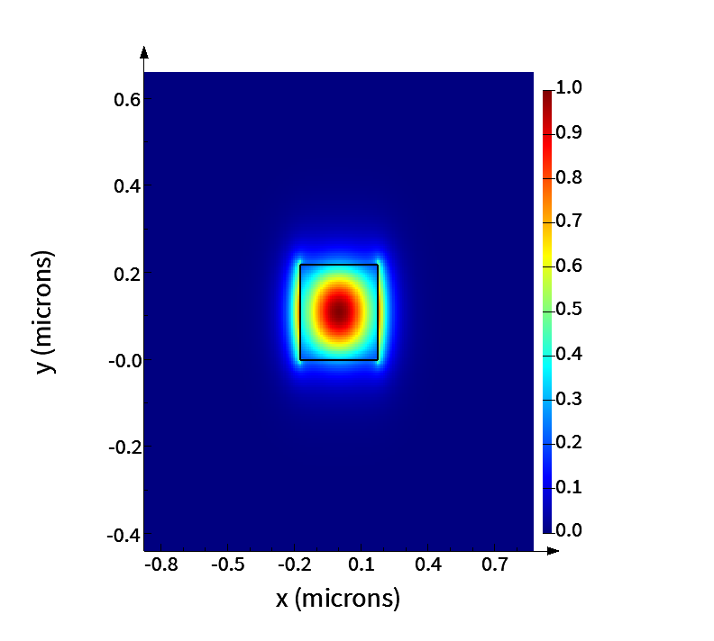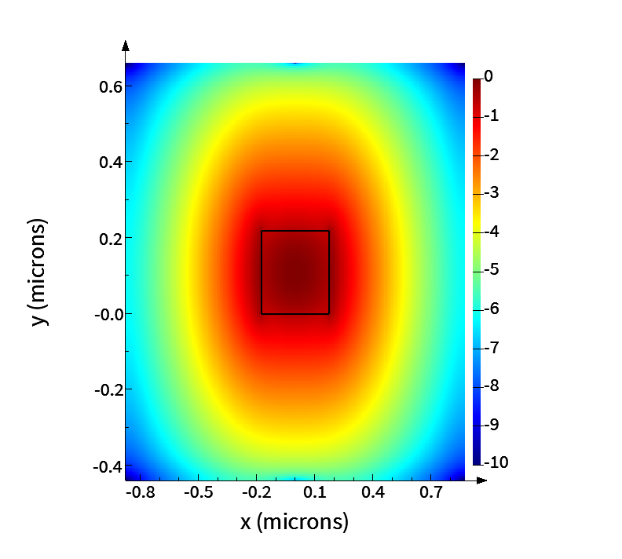

Fig. 1. E Intensity Plot, Linear Scale(left) and Log Scale(right)

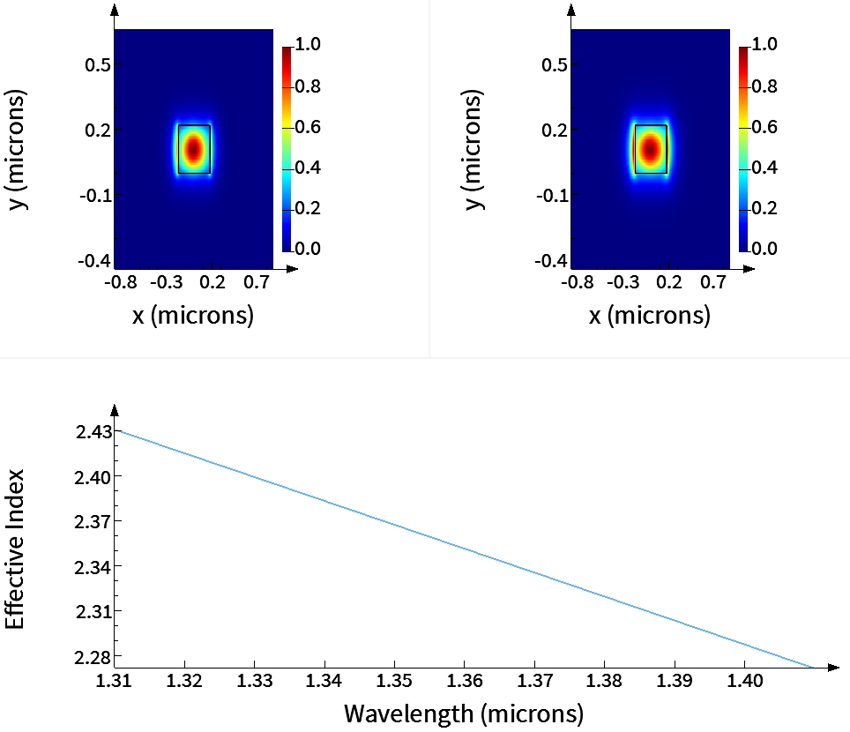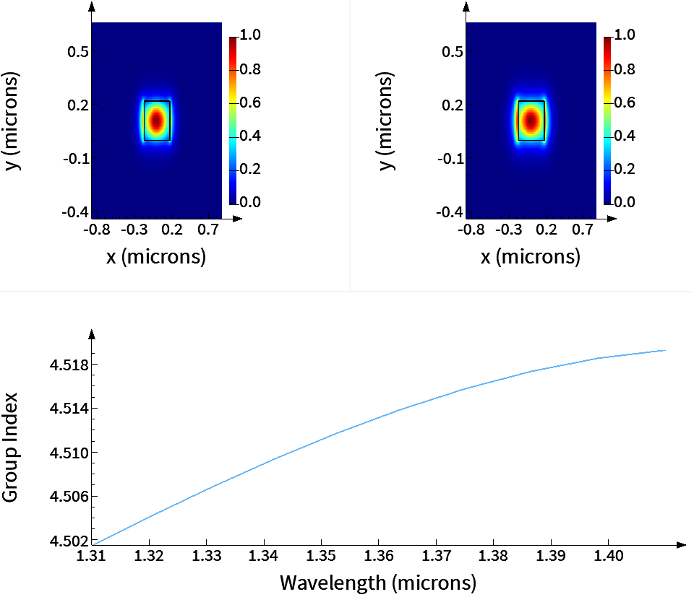

Fig. 2. Effective Index and Group Index Plot with Wavelength Sweep Starting at 1310nm

Simulation bandwidth setting: min = 1.01 μm, max = 1.61 μm.

Group index ng = 4.4879 when wavelength = 1310nm

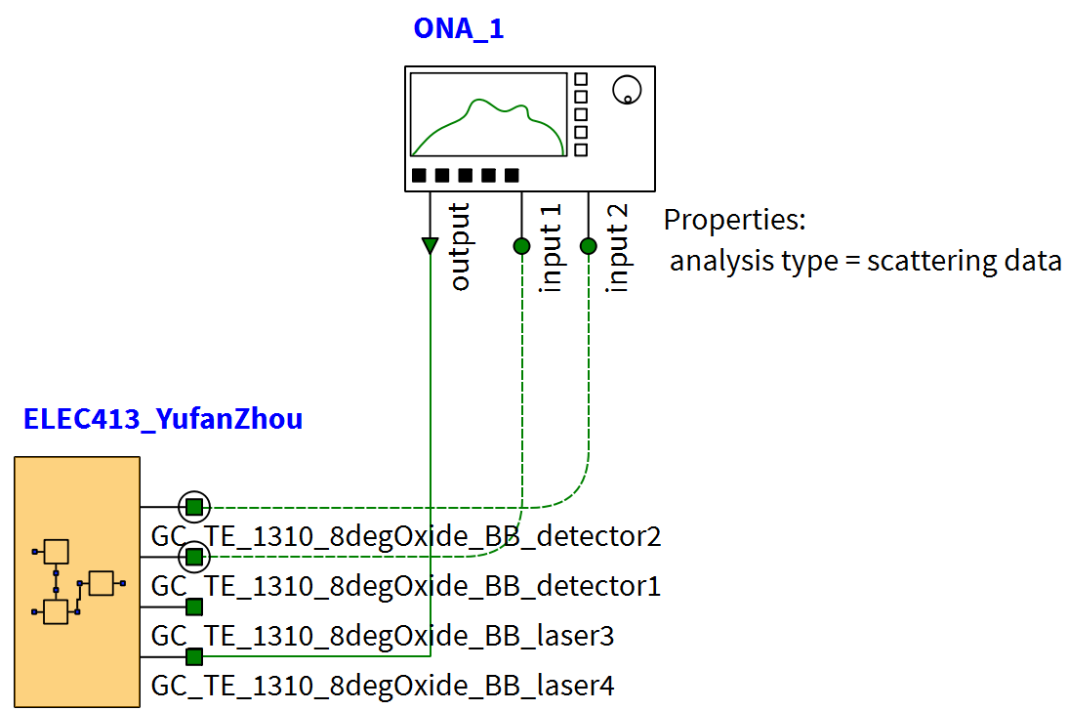

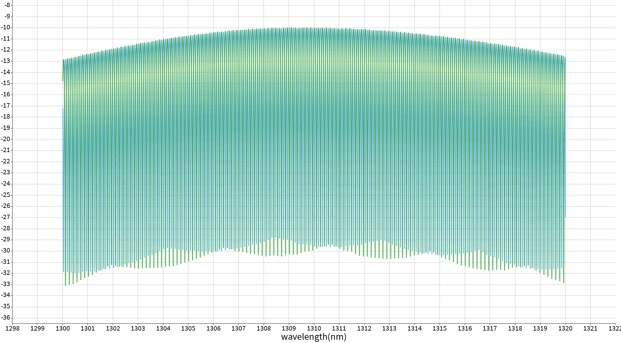

## Design and Fabrication

Proposed design layout and fabrication details.

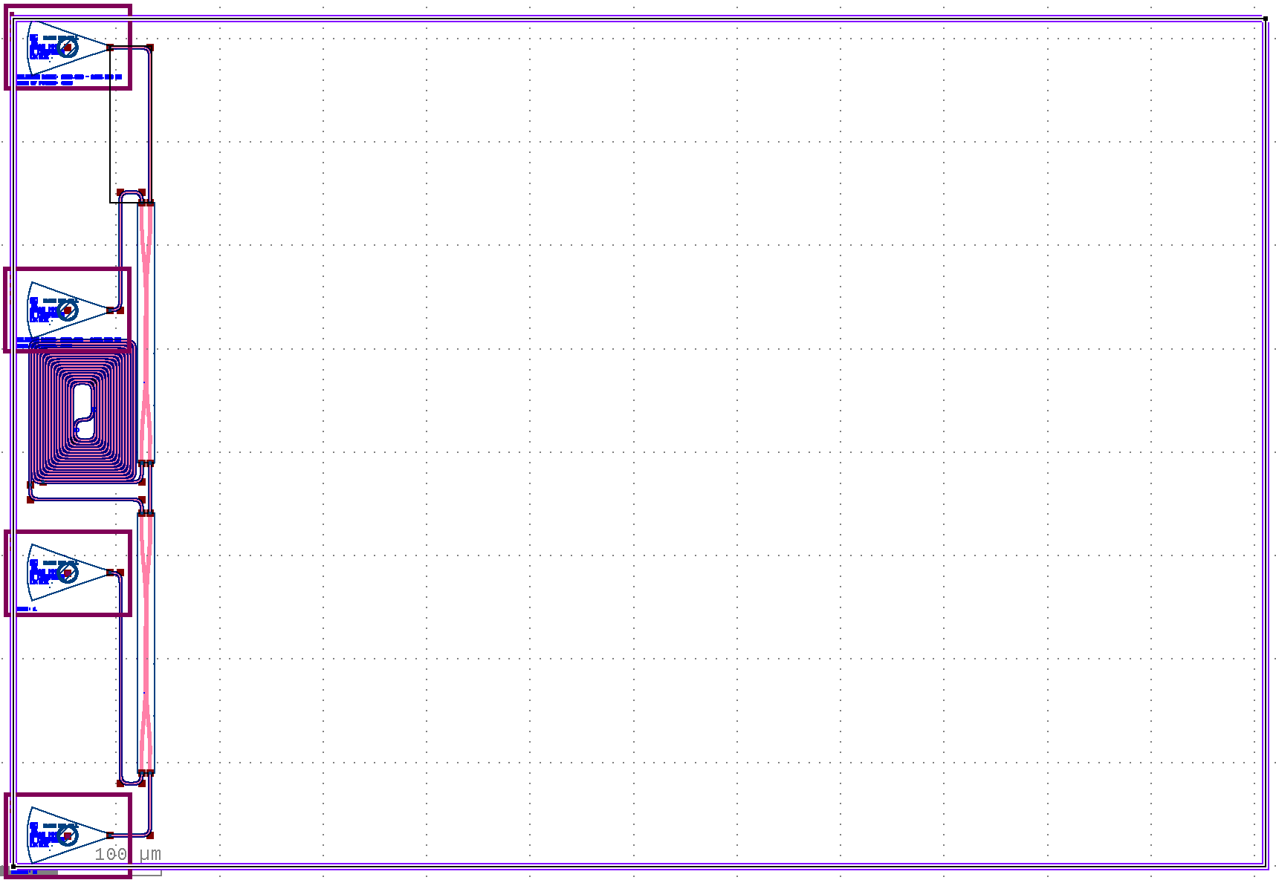

Fig. .Mask layout of the MZI,

## Conclusion and Future Work

## References