Location Analysis for New Restaurant Opening

Dulal Das

November 28, 2019

1. **Introduction**

Opening a restaurant is a difficult undertaking. But the work is more manageable if broken down into different sub-tasks. There are many tasks which needs to be taken care of while opening a restaurant. Some of them are the following (assuming that the person already has the required funds):

1. Choose a restaurant concept
2. Form the menu items
3. Write the restaurant business plan
4. Choose a location
5. Permits and Licenses etc.

This assignment focuses on point 4 – Choose a location, to open a restaurant in the city of Bangalore (Bengaluru), Karnataka, India.

When choosing a location for a new restaurant, the following features are among the most important:

1. Visibility and accessibility
2. The demographics
3. Labour costs and minimum wage
4. Competition in the area etc.

So, what is Location Analysis? Location analysis is a technique for finding the best location to open a new restaurant. We need to analyse potential locations and their access to customers, their location in relation to equipment and food suppliers and other important factors.

So, choosing a good location for your business might be the single most effective thing to do, to get success. Having a good menu and professional staff is important to restaurant success but having a good location can give the necessary push for success in the restaurant business.

In this assignment we will try to find the optimal location to open a new restaurant in the city of Bangalore. Since there are lots of restaurants in Bangalore, we will try to detect locations that are not already crowded with restaurants. We would prefer locations which are close to the city centre as possible.

1. **Data**

Data has been collected from the following sources:

1. Dataset with various neighbourhoods and its Pin codes are collected from the link <https://finkode.com/ka/bangalore.html>. This dataset has the neighbourhoods with the pin codes and the district name.

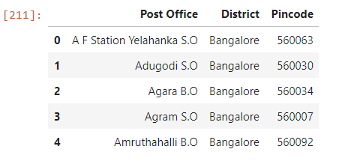

1. geopy.geocoders is used to collect the geo coordinates for various neighbourhoods in Bangalore city.

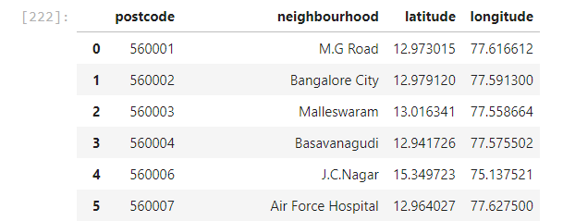

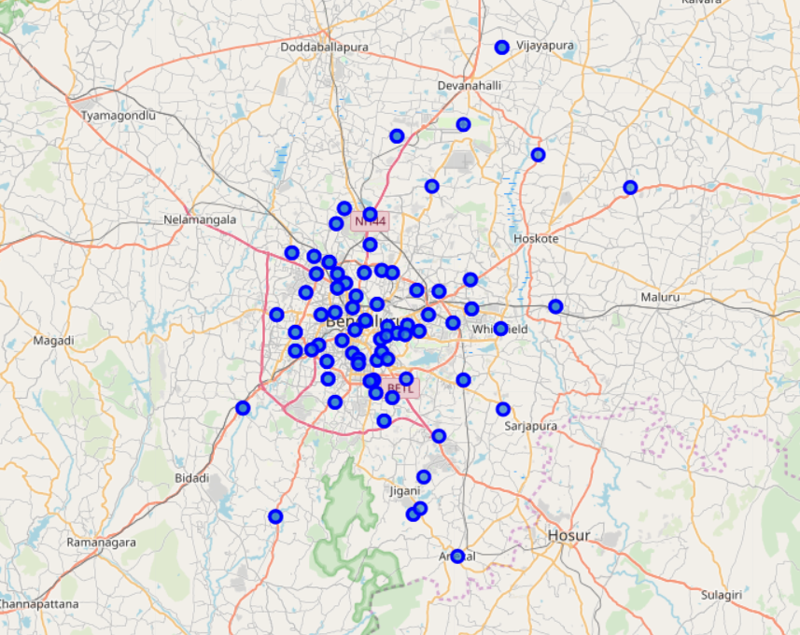

1. Foursquare API is used for collecting various venue details in the neighbourhoods of Bangalore city.

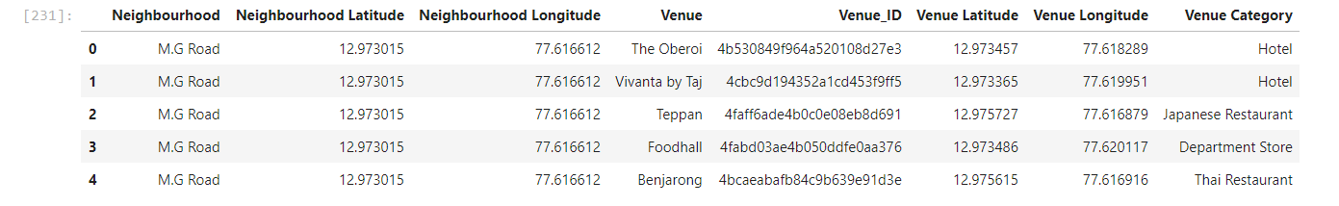

As we are only doing location analysis for opening a new restaurant in the city, we will remove all other venue details from the dataset and keep only the venues which are restaurants.

So, the dataset will look like as below:

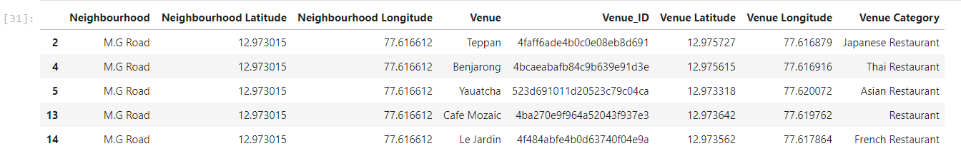

Based on the definition of our problem, factors that will influence our decisions are the following:

1. Number of existing restaurants in the neighbourhood.
2. Distance between the restaurants.
3. Distance of neighbourhood from the city centre.
4. We will even look into various zones in Bangalore city and try to figure out the best place to open a restaurant in a zone as well.