**Neon Juan**: There Can Only Be Juan

Game Design Document

(April 2014)

**Creative Director**

Stephen Dailey

**Expected Completion**

August 2014

**Authors**

Stephen Dailey

Shane Harrison

Lookmai Rattana

Mitchell Halman

Matt Hines

Copyright © 2014

[Video Game Design and Development Club](https://orgsync.com/63632/chapter)

[Old Dominion University](http://www.odu.edu)

Table of Contents

Introduction 3

Story 4

Characters 5

Juan: 5

Narrator: 5

Phil the TACO Truck Driver: 5

Bosses 5

Enemies 5

Level/environment design 7

Gameplay 9

Art and Style 10

Sound and Music 11

User Interface, Game Controls 12

Inspirations and References 13

Megaman X 13

Timesplitters 2 – NeoTokyo story level 13

Teenage Mutant Ninja Turtles 13

# Introduction

This document is called a Game Design Document (GDD). GDDs are used in industry as a way for members of the development team to keep production organized. Additionally, the GDD is used as a type of contract between the development team and the producer. Artists, Designers, and Programmers will create this document and reference it during production. This hypothetically means any member of the club can edit this document. To keep organized however, this responsibility will be that only of the team leads. The document can contain paragraphs, images, or even flow charts.

Neon Juan is a project of the Video Game Design and Development Club. All aspects of this game will be created by the members of the club.

# Story

Neon Juan: There Can Only Be Juan, is a story about the character of Juan. Juan has been framed by the “cyberpunk-style” government as the “most Juan-ted man in Mexico.” The government is named The Association of Corrupt Overlords (T.A.C.O).

# Characters

## Juan:

The main character. The player plays as Juan. Juan discovers the secret ingredient in T.A.C.O.'s products and fights to end T.A.C.O's evil scheme of mind control.

## Narrator:

The narrator for the game. The narrator is characterized in the 3rd person omniscient.

## Phil the TACO Truck Driver:

Phil is Juan's Step-brother and is part of the Gobierno or T.A.C.O. He is the *man on the inside*. Drops pickups. “Have Juan on the house.”

## Bosses

1. Chip and Potle
2. T.A.C.O Executive
3. Flying Sombrero
4. Veleton
5. Walking Taco
6. Luchudora the destroya (Dora + Muscleman)
7. Hot Tamale

## Enemies

1. Ninjas
2. Beta Max
3. TACO Worker
4. Chupuracabra
5. Generic Luchadors
6. Juan Bots
7. Mini Skeletons
8. Futuristic Meriatchi Band
9. Mutant Cacti
10. Piñatas

# Level/environment design

The game takes place at night on the rooftops of a large city. This city follows the portrayal of the future given by 1980's media. Bright, colorful, neon lights will surround the city, as well as advertisements. Although the setting is futuristic and modeled after representation of a cyber-Tokyo in various futuristic games, the nationality of the location is Mexican.

*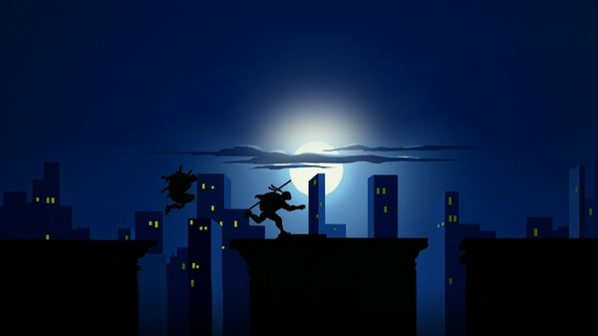Figure 1: Teenage Mutant Ninja Turtles Rooftops*

The game will be played on a single level. There will be one platform that is the rooftop of a building. The building will have almost nothing on it. Perhaps water towers, or heating units. The player will only have access to this one rooftop, however many other buildings can be seen in the background and surrounding area.

*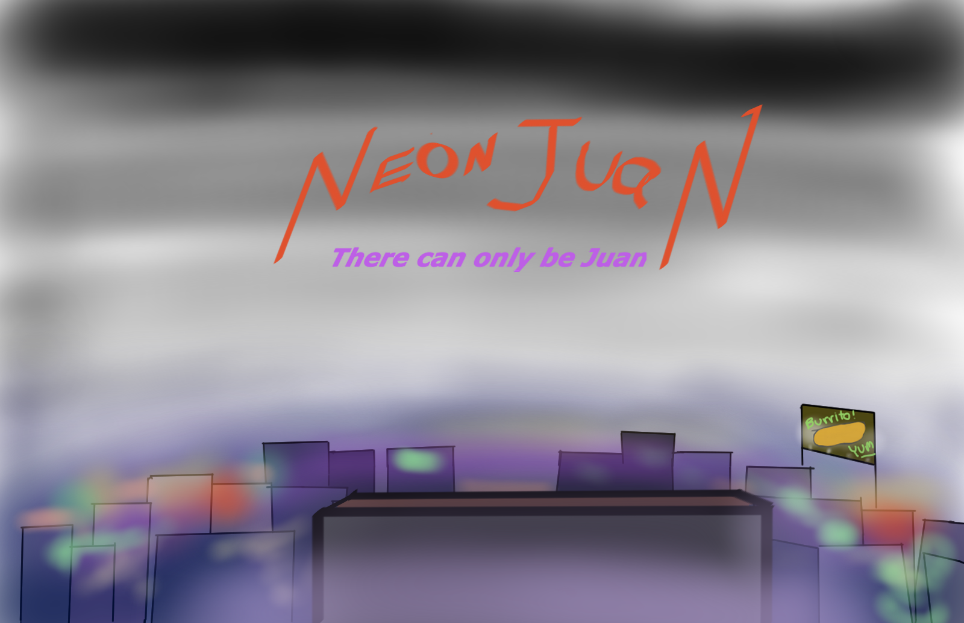Figure 2: Initial level concept*

# Gameplay

Neon Juan will be a fast-paced beat'em up.

Juan's movements will be quick, and slick, similar to the gameplay of Megaman X once the player acquires the dash boots. During left and right movements, the player will hover in mid air like X and travel at a high rate. Juan will be able to jump three body lengths high and will be pulled back down to the ground very quickly. The jump should feel as if the player launches themselves into the air.

*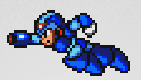Figure 3: Dash example*

Combat should flow and have synergy with the quick character movements. The player will use futuristic variations of weapons one might find in Mexico. The player will pull Laser guns and Laser swords seemingly out of nowhere. Punches and kicks will be powered up with neon glows.

Enemies will come from off camera and try to defeat Juan. This can happen in two different ways. The first is by depleting Juan's life energy by inflicting damage through combat. The second is by knocking Juan off the top of the building.

Power ups: Players receive power ups from Phil dropping down different edible power-ups. Also with each new skin the player receives comes new power-ups and attacks.

Health: With each hit, Juan's Mug Shot will increase in receiving injuries until a Game Over

# Art and Style

The art is going to be one of the most important elements of Neon Juan. In order to capture the feel of the game setting as discussed in Section 4, lighting effects will need to be employed. The game will be in 2D, with parallax backgrounds.

Sound and Music

There will be an audible narrator who speaks in mainly Spanish. Otherwise, the narrator is making puns in English. Spanish voice will be accompanied by Japanese subtitles.

The background music for the game will be techno driven with a Mexican flare.

User Interface, Game Controls

The player will have a joystick and several buttons to execute combat maneuvers.

# Inspirations and References

Megaman X <https://www.youtube.com/watch?v=AISfltM4HRc>

Timesplitters 2 – NeoTokyo story level <https://www.youtube.com/watch?v=KVz5IqzeyMs>

## Teenage Mutant Ninja Turtles