Stanley Zheng

CS 495/595 Web Sciences

September 12th, 2013

1. Task: Show knowledge on how to parse and post parameters to a website. (like if it was done in the browser by keyboard input)   
   Here is a simple wufoo form and the output piped into an **index** file

curl -d "Field1= dog&Field2=cat&Field3=OldMcDonald&Field4=Had a farm&Submit=submit" https://acmodu.wufoo.com/forms/z7x4m1/ > index.html

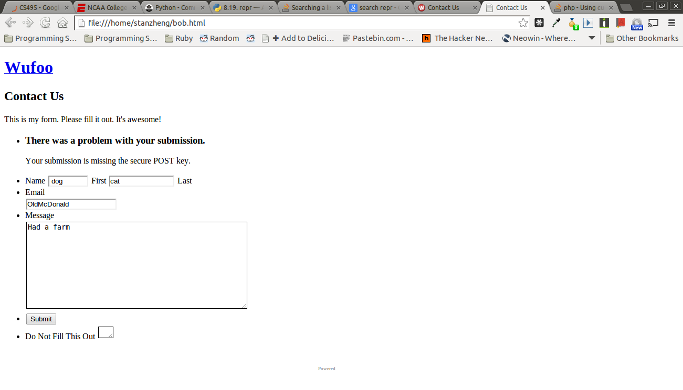

2. Task: Using beautifulsoup to scrape scores from Espn given three parameters: team name, time, and a valid espn-url. The libraries used to accomplish this include

* URLIB2
* SYS
* TIME

From here the program will accept system arguments of:

*$python ./q2.py team seconds website*

The Tags that wrapped each score box header is in a ‘div mod-content’ .

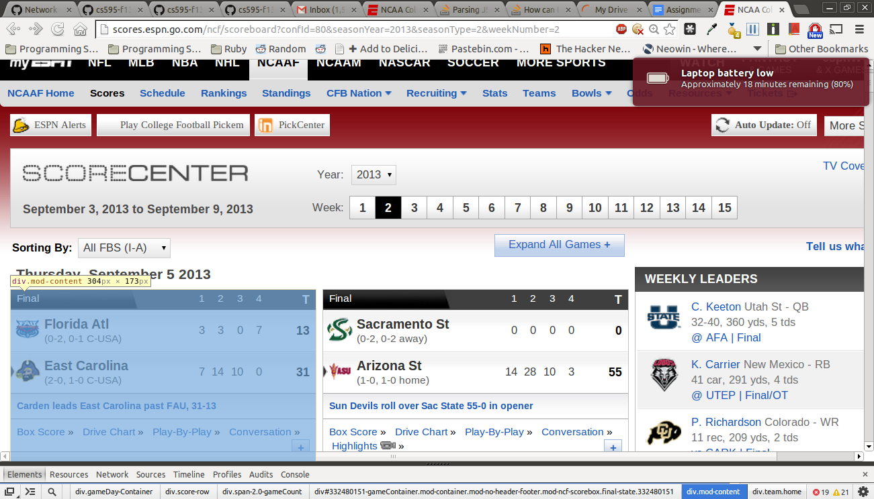

* The key information we are searching for are enclosed in the following classes
  + class: team visitor #team home score
  + class: team home #team home name
  + in tag <li>, class: final
* From here *** the following is incomplete as code is not working
* Code should parse the new ‘home’ and ‘visitor’ for the names
* Then it should print into the screen
  + Old Dominon:0, East Carolina 53

3. Task: Given this figure (source: <http://www9.org/w9cdrom/160/160.html#bowtie>)

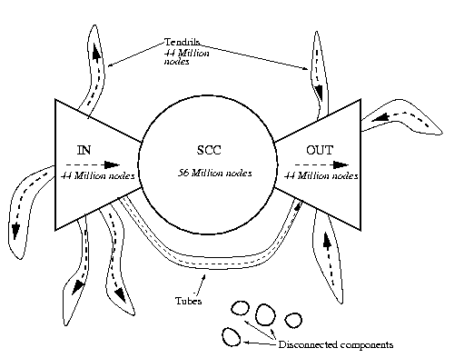

Now consider the following graph:

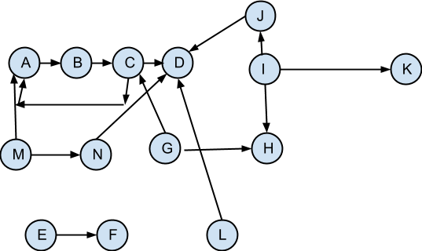

For the above graph, give the values for:

IN: **M, A** nodes that have input, original content

SCC: **G,C,B, J**  
 The super connected content sites

OUT: **H, G**

The content leaving the SCC,

Tendrils**: I, L, D, K**  
 Go in and out dont touch SCC

Tubes: **N**  
 The ones that connect all from in to out without touching SCC

Disconnected:**E, F;**   
 The nodes with no connections to the rest (lost or spam)

Work Cited and Links used

* http://stackoverflow.com/questions/9942594/unicodeencodeerror-ascii-codec-cant-encode-character-u-xa0-in-position-20
* <http://www.crummy.com/software/BeautifulSoup/bs4/doc/>
* <http://www9.org/w9cdrom/160/160.html#bowtie> figure nine
* google groups
  + Mat help <https://groups.google.com/forum/#!topic/cs595-f13/_qkclv95Itg>
  + Scott assist