1. Using D3, create a graph of the Karate club before and after the split.  
  
- Weight the edges with the data from: http://vlado.fmf.uni-lj.si/pub/networks/data/ucinet/zachary.dat  
  
- Have the transition from before/after the split occur on a mouse click.  
  
**Approach**

1. Weight the Edges   
   From the matrix, discover the weight of the edges between the vertices. The known is there are 32 nodes and the the matrix lookup produces the weight count which can be used to determine edge betweenness and cohesion.   
     
   The data could then be visualized as per assignment 6, as two distinct communities or even further breakdown.

**Method**

To massage this data from a matrix -> json -> d3.js -> __ -> profit? I required the dataset to be broken into json.   
  
Given my weakness in parsing this matrix, I searched for a json’ifed dataset already.   
  
From @mbostock example gallery, this prime force graph can be found. <http://bl.ocks.org/mbostock/1129492> Upon closer examination, the dataset matches a json’ified and name tagged dataset of all 34 node connections.

I prettified the JSON and used it as my new primary dataset after checking the data’s veracity.

Thanks @mbostock - raw at <https://gist.github.com/mbostock/1129492>   
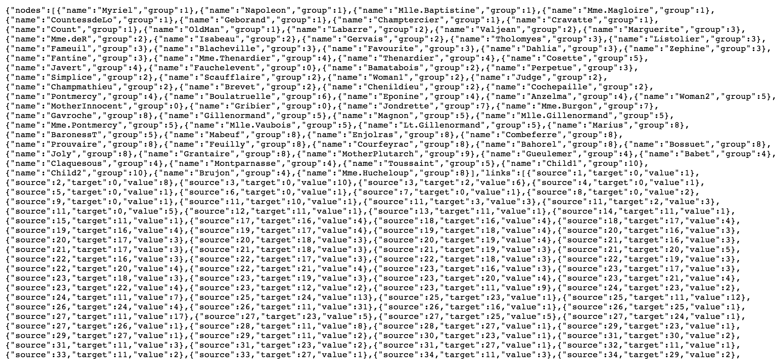

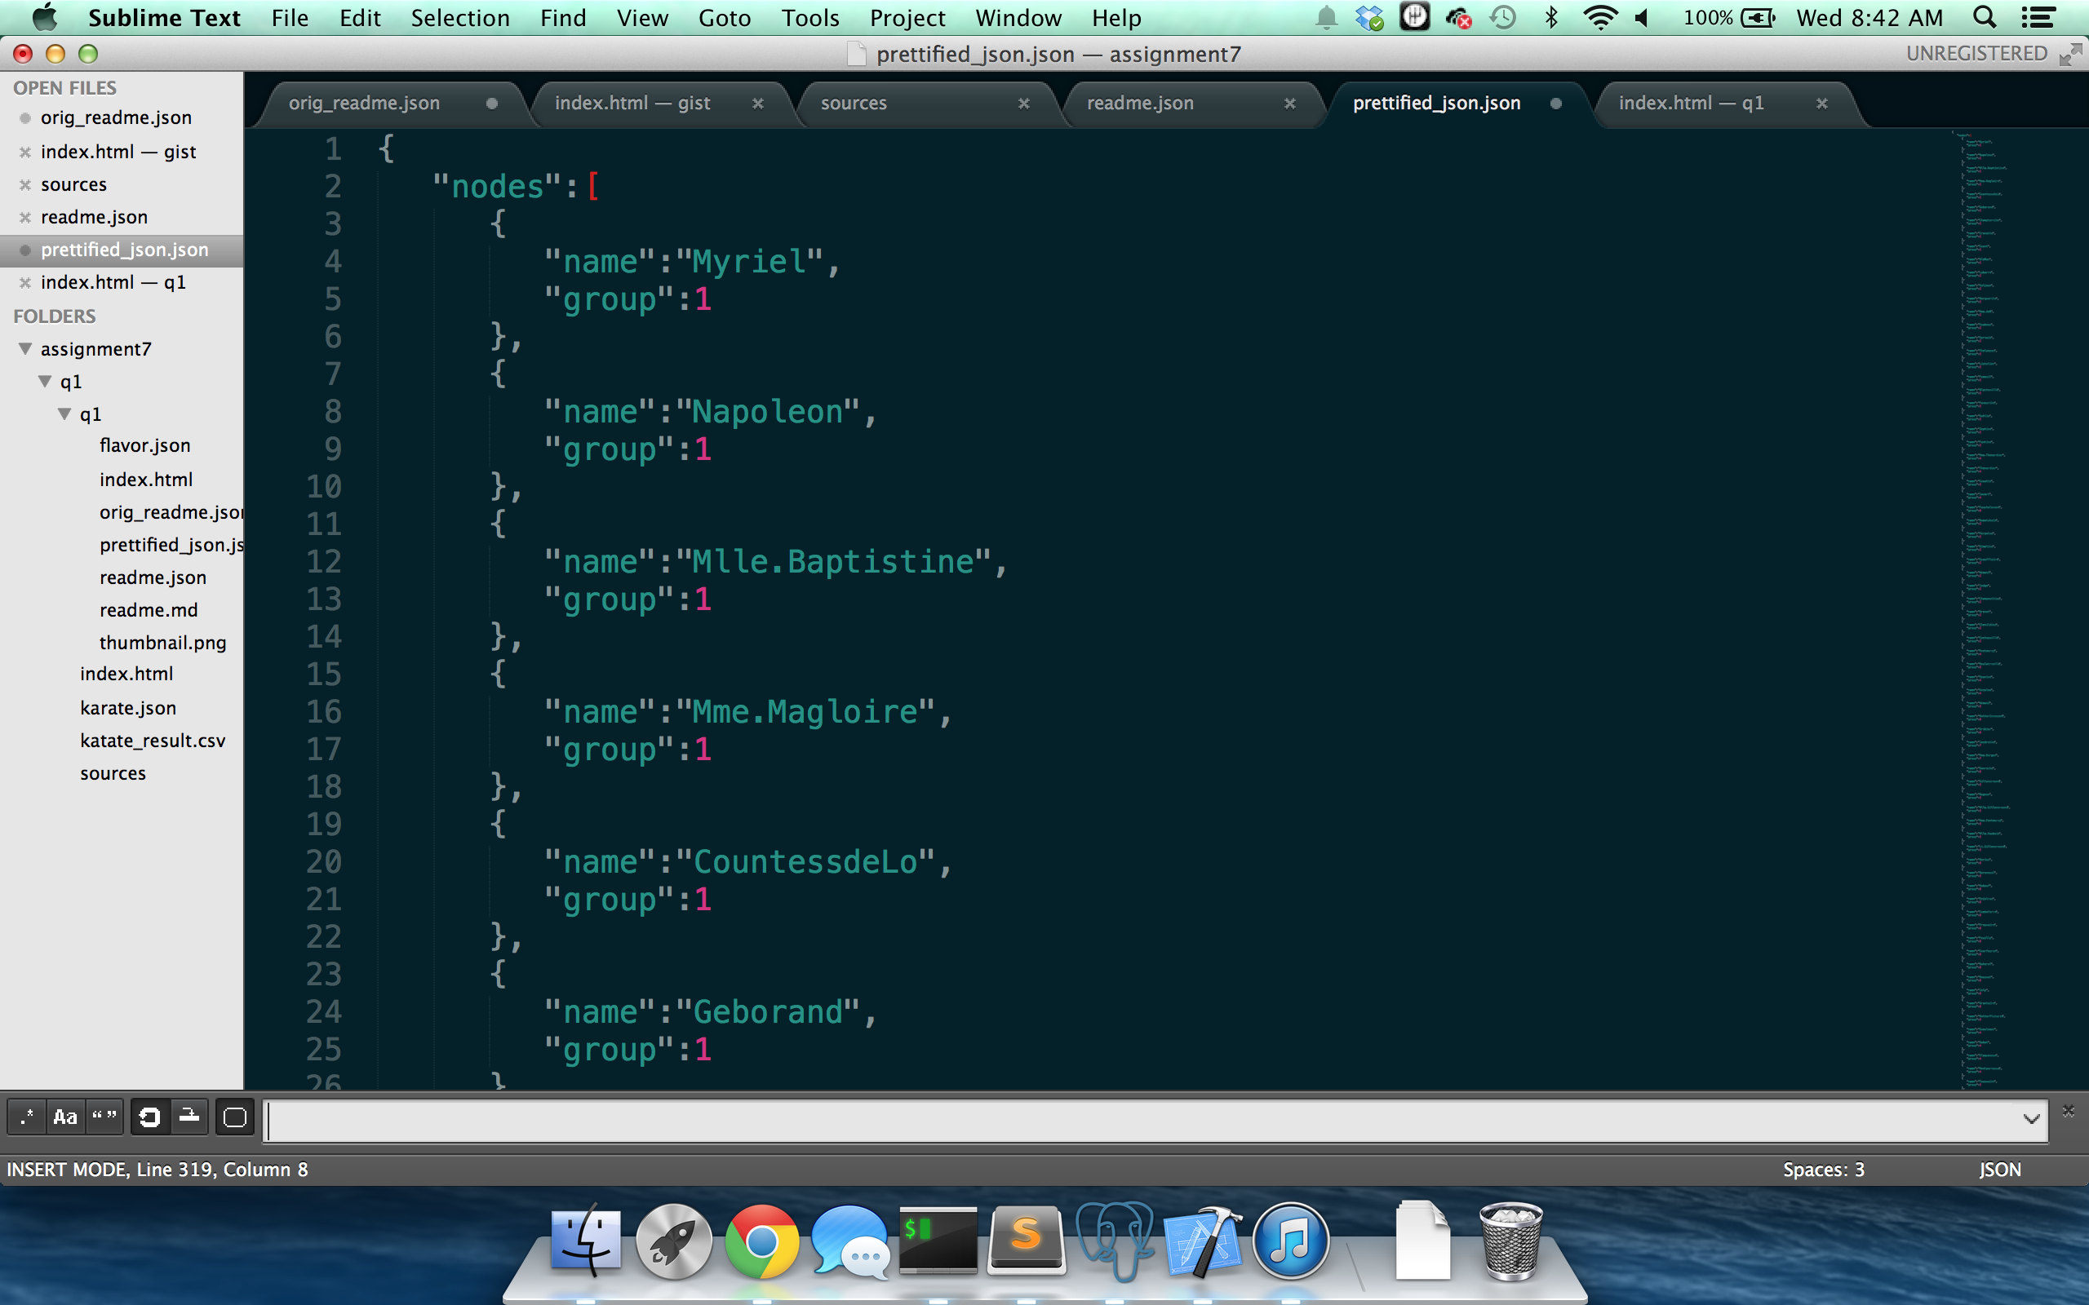

**Visualizing**

* Using visualizations from

2. Use D3 to create a who-follows-whom graph of your Twitter  
account. Use my twitter account ("@phonedude_mln") if you do not  
have an interesting number of followers.