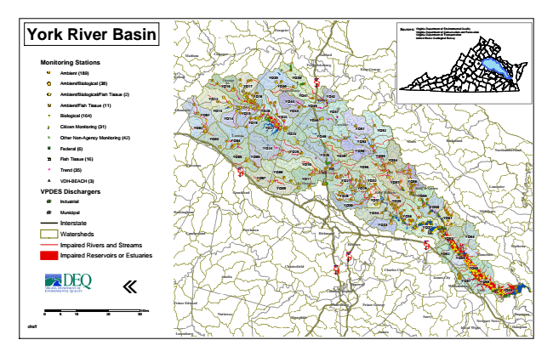

**York River Basin**

**Monitoring Stations**

Ambient (189)

Ambient/Biological (38)

Ambient/Biological/Fish Tissue (2)

Ambient/Fish Tissue (11)

#* Biological (164)

kj Citizen Monitoring (31)

k Other Non-Agency Monitoring (42)

XW Federal (6)

Fish Tissue (16)

^ Trend (35)

!A VDH-BEACH (3)

**VPDES Dischargers**

A@ Industrial

A@ Municipal

Interstate

Watersheds

Impaired Rivers and Streams

Impaired Reservoirs or Estuaries

«

0 5

10 20 30 Sources: Virginia Virginia Department Department of of Environmental Conservation and Quality Recreation Virginia Department of Transportation United States Geological Survey

*draft*

Miles

**Fauquier**

**Madison**

**Culpeper**

**Stafford**

**Fredericksburg**

**King George**

**Greene**

**Orange**

**YO16**

**YO17**

**YO39**

**YO38 YO40**

§ ̈¦ 95

**Spotsylvania**

**YO12**

**YO18**

**YO44**

**YO41**

**YO42**

**YO45**

**Westmoreland**

**Albemarle**

**YO01**

**YO13 YO14**

**YO15**

**YO19**

**YO20**

**YO22**

**YO43**

**YO46**

**YO47**

**Caroline YO02**

**YO21**

**YO51**

**YO52**

**YO03**

**Louisa YO04**

**YO23**

**YO48**

**YO53**

**Essex**

**Richmond**

**YO05**

**YO24**

**YO25**

**YO26**

**YO49**

**YO50**

**Northumberland**

**YO06**

**YO55**

**YO54 Fluvanna**

§ ̈¦ 64

**YO10**

**YO56 YO08**

**YO07**

**YO11 Hanover**

**YO27**

**YO32**

**YO57**

**YO58**

**YO09**

**YO29**

**King & Queen**

**Lancaster Goochland**

**YO28**

**King William**

**YO59 YO31**

**YO35 YO30**

**YO60 Buckingham**

**YO34**

**Middlesex YO36**

**YO61**

**Cumberland**

**Powhatan**

**Richmond**

**YO33**

**YO37**

**Henrico**

§ ̈¦ 64

**YO63**

**YO64**

**Mathews**

**YO62**

**YO65**

**Gloucester**

**Chesterfield**

§ ̈¦ 95

**YO66**

**Amelia**

**James City**

**YO67**

**YO68 Williamsburg Colonial Heights**

**York**

**YO69**

**Prince George**

**Dinwiddie**

**Surry**

**Newport News**

**Isle of Wight**

**Hampton Sussex**

**New Kent**

**§ ̈¦ 295**

**Charles City**

**Hopewell**

**Prince Edward**

**Petersburg**

**Lunenburg**

**Nottoway**

**Poquoson**