**Annual Plan**

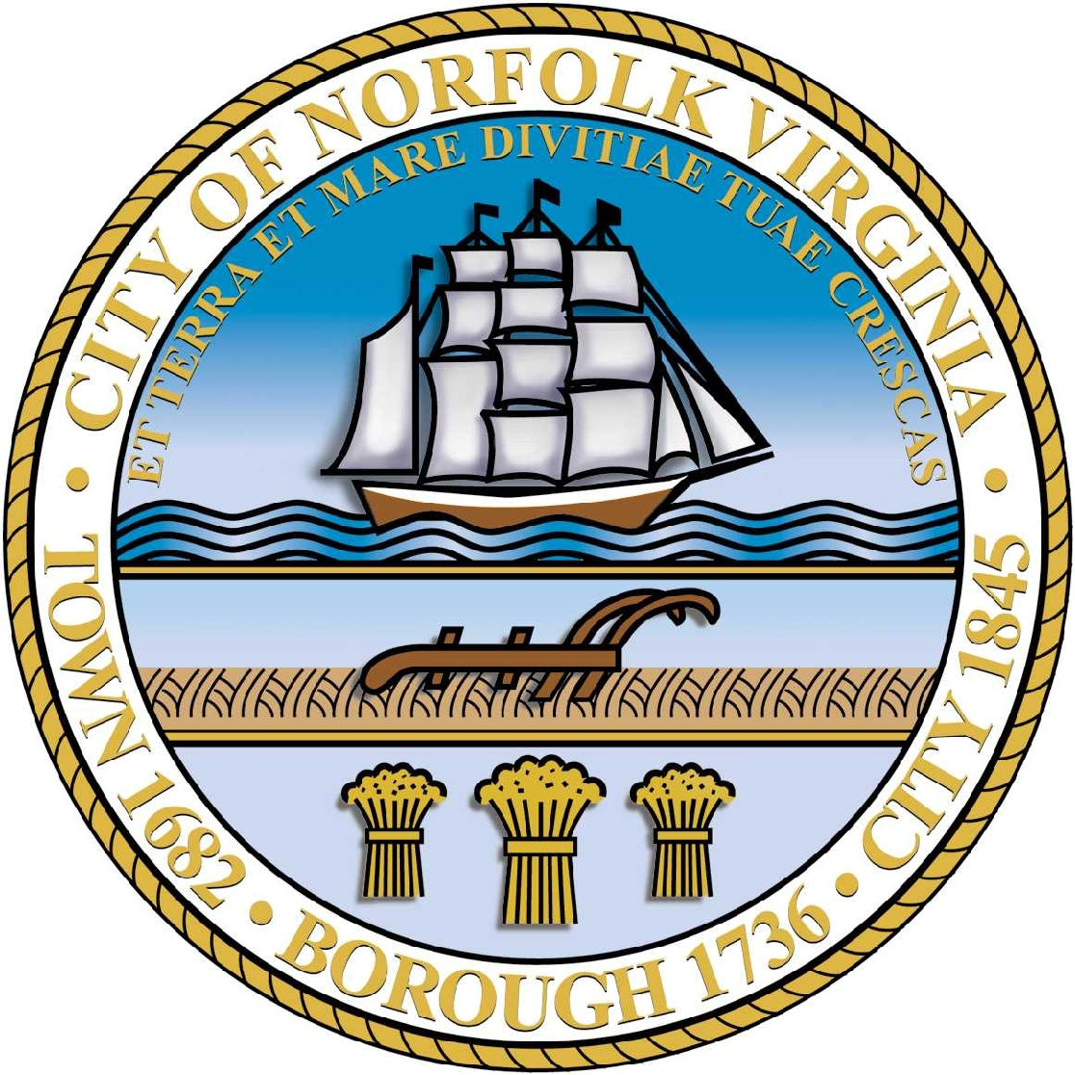

**ANNUAL PLAN**

U.S. Department of Housing and Urban Development (HUD) regulations require that every three to five years participating jurisdictions prepare a Consolidated Plan. The City of Norfolk is currently in the 2012-2016 Consolidated Plan period, and the Fiscal Year 2014 Annual Action Plan represents the third year of this Consolidated Plan period. A Consolidated Plan is developed with the purpose of identifying opportunities for strategic planning and citizen participation using a comprehensive approach. The Consolidated Plan enables the city, community based organizations, and citizens to provide input that directs the scope of activities upon which to focus during the Consolidated Plan period. The diversity and range of experience contributed by participants are just two of the many benefits of the development process.

Annually, grantees are required to prepare an Annual Action Plan to update the goals and objectives for planned projects and programs and to demonstrate how these activities relate to the Consolidated Plan. The Annual Plan describes priority projects for neighborhood revitalization, public improvements, housing development, economic development, public services, and homeless activities. The Annual Plan also identifies funding priorities and details the projects proposed to receive federal funds under the Community Development Block Grant (CDBG) Program, HOME Investment Partnership (HOME) Program, and Emergency Solutions Grant (ESG) Program.

For the current Consolidated Plan period (FY 2012-FY 2016) the city will continue to focus on programs and services designed to benefit lower income residents of Norfolk. Efforts outlined in this Annual Action Plan are identified utilizing HUD’s Performance Outcome Measurement System outcome categories: Economic Opportunities, Suitable Living Environments, and Decent Housing. Funding considerations are given to a broad range of issues that include, but are not limited to:

* Efforts to eliminate homelessness
* Methods for improving housing quality
* Increasing homeownership
* Strengthening economic development opportunities

**Available Resources**

|  |  |
| --- | --- |
| CDBG Entitlement | 4,042,698 |
|  |  |
| CDBG Program Income | 0 |
|  |  |
| CDBG Revolving Loan Fund (Rehab Payments) | 275,000 |
|  |  |
| CDBG Fund Balance (Reprogrammable Dollars) | 0 |
|  |  |
| **Total Community Development Block Grant Program** | **4,317,698** |
|  |  |
| **Emergency Shelter Grant Program** | **388,122** |
|  |  |
| HOME Entitlement | 973,108 |
|  |  |
| HOME Program Income | 0 |
|  |  |
| HOME Fund Balance (Reprogrammable Dollars) | 0 |
|  |  |
| **Total HOME Investment Partnership Program** | **$973,108** |
|  |  |
| **Total Resources** | **$5,678,928** |
|  |  |

540 Annual Plan

**Community Development Block Grant Program (CDBG)**

The CDBG Program is a federal funding source that allows local officials and residents unprecedented flexibility in designing their own programs within a wide range of eligible activities. The CDBG Program was created over 30 years ago under the administration of President Gerald R. Ford. Over the past three decades, the goal of the CDBG program remains the same: to encourage more broadly conceived community development projects, and expand housing opportunities for people living in low and moderate-income households.

The city’s budget for the FY 2014 CDBG Program is $4,317,698 which rehabilitation loan payments from prior years that will be reprogrammed. Proposed FY 2014 Annual Plan include:

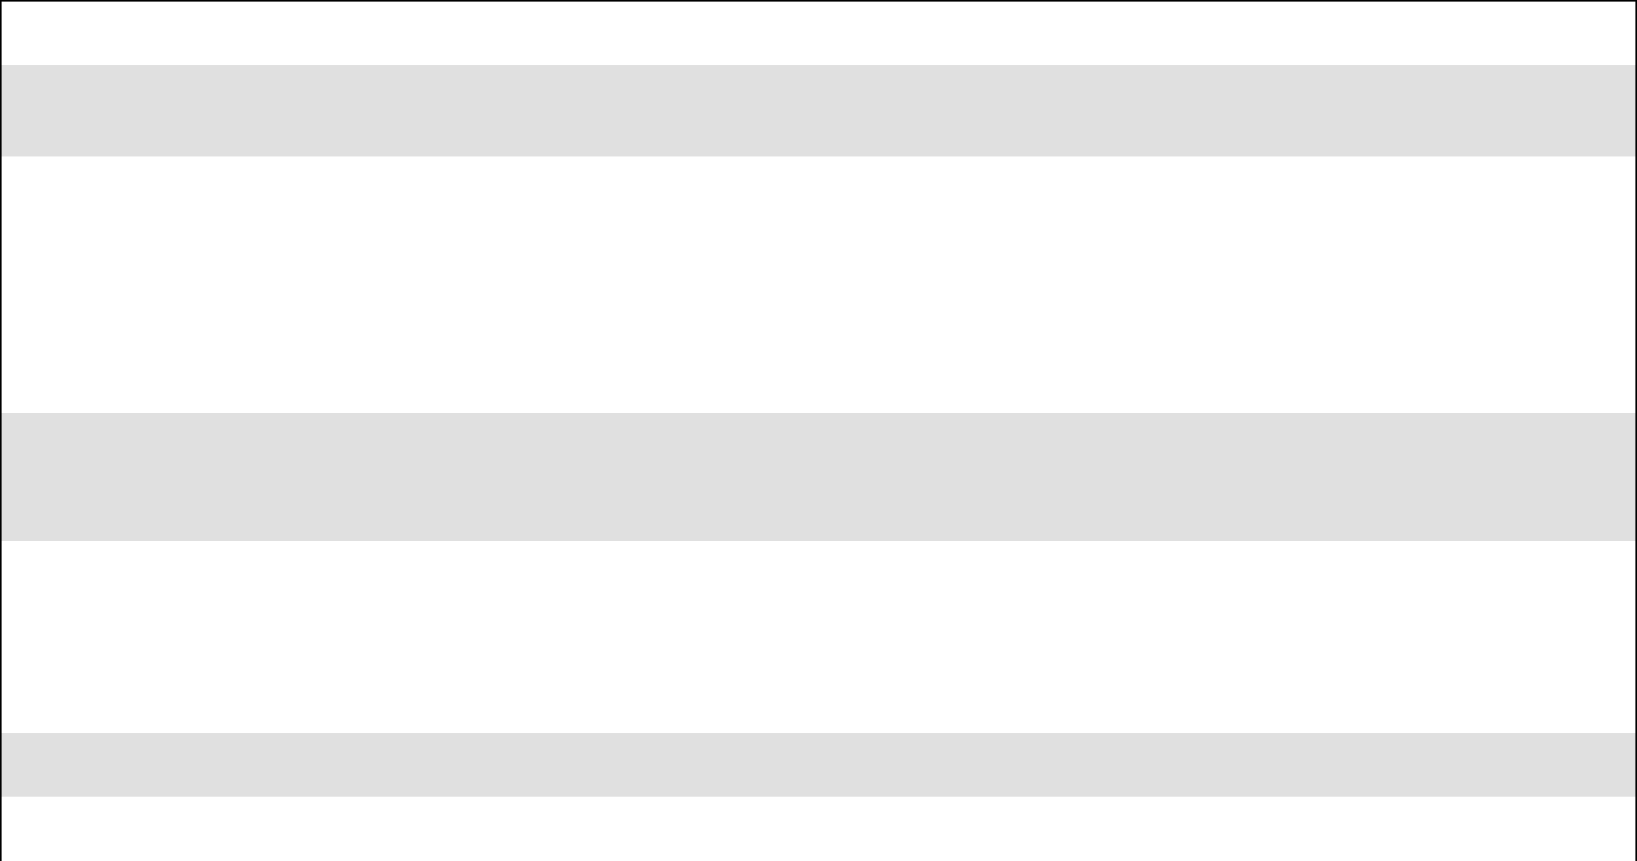

includes an estimated $275,000 in The major accomplishments of the

**COMPARISON OF GRANT RESOURCES, FY 2012 to FY 2014**

|  |  |  |  |  |  |  |
| --- | --- | --- | --- | --- | --- | --- |
|  | **FY2012** | **FY2013** | **FY2014** | **Inc/Dec** | **%** |  |
|  | **FY2013-FY2014** | **Difference** |  |
|  |  |  |  |  |
|  |  |  |  |  |  |  |
| CDBG Entitlement | 4,717,815 | 3,887,210 | 4,042,698 | 155,488 |  |  |
|  |  |  |  |  |  |  |
| CDBG Program Income | 131,000 | 0 | 0 | 0 |  |  |
|  |  |  |  |  |  |  |
| CDBG Revolving Loan Fund | 200,000 | 275,000 | 275,000 | 0 |  |  |
|  |  |  |  |  |  |  |
| CDBG Fund Balance | 0 | 2,525,154 | 0 | -2,525,154 |  |  |
|  |  |  |  |  |  |  |
| **CDBG Total** | **5,048,815** | **6,687,364** | **4,317,698** | **-2,369,666** | **-35%** |  |
|  |  |  |  |  |  |  |
| **ESG Total** | **227,807** | **408,550** | **388,122** | **-20,428** | **-5%** |  |
|  |  |  |  |  |  |  |
| HOME Entitlement | 1,746,031 | 1,024,324 | 973,108 | -51,216 |  |  |
|  |  |  |  |  |  |  |
| HOME Program Income | 395,000 | 15,495 | 0 | -15,495 |  |  |
|  |  |  |  |  |  |  |
| HOME Fund Balance | 0 | 646,646 | 0 | -646,646 |  |  |
|  |  |  |  |  |  |  |
| **HOME Total** | **2,141,031** | **1,686,465** | **973,108** | **-713,357** | **-42%** |  |
|  |  |  |  |  |  |  |
| **Grand Total** | **7,417,653** | **8,782,379** | **5,678,928** | **-3,103,451** | **-35%** |  |
|  |  |  |  |  |  |  |

**Land Inventory**

Norfolk Redevelopment and Housing Authority’s (NRHA) CDBG acquisition inventory continues to undergo detailed evaluations. The evaluations are a result of technical assistance NRHA receives from HUD and the City of Norfolk administrative staff. The results of the evaluations are presented to HUD in the Land Inventory section of each year’s Consolidated Annual Performance Evaluation Report (CAPER). The city and NRHA are working together to develop a comprehensive plan for disposition of these properties that meets the national objectives of the CDBG program.

**HOME Investment Partnerships Program (HOME)**

The goal of HOME Program funding is to stimulate revitalization of inner-city neighborhoods by providing assistance to first-time homebuyers and existing homeowners. In FY 2014, HOME funds will provide assistance for the purchase of newly constructed homes, rehabilitation of owner-occupied homes, and improvements of multi-family dwellings. The strategy in these communities is to strengthen traditional neighborhood characteristics by rehabilitating homes, building new homes that emulate the impressive architectural style of existing structures, enhancing security and aesthetics with streetscape improvements, including trees and lighting, and providing key retail services and employment opportunities. In FY 2014, HOME funds will also be used to provide Tenant Based

Annual Plan 541

Rental Assistance (TBRA). TBRA is a rental subsidy that helps individual households afford housing costs such as rent, utility costs, security deposits, and/or utility deposits. The city is using TBRA as a resource in its efforts to end homelessness.

**Emergency Solutions Grant Program (ESG)**

The ESG program has been retooled for FY 2014. The “new” ESG program has additional eligible activities such as street outreach and rapid re-housing. The ESG Program will continue to provide short-term homeless prevention assistance to persons at imminent risk of losing their own housing due to eviction, foreclosure, or utility shutoffs. This program currently provides funding for the Department of Human Services, the Planning Council and five emergency shelters.

**Prior Year Self-Evaluation**

In FY 2013 (Project Year 2012), the city funded 21 public service programs. The funding for these programs encompassed a variety of services to benefit youth, seniors, homeless persons, and other special needs groups. Award amounts ranged from $9,185 to $70,975. The city also supported community development projects – “bricks and mortar” activities - based on clearly identified needs. Among these initiatives were programs that focused on handicap accessibility projects and home maintenance repairs for special needs populations and low to moderate-income homeowners. Both the public service programs and the community development projects were based on priorities identified in the 2012-2016 Consolidated Plan. Specific program accomplishments, which include the percent of goals met, are provided in the Goals and Accomplishments Summary section of the Consolidated Plan.

Over the last year, the city has recognized several administrative successes. Financial monitoring was conducted for all sub-recipients including NRHA and on-site monitoring was completed for the majority of our public service sub-recipients. Mandatory training was held for all sub-recipients in an effort to improve compliance. The City of Norfolk is currently undergoing a HUD audit and will address unresolved issues upon completion.

**Summary of Citizen Comments and Disposition**

The City of Norfolk is also required to summarize the comments received from the community at various stages of the Annual Plan adoption process and describe actions taken to address these comments. In the city’s official submission to HUD, this section summarized the comments and their disposition from the public received at the open forum, during the public comment period, at the City Planning Commission’s public hearing, and also during the City Council’s public hearing.

**Impacts of Sequestration**

On August 2, 2011, Congress passed the Budget Control Act of 2011 as part of an agreement to resolve the debt-ceiling crisis. Congress included sequestration in the Budget Control Act of 2011 as a tactic to encourage bipartisan compromise on deficit reduction efforts. Sequestration, sometimes called the sequester, is a process that automatically cuts the federal budget across most departments and agencies. As a result of sequestration, the funding allocations for Annual Plan funding are preliminary and expected to change.

542 Annual Plan

|  |  |  |  |  |
| --- | --- | --- | --- | --- |
| **Community Development Public Service** | **FY2012** | **FY2013** | **FY2014** |  |
| **Approved** | **Approved** | **Proposed** |  |
|  |  |
| AIDS Care Center for Education & Support | 37,575 | 37,575 | 39,529 |  |
| Services – Housing Solutions |  |
|  |  |  |  |
|  |  |  |  |  |
| Barrett Haven | 9,185 | 9,185 | 0 |  |
|  |  |  |  |  |
| Building Trades Academy, Inc. | 23,468 | 23,468 | 24,688 |  |
|  |  |  |  |  |
| Child & Family Services of Eastern Virginia | 25,050 | 25,050 | 26,353 |  |
|  |  |  |  |  |
| City of Norfolk – Department of Human | 25,000 | 0 | 0 |  |
| Services |  |
|  |  |  |  |
|  |  |  |  |  |
| City of Norfolk – City Community Initiative | 0 | 0 | 50,482 |  |
|  |  |  |  |  |
| City of Norfolk – Neighbors Building | 49,317 | 0 | 0 |  |
| Neighborhoods Initiative |  |
|  |  |  |  |
|  |  |  |  |  |
| Ecumenical Family Shelter (The Dwelling Place) | 15,030 | 15,030 | 15,812 |  |
| – In Home Services |  |
|  |  |  |  |
|  |  |  |  |  |
| ForKids, Inc. – Permanent Supportive Housing | 12,525 | 12,525 | 13,176 |  |
| Solutions |  |
|  |  |  |  |
|  |  |  |  |  |
| Foodbank of Southeastern Virginia | 29,225 | 29,225 | 30,745 |  |
|  |  |  |  |  |
| International Black Women’s Congress – | 32,565 | 32,565 | 0 |  |
| Certified Nursing Assistant |  |
|  |  |  |  |
|  |  |  |  |  |
| Oakmont Community Development Corp. | 16,700 | 16,700 | 17,585 |  |
|  |  |  |  |  |
| Park Place School | 13,115 | 13,115 | 0 |  |
|  |  |  |  |  |
| Park Place Dental Clinic (formerly American Red | 33,400 | 33,400 | 35,137 |  |
| Cross Dental Clinic) |  |
|  |  |  |  |
|  |  |  |  |  |
| Garden of Hope – Kids of Incarcerated Parents | 36,740 | 36,740 | 38,687 |  |
|  |  |  |  |  |
| Southeastern Tidewater Opportunity Project | 58,450 | 0 | 0 |  |
| (STOP) – Homeless |  |
|  |  |  |  |
|  |  |  |  |  |
| St. Columba Ecumenical Ministries – Homeless | 12,525 | 12,525 | 13,182 |  |
| Assistant |  |
|  |  |  |  |
|  |  |  |  |  |
| St. Columba Ecumenical Ministries – Housing | 20,875 | 20,875 | 21,981 |  |
|  |  |  |  |  |
| The Planning Council – Continuum of Care | 35,905 | 35,905 | 37,808 |  |
|  |  |  |  |  |
| The Planning Council – ShelterLink | 10,521 | 10,521 | 11,079 |  |
|  |  |  |  |  |
| The Salvation Army | 70,975 | 70,975 | 74,694 |  |
|  |  |  |  |  |
| Urban League of Hampton Roads, Inc. | 20,875 | 0 | 0 |  |
|  |  |  |  |  |

Annual Plan 543

|  |  |  |  |  |
| --- | --- | --- | --- | --- |
| **Community Development Public Service** | **FY2012** | **FY2013** | **FY2014** |  |
| **Approved** | **Approved** | **Proposed** |  |
|  |  |
| Virginia Supportive Housing (Support Services | 20,875 | 20,781 | 21,883 |  |
| for Gosnold) |  |
|  |  |  |  |
|  |  |  |  |  |
| William A. Hunton YMCA | 26,720 | 26,720 | 28,136 |  |
|  |  |  |  |  |
| YMCA of South Hampton Roads | 37,575 | 37,575 | 39,566 |  |
|  |  |  |  |  |
| **Total CDBG Public Service** | **674,191** | **520,455** | **540,523** |  |
|  |  |  |  |  |

|  |  |  |  |  |
| --- | --- | --- | --- | --- |
| **Community Development Project Use** | **FY 2012** | **FY 2013** | **FY 2014** |  |
| **Approved** | **Approved** | **Proposed** |  |
|  |  |
|  |  |  |  |  |
| Chesterfield Heights Community Resource & | 272,464 | 0 | 0 |  |
| Women’s Residential Center |  |
|  |  |  |  |
|  |  |  |  |  |
| Dept. of Neighborhood Preservation – Home | 50,884 | 0 | 0 |  |
| Maintenance |  |
|  |  |  |  |
|  |  |  |  |  |
| Dept. of Public Works – ADA Ramps | 200,000 | 143,670 | 149,417 |  |
|  |  |  |  |  |
| City of Norfolk – City Project Initiatives | 0 | 0 | 338,000 |  |
|  |  |  |  |  |
| Ecumenical Family Shelter – Hallway and | 0 | 15,994 | 0 |  |
| Exterior Repairs |  |
|  |  |  |  |
|  |  |  |  |  |
| Ecumenical Family Shelter – Kitchen Renovation | 0 | 55,683 | 0 |  |
|  |  |  |  |  |
| ForKids, Inc. | 16,500 | 0 | 0 |  |
|  |  |  |  |  |
| Grant Administration | 334,422 | 260,297 | 262,099 |  |
|  |  |  |  |  |
| Southeastern Tidewater Opportunity Project | 200,000 | 143,376 | 149,111 |  |
| (STOP) – Home Maintenance |  |
|  |  |  |  |
|  |  |  |  |  |
| The Planning Council, Inc. – The Healing Place | 0 | 0 | 25,000 |  |
|  |  |  |  |  |
| Virginia Supportive Housing | 0 | 110,416 | 40,000 |  |
|  |  |  |  |  |
| **Total CDBG Project Use** | **884,422** | **884,822** | **963,627** |  |
|  |  |  |  |  |

544 Annual Plan

|  |  |  |  |  |
| --- | --- | --- | --- | --- |
| **Community Development – NRHA Projects** | **FY 2012** | **FY 2013** | **FY 2014** |  |
| **Approved** | **Approved** | **Proposed** |  |
|  |  |
|  |  |  |  |  |
| NRHA Administration | 598,500 | 665,000 | 521,441 |  |
|  |  |  |  |  |
| NRHA Disposition/Lease/Retention | 282,982 | 0 | 0 |  |
|  |  |  |  |  |
| NRHA Home Repair Grant | 528,650 | 514,607 | 514,607 |  |
|  |  |  |  |  |
| NRHA Rehabilitation | 1,516,440 | 3,760,912 | 1,436,619 |  |
|  |  |  |  |  |
| NRHA Site Improvement – Park Place | 0 | 174,000 | 0 |  |
|  |  |  |  |  |
| Site Improvements – AAA Salvage Yard | 277,961 | 0 | 0 |  |
|  |  |  |  |  |
| Revolving Loan Fund | 200,000 | 275,000 | 275,000 |  |
|  |  |  |  |  |
| HomeNet | 62,625 | 62,625 | 65,882 |  |
|  |  |  |  |  |
| **Total NRHA Project Use Allocation** | **3,467,158** | **2,912,319** | **2,813,549** |  |
|  |  |  |  |  |

|  |  |  |  |  |
| --- | --- | --- | --- | --- |
| **Emergency Solutions Grant Program** | **FY 2012** | **FY 2013** | **FY 2014** |  |
| **Approved** | **Approved** | **Proposed** |  |
|  |  |
|  |  |  |  |  |
| Administration | 14,139 | 30,641 | 29,109 |  |
|  |  |  |  |  |
| Dept. of Human Services* – Street Outreach | 31,200 | 34,130 | 29,717 |  |
|  |  |  |  |  |
| Dept. of Human Services* – Homeless Prevention | 35,835 | 33,026 | 40,000 |  |
|  |  |  |  |  |
| Dept. of Human Services* – Rapid Rehousing | 45,800 | 52,000 | 68,846 |  |
|  |  |  |  |  |
| Dept. of Human Services* – HMIS | 0 | 1,350 | 0 |  |
|  |  |  |  |  |
| Ecumenical Family Shelter (The Dwelling Place) | 49,997 | 55,000 | 43,011 |  |
|  |  |  |  |  |
| ForKids, Inc. | 49,770 | 55,000 | 43,012 |  |
|  |  |  |  |  |
| Salvation Army | 25,494 | 34,000 | 29,606 |  |
|  |  |  |  |  |
| St. Columba Ecumenical Ministries, Inc. | 27,675 | 30,000 | 26,672 |  |
|  |  |  |  |  |
| The Planning Council, Inc. | 36,403 | 46,403 | 46,403 |  |
|  |  |  |  |  |
| YWCA of South Hampton Roads | 27,078 | 37,000 | 31,746 |  |
|  |  |  |  |  |
| **Total Emergency Shelter Grant** | **230,556** | **408,550** | **388,122** |  |
|  |  |  |  |  |

*Funded under ESG Program.

Annual Plan 545

|  |  |  |  |  |
| --- | --- | --- | --- | --- |
| **HOME Investment Partnership Program\*** | **FY 2012** | **FY 2013** | **FY 2014** |  |
| **Approved** | **Approved** | **Proposed** |  |
|  |  |
|  |  |  |  |  |
| Beacon Light CHDO | 90,332 | 51,902 | 48,656 |  |
|  |  |  |  |  |
| CHDO Operating Fund | 0 | 0 | 50,000 |  |
|  |  |  |  |  |
| Department of Human Services | 25,000 | 0 | 0 |  |
|  |  |  |  |  |
| Habitat for Humanity | 0 | 51,900 | 48,655 |  |
|  |  |  |  |  |
| HOME Administration – City of Norfolk | 2,000 | 0 | 0 |  |
|  |  |  |  |  |
| HOME Administration – NRHA | 209,940 | 100,280 | 97,310 |  |
|  |  |  |  |  |
| Homebuyer Assistance | 1,212,332 | 423,837 | 500,000 |  |
|  |  |  |  |  |
| Office to End Homelessness – Rapid Exit | 70,099 | 0 | 26,633 |  |
|  |  |  |  |  |
| Plumb Line CHDO | 88,308 | 51,900 | 48,655 |  |
|  |  |  |  |  |
| Virginia Supportive Housing | 360,000 | 360,000 | 153,199 |  |
|  |  |  |  |  |
| **Total HOME Program** | **2,058,011** | **1,039,819** | **973,108** |  |
|  |  |  |  |  |



*HUD regulations require at least five percent of the HOME allocation be used for Community Housing Development Organizations (CHDO) programs.

546 Annual Plan

[PDF to Word](http://pdfonline.blogspot.com)