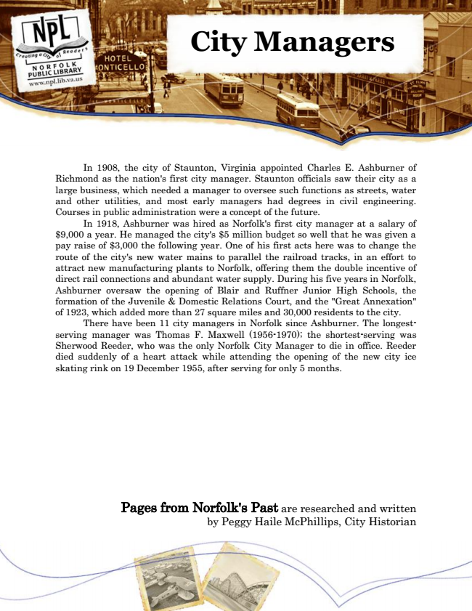

**City Managers**

In 1908, the city of Staunton, Virginia appointed Charles E. Ashburner of Richmond as the nation's first city manager. Staunton officials saw their city as a large business, which needed a manager to oversee such functions as streets, water and other utilities, and most early managers had degrees in civil engineering. Courses in public administration were a concept of the future.

In 1918, Ashburner was hired as Norfolk's first city manager at a salary of $9,000 a year. He managed the city's $5 million budget so well that he was given a pay raise of $3,000 the following year. One of his first acts here was to change the route of the city's new water mains to parallel the railroad tracks, in an effort to attract new manufacturing plants to Norfolk, offering them the double incentive of direct rail connections and abundant water supply. During his five years in Norfolk, Ashburner oversaw the opening of Blair and Ruffner Junior High Schools, the formation of the Juvenile & Domestic Relations Court, and the "Great Annexation" of 1923, which added more than 27 square miles and 30,000 residents to the city.

There have been 11 city managers in Norfolk since Ashburner. The longest- serving manager was Thomas F. Maxwell (1956-1970); the shortest-serving was Sherwood Reeder, who was the only Norfolk City Manager to die in office. Reeder died suddenly of a heart attack while attending the opening of the new city ice skating rink on 19 December 1955, after serving for only 5 months.

Pages from Norfolk's Past are researched and written by Peggy Haile McPhillips, City Historian