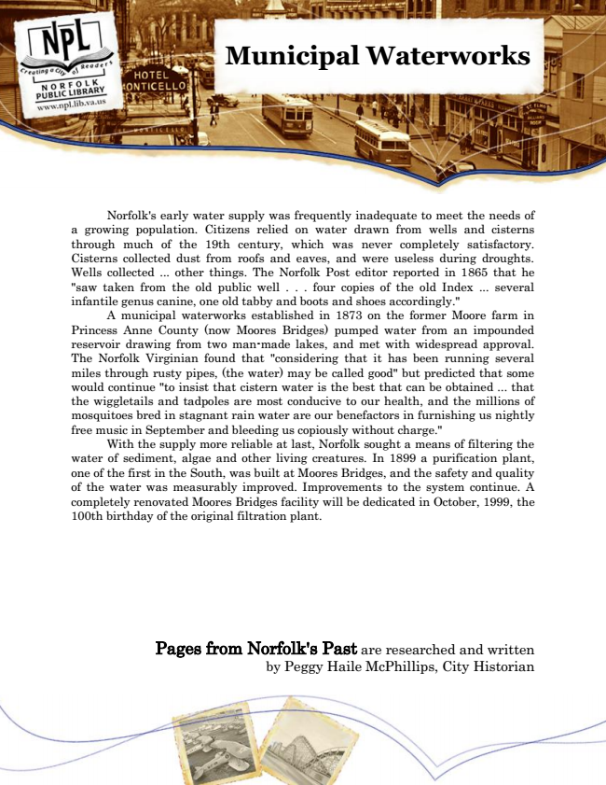

**Municipal Waterworks**

Norfolk's early water supply was frequently inadequate to meet the needs of a growing population. Citizens relied on water drawn from wells and cisterns through much of the 19th century, which was never completely satisfactory. Cisterns collected dust from roofs and eaves, and were useless during droughts. Wells collected ... other things. The Norfolk Post editor reported in 1865 that he "saw taken from the old public well . . . four copies of the old Index ... several infantile genus canine, one old tabby and boots and shoes accordingly."

A municipal waterworks established in 1873 on the former Moore farm in Princess Anne County (now Moores Bridges) pumped water from an impounded reservoir drawing from two man-made lakes, and met with widespread approval. The Norfolk Virginian found that "considering that it has been running several miles through rusty pipes, (the water) may be called good" but predicted that some would continue "to insist that cistern water is the best that can be obtained ... that the wiggletails and tadpoles are most conducive to our health, and the millions of mosquitoes bred in stagnant rain water are our benefactors in furnishing us nightly free music in September and bleeding us copiously without charge."

With the supply more reliable at last, Norfolk sought a means of filtering the water of sediment, algae and other living creatures. In 1899 a purification plant, one of the first in the South, was built at Moores Bridges, and the safety and quality of the water was measurably improved. Improvements to the system continue. A completely renovated Moores Bridges facility will be dedicated in October, 1999, the 100th birthday of the original filtration plant.

Pages from Norfolk's Past are researched and written by Peggy Haile McPhillips, City Historian